# **Miscellaneous**

## **Random retrieval what you will go for between ArrayList and LinkedList?**

1. An ArrayList is preferable over a LinkedList. The reason is that an ArrayList provides O(1) time complexity for retrieving an element at a specific index, while a LinkedList has O(n) time complexity for the same operation. accessing any element is very fast and predictable, regardless of the size of the list.
2. ArrayList allows direct access to any element using an index. This is because all elements in an ArrayList are stored in a contiguous block of memory, enabling direct and immediate access via array indexing.
3. LinkedList provides O(n) time complexity for random access. To access an element at a particular index, you have to traverse the list from the beginning (or end, if it's closer) until you reach the desired position. This makes random access operations slow, especially as the size of the list grows.
4. **Memory Overhead**: Although not directly related to retrieval time, LinkedList also incurs additional memory overhead due to the storage of pointers (references to next and possibly previous nodes), while ArrayList uses a single contiguous block of memory.

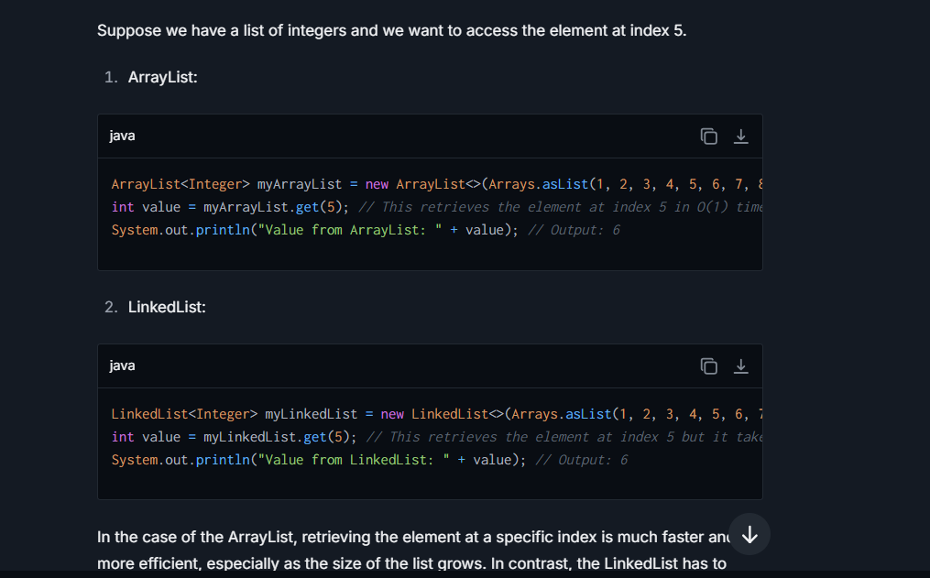

## **What is java I/O and file handling Explain ?**

Java I/O (Input/Output) refers to the process by which Java programs perform input and output operations, these operations often involve reading from or writing to files, networking streams, keyboard input, console output, and more. Java provides strong support for I/O operations through the **java.io** package, ensuring that Java applications can interact effectively with data sources or destinations.

**Components of Java I/O:**

**1. Streams:** The core concept in I/O is the stream, which is a sequence of data. In Java, a stream is either an input stream (for reading data) or an output stream (for writing data). Streams can be connected to various data sources and destinations, including files, network connections, and even arrays in memory.

**2. Readers and Writers:** For handling character data, Java uses **Reader** and **Writer** classes. These are designed for char-oriented I/O, unlike **InputStream** and **OutputStream**, which are byte-oriented. This distinction is important for supporting internationalization (i18n), as characters in many languages require more than one byte.

**Java File Handling:**

File handling in Java is largely performed using classes from the **java.io** package, such as **File**, **FileInputStream**, **FileOutputStream**, **FileReader**, **FileWriter**, **BufferedReader**, and **BufferedWriter**.

**File Class:** It is an abstract representation of file and directory pathnames. It defines methods to create, delete, and query file characteristics (such as permissions).

**Reading Files:**

* **Using FileInputStream:** Read byte-based data from a file.

## **What is super keyword ?**

The **super** keyword in Java is a reference variable which is used to refer directly to the immediate parent class object. It is particularly useful in cases of inheritance, where a class extends to another class (parent class). The **super** keyword provides a way to access members (methods, constructors, and fields) of the parent class from within a subclass.

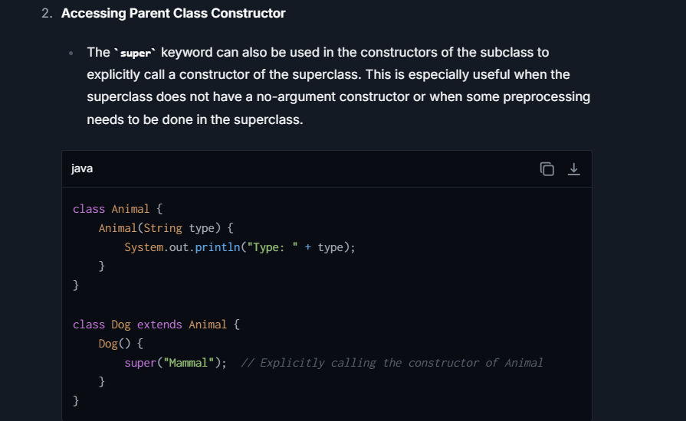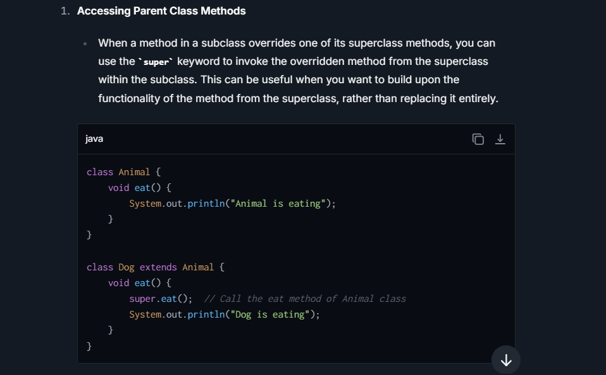

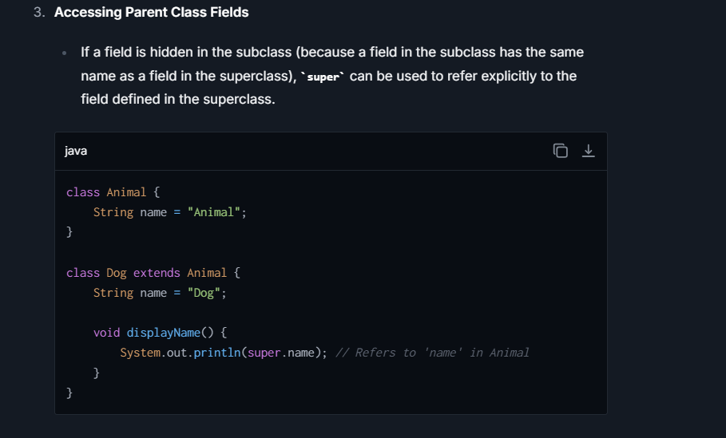

## **What is Static Keyword?**

The **static** keyword in Java can be applied to variables, methods, and blocks and defines them as belonging to the class, rather than instances of the class:

* **static variable:** A variable declared as static is shared among all instances of the class. It is used to refer to the common property of all objects (which is not unique for each object), e.g., the company name of employees, college name of students, etc. Example: **static int employeeCount;**
* **static method:** A static method can be invoked without needing an instance of the class. Thus, it can access only static data. It cannot access non-static data (instance variables) and it cannot call non-static methods directly

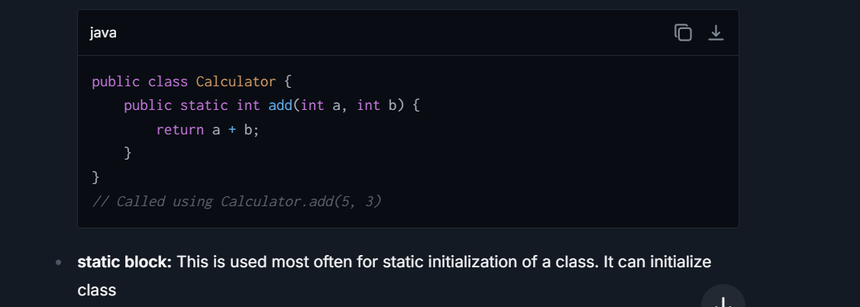

## **What is final keyword in java ?**

The **final** keyword in Java is a modifier used with variables, methods, and classes, and it serves to restrict the further modification or extension of these elements in certain ways. Different usages of the **final** keyword have different implications:

**1. Final Variables:**

When a variable is declared as **final**, its value cannot be modified once it has been initialized. This applies to both primitive data types and objects.

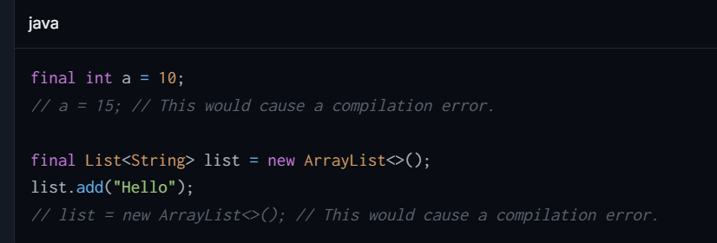

**2.Final Methods:**

A method declared as **final** cannot be overridden by subclasses. This is often used to prevent alteration of behavior (method implementation) in a class hierarchy, especially when a certain method implementation is considered critical to the class's integrity or functionality.

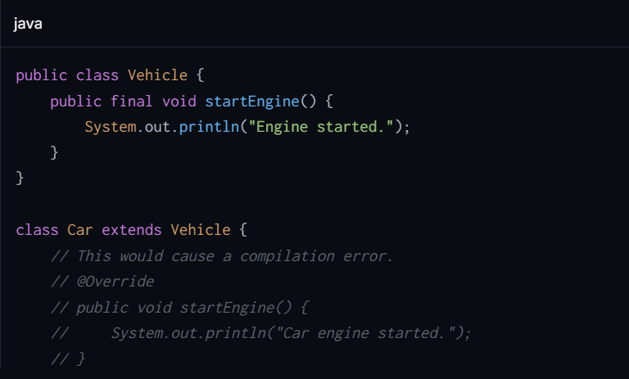

**3.Final Classes:**

If a class is declared as **final**, it cannot be subclassed. This is particularly useful when you want to prevent any modification or extension of the class, often for reasons of security, immutability, or certain design constraints

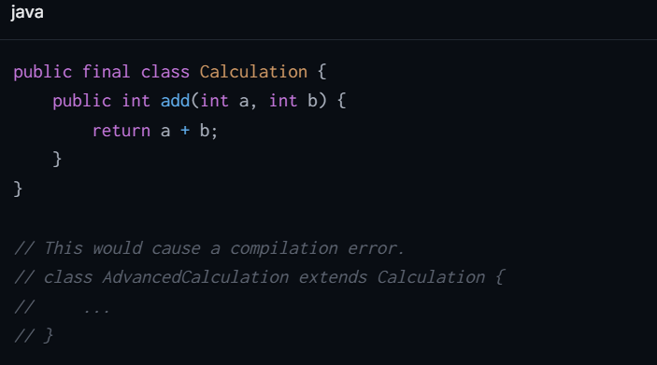

## **What is Immutable object?**

An immutable object in Java is an object whose state cannot be modified after it is created. This is useful for creating simple, reliable code, as immutable objects are:

* Naturally thread-safe and have no synchronization issues.
* Good candidates for key values in maps because their immutable nature ensures that the hashcode doesn't change.

**To create an immutable class in Java:**

1. **Declare the class as final**: Prevents the class from being subclassed.
2. **Set all fields private and final**: Ensures fields are initialized only once inside the constructor and never exposed to modification outside the class.
3. **No setters**: Avoid providing methods that modify fields or objects referred to by fields.
4. **Ensure exclusive access to mutable objects**: Don't share references to mutable objects. Return new copies of mutable objects, or return immutable objects, where necessary.
5. **Initialize all fields via constructor**: Providing explicit constructor to initialize all fields along with deep copies of mutable objects.

## **What is Exit() method?**

The exit () method in Java is a static method from the System class that terminates the currently running Java Virtual Machine (JVM). The method is commonly used to abruptly terminate a Java application. It requires an argument of type int, which serves as a status code to signal to the operating system or the calling process about the nature of the program's termination.

## **Suppose we have create a object of EMP class, how we can use TreeMap for EMP class object?**

To use a TreeMap with objects of a custom class (like **EMP**), the class must either implement the **Comparable** interface or you must provide a **Comparator** when creating the **TreeMap**. This is because **TreeMap** stores its keys in a sorted order, and to maintain this order, it needs to know how to compare the keys

**Step 1: Define the EMP Class**

Assuming the **EMP** class has attributes like **id** and **name**, you can implement the **Comparable** interface to decide the sorting order based on one of these fields

**Step 2: Use EMP Objects as Keys in TreeMap**

You create a **TreeMap** where each key-value pair maps an **EMP** object to a string (which could represent a department, for instance):

## Difference between **ArrayList vs Linkedlist ?**

| **Feature** | **Array** | **LinkedList** |
| --- | --- | --- |
| Structure | Fixed size, contiguous memory allocation. | Dynamic size, consists of nodes where each node contains data and a reference to the next node. |
| Size Modification | Cannot be resized once initiated. | Can grow or shrink dynamically as elements are added or removed. |
| Memory Usage | Efficient memory usage as elements are stored in continuous memory blocks. | Higher memory usage due to storage of additional references for each element (next, and possibly previous). |
| Element Access | Direct access via index, O(1) time complexity. | Sequential access required, O(n) time complexity for accessing an element by index. |
| Insertions and Deletions | Slow, especially at the start or middle, O(n) due to shifting elements. | Fast at the start and potentially at the end, O(1). Insertions/deletions in the middle require traversal, making it O(n). |
| Use Cases | Suitable for applications where frequent access to elements by index is needed. | Suitable for applications where frequent insertion and deletion of elements are required. |
| Element Type | Can hold any data type, primitives or objects. Length must be defined at creation. | Typically used for storing objects. Does not support primitive data types directly (requires wrappers). |
| Search Efficiency | Linear search is O(n); if sorted, binary search can be applied in O(log n). | Always O(n) as elements are not contiguous in memory. |
| Implementation Overhead | Minimal implementation overhead. | Additional overhead due to handling of node references and dynamic size. |

## Difference between Set and List in Java ?

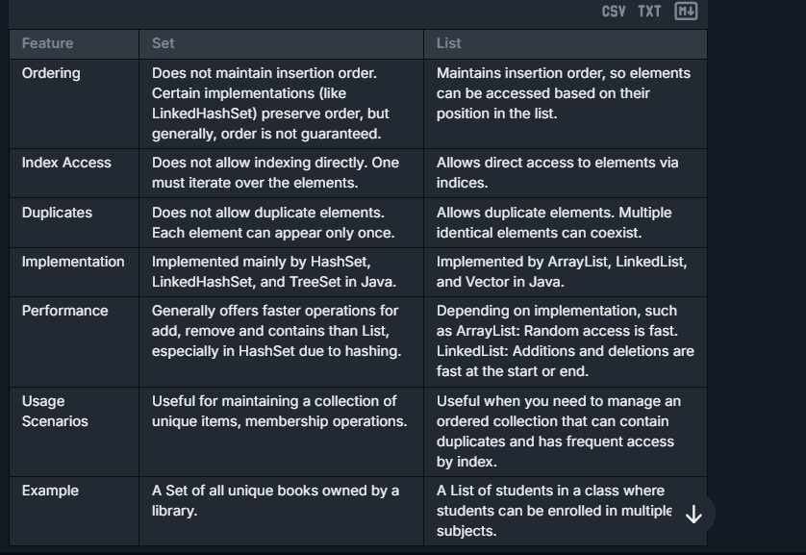

## **Difference Between This and Super Keyword?**

|  |  |  |
| --- | --- | --- |
| **Reference** | Refers to the current instance of the class. | Refers to the superclass (parent class) of the current instance. |
| **Usage** | Commonly used to refer to current class instance variables, methods, and constructors. | Used to refer to superclass instance variables, methods, and constructors. |
| **Constructors** | Used to call constructors of the same class, typically seen in overloaded constructors. | Used to call constructors of the parent class. Must be the first statement in the subclass constructor. |
| **Method Overriding** | Can be used to call another method within the same class. | Often used to call a method in the superclass that has been overridden in the current class. |
| **Variables** | Accesses an instance variable of the current object. This helps to distinguish between local variables (parameters) and instance variables when they have the same name. | Accesses an instance variable from the superclass that might be hidden by a field in a subclass with the same name. |
| **Accessibility** | Cannot be used from a static context as it does not reference a static object. | Similar to **this**, it cannot be used from a static context since **super** also refers to a current superclass instance which does not exist statically. |
| **Inheritance** | Does not imply any form of inheritance. It's self-referential. | Directly implies and relies on inheritance, as it is used to interact with the parent class structure. |
| **Use in Constructors** | **this()** invokes another constructor of the same class. Often used for constructor chaining within the same class. | **super()** invokes a constructor of the base class and is used for initializing a parent class before the child class. |

## Final

The **final** keyword in Java can be applied to variables, methods, and classes, and it has different implications

1. **Final variable**: When a variable is declared with the **final** keyword, its value cannot be changed once it is initialized. This makes it a constant. For example:

java

final int MAX_VALUE = 100;

MAX_VALUE = 200; *// This will result in a compilation error*

In this example, **MAX_VALUE** is a constant and its value cannot be changed after it is set to 100.

1. **Final** method: When a method is declared **final**, it can not be overridden by subclasses. This is useful when you want to prevent a specific behavior of a method in a class hierarchy from being altered. For example:

public class Animal {

public final void makeSound() {

System.out.println("Some sound"); }}

public class Dog extends Animal {

public void makeSound() { *// This will result in a compilation error*

System.out.println("Bark"); }}

In this example, the **makeSound()** method in the **Animal** class is declared as final. Therefore, the **Dog** class cannot override the **makeSound()** method.

1. **Final** class: When a class is declared as **final**, it cannot be subclassed. This is useful when creating an immutable class or preventing further inheritance. For example:

java

public final class Car {

public void drive() {

System.out.println("Car is driving"); }}

public class ElectricCar extends Car { *// This will result in a compilation error*

public void drive() {

System.out.println("Electric Car is driving"); }}

In this example, the **Car** class is declared as final, which means no other class can inherit from it, including the **ElectricCar** class.

# **JVM & Garbage Collection ?**

## **What is Class Loader?**

A Class loader is part of the Java Runtime Environment (JRE) that dynamically loads Java classes into memory. Class loaders are responsible for loading classes when the JVM requests them. They locate, load, and validate the classes, making sure they are properly structured and secure.

**Key Types of Class Loaders**

1. **Bootstrap Class Loader**: The root class loader that loads core Java classes from the rt.jar (like java.lang.*).

It is the root of the ClassLoader hierarchy and written in native code (C/C++),

It is invisible in Java.

1. **Extension ClassLoader (or Platform ClassLoader in Java 9+):**
   * Loads Java extensions from the ext directory or the java.ext.dirs system property.
   * Includes classes like javax.*.

**3. Application ClassLoader (System ClassLoader):**

* 1. Loads application classes and libraries specified in the CLASSPATH or from the application's jar files.
  2. It is the default ClassLoader for most applications.

 🡨-------------------------------------------------**How Class Loaders Work**----------------------------------------------------------🡪

When a Java class is requested, the JVM first checks if the class is already loaded. If not, it delegates the request up the hierarchy, from the child to the parent class loader. If the class is not found by the Bootstrap or Extension loaders, the Application class loader attempts to load it.

## **Define JVM architecture with an example?**

VM (Java Virtual Machine) architecture is composed of various components that help in the execution of Java applications. Here is a simplified explanation of its architecture followed by an example:

1. **Class Loader**: This component is responsible for loading class files. It reads the compiled .class files generated by the Java Compiler (from the JDK) into the runtime data areas.
2. **Runtime Data Areas**: These areas are used for memory storage during execution of the program. They include method area, heap, Java stack, PC registers, and native method stack.
3. **Execution Engine**: This component executes the bytecode that has been loaded into the runtime data areas. It has 3 main functions: interpreter (reads and executes bytecode one line at a time), JIT Compiler (compiles entire bytecode to native code to enhance speed), and garbage collector (manages and frees memory in the heap).
4. **Native Interface**: Enables Java code running in JVM to call libraries and native applications specific to the hardware.
5. **Native Libraries**: Collections of C/C++ libraries that interact with OS specific functions beyond JVM capabilities.

**Example of JVM Execution:**

When you run a Java program, say **HelloWorld.java**, here's how JVM architecture works:

1. The source code **HelloWorld.java** is compiled by JDK's Java compiler into bytecode **HelloWorld.class**.
2. The class loader loads **HelloWorld.class** into JVM.
3. Bytecode is stored in method area. Whenever **HelloWorld** creates an object, memory for that object is allocated from the heap.
4. Execution engine interprets the bytecode of **main** method from method area or compiles it into faster native code.
5. The **main** method is executed by JVM which prints the **Hello, World!** Output

## **What is JIT and Interpreter in Java ?**

Java combines an **Interpreter** and a **Just-In-Time (JIT) compiler** for executing code.

**1. Interpreter:**

* The **Interpreter** reads and executes the bytecode line by line. Whenever a method or statement is encountered, the interpreter translates the bytecode of that method into machine code (native instructions) at runtime.
* It is simple and quick for small pieces of code but can be slower for repeatedly executed code since it needs to re-interpret the same bytecode every time.

**2. JIT Compiler:**

* The **JIT (Just-In-Time) Compiler** works alongside the interpreter. When the JVM notices that certain parts of code (like loops or frequently called methods) are executed repeatedly, the JIT compiler compiles the bytecode for those portions into native machine code, reducing the overhead of repeatedly interpreting the same code.
* JIT compiles the "hot" or frequently used code and caches the native code for future execution, significantly improving performance.

**Key Difference:**

* **Interpreter** executes code line by line without producing any reusable machine code.
* **JIT Compiler** converts the bytecode into reusable machine code (native instructions), optimizing for performance.

**When Each Comes Into Play:**

* **Interpreter**: At the initial stage when the program starts, the Interpreter quickly executes the code.
* **JIT Compiler**: Comes into play for "hot code" (frequently executed code), ensuring faster execution during subsequent calls.

## **Explain memory spaces in JVM?**

In it, memory is primarily divided into several distinct spaces to manage different aspects of Java application execution. Each of these memory spaces has a specific role to play in the operation of the JVM. Below is an overview of the primary memory spaces utilized by the JVM:

1. **Method Area**: This part of memory is shared among all Java Virtual Machine threads and stores per-class structures such as the runtime constant pool, field and method data, and the code for methods and constructors. It is used to store class-level information.
2. **Heap Area**: This is a shared memory space where all the Java objects (including instances of classes) are allocated. This area is the runtime data area from which memory for all class instances and arrays is allocated. It is also the area that is managed by the garbage collector, which frees memory by collecting and removing objects that are no longer in use.
3. **Java Stack Area (JVM Stack)**: Each thread has its own JVM stack, created at the same time as the thread. This area stores frames that are used to store data and partial results, and to perform dynamic linking, return values for methods, and dispatch exceptions. Each method call creates a new frame that is pushed onto the calling thread's stack.
4. **Program Counter (PC) Register**: Every JVM thread has its own PC Register. It holds the current instruction address of the method that the thread is currently executing. If the method being executed is native, the PC register is undefined.
5. **Native Method Stack**: This is similar to the Java Stack but is used by the JVM for executing native code (code written in languages other than Java, such as C or C++).
6. **Direct Memory (Non-Heap Memory)**: This is memory that is not managed by the JVM's memory management but can be utilized by the Java application, typically for high-performance applications. It includes the memory used by the JVM itself for its operation which is not part of the heap or stack, and also the memory allocated using **ByteBuffer** allocated with **allocateDirect()** method in Java. It's useful for large memory operations and interacting with native libraries

## **What is Stack and Heap Memory ?**

2 Types of Memory : --> Heap -> Stack  
-->scope will create for the methods, there are 2 methods (main(),memory Test())  
--> Within the scope, We have the access all the variable  
  
Stack memory is smaller and faster.  
because it's meant for temporary data like local variables and method stack frames.  
<-----------------------------------------Stack Memory:----------------------------------------------->  
  
-> Store Temporary Variables and separate memory block for methods.  
-> Store Primitive data types -  
-> Store Reference of the heap objects  
 Strong reference  
 Weak reference  
 Soft reference  
  
-> Each thread has its own Stack memory.  
-> Variables within a SCOPE is only visible and as soon as any variable goes out of the SCOPE,  
it get deleted from the Stack (in LIFO order)  
  
-> When Stack memory goes full, its throws "java.lang.StackOverflowError  
  
  
<----------------------------------- Heap Memory --------------------------------------------------->  
  
 -> Store Objects.  
 -> There is no order of allocating the memory.  
 ->Heap memory is shared with all the threads.  
 ->Heap also contains the String Pool.  
 ->When Heap memory goes full, its throws "java.lang.OutofMemoryError"  
 -> Heap memory is further divided into:  
 1. Young Generation (minor GC happens here)  
 Eden  
 Survivor(S0/S1)  
 2. Old/Tenured Generation (major GC happens here)  
 3. Permanent Generation  
 ->Heap memory has MUCH MORE memory than stack memory in any system,  
 because it is used to store long-lived, large objects and shared data structures.

## **What is Heap memory, types ?**

**Heap Memory** is used to store objects and dynamic data at runtime. When you create an object using the **new** keyword, the JVM allocates space for it in the **Heap Memory**. Heap memory is **shared** across all threads of an application, meaning different parts of your program use the same heap for storing objects.

**What is Heap Memory?**

* Heap memory is a large pool of memory used in Java to store:
  + **Objects**: Instances of classes created at runtime.
  + **Arrays**: Dynamically allocated arrays.
  + **Class-level variables**: Fields of objects and static class members (part of the Method area).
* It is dynamically allocated during runtime and deallocated by the **Garbage Collector** when objects are no longer reachable.

**Types of Heap Memory**

For efficient memory management and garbage collection, the JVM divides the heap into **different sections (regions)**:

1. **Young Generation**: For new or short-lived objects.
2. **Old Generation (Tenured Generation)**: For long-lived objects.
3. **MetaSpace (or Permanent Generation in Java 7 and earlier)**: Stores class metadata and other runtime information.

**Heap Memory Types (Explained in Detail)**

**1. Young Generation (Young Gen)**

The **Young Generation** is where **new objects** are created. Most of these objects are **short-lived** and become eligible for Garbage Collection quickly (e.g., temporary variables, intermediate results).

* **Structure of Young Generation**:
  1. **Eden Space**:
     + All **new objects** are allocated in the Eden space.
     + When the Eden space is full, **Minor GC (Garbage Collection)** is triggered, and garbage is removed.
  2. **Survivor Spaces (S0 and S1)**:
     + There are two survivor spaces: **S0** (Survivor 0) and **S1** (Survivor 1).
     + Objects that survive a Minor GC cycle (i.e., objects still in use) are moved from the Eden space to one survivor space.
     + Survivor spaces act as a **holding area** for young objects that may later be moved to the **Old Generation**.
* **Object Promotion**:
  1. If an object lives through multiple Minor GC cycles (i.e., survives in survivor spaces for a certain threshold), it is **promoted** to the **Old Generation**. This is called **object promotion**.

**Key Characteristics of Young Gen**:

* Objects are removed quickly by **Minor GC** since most are short-lived.
* Divided into **Eden Space** and **Survivor Spaces (S0/S1)**.

**2. Old Generation (Tenured Generation)**

The **Old Generation** is where **long-lived objects** are stored. Objects that survive multiple Minor GC cycles are **promoted** (moved) to the Old Generation.

**Key Characteristics of Old Gen**:

* Contains objects with a **longer lifecycle** (e.g., cached data, session objects, database connections).
* Garbage Collection in this region is known as **Major GC (or Full GC)**.
* Major GC takes **more time** than Minor GC because it scans a larger portion of memory.
* This region is often compacted to reduce memory fragmentation.

**When Are Objects Moved to Old Gen?**

* Objects are moved to the Old Generation when:
  1. They survive a certain number of Minor GCs in Young Generation.
  2. Their **age threshold** for promotion (defined by JVM) is reached.

**3. MetaSpace (or Permanent Generation in Java 7 and earlier)**

**MetaSpace** stores class metadata and runtime information, such as:

* Class definitions.
* Method and field information.
* Static variables.

**Key Characteristics**:

* Starting from **Java 8**, MetaSpace replaced the **Permanent Generation (PermGen)**.
* Unlike PermGen (which was part of the heap), MetaSpace resides in **native memory**, meaning it is not part of the heap.

**Why was PermGen replaced with MetaSpace?**

* **MetaSpace** eliminates the fixed-size limitation of PermGen, and memory usage grows dynamically based on the application's needs, reducing potential **OutOfMemoryError** caused by PermGen.

## **What is type reference and types ?**

 A **Reference** is like a "pointer" to an object in memory. It enables interaction with objects stored in **Heap Memory**. A reference determines how the Garbage Collector or JVM manages the lifecycle of an object.

Through **reference types**, Java spec defines how objects are tracked, accessed, and eventually garbage-collected.

**Types of References in Java :-**

**Strong Reference (default), Weak Reference, Soft Reference, Phantom Reference**

**1. Strong Reference**

This is the default reference type in Java. A strong reference is created whenever you directly assign an object to a variable. As long as a strong reference exists to an object, the garbage collector (GC) will never remove that object from memory.

**Characteristics:**

* Strongly referenced objects are not eligible for garbage collection, even if the JVM runs low on memory.
* You must explicitly set the reference to null to make the object eligible for GC.

**Use Case:**

* Default usage when creating objects and references in regular programming.

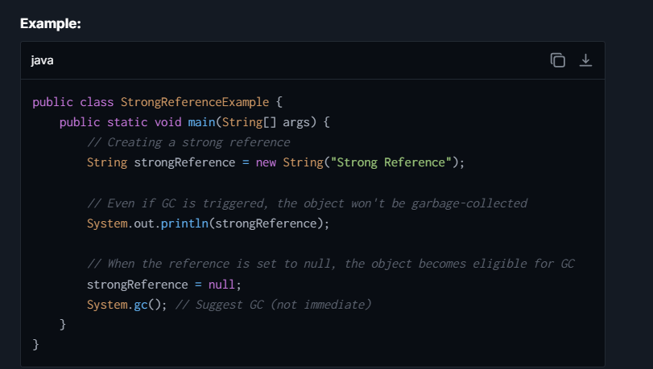

**2. Weak Reference**

A **Weak Reference** allows an object to be collected by the garbage collector **if no strong references** exist to that object. These references are often used in caching mechanisms or data structures like **WeakHashMap**.

**Characteristics:**

* Weak references do **not prevent GC**.
* Useful for applications where objects should not be kept in memory unnecessarily.

**Use Case:**

* Implementation of **WeakHashMap**, where the keys are weakly referenced, allowing unused entries to be automatically removed.
* Useful for caching data that can be recreated if needed.

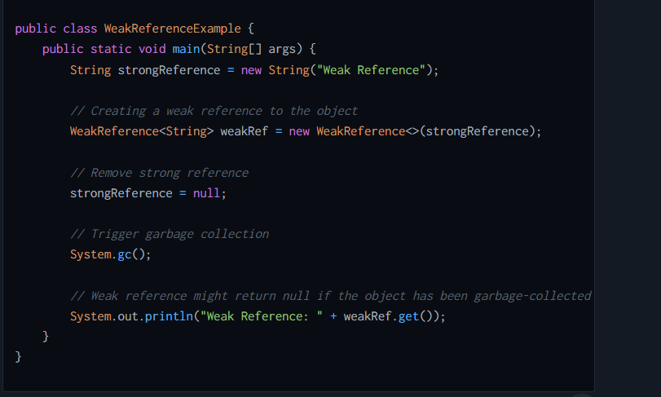

**3. Soft Reference**

A **Soft Reference** is stronger than a weak reference but still allows the object to be garbage-collected **only when the JVM runs low on memory**. Soft references are **ideal for caching** when memory constraints are not critical.

**Characteristics:**

* Objects referenced by soft references will **stay in memory** until the JVM needs to free space.
* Often used to implement memory-sensitive caching systems

**Use Case:**

* Frequently used in **caching** systems where we want to keep objects in memory as long as there’s no memory shortage.
* Example: Image caching or session management in web applications.

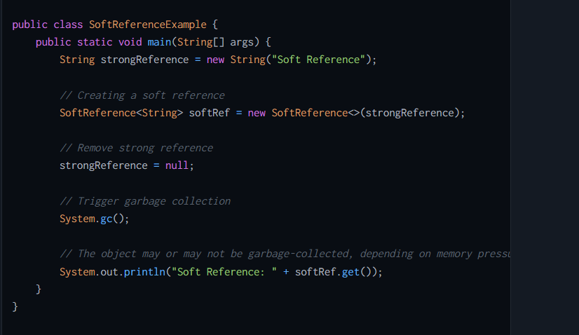

**4. Phantom Reference**

A **Phantom Reference** is the weakest type of reference in Java. Phantom-referenced objects are eligible for garbage collection **immediately** once all strong, soft, and weak references are removed. However, instead of being removed outright, a **ReferenceQueue** can be used to notify the application when the object is finalized and garbage-collected.

**Characteristics:**

* Always returns **null** when **.get()** is called.
* Often used to execute **cleanup tasks after garbage collection**.
* Does not keep the object alive in memory.

**Use Case:**

* Used for managing resources after an object’s lifecycle is over (e.g., cleanup of native resources or unregistering observers).
* Advanced techniques for memory-sensitive applications.

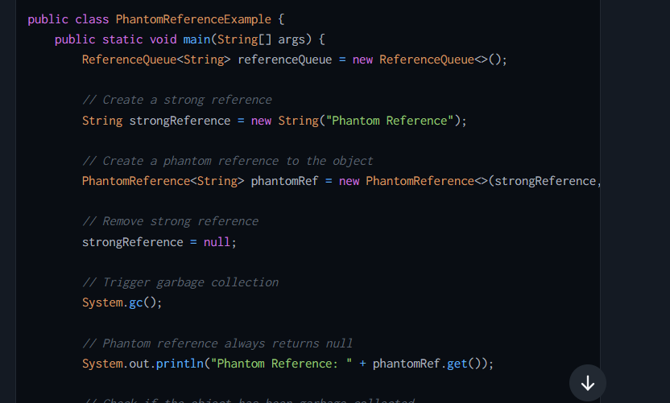

## **What is Garbage Collector and algorithm?**

The **Garbage Collector (GC)** is a **memory management** tool in Java that automatically handles the deallocation of objects that are no longer in use, freeing up memory in the Java Heap to allow new object creation. The GC is part of the **Java Virtual Machine (JVM)** and ensures that Java applications make efficient use of memory.  
**Key Features of the Garbage Collector:**

* **Automatic Memory Management:** The GC automatically identifies objects that are no longer reachable and reclaims memory without explicit intervention by the programmer.
* **Prevents Memory Leaks:** By clearing memory held by unreachable objects, the GC prevents memory from being unnecessarily occupied.
* **Non-deterministic:** The exact timing of when the GC will run is unpredictable. It depends on JVM implementations and memory usage.
* **Generational Approach:** The heap is divided into different regions (e.g., Young, Old/tenured generation) to optimize GC performance by segregating short-lived and long-lived objects**.**

## **What are the types of GC?**

Several types of **garbage collectors**, such as the **Serial GC, Parallel GC, Concurrent Mark Sweep (CMS) GC**, and **G1 GC**

**1. Serial Garbage Collector**

* **What it is:** The simplest, single-threaded garbage collector. It works by stopping all application threads during garbage collection ("Stop-the-World").
* **How it works:** It performs garbage collection in a sequential manner, cleaning all objects in a single thread.

**Advantages:**

* Simple and easy to understand.
* Works well with small heaps.
* Minimal overhead since only one thread is used for GC.

**Disadvantages:**

* Freezes (pauses) the application while doing garbage collection, leading to poor performance in multi-threaded applications.
* Not suitable for modern applications with large heaps or high concurrency.

**Use Case:**

* Single-threaded applications or small applications with low memory requirements.

**2. Parallel Garbage Collector (Throughput Collector)**

* A multi-threaded garbage collector that performs collection using multiple threads, reducing overall GC duration.
* **How it works:**
  + It uses multiple threads to collect garbage (stop-the-world still applies).
  + Designed to prioritize throughput (maximum application execution time and minimal GC time).

**Advantages:**

* More efficient than Serial GC for large heaps.
* Suitable for applications where high throughput is more important than low response times.
* Reduces total GC time due to parallelism**.**

**Disadvantages:**

* Still has application pauses, as it stops all threads during garbage collection.
* Not ideal for applications requiring low latency or real-time responsiveness.

**Use Case:**

* Batch processing, data processing systems, or applications that value throughput over small pauses.

**3. Concurrent Mark-Sweep (CMS) Garbage Collector**

* A garbage collector designed for low-latency applications by performing most of the garbage collection work concurrently with the application.
* **How it works:**
  + Divided into multiple phases (mark and sweep). Most of the GC work (like marking unused objects) happens while the application is running.
  + It minimizes application pause times.

**Advantages:**

* Significantly reduces pause times compared to Serial and Parallel GC.
* Performs most of the work concurrently with the application.

**Disadvantages:**

* Consumes more CPU resources since it runs GC tasks alongside the application.
* Fragmentation: CMS doesn’t compact memory, so memory may become fragmented over time.
* CPU overhead makes it unsuitable for CPU-intensive applications.

**Use Case:**

* Web servers or low-latency applications, where responsiveness is critical.
* Suitable for scenarios where pause times should be minimal.

**4. G1 Garbage Collector (Garbage-First GC)**

* A modern GC that divides the heap into smaller regions and prioritizes collecting garbage from regions with the most garbage.
* **How it works:**
  + It minimizes pauses by focusing on regions with more garbage first.
  + It compacts memory during GC, solving the fragmentation issue present in CMS.

**Advantages:**

* Provides predictable pause times by focusing on regions with the most garbage.
* Solves memory fragmentation issues (compacts memory).
* Works well for large heaps**.**

**Disadvantages:**

* More complex than other GCs, resulting in slightly higher overhead in some scenarios.
* May not be as fast as Parallel GC for throughput-heavy applications**.**

**Use Case:**

* Ideal for large, multi-threaded applications like enterprise systems.
* Applications that need predictable performance and handle large heaps**.**

**5. Z Garbage Collector (ZGC)**

* A low-latency collector designed for massive heaps (up to 16 terabytes) with extremely minimal pauses.
* **How it works:**
  + Almost all garbage collection work is done concurrently with the application.
  + Extremely short "stop-the-world" pauses.

**Advantages:**

* Ultra-low pause times (usually below 10 milliseconds), even for large heaps.
* Supports massive heaps up to 16 TB.
* Practically eliminates pause-related performance issues.

**Disadvantages:**

* High memory overhead due to additional bookkeeping by ZGC.
* Higher CPU and resource consumption compared to other GCs.

**Use Case:**

* Real-time applications requiring ultra-low latency, such as financial systems (e.g., trading platforms).
* Large applications requiring massive heaps and responsiveness, like machine learning systems.

**6. Shenandoah Garbage Collector**

* Another low-pause GC that works by performing garbage collection concurrently with the application threads.
* **How it works:**
  + Compacts memory during garbage collection to avoid fragmentation.
  + Attempts to keep application stop-the-world pauses short.

**Advantages:**

* Low pause times since most work is done concurrently.
* Handles compaction during GC, avoiding memory fragmentation.
* Suitable for low-latency applications.

**Disadvantages:**

* Higher resource (CPU and memory) usage compared to traditional GCs.
* May not perform well for applications with very large heaps.

**Use Case:**

* Low-latency applications where response time is critical.
* Multi-threaded applications with medium-to-large heaps.

**7. Epsilon Garbage Collector (No-Op GC)**

* What it is: A no-op garbage collector that doesn’t perform any garbage collection. Introduced in Java 11.
* How it works:
  + Allocates memory until the heap is full. Once memory is exhausted, the application terminates.

**Advantages:**

* No overhead from garbage collection at runtime.
* Useful for manual memory management testing or short-lived applications.

**Disadvantages:**

* Memory is never reclaimed, so the application will crash once memory is exhausted.
* Completely impractical for long-running applications.

**Use Case:**

* Benchmarking and performance testing (to measure overhead caused by garbage collectors).
* Short-lived applications where GC isn't required.

## **What is Mark and Sweep Algoritham ?**

**Mark-and-Sweep Algorithm**

The Mark-and-Sweep algorithm is one of the oldest and most commonly used garbage collection algorithms. It's at the core of many modern Java Garbage Collectors. It involves two main phases: Mark Phase and Sweep Phase.

1. **Mark Phase:**
   * The garbage collector traverses the object graph starting from the root references (e.g., local variables, active threads, static fields).
   * All reachable (live) objects are marked. Objects that cannot be reached from root references are considered unreachable.
2. **Sweep Phase:**
   * The GC scans the heap and clears (or reclaims) memory occupied by unreachable (unmarked) objects.
   * Objects that were marked during the mark phase remain intact.

**Drawbacks of Mark-and-Sweep:**

* **Stop-the-World Pause:** During the mark-and-sweep process, the application might experience a pause.
* **Fragmentation:** The sweep phase doesn't compact memory, leading to fragmentation if collected spaces are scattered throughout the heap**.**
* **Performance:** Traversing the heap and marking references can be slow in large heaps**.**

**Advantages:**

* + **Avoid manual memory management**: Developers don’t need to manually allocate or deallocate memory, reducing coding errors like dangling pointers or double-free issues.
  + **Eliminates dead objects:** Ensures unused objects are removed, freeing up heap space.
  + Within the JVM, Mark-and-Sweep ensures the system runs smoothly without memory leaks provided the code is clean.

**Challenges:**

* + **Stop-the-world pauses**: During the mark-and-sweep operation, the application may pause for a noticeable time, especially for large heaps, impacting performance-sensitive applications.
  + **Fragmentation**: Sweep phase may leave the heap memory fragmented, potentially requiring subsequent compaction operations.

**Examples of Practical Implications:**

* In real-time systems, a large heap and a stop-the-world pause during GC can lead to performance bottlenecks**.   
  For instance:**
  + In a stock-trading system, a GC pause can delay order processing, affecting client experience.

## **What is Minor GC and Major GC?**

* **Minor GC** refers to the garbage collection process that clears the **Young Generation** of the heap. This involves cleaning up **short-lived objects** that are no longer reachable.
* When the **Eden Space** (where new objects are created) is **full**, Minor GC is triggered to reclaim memory and move surviving objects to **Survivor Spaces** or promote them to the **Old Generation**.  
  **Trigger for Minor GC**:
* When the Eden Space fills up, Minor GC is triggered to clean memory.

**Major GC** refers to the garbage collection process that cleans up the Old Generation of the heap. This involves long-lived objects that have been promoted from the Young Generation and are no longer reachable.  
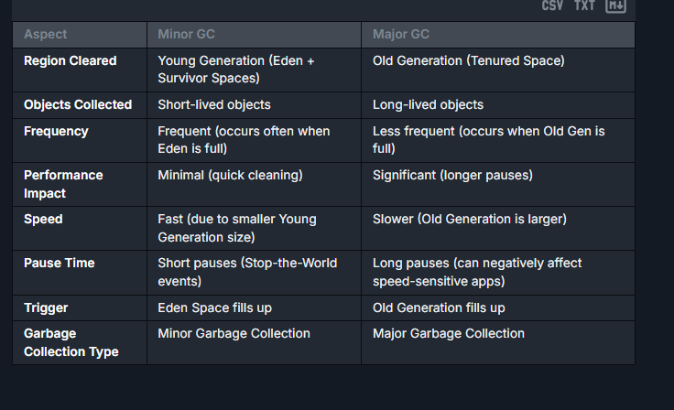

## **How to Detect/Prevent Memory Leaks?**

**Detecting Memory Leaks:** Memory leaks happen when objects are no longer needed but are still referenced, preventing the GC from removing them. Here’s how to detect leaks:

* **Monitor heap usage**: Using tools like **VisualVM**, **JProfiler**, or **Eclipse Memory Analyzer**, monitor if the heap usage keeps increasing over time without going down after GC runs.
* **Heap dump analysis**: Generate heap dumps (**jmap** or tools like VisualVM) and inspect the references to objects persisting in memory unnecessarily.
* **Enable GC logging**: Analyze GC logs with flags like **-XX:+PrintGCDetails** and **-Xloggc:gc.log** to spot unusual behavior in garbage collection.

**Preventing Memory Leaks:**

* **Close resources**: Always close connections, file streams, and other resources (e.g., with **try-with-resources**).
* **Avoid static references**: Don’t store large objects in static variables unless necessary.
* **Use weak references**: Use **java.lang.ref.WeakReference** for objects that can be garbage collected when memory is needed.
* **Proper data structure use**: Ensure collections (like **Map**, **List**) are being cleared when no longer needed.

## **What is Event driven architecture ?**

Event-driven architecture (EDA) ek tarah ka architectural pattern hai jo applications ke design mein use hota hai, jahan components ya services ek dusre se events ke through communicate karte hain. Yeh pattern khaaskar us scenario mein useful hota hai jahan aapko real-time data processing aur immediate response ki zarurat hoti hai, jaise ki financial trading systems ya instant messaging systems mein.

Is architecture mein, jab bhi koi significant ya notable change hota hai, jaise koi user ka action ya external system ka update, toh ek event generate hota hai. Yeh event phir se other parts of the system ko notify karta hai jo is event pe react karte hain.

Event-driven systems mein, components loosely coupled hote hain, matlab ye ki unhe sirf un events ke bare mein pata hota hai jinhe vo sun rahe hote hain, na ki pure system ke internal workings ke bare mein. Isse system ko modify karna aur scale karna easier ho jata hai, kyunki aapko sirf specific parts ko update karna padta hai bina baaki system ko disturb kiye.

Primarily, EDA mein teen main components hote hain or concepts hote hain:

1. **Event Producers:** Ye wo components ya services hote hain jo events generate karte hain. Example ke liye, ek web application jo user interactions ko track karta ho.
2. **Events:** Ye vo messages ya data packets hote hain jo kisi change ya update ko represent karte hain. Events ko usually lightweight rakha jata hai taki ve quickly transmit ho sake.
3. **Event Consumers:** Ye wo components ya services hote hain jo events ko sunte hain aur respond karte hain. Example ke liye, ek email system jo kisi user action par based email send karta hai.

Advantages ki baat karein to, EDA help karta hai in ensuring ki system responsive rahe, scalable ho, aur better error handling provide kare, especially in distributed environments jaise microservices.

## **What is Constant Pool ?**

**Characteristics of the Constant Pool include:**

It is a fundamental component of Java's runtime memory structure, specifically located within the method area.

1. **Containment of Different Constants**: The Constant Pool stores various types of constants, including numerical literals (such as integers and floating-point numbers), string literals, and more complex elements like method and field references. These constants are used by the bytecodes of methods and constructors.
2. **Class-Level Storage**: The Constant Pool is per-class or per-interface. Each class file has its own Constant Pool that is created by the Java ClassLoader during class loading.
3. **Efficiency in Execution**: Storing repeated information in one place helps in optimizing the space and speed. For example, if multiple methods in a class refer to a particular string or float value, this value is stored only once in the constant pool and referenced wherever needed. This approach reduces redundancy and increases performance.
4. **Symbol Resolution**: Before the JVM executes the class methods, it must resolve the symbols in the Constant Pool to direct references to the loaded classes' methods, fields, and other resources. This process is known as "linking".

## **What is asychronous programming ?**

**Asynchronous programming** is a programming paradigm that allows tasks to run independently of the main thread without blocking the execution of other tasks. It is a way to handle operations that might take some time to complete, such as network requests, file input/output, or database queries, without freezing or blocking the program's workflow.

In simpler words, **asynchronous programming** allows your program to perform lengthy or time-consuming operations in the background, freeing the main thread to continue executing other tasks.

**Key Concepts of Asynchronous Programming:**

1. **Non-blocking**:
   * Asynchronous operations allow the main thread (or event loop) to continue executing other tasks while waiting for a result.
   * Instead of "waiting," your program receives a notification (callback, promise, or event) when the task is complete.
2. **Concurrency**:
   * Asynchronous programming enables the execution of multiple tasks at the same time without waiting for one task to complete before starting the next.
3. **Event-driven**:
   * Most asynchronous programming models are **event-driven**, meaning a task doesn't execute right away but starts when an event (e.g., a response to a network request) is triggered.

## **How Can We modify that final list ?**

Java mein jab aap ek list ko 'final' keyword ke saath declare karte hain, toh aap us list ke reference ko nahi badal sakte, i.e., us list ko kisi aur list se replace nahi kar sakte. Lekin, aap list ke andar ke elements ko modify kar sakte hain. 'Final' sirf reference ke constancy ko ensure karta hai, list ke content ko immutable nahi banata.

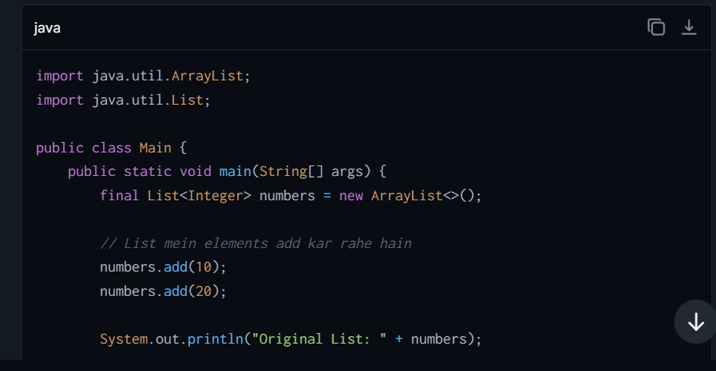

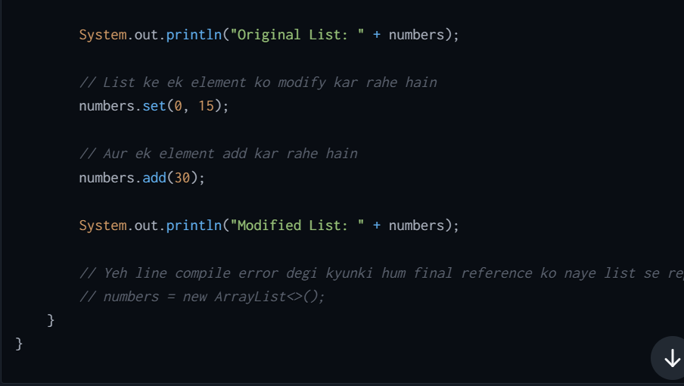  
Is example mein:

* **numbers** list ko **final** ke saath declare kiya gaya hai.
* Humne is list mein successfully integers add kiye, ek existing item ko modify kiya, aur aur integers add kiye.
* Koi bhi attempt jisse **numbers** reference ko doosri list ke saath replace kiya jaye (commented-out line) compilation error ka karan banega.

Is tarah, aap ek final declared list ke reference ko toh nahi badal sakte, lekin aap us list ke contents ko jarur modify kar sakte hain. Isme add, modify, ya elements remove karna included hai.

## **What is the root class? Methods in root class?**

The root class in Java is the class named **Object**. It is the superclass of all other classes in Java, meaning that every other class implicitly extends **Object** if no other superclass is explicitly specified. The Java **Object** class is part of the **java.lang** package, which is automatically imported, so you don't need to explicitly import it in your Java programs.

**There are certain Methods** :-

1. **equals (Object obj)**: This method checks if the current object is equal to the object passed as an argument. It's often overridden in subclasses to provide equality based on the contents of the objects rather than their memory addresses.
2. **hashCode()**: This method returns a hash code value for the object. This method is often overridden in conjunction with **equals()** to ensure that equal objects have the same hash code.
3. **toString()**: Returns a string representation of the object, which can be very useful for debugging. By default, it returns the class name followed by the object's hash code in hexadecimal. However, it's commonly overridden to provide more informative information about the object.
4. **getClass()**: Returns the runtime class of the object. This can be useful for reflection, enabling you to get information about the class at runtime.
5. **clone()**: Creates and returns a copy of the object. The class must implement the **Cloneable** interface for this method to not throw a **CloneNotSupportedException**.
6. **finalize()**: This method is called by the garbage collector before the object is destroyed. It can be overridden to provide cleanup actions, but its use is generally not recommended as it makes performance unpredictable and will be deprecated.
7. **notify()**, **notifyAll()**, and **wait()**: These are methods that are used for thread synchronization. These methods are used to coordinate the activities of multiple threads that use the same object.

## **Difference between Reference types ?**

## **Difference between young generation and old generation ?**

| **Feature** | **Young Generation** | **Old Generation** |
| --- | --- | --- |
| **Definition** | The memory area where newly created objects are allocated. It is part of the heap memory used for short-lived objects. | The memory area that stores long-lived objects that have survived multiple garbage collection cycles in the Young Generation. |
| **Purpose** | Designed to quickly allocate and reclaim memory for objects that are no longer needed soon after creation (short-lived). | Designed to retain objects that have a longer lifecycle and are in use for a significant part of the application lifecycle. |
| **Subdivisions** | The Young Generation is divided into: <br>- **Eden Space**: Where new objects are initially allocated. <br>- **Survivor Spaces** (**S0** and **S1**): Where objects are promoted before being moved to the Old Generation. | The Old Generation isn't further divided, but it contains objects that survived multiple garbage collection cycles from the Young Generation. |
| **Garbage Collection Type** | Garbage collection in the Young Generation is referred to as **Minor GC**. It happens more frequently and is optimized to occur quickly. | Garbage collection in the Old Generation is referred to as **Major GC** (or **Full GC**). It is less frequent but takes more time as it scans a larger memory space. |
| **Frequency of GC** | Collection occurs frequently, as most objects in this region have a short lifespan. | Collection occurs less frequently because objects in this region typically have longer lifespans. GC here is more computationally expensive. |
| **Object Promotion** | Objects that survive multiple GC cycles in the Young Generation are promoted to the Old Generation based on the JVM’s promotion policy. | Objects remain in the Old Generation until they are no longer referenced and can be cleared during a Major/Full GC. |
| **Efficiency** | GC in the Young Generation is designed to be fast and efficient as it works on small memory spaces (most objects are quickly identified as garbage). | GC in the Old Generation is slower and more expensive, as it works on larger memory spaces and considers objects with complex references. |
| **Memory Reclamation** | Easier and faster to reclaim because most objects are short-lived and quickly become eligible for garbage collection. | Slower to reclaim because objects might have complex relationships and references, and tracing them takes more effort. |
| **Impact on Application Performance** | Minor GC is generally quick and has a negligible impact on application performance. | Major GC can pause the application (Stop-The-World), and if not tuned properly, it can result in performance degradation. |
| **Typical Objects in Region** | Objects recently created (e.g., short-lived variables like loop counters, method call objects, etc.). | Objects that are long-lived or continually referenced (e.g., cached data, session information, application constants, etc.). |

# **Collection**

## **What is collection and What are the types of collection ?**

**A** collection is a group of objects that are kept together and treated as a single unit. Collections help manage data efficiently by providing different data structures for organizing, storing, and manipulating data

1. Collection Interface:
   * Set Interface:
   * List Interface
   * Queue Interface:
2. Map Interface:
   * HashMap

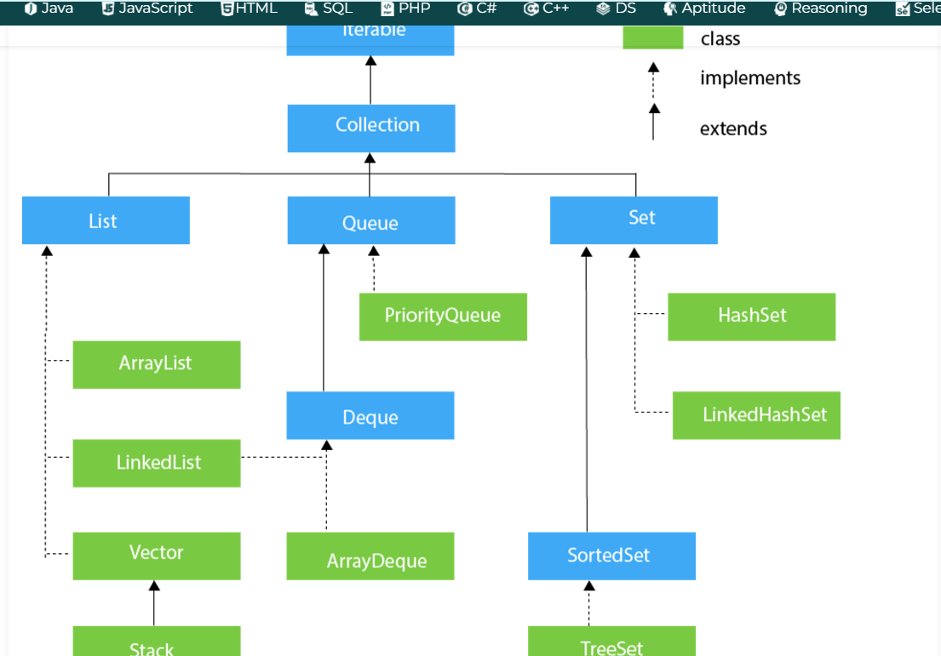

## **What is Map ?**

A Map is an object that stores data in key-value pairs. Each key is unique, and each key can map to at most one value. Maps are useful for fast data retrieval based on keys

**Key Characteristics of the Map Interface  
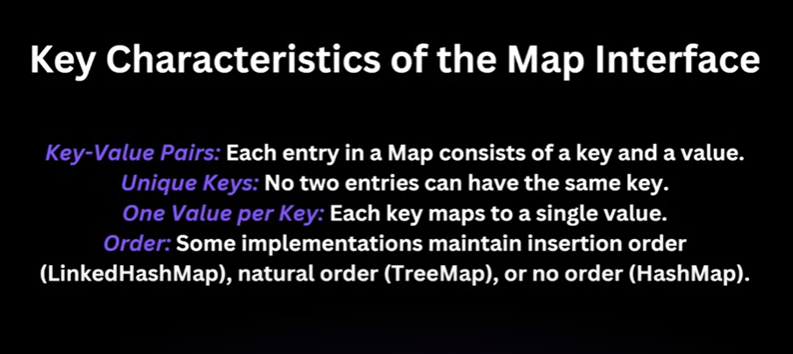**

## **When we insert null value in treeset internally other than exception?**

"When We insert a null value into a **TreeSet** that is using natural ordering (e.g., the elements implement the **Comparable** interface), Java will throw a **NullPointerException**. This occurs because the **compareTo()** method by which the **TreeSet** uses to maintain order, is invoked on the inserted element, passing the existing elements as the argument. Since the **Comparable** contract does not support null arguments, trying to invoke a comparison with or on a null value results in a **NullPointerException**.

To avoid this, when designing a **TreeSet** that needs to handle null values, you would use a custom **Comparator** that explicitly checks for nulls before comparing values. For instance, you could treat null as less than any non-null value, or vice versa, depending on your specific business logic. However, if your custom comparator does not account for nulls, inserting a null would still lead to exception.”

## **Improvements of collision handling in hashmap ?**

A collision in a **HashMap** occurs when two or more keys hash to the same index in the underlying array that stores the entries.

Before Java 8, collisions were handled by linking new entries onto a linked list at the particular index. This approach had a potential performance problem: if too many entries collided at the same index, time complexity for operations such as get() and put() could deteriorate to O(n), where 'n' is the number of entries in the linked list.

**Improvements in Java 8:**

Java 8 introduced a new way of handling high collision scenarios by balancing between linked lists and balanced trees, specifically red-black trees. This hybrid approach works as follows:

1. **Initial Storing with Linked List:** When entries are added to a **HashMap**, they are initially stored in a linked list format at each bucket of the array (each index in the array).

when the number of items in any particular bucket exceeds a certain threshold (TREEIFY_THRESHOLD, which is 8), the linked list at that bucket is converted into a red-black tree. This helps keep the time complexity of search operations close to O(log n), which is significantly better than O(n) in the worst cases of long linked lists.

If the number of elements in a bucket drops below another threshold (UNTREEIFY_THRESHOLD, which is 6) during removal operations, the red-black tree is converted back to a linked list. This helps in maintaining optimal memory usage and performance as maintaining a tree structure can be more memory-intensive than a linked list.

## **Internal working of HashMap:**

* Internally, HashMap uses an array of nodes (buckets), where each node is a linked list to handle collisions. When inserting a key-value pair, the key’s hashCode() is Calculate using the **Hashfunction**, and the data is placed into the appropriate bucket based on this hash code. If a bucket contains multiple items, a linked list is used to handle such collisions, where each node contains a reference to the next. In Java 8, when a bucket becomes too populated, it is converted from a linked list to a balanced tree, which improves performance from O(n) to O(log n) in the worst case.
* **4 basic Component of Hashmap :-**  
  Key, Value, Bucket and Hash function

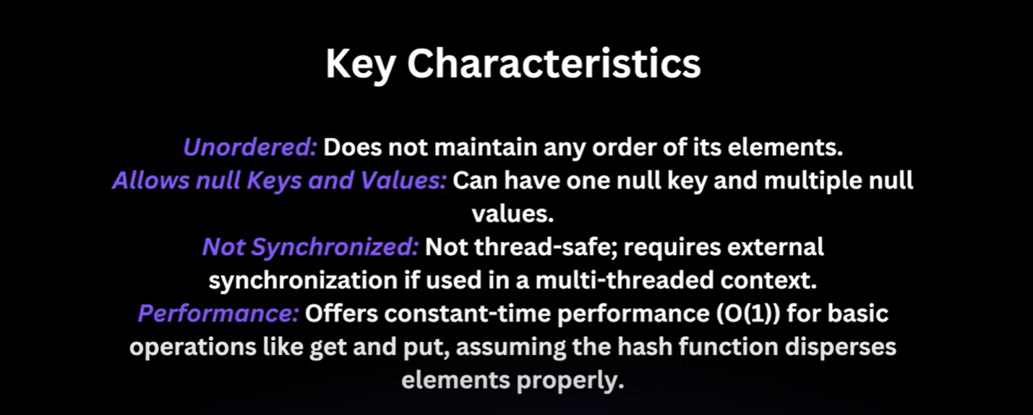

**E.G** **:-**  
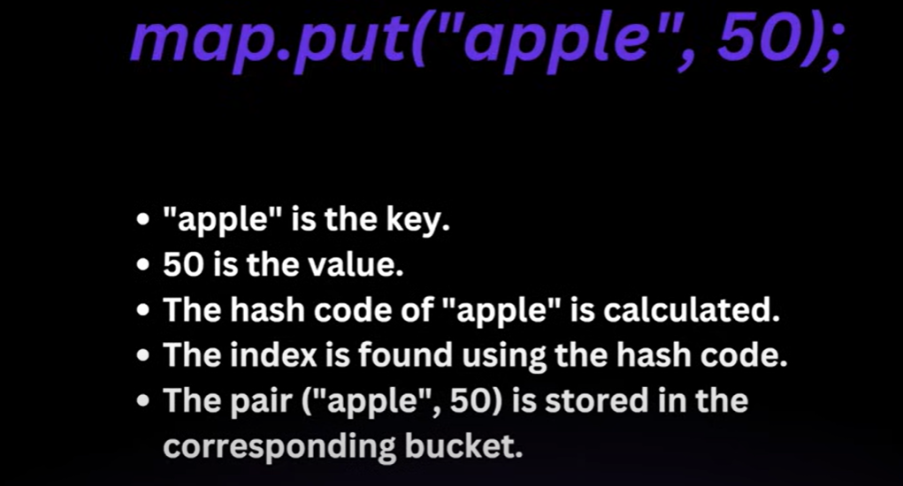

## **Internal working of Concurrent HashMap**

**Internal Working:**

* Instead of locking the entire map for thread safety (like **Hashtable**), **bucket-level locking** is used.
* The map is divided into segments (internally), and only the relevant segment is locked for write operations while read operations remain non-blocking.
* Java 8 replaced segments with **Concurrent Hash Buckets**:
  + Uses **CAS** (Compare-and-Swap) operations for better concurrency.
  + Threads can read from the map with minimal locking, and updates are more efficient than synchronizing the entire map.

## **Internal working of HashSet**

* Each element added to a HashSet is actually stored as a key in an internal HashMap with a dummy value (PRESENT), since the keys in a HashMap are guaranteed to be unique.
* The hashCode() and equals() methods are used to determine if an element already exists in the set.
* Operations like add, remove, and contains are O(1) on average.
* HashSet internally uses a HashMap to store its elements. Each element you add to the HashSet is stored as a key in the underlying HashMap, with a single dummy value shared by all elements. HashSet's performance highly depends on the initial capacity and load factor.

## **Internal working of ForkJoinPool**

The **ForkJoinPool** is a special kind of thread pool designed for parallelism. It divides a large task into smaller tasks (forks), computes them in parallel, and joins the results.

**Internal Working:**

* **Work-Stealing Algorithm**:
  + The pool uses multiple worker threads that try to execute tasks.
  + When a thread finishes its task, it "steals" tasks from other threads’ work queues.
* **RecursiveTasks and RecursiveActions**:
  + **RecursiveTask<V>** is used when there is a return value.
  + **RecursiveAction** is used when the operation does not return a value.

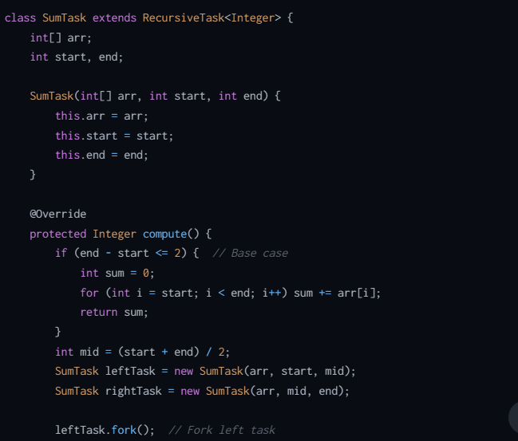

## **Internal working of Get():**

The **get(key)** method in **HashMap** retrieves the value associated with the given key.

**Internal Working:**

1. **HashCode Computation**:
   * The **hashCode()** of the key is computed to determine the hash bucket.
2. **Bucket Traversal**:
   * The corresponding bucket is searched for the key using the **equals()** method.
3. **Return Value**:
   * If a matching key is found, the associated value is returned.
   * If not, **null** is returned.

## **What is HashFunction ?**

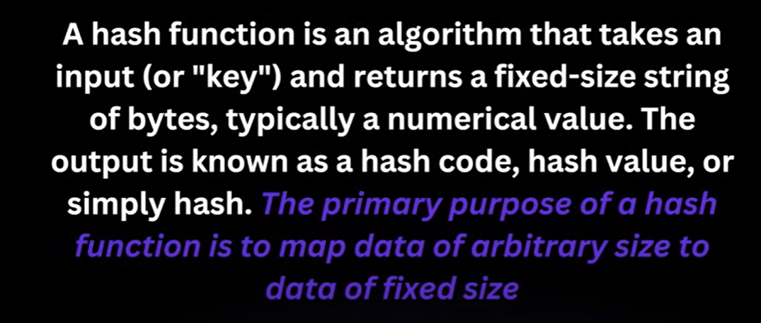

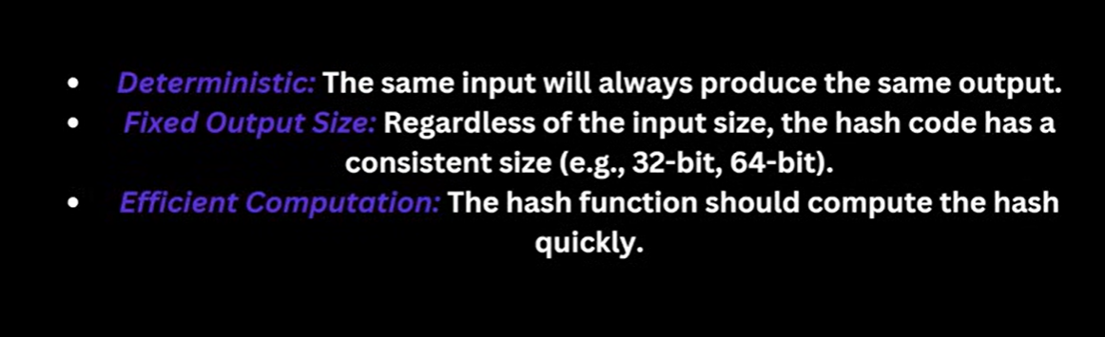

## **What is Rehashing ?**

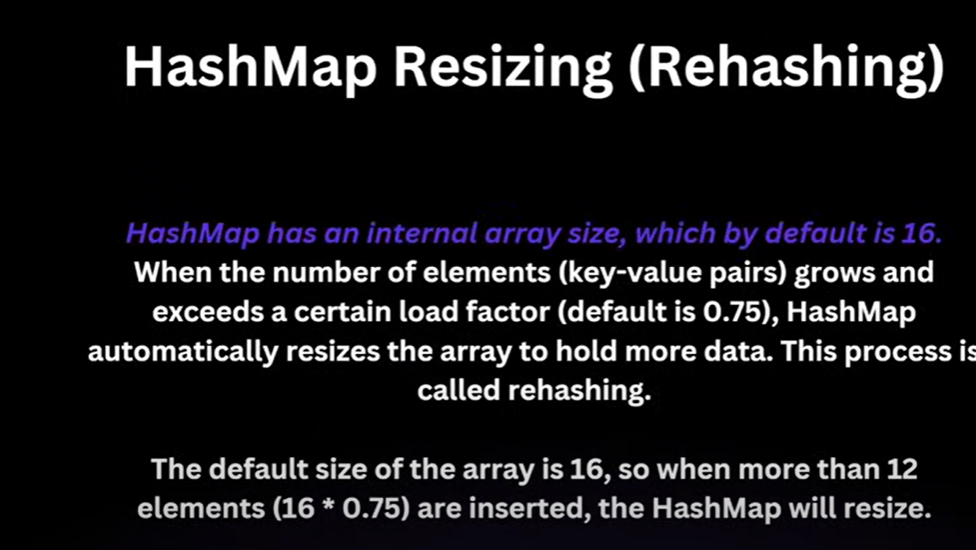

## **What is the hashtable, explain with an example?**

Hashtable is a data structure that offers a similar functionality to HashMap, storing key-value pairs, but it is synchronized, making it thread-safe at the expense of performance.

For example, if you store the pairs (1, "one") and (2, "two") in a Hashtable, retrieving the value associated with key 1 would directly access the bucket computed from the hash of 1, returning "one". If two keys compute to the same bucket, a linked list resolves collisions

## **Equals() and hashcode() methods:**

* The **hashCode()** method returns an integer and is used in determining where to store entries in hash-based collections. When you add an object as a key to a HashMap or insert an element into a HashSet, the object’s **hashCode()** method is called to calculate the hash code, which helps find the bucket where the entry should be placed. This process needs to be efficient since it affects the performance of adding and retrieving elements
* The **equals()** method checks if some other object passed to it as an argument is equal to the object on which this method is invoked. It is a method for a detailed comparison between two objects for equivalence.

## **What are the properties of key in hashmap ?**

In a HashMap, keys have specific properties that allow the map to efficiently store, retrieve, and manage data associations. Here are the key properties:

1. **Uniqueness**: Keys must be unique within a HashMap. No two entries in a HashMap can have the same key, although different keys can be associated with the same value.
2. **Immutability**: Keys should ideally be immutable. Immutable objects, once created, cannot have their state changed. Using immutable objects as keys helps maintain the integrity of the key. If a key is mutable and altered after it's placed in the HashMap, it could potentially lose its location in the map, making it impossible to retrieve the value associated with the key.
3. **Consistent Implementation of equals() and hashCode() Methods**:
   * **hashCode()**: The hashCode() method of a key object tells the HashMap in which bucket to store the entry. This method must return the same integer result for the same object at different times, provided no information used in equals comparisons on the object is modified. If two keys are considered equal, they must return the same hash code.
   * **equals()**: The equals() method checks whether two keys are identical or not. It is used to compare a new key with keys existing in the map to ensure no duplicate keys are stored in the map. If two keys are identical according to the equals() method, they are considered the same key.
4. **Non-null**: In a HashMap, keys must be non-null. Attempting to store a null key will throw a **NullPointerException**. This is mandatory because the default hash code method for objects in Java does not handle null.

## **What are the fail fast and fail safe collections ?**

* **Fail Fast**: These collections immediately throw a ConcurrentModificationException if the collection is structurally modified by any means other than the iterator's own remove method during iteration. Examples include most of the collections in the **java.util** package, like **ArrayList**, **HashMap**.
* **Fail Safe**: These collections use mechanisms like copying the collection to a separate version thus they allow modifications of a collection while iterating without throwing errors. This does not reflect changes made to the collection while it is being iterated. Example includes collections from **java.util.concurrent** package like **CopyOnWriteArrayList**

## **What is the Concurrent Collection ?**

Concurrent collections in Java are specialized data structures designed for use in multithreaded environments. These collections support concurrent access from multiple threads without the need for external synchronization. In simpler terms, they are thread-safe versions of traditional collections like lists, queues, and maps, but with enhanced features to handle operations performed simultaneously by multiple threads.

Java provides these collections in the **java.util.concurrent** package, which includes several classes designed to enhance performance and scalability when multiple threads are manipulating the collection concurrently.

**Key Features of Concurrent Collections:**

**Thread-Safe Operations:** Concurrent collections ensure that the integrity of the data structure remains intact even when accessed by several threads simultaneously.

**Improved Performance**: Instead of locking the entire collection, many concurrent collections lock only portions of the data or use optimistic strategies to minimize wait times. This approach significantly improves throughput and performance when compared to traditional synchronized collections**.**

**Non-blocking Algorithms:** Some concurrent collections employ algorithms that achieve thread safety without traditional locking mechanisms. These non-blocking algorithms use atomic operations to manage shared data, which helps in avoiding potential deadlocks and bottlenecks due to thread contention**.**

**Weak Consistency:** Concurrent collections typically provide weak consistency instead of strong consistency. This means that while all operations on the collection are thread-safe, the results of actions (like iterating over the collection) may not reflect the most current state of the collection, particularly when it's being modified concurrently.Key Classes in the java.util.concurrent Package:

## **What are Common Concurrent Collections:**

**ConcurrentHashMap**: This is a thread-safe version of HashMap. It allows concurrent read operations and several write operations to proceed concurrently. It is typically used in scenarios where you have a large number of threads that read and write map entries.

**ConcurrentLinkedQueue**: An unbounded thread-safe queue based on linked nodes. It follows FIFO (First-In-First-Out) ordering and is suitable for applications that rely heavily on concurrently adding and removing elements.

**BlockingQueue**: This is not just a single class but a whole family of classes like ArrayBlockingQueue, LinkedBlockingQueue, PriorityBlockingQueue, etc. These queues support operations that wait for the queue to become non-empty when retrieving elements and wait for space to become available in the queue when storing elements.

**CopyOnWriteArrayList and CopyOnWriteArraySet**: These are versions of ArrayList and Set that create a complete copy of the underlying array every time the array is modified. They are particularly useful in environments where you have few mutations to the collection but many iterations over it

## **What is Concurrent Modification Exception and when it raises explain with an example**

It is a **runtime exception** in Java that occurs when a collection is **modified** (e.g., adding, removing, or updating elements) while it is **being iterated** using fail-fast iterators (like those provided by **ArrayList**, **HashMap**, etc.), but not in a thread-safe manner.

This exception is used to prevent unexpected behavior or inconsistencies when a collection is structurally modified (e.g., elements are added or removed) during an active iteration.

**When Does It Happen?**

The exception is raised when:

1. **Structural Modification**: A structural change (such as adding, removing, or modifying elements) is made to a collection while an iteration over that collection is in progress, and:
   * The modification is not performed through the iterator itself (e.g., using **Iterator.remove()**).
   * The collection is not fail-safe (thread-safe collections like **CopyOnWriteArrayList** don't throw this exception).
2. **Single Thread**: This exception can happen even in **single-threaded environments** if you modify the collection while iterating over it using a fail-fast iterator.
3. **Multi-threaded Environments**: It is most common in multi-threaded environments where one thread modifies a collection while another thread is iterating over it without proper synchronization.

**How Does It Work Internally?**

1. **modCount Variable**:
   * Collections like **ArrayList**, **HashMap**, etc., use an internal variable **modCount** to track the number of structural modifications (e.g., additions or removals).
   * Whenever a collection is structurally modified, **modCount** is incremented.
   * Iterators also maintain an internal snapshot of **modCount** when they are created (called **expectedModCount**).
2. **Fail-Fast Behavior**:
   * During iteration, the iterator checks whether the **modCount** of the collection matches its **expectedModCount**.
   * If they mismatch during any operation (like **next()**), the iterator throws a **ConcurrentModificationException**, signaling that the collection was structurally modified unexpectedly.

**How to Avoid ConcurrentModificationException?**

**1. Use the Iterator's remove() Method**

To safely remove elements during iteration, use the **remove()** method provided by the **Iterator**. This ensures that both the **modCount** and **expectedModCount** remain consistent.

**2. Use Concurrent Collections**

If your application involves multi-threaded operations, consider using thread-safe collections like:

* **CopyOnWriteArrayList**:
  + Creates a copy of the collection on structural modifications, so no exceptions occur during iteration.
  + Best for read-heavy scenarios with infrequent writes.

3. **Synchronize the Collection**

If you use Synchronized Collections (e.g., Collections.synchronizedList), perform external synchronization during iteration

## **What is CopyOnWriteArrayList ?**

It is a **thread-safe version of ArrayList**. It is designed for use in **multi-threaded environments** where the list is frequently read but rarely modified.

The key feature of **CopyOnWriteArrayList** is that **it creates a new copy of the internal array before adding a new element, when the list is modified** (e.g., when adding, removing, or updating elements). This makes it highly efficient for read-heavy operations, as read operations are performed on a **snapshot** of the data without requiring locks.  
**Internal Working:**

* On any mutative operation (like **add**, **remove**), the entire internal array is **copied**, and the modification is made to the new copy. The old copy remains unmodified for other threads to continue reading.
* This is useful in scenarios with **frequent iteration** and **rare updates** since iterators in this class do not need synchronization and do not throw **ConcurrentModificationException**.

**How CopyOnWriteArrayList Works Internally**

1. **Array Copy on Write**:
   * When a mutative operation (e.g., **add**, **remove**) is performed, the entire internal array is **copied**, and the modification is applied to the new copy.
2. **Read Operations**:
   * Operations like **get()** or iteration are performed on the current, immutable **snapshot** of the array. No lock is required for reads, making these operations very fast.
3. **Iterators**:
   * Iterators returned by **CopyOnWriteArrayList** operate on the **snapshot** of the array that existed at the time the iterator was created. Changes to the list made after the iterator was created will not affect the iterator.

**Internal Structure:**

Internally, **CopyOnWriteArrayList** uses an array (**Object[]**) to store its elements. Its key operations work as follows:

* **Adding an Element (add)**:
  + Create a copy of the existing array.
  + Add the new element to the new array.
  + Replace the internal reference to point to the new array.
* **Removing an Element (remove)**:
  + Create a copy of the existing array.
  + Exclude the removed element in the new array.
  + Replace the internal reference to point to the new array.
* **Iterating (iterator())**:
  + Creates an immutable snapshot of the array and iterates over that snapshot.

**When to Use CopyOnWriteArrayList**

1. **Read-Mostly Scenarios**:
   * If your application scenario involves **frequent reads** and **infrequent writes**, **CopyOnWriteArrayList** is the best choice.
   * Examples:
     + Maintaining a list of event listeners.
     + Storing configuration data that rarely changes.
     + Maintaining a thread-safe cache of frequently-read values.
2. **Avoiding ConcurrentModificationException**:
   * If you are performing **concurrent modifications** and iterations on a list but don’t want the hassle of synchronization or encountering **ConcurrentModificationException**.

**Advantages of CopyOnWriteArrayList**

1. **Thread-Safe Without Locks**:
   * Readers do not need to acquire locks, achieving better performance in read-heavy scenarios.
2. **No ConcurrentModificationException**:
   * Iterators work on snapshots of the list, eliminating the risk of concurrent modification errors.
3. **Simple for Multi-Threading**:
   * Easy to use in multi-threaded environments without complex synchronization.

**Disadvantages of CopyOnWriteArrayList**

1. **Memory Overhead**:
   * Each write operation creates a new copy of the array, which can consume more memory, especially with large lists or frequent writes.
2. **Write Performance**:
   * Writing operations are expensive, as every modification involves copying the entire array.
   * This makes it unsuitable for scenarios with frequent updates.
3. **Snapshot Iteration**:
   * Iterators are detached from the live list, so changes made during iteration are not reflected immediately.

## **What is Queue?**

A queue in computer science and specifically in data structures is an abstract data type that follows the First-In, First-Out (**FIFO**) principle. This means that the first element added to the queue will be the first one to be removed. It's similar to the concept of a

**E.G :-** Line or queue at a ticket stand where the first person in line is the first to get service.

There are various implementations of the queue interface in Java, such as LinkedList and ArrayDeque. Queues are typically used in programming to handle a set of tasks or data in an ordered way, ensuring that operations are performed in the correct sequence.  
When we add the element then we call **enqueue.** It add the element at the **end.**

When we remove the element then we call **dequeue.** It remove the element at the **first.**

## **What is Priority Queue? Explain Internal Working ?**

A PriorityQueue is a specific type of queue in Java (and other languages) that differs from the standard FIFO Queue. Instead of serving elements in their order of insertion, a priority queue retrieves elements based on their priority. This means that it does not necessarily follow the FIFO principle; instead, it orders elements according to their natural ordering or according to a Comparator provided at the queue's creation.

E.G :-**Traffic Management:**

In network routing and traffic management, priority queues are used to control the flow of data packets. Packets with higher priority might be system critical updates or real-time communication packets like VoIP or video, which need to be transmitted before packets from regular data streams. This helps in maintaining quality of service and ensuring timely data transmission for critical applications.

**Internal Working of Priority Queue:**

**Storage Structure**: The Java PriorityQueue is often implemented internally using a binary heap, which can efficiently support the operations required by the priority queue. A binary heap is a complete binary tree where each node is smaller than or equal to its children, which ensures the smallest element can be quickly removed.

**Adding Elements:** When an element is added to a PriorityQueue, it's initially placed at the next available position in the heap to maintain the complete tree property. Then, a "heapify up" or "bubble up" process begins, where the newly added element is compared with its parent in the heap and swapped if necessary. This process continues until the heap property is restored (i.e., each node is less than its children).

**Removing Elements:** The element removed from a PriorityQueue is always the root of the heap (the smallest element, in the case of a min-heap). After removing the root, the last element in the heap is moved to the root position. A "heapify down" or "bubble down" process then starts, where the new root is compared with its children and swapped with one of them to maintain the heap property, if necessary. This continues until the heap is reordered properly.

**Peeking**: When querying the next element to be removed (peek operation), the PriorityQueue returns the element at the root of the heap without removing it, which is a constant-time operation since it's always at a known position in the structure.

A Dequeue, short for "double-ended queue," is an abstract data type that generalizes a queue, allowing elements to be added and removed from both the front and back of the collection. This flexible structure is useful in various scenarios where a simple queue (FIFO - First In First Out) or a stack (LIFO - Last In First Out) would be insufficient.

## **What is DeQueue? Explain Internal Working**

one of the most commonly used implementations of a dequeue is **ArrayDeque**. Let's explore how **ArrayDeque** works internally:

Internally, it functions like a circular buffer, meaning the elements are arranged in a circle within an array. This arrangement is enabled by two pointers, **head** and **tail**, that track the first and last elements of the deque, respectively. When you add an element at the front (**addFirst**), the **head** pointer is moved back one position (wrapping around to the end of the array if necessary) and the new element is placed there. This operation, as well as adding elements at the back (**addLast**) where the **tail** pointer is moved forward, are generally quick, constant time operations, unless the array needs to be resized to accommodate more elements. Similarly, removing elements is just as efficient: removing from the front (**removeFirst**) involves moving the **head** forward, and from the back (**removeLast**), moving the **tail** back. These operations don't require any shifting of elements, making them fast and efficient. The circular nature of the buffer efficiently uses array space and allows for these operations to be performed rapidly without rearranging the entire array.

E.G :- **Palindromic Checker:**

A common coding problem to check if a string is a palindrome can be efficiently solved with a dequeue. By adding each character to a dequeue, you can continuously compare and remove characters from both ends to check for palindromic properties without needing extra space for the reversed string.

## **What are types of lock in locking mechanism?**

**1. Intrinsic Lock (or Monitor Lock):**

* Also known as a **synchronized lock**, this is provided by the **synchronized** keyword in Java.
* Every object in Java has a lock (or monitor) associated with it. When a thread enters a **synchronized** block or method, it acquires the **intrinsic lock**.
* If another thread tries to access the same synchronized code, it has to wait until the first thread releases the lock.

**Key Characteristics:**

* **Reentrant**: A thread holding a synchronized lock can re-enter synchronized blocks or methods it already holds the lock for.
* **Blocking**: Threads that need the lock block until the lock becomes available.

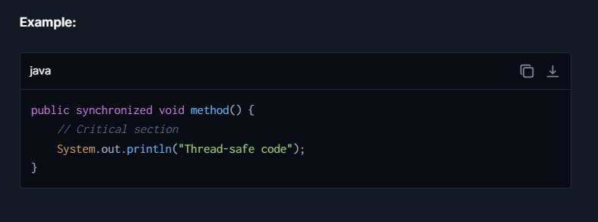

**2. Explicit Lock (from java.util.concurrent.locks):**

Java provides explicit locking through the **Lock** interface (**ReentrantLock**, **ReadWriteLock**, etc.). This provides more advanced locking mechanisms compared to intrinsic locks.

* **Lock Interface**: A generic locking mechanism.
* **ReentrantLock**: A commonly used explicit lock that allows advanced features such as fairness policies and non-blocking attempts to acquire locks.

**Key Characteristics:**

* **Fine-grained Control**: Explicit methods like **lock()**, **unlock()**, and **tryLock()**.
* **Fairness**: Can prevent starvation by granting locks in the order they were requested.

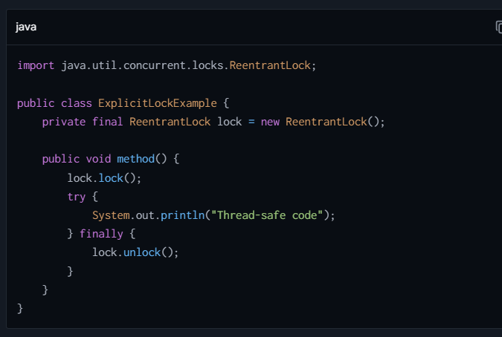

**3. ReadWriteLock:**

* A specialized lock in the **java.util.concurrent.locks** package that allows multiple threads to read a resource concurrently, but only one thread to write at a time.
* Provided by the **ReadWriteLock** interface (**ReentrantReadWriteLock** is its implementation).

**Key Characteristics:**

* **Multiple Readers**: Multiple read locks can be held simultaneously.
* **Single Writer**: A write lock is exclusive and requires all read locks to be released.

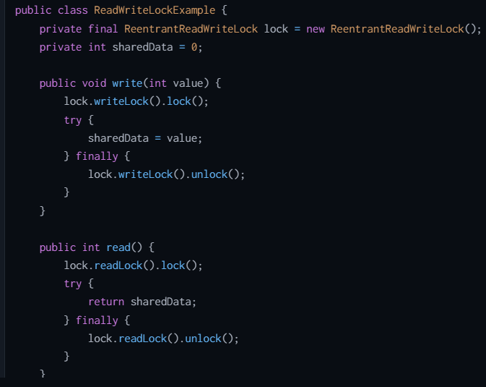

**4. Optimistic Locking:**

* **No physical lock is used**, but instead, a mechanism (like **compare-and-swap**, CAS) ensures that shared data is updated atomically.
* Optimistic locking assumes that collisions (e.g., two threads modifying the same resource) are rare and tries to complete operations without locking.
* Used in **Atomic** classes (**AtomicInteger**, **AtomicReference**, etc.) or frameworks like Hibernate.

**Key Characteristics:**

* Faster for read-heavy workloads.
* Avoids blocking threads by retrying operations upon failure.

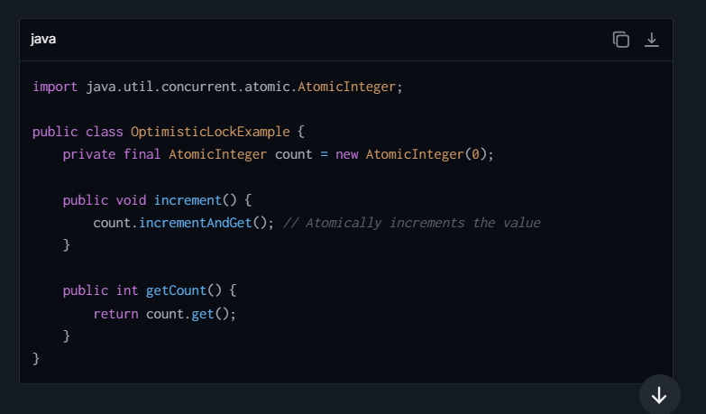

**5. Pessimistic Locking:**

* In pessimistic locking, a lock is applied to a resource as soon as it is accessed to block other threads or transactions from modifying it.
* Assumes that collisions are likely and prevents other threads from accessing the resource until the owning thread releases it.
* Common in database systems.

**Key Characteristics:**

* Safe but can cause performance bottlenecks.
* Example: Using **synchronized** or **explicit locks**.

**6. Spin Lock:**

* A lightweight locking mechanism where a thread constantly "spins" (or repeatedly checks) in a loop until the lock is available, instead of being blocked.
* Useful in low-contention scenarios as it avoids the overhead of context switches.

**Key Characteristics:**

* High CPU usage during spinning.
* Not natively available in Java but can be implemented using CAS (compare-and-swap) operations.

## **Difference b/w Collection and Stream ?**

| **Criteria** | **Collection** | **Stream** |
| --- | --- | --- |
| **Main Purpose** | Designed primarily for storing and managing groups of data elements. Collections can be modified and accessed extensively. | Used for expressing complex data processing operations like filtering, mapping, and reducing elements in a declarative way. Streams are not for data storage. |
| **Mutability** | Mutable; elements can be added, removed, or updated directly. | Immutable; stream operations do not modify the source collection and instead return a new stream. |
| **Iteration** | Requires manual iteration, such as using for-loops or iterators. | Automatically handles iteration internally during operations. Users do not control the iteration process directly. |
| **Data Handling** | Collections hold and manage data directly, allowing direct access and manipulation of their elements. | Streams do not hold data; they compute on the provided source data through a pipeline of operations. |
| **Memory Usage** | Consumes more memory when handling large datasets since all elements must typically be stored in memory. | Generally more memory-efficient for large datasets as they process items on-demand without storing all of them. |
| **Concurrency** | Not inherently thread-safe; synchronization or concurrent collections are needed for safe multi-threaded access. | Designed to easily support parallel processing, simplifying concurrency with methods like **parallelStream()**. |
| **Typical Use Case** | Ideal when you need to frequently add, remove, or access elements directly. For example, manipulating a list of user objects. | Best for filtering, sorting, or aggregating data without altering the original data source. Suitable for chaining operations in queries. |
| **Example Operations** | **add()**, **remove()**, **get()**, **set()** | **filter()**, **map()**, **collect()**, **reduce()** |

## **Difference between ConCurrentHashMap v/s SynchronizedHashMap ?**

| **Feature** | **ConcurrentHashMap** | **SynchronizedHashMap** |
| --- | --- | --- |
| **Definition** | A thread-safe implementation of **Map** optimized for high concurrency. Implements finer-grained locking for better scalability in multi-threaded environments. | A **HashMap** wrapped with **Collections.synchronizedMap()** to ensure thread-safety. All map operations are synchronized at the method level. |
| **Synchronization Mechanism** | Uses **fine-grained locks** (on individual segments/buckets). Multiple threads can read and write concurrently without blocking each other. | Synchronizes the entire map, meaning only one thread can access the map at any moment, even for read operations. |
| **Performance** | Highly performant in multi-threaded environments due to reduced contention (fine-grained locking). Supported by lock-striping within buckets. | Slower in multi-threaded environments because all methods are synchronized, resulting in higher contention among threads. |
| **Concurrency Level** | Allows multiple threads to access different segments (default concurrency level is 16). Facilitates concurrent reads and updates. | Only one thread is allowed to access the map at a time, even for non-conflicting operations. |
| **Null Keys and Values** | Does **not allow null keys or null values**. Adding a **null** key or value will throw a **NullPointerException**. | Allows **one null key** and multiple **null** values (similar to regular **HashMap**). |
| **Iterator Type** | Iterators are **fail-safe**. They provide a snapshot of the elements at the time of creation and do not throw **ConcurrentModificationException** if the map is modified during iteration. | Iterators are **fail-fast**. They throw **ConcurrentModificationException** if the map is modified while being iterated. |
| **Granular Locking** | Locking is at the segment/bucket level. Multiple threads can modify different parts of the map concurrently without interference. | Entire map is locked for all operations (coarse-grained locking), limiting concurrency. |
| **Thread Safety** | Provides scalable thread-safe operations using fine-grained blocking and atomic operations (e.g., **putIfAbsent**, **compute**). | Provides thread-safe operations where all methods are synchronized, but scalability is affected. |
| **Usage Scenarios** | Suited for high-concurrency use cases where high read/write frequency is required (e.g., caching, counters, real-time updates). | Suited for use cases with low-to-moderate concurrency, where simplicity is more important than scalability or performance. |
| **Introduced In** | Java 1.5 (as part of **java.util.concurrent** package). Supports advanced concurrency utilities. | Can be used since Java 1.2 by wrapping a regular **HashMap** with **Collections.synchronizedMap()**. |

## **Difference b/w Comparable and Comparator ?**

|  |  |
| --- | --- |
| 1) Comparable provides a **single sorting sequence**. In other words, we can sort the collection on the basis of a single element such as id, name, and price. | The Comparator provides **multiple sorting sequences**. In other words, we can sort the collection on the basis of multiple elements such as id, name, and price etc. |
| 2) Comparable **affects the original class**, i.e., the actual class is modified. | Comparator **doesn't affect the original class**, i.e., the actual class is not modified. |
| 3) Comparable provides **compareTo() method** to sort elements. | Comparator provides **compare() method** to sort elements. |
| 4) Comparable is present in **java.lang** package. | A Comparator is present in the **java.util** package. |
| 5) We can sort the list elements of Comparable type by **Collections.sort(List)** method. | We can sort the list elements of Comparator type by **Collections.sort(List, Comparator)** method. |

## **Difference between Failfast and failSafe ?**

| **Feature** | **Fail Fast** | **Fail Safe** |
| --- | --- | --- |
| **Definition** | Fail Fast systems immediately report any problem as soon as it occurs during the operation, particularly during iteration. | Fail Safe systems handle errors internally and attempt to continue operation without failing, even in the face of errors during iteration. |
| **Error Detection** | Designed to detect concurrent modifications as early as possible and throw **ConcurrentModificationException**. | Typically do not throw **ConcurrentModificationException** because the operations do not affect the original structure directly. |
| **Implementation** | Common in Java's standard collections like **ArrayList**, **HashMap**, etc., where iterators directly reflect the structure of the collection. | Implemented through copies of the original data or thread-local variables; seen in classes like **CopyOnWriteArrayList**, **ConcurrentHashMap**. |
| **Behavior on Errors** | Immediately stops the operation by throwing exceptions, preventing any further potentially unsafe operations. | Continues processing, often using mechanisms like cloning elements or working on separate copies without affecting the main data. |
| **Performance Impact** | Typically faster under single-threaded conditions because there is no overhead of handling duplication of data. | Can be slower and consume more memory if iterating over large data sets since it involves maintaining a separate copy or more elaborate state management. |
| **Use Case** | Suitable for single-threaded environments where modifications while iterating are considered programming errors that need immediate attention. | More suitable in multi-threaded environments where data consistency and application stability are prioritized even if the original collection is modified during iteration. |
| **Data Consistency** | Risk of data inconsistency if error handling is not properly managed, because operations cease at the first sign of trouble. | Higher data consistency and uptime, especially in distributed systems or concurrent applications where interruptions are conditionally managed. |
| **Thread Safety** | Not thread-safe without external synchronization. | Often inherently thread-safe or better suited to handle concurrent operations safely. |
| **Example** | Using an **Iterator** on an **ArrayList** while modifying the list directly can throw **ConcurrentModificationException**. | Iterating over a **CopyOnWriteArrayList** while another thread modifies the list will not throw an exception; modifications won't be visible during current iteration. |

## **Differenece b/w Hashmap and Hashset**

| **Aspect** | **HashMap** | **HashSet** |
| --- | --- | --- |
| Definition | Java HashMap is a hash table based implementation of the Map interface. | HashSet is a Set. It creates a collection that uses a hash table for storage. |
| **Implementation** | **Implements Map, Cloneable, and Serializable interfaces.** | **Implements Set, Cloneable, Serializable, Iterable, and Collection interfaces.** |
| **Stores** | **Stores a key-value pair. Maintains the mapping of key and value.** | **Stores objects directly.** |
| **Duplicate values** | **Does not allow duplicate keys, but accepts duplicate values.** | **Does not allow duplicate values.** |
| **Null values** | **Can contain one null key and multiple null values.** | **Can contain one null value.** |
| **Method of insertion** | **Uses the put() method to add elements.** | **Uses the add() method to add elements.** |

## Difference between Hashmap and Concurrent Hashmap

| **Feature** | **HashMap** | **ConcurrentHashMap** |
| --- | --- | --- |
| **Concurrency Support** | Non-synchronized, not thread-safe. Suitable for single-threaded applications. | Synchronized, thread-safe. Suitable for multi-threaded applications. |
| **Performance** | Generally faster in non-concurrent environments because it does not involve any synchronization overhead. | Generally slower than **HashMap** in single-threaded contexts due to its synchronization mechanisms, but provides significant performance advantages in multi-threaded scenarios by allowing concurrent reads and updates. |
| **Internal Working** | Stores elements (key-value pairs) in an array of buckets. When a **HashMap** is accessed by multiple threads, concurrent modifications can corrupt the data structure leading to data inconsistency and unpredictable results. | Uses a segment-locking mechanism that divides the map into different segments, each of which can be locked independently. This allows a higher degree of concurrency with fewer bottlenecks. |
| **Iterator Safety** | Iterators in **HashMap** are fail-fast. Any concurrent modification during iteration will throw a **ConcurrentModificationException**. | Iterators in **ConcurrentHashMap** do not throw **ConcurrentModificationException** if the container is modified during iteration. Instead, they operate on a snapshot of the keys in the map at the time of creation of the iterator. |
| **Null Allowance** | Allows null values and one null key. | Does not allow null keys or null values; adding a null key or value will throw a **NullPointerException**. |
| **API Coverage** | Provides all basic operations like **put**, **get**, **remove**, and operations like **containsKey**, **containsValue**, etc. | Provides all operations available in **HashMap**, plus a few additional atomic operations like **putIfAbsent**, **remove**, and **replace**, which are useful in multi-threaded environments. |
| **Locking Mechanism** | No locking mechanism; synchronization, if needed, must be handled externally using wrappers like **Collections.synchronizedMap()**. | Uses fine-grained locks for segments of the map, reducing contention and increasing throughput. |
| **Use Case** | Recommended when there are no multi-threading scenarios involved. | Recommended for high-concurrency applications, where reads are more common than writes, and thread safety is a priority. |

## **Difference between PriorityQueue and DeQueue?**

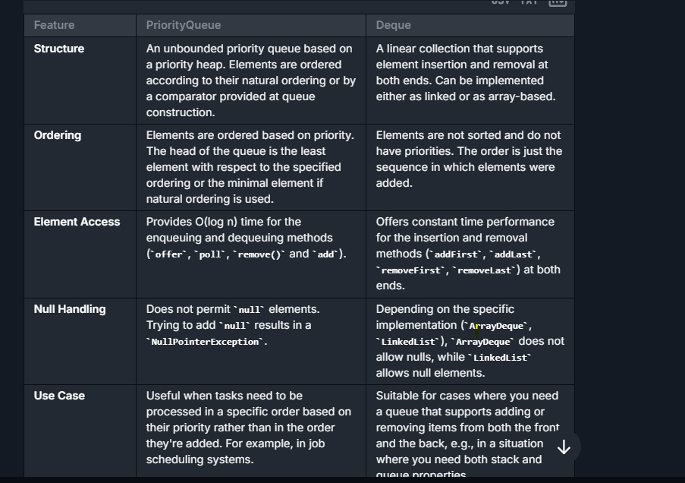

# DIFFERENCES

## Difference between Authentication and Authorisation

| **Aspect** | **Authentication** | **Authorization** |
| --- | --- | --- |
| **Definition** | Process of verifying the identity of a user or system. It confirms who the user is. | Process of verifying what access rights a user or system has after their identity is confirmed. It determines what users can and cannot do. |
| **Question Answered** | "Who are you?" | "What are you allowed to do?" |
| **Techniques (Spring Security)** | Use of credentials like usernames, passwords, tokens (e.g., JWT), biometrics, etc. | Roles, permissions, and policies that control what resources and operations a user can access based on their roles. |
| **Example (Spring Security)** | User provides a username and password to login. After verification, they are granted a token (e.g., JWT). | Checking if the user token includes admin rights to allow modification of sensitive data in the database. |
| **Usage in Microservices** | Each microservice might require a separate authentication check, commonly at the API gateway or by using a centralized Identity Provider (IdP) like Keycloak. | Each microservice handles authorization checks independently, often based on the authenticated credentials (roles/permissions embedded in token). |
| **Tools and Implementations** | Spring Security, OAuth 2.0, OpenID Connect, JSON Web Tokens (JWT) | Spring Security annotations like **@PreAuthorize**, **@Secured**, externalized policy management systems (e.g., OPA - Open Policy Agent) |
| **Key Objective** | Ensure users are who they claim to be by securely managing identities and credentials. | Ensure that each user has appropriate access levels and permissions for specific resources and services. |

## Difference between abstract class and interface

|  |  |
| --- | --- |
| **Abstract class** | **Interface** |
| 1) Abstract class can **have abstract and non-abstract** methods. | Interface can have **only abstract** methods. Since Java 8, it can have **default and static methods** also. |
| 2) Abstract class **doesn't support multiple inheritance**. | Interface **supports multiple inheritance**. |
| 3) Abstract class **can have final, non-final, static and non-static variables**. | Interface has **only static and final variables**. |
| 4) Abstract class **can provide the implementation of interface**. | Interface **can't provide the implementation of abstract class**. |
| 5) The **abstract keyword** is used to declare abstract class. | The **interface keyword** is used to declare interface. |
| 6) An **abstract class** can extend another Java class and implement multiple Java interfaces. | An **interface** can extend another Java interface only. |
| 7) An **abstract class** can be extended using keyword "extends". | An **interface** can be implemented using keyword "implements". |
| 8) A Java **abstract class** can have class members like private, protected, etc. | Members of a Java interface are public by default. |

## Difference between **Annotation vs Reflection**

| **Feature** | **Annotation** | **Reflection** |
| --- | --- | --- |
| Definition | Metadata that provides data about a program but is not part of the program itself. | Ability to inspect and modify the runtime behavior of applications. |
| Usage | To provide information to the compiler or to be used by various tools during runtime | To inspect classes, interfaces, fields, and methods at runtime without knowing the names of the classes, methods, etc. |
| Examples | @Override, @Deprecated, @SuppressWarnings | java.lang.Class, java.lang.reflect.Method |
| When Applied | At compile time and runtime, depending on the retention policy | At runtime only |
| Key Java Package | java.lang.annotation | java.lang.reflect |
| Primary Purpose | Used for injecting additional information into code | Used for dynamic operations, e.g., creating objects, invoking methods, and setting field values dynamically |
| Execution Aspect | Compiler reads annotations to enforce certain checks or enhance code functionality | Enables dynamic behavior of applications via direct manipulation of code and logic structures |
| Dependence | Annotations are static and defined before runtime | Reflection operates dynamically during runtime |

## **Difference between Application Context and Bean Factory ?**

| **Feature** | **Application Context** | **Bean Factory** |
| --- | --- | --- |
| **Overview** | Higher-level interface that extends the BeanFactory interface. It provides additional features beyond basic bean factory capabilities. | Lower-level interface for managing beans. It is primarily focused on creating and managing beans and is less feature-rich compared to ApplicationContext. |
| **Functionality** | Contains all functionality of BeanFactory and adds more enterprise-specific functionality like event propagation, declarative mechanisms to create a bean, and various facilities to look up. | Primarily focused on bean instantiation and configuration. It is a simpler and lighter-weight container and provides core features needed for bean management. |
| **Bean Post Processing** | Supports registering BeanPostProcessors which allows for custom processing before and after bean initialization. | BeanFactory also supports BeanPostProcessors but using them is not as integrated or straightforward as in ApplicationContext. |
| **Resource Management** | Provides a more generic way to access resources such as URLs and files. | Basic resource access, more limited compared to ApplicationContext. |
| **Message Resource Handling** | Supports internationalization for messages. | Does not support internationalization. |
| **Event Propagation** | Provides built-in support for event publication and handling. | Does not support event handling mechanisms. |
| **AOP Integration** | Provides support for Aspect-Oriented Programming including managing aspects and AOP-enabled beans. | Requires manual setup for AOP support, it's not inherently integrated. |
| **Web-Specific Contexts** | Includes capabilities for web-based applications, allowing for contexts such as ServletContext. | No web-specific features or support directly available. |

## Difference between **ArrayList vs Linkedlist**

| **Feature** | **Array** | **LinkedList** |
| --- | --- | --- |
| Structure | Fixed size, contiguous memory allocation. | Dynamic size, consists of nodes where each node contains data and a reference to the next node. |
| Size Modification | Cannot be resized once initiated. | Can grow or shrink dynamically as elements are added or removed. |
| Memory Usage | Efficient memory usage as elements are stored in continuous memory blocks. | Higher memory usage due to storage of additional references for each element (next, and possibly previous). |
| Element Access | Direct access via index, O(1) time complexity. | Sequential access required, O(n) time complexity for accessing an element by index. |
| Insertions and Deletions | Slow, especially at the start or middle, O(n) due to shifting elements. | Fast at the start and potentially at the end, O(1). Insertions/deletions in the middle require traversal, making it O(n). |
| Use Cases | Suitable for applications where frequent access to elements by index is needed. | Suitable for applications where frequent insertion and deletion of elements are required. |
| Element Type | Can hold any data type, primitives or objects. Length must be defined at creation. | Typically used for storing objects. Does not support primitive data types directly (requires wrappers). |
| Search Efficiency | Linear search is O(n); if sorted, binary search can be applied in O(log n). | Always O(n) as elements are not contiguous in memory. |
| Implementation Overhead | Minimal implementation overhead. | Additional overhead due to handling of node references and dynamic size. |

## **Difference between Array and List in Java**

| **Feature** | **Array** | **List** |
| --- | --- | --- |
| Size | Fixed. The size is defined at the time of creation and cannot be changed. | Dynamic. Lists can grow or shrink as elements are added or removed. |
| Type Safety | Can hold primitives or objects. The type is defined when the array is declared. | Generic. Can hold any type of objects but not primitives directly (use wrapper classes). |
| Dimension | Can be multi-dimensional (e.g., 2D arrays). | Typically one-dimensional, though lists of lists can simulate multi-dimensionality. |
| Performance | Very efficient in terms of performance since arrays are a contiguous block of memory. | Less efficient compared to arrays due to additional layer of abstraction, more memory overhead. |
| Flexibility | Less flexible as it does not automatically adjust size and has fixed type. | More flexible with regard to size and operations like insertion, deletion, and resizing. |
| Method and Operations | Limited methods. Manipulations require manual handling or java.util.Arrays helper class. | Rich set of methods provided by implementations like ArrayList or LinkedList (add, remove, indexOf, contains, etc.). |
| Example Use | Effective for storing and handling fixed set of strongly typed items. Suitable for performance-sensitive scenarios. | Ideal for cases where the number of elements varies, or frequent insertion and deletion operations are needed |

## **Diference between Autowiring vs Dependency Injection**

| **Feature** | **Autowiring** | **Dependency Injection** |
| --- | --- | --- |
| **Definition** | Autowiring is a Spring framework mechanism that automatically injects dependencies into Spring beans. | Dependency Injection (DI) is a design pattern used to implement IoC, allowing a program design to follow the Dependency Inversion Principle. |
| **Mechanism** | In Spring, autowiring automatically resolves and injects bean dependencies by matching data types or qualifiers/identifiers. | DI can be implemented manually or using frameworks like Spring. It involves supplying objects (dependencies) to a class, rather than the class creating them internally. |
| **How It Operates** | Spring's autowiring can be done by types, names, constructors, etc., based on the configuration. It is more specific to how Spring configures objects with less manual setup. | DI can be implemented through constructors, setters, or interfaces. This is a broader concept applicable beyond Spring to any DI framework or even manual DI setups. |
| **Flexibility** | Autowiring is relatively less flexible as it relies on Spring's configuration to manage injections. It dictates how dependencies should be injected based on its own resolution logic. | DI is highly flexible in terms of how dependencies are provided to the dependent objects. This can be controlled entirely by the developer or through the configuration when using frameworks. |
| **Usage** | Used within the Spring framework to simplify dependency management by reducing boilerplate code. | Used in both Spring-driven applications and other programming environments to decouple class dependencies and to increase code modularity and testability. |
| **Configuration** | Typically configured using annotations like **@Autowired** or through XML/Java Config auto-scan and automatic wiring settings. | Configured manually or via IoC containers like Spring, Google Guice, etc. It uses annotations like **@Inject** or **@Autowired**, XML files, or programmatically. |
| **Scope** | Mostly limited to the Spring or similar frameworks supporting autowiring. Not a pattern by itself, but a feature of the framework. | Generic design pattern applicable in numerous programming environments and frameworks. It is a fundamental software design principle. |
| **Control** | Often criticized for hiding the control of dependencies too much (less transparent), which can lead to issues like unsatisfied dependencies that are harder to debug. | Provides explicit control over the dependencies, making it clearer where and how dep |

## **Difference between Clustered and Non-Clustered Index ?**

Clustered and non-clustered indexes are types of database indexes that significantly impact data retrieval performance. They organize the physical and logical structure of data differently. Below is a detailed table explaining how clustered and non-clustered indexes compare across various features:

| **Feature** | **Clustered Index** | **Non-Clustered Index** |
| --- | --- | --- |
| **Data Structure** | In a clustered index, the index structure and data are intertwined. The rows of data are stored physically on the disk in the order of the indexed column. Essentially, the table is sorted based on the clustered index. | A non-clustered index has a separate structure from the data rows. It stores the indexed column values and pointers to the corresponding rows, which can be spread anywhere across the table’s data pages. |
| **Storage** | Only one clustered index can be created per table because the data rows themselves follow the order of the clustered index. | Multiple non-clustered indexes can be created on a table, as they do not affect how the actual data is physically stored. |
| **Performance** | Lookups are generally faster with clustered indexes because navigating the index directly leads to the row with all data (no additional lookups needed). Most effective for range scans. | Generally slower for direct lookups as there is an extra step involved. After finding the index entry, the database engine uses the row pointer to fetch the actual data from the table. |
| **Storage Space** | Does not require extra space beyond storing the table data in a sorted order on disk. | Consumes extra storage space in addition to the actual table data because it maintains a separate index structure. |
| **Best Use Cases** | Most beneficial when data access patterns include a lot of range-based queries, or there's frequent access by the indexed column due to its ordered storage and direct access to data rows. | Ideal for tables where multiple columns need to be frequently searched independently. Also advantageous when inserts and deletes are frequent as it causes less disruption to the physical table. |
| **Impact on Data Modification** | Data modifications (INSERT, UPDATE, DELETE) can be slower as maintaining the order of rows may require moving data to handle new entries and to maintain the sort order. | Generally, has a lesser impact on data modification performance. Although new entries and modifications require index updates, there usually are no large-scale data movements within the table data. |
| **Example** | If a table has a clustered index on the primary key column **EmployeeID**, then the table data is physically sorted by **EmployeeID**. Accessing employees by ID range (e.g., 1000-1100) is very efficient. | If there are non-clustered indexes on **LastName** and **DepartmentID**, searching for employees by lastName or department involves navigating the non-clustered index to find pointers to the actual data elsewhere on disk. |

## **Difference Comparable and Comparator ?**

|  |  |
| --- | --- |
| 1) Comparable provides a **single sorting sequence**. In other words, we can sort the collection on the basis of a single element such as id, name, and price. | The Comparator provides **multiple sorting sequences**. In other words, we can sort the collection on the basis of multiple elements such as id, name, and price etc. |
| 2) Comparable **affects the original class**, i.e., the actual class is modified. | Comparator **doesn't affect the original class**, i.e., the actual class is not modified. |
| 3) Comparable provides **compareTo() method** to sort elements. | Comparator provides **compare() method** to sort elements. |
| 4) Comparable is present in **java.lang** package. | A Comparator is present in the **java.util** package. |
| 5) We can sort the list elements of Comparable type by **Collections.sort(List)** method. | We can sort the list elements of Comparator type by **Collections.sort(List, Comparator)** method. |

## **Difference between Compile time and Run time Exception**

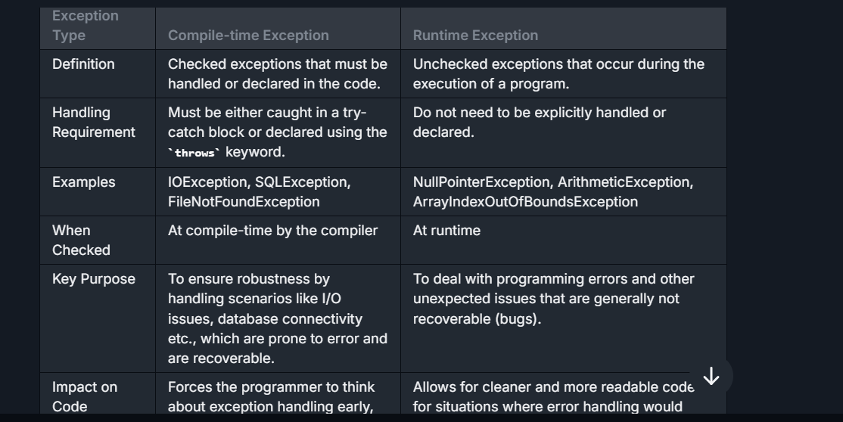

## **Difference between @Controller and @RestController ?**

| **Feature** | **@Controller** | **@RestController** |
| --- | --- | --- |
| **Definition** | **@Controller** is a class-level annotation used in Spring MVC to define a web controller. It indicates that the class handles requests and can return a view or data. | **@RestController** is a specialized version of the **@Controller** annotation that combines **@Controller** and **@ResponseBody** annotations. It simplifies the development of RESTful web services. |
| **Handling Data** | Return value from methods are typically the name of the template or the view to render, unless methods are annotated with **@ResponseBody**, in which case data is written directly to the response body. | Automatically serializes return objects into HTTP responses, mostly in JSON or XML format. All handler methods imply **@ResponseBody** semantics by default. |
| **Use Case** | Used for applications that require view technologies like JSP, Thymeleaf, or handling HTML content. | Primarily used for RESTful services where the response is data-driven (JSON/XML), not view-driven. |
| **Annotations Needed for Response** | For returning data, methods need to be annotated with **@ResponseBody** or use **ResponseEntity** to directly handle response details and status codes. | No need for **@ResponseBody** on individual methods, as the class-level **@RestController** ensures that all methods in the class include this behavior. |
| **Header Manipulation** | Response headers can be manipulated using **HttpServletResponse** or **ResponseEntity**. | Response headers can also be manipulated, but typically managed using **ResponseEntity** for REST services. |

## Difference between Deep copy and shallow copy explain ?

| **Feature** | **Shallow Copy** | **Deep Copy** |
| --- | --- | --- |
| Definition | Creates a new object which stores the references of the objects found in the original. | Creates a new object and recursively copies all objects it references, not just the top-level references. |
| Memory Allocation | Less memory usage since only references are duplicated. | More memory usage as copies of all nested objects are created. |
| Changes to Copied Objects | Changes to the objects inside the original will be reflected in the shallow copy as they share references. | Changes to the objects inside the original will not affect the deep copy as they are entirely separate. |
| Copying Process | Simple and fast because it only copies object references, not the actual objects. | Time-consuming and complex due to the necessity of copying every element and their nested objects. |
| Suitable For | Suitable when working with immutable objects or when there's no concern about the independence of objects. | Suitable for cases where full independence of copies from the original objects is crucial. |
| Implementation | Usually can be achieved by simple member-wise copying. | Often requires custom methods or functions to ensure all objects are cloned completely, including objects referenced by the initial object. |
| Common Usage Examples | Copying references of strings or database connections in a new object where the actual data isn't modified. | Cloning a complex data structure like a linked list or a tree where modifications to clone should not affect the original. |
| Impact of Modifications | Modifications to objects contained in the shallow copy will reflect in all copies since they reference the same objects. | Modifications in the deep copy do not affect the original object or any other copies. |

## **Difference between Dependency Injection vs IOC Container ?**

| **Feature** | **Dependency Injection (DI)** | **IOC Container** |
| --- | --- | --- |
| **Definition** | DI is a design pattern used to implement Inversion of Control, focusing on the delivery of dependencies to an object. | An IOC Container is a framework that manages the creation and injection of dependencies automatically. |
| **Purpose** | The primary purpose of DI is to reduce the coupling between software components and increase modularity, making the system easier to manage and test. | The main purpose of an IOC container is to instantiate objects, wire them together, manage their complete lifecycle, and provide configuration management. |
| **Implementation** | Implemented by passing dependencies into an object’s constructor, or by setting the object’s dependencies through setters or properties. | Provides mechanisms to configure an application’s components in a flexible manner (either via XML, annotations, or code) and automatically resolves and injects dependencies as needed. |
| **Control** | Dependency Injection gives the control of managing dependencies to the external system or framework, rather than the components themselves creating or searching for their dependencies. | An IOC container takes over the responsibility of managing object creation and wiring, acting as a sort of factory for generating objects based on a configuration file or annotations. |
| **Mechanism** | Works by users explicitly using constructors, methods, or properties to inject dependencies. | Works by reading configuration metadata (XML, annotations, or code configuration) and automatically orchestrating the provisioning and injection of dependencies. |
| **Usage** | Used directly within the components to allow external injection of dependencies. | Used as a tool or infrastructure that reads and interprets defined configurations to manage the application components. |
| **Example Tools/Frameworks** | DI patterns can be accomplished manually or can be facilitated by frameworks like Spring, Google Guice, .NET Core, etc. | Examples include Spring Framework, .NET Core built-in IOC container, Autofac, Unity Container, etc. |
| **Flexibility** | Allows flexibility in terms of how dependencies are provided to an object, either through constructor injection, setter injection, or method injection. | Provides higher-level flexibility and control for managing object lifecycles, configurations, and advanced wiring scenarios that go beyond simple dependency provision. |
| **Scope** | Generally limited to the injection and management of dependencies. | Encompasses a broader scope including object creation, lifecycle management, configuration, and dependency resolution. |

## Difference between Equals and hashcode

| **Feature** | **equals()** | **hashCode()** |
| --- | --- | --- |
| **Purpose** | Used to compare two objects for equality based on their content or logic defined within the method. Determines whether two objects are "equal". | Used to return an integer value (hash code) that represents the object. Typically used in hash-based collections like **HashMap** and **HashSet**. |
| **Default Behavior** | By default, **equals()** in **Object** uses **==**, meaning it checks for reference equality (whether two object references point to the same memory address). | By default, **hashCode()** in **Object** returns a hash code based on the object's memory address. |
| **Relation Between Them** | Objects considered equal by the **equals()** method must have the same **hashCode()** value for proper functionality in hash-based collections. (contract: if **equals()** returns **true**, **hashCode()** must be the same). | Objects that have the same **hashCode()** are not necessarily equal based on the **equals()** method. Hash collisions can occur, meaning different objects can have the same hash code. |
| **Override Requirement** | Should be overridden to compare object content if custom equality logic is needed. | Must be overridden if **equals()** is overridden to ensure consistency between **equals()** and **hashCode()** for hash-based collections. |
| **Impact on Hash-Based Collections** | Used by hash-based collections to compare keys or values for equality (e.g., when retrieving a value from **HashMap**). | Used by hash-based collections to determine the bucket where an object should be stored. |

## Difference between Exception and Error ?

|  |  |  |
| --- | --- | --- |
| **Basis of Comparison** | **Exception** | **Error** |
| **Recoverable/ Irrecoverable** | Exception can be recovered by using the try-catch block. | An error cannot be recovered |
| **Type** | It can be classified into two categories i.e. checked and unchecked. | All errors in Java are unchecked. |
| **Occurrence** | It occurs at compile time or run time. | It occurs at run time. |
| **Package** | It belongs to java.lang.Exception package. | It belongs to java.lang.Error package. |
| **Known or unknown** | Only checked exceptions are known to the compiler. | Errors will not be known to the compiler. |
| **Causes** | It is mainly caused by the application itself. | It is mostly caused by the environment in which the application is running. |
| **Example** | **Checked Exceptions:** SQLException, IOException **Unchecked Exceptions:** ArrayIndexOutOfBoundException, NullPointerException, ArithmaticException | Java.lang.StackOverFlow, java.lang.OutOfMemoryError |

## Difference between Fail Fast and Fail Safe ?

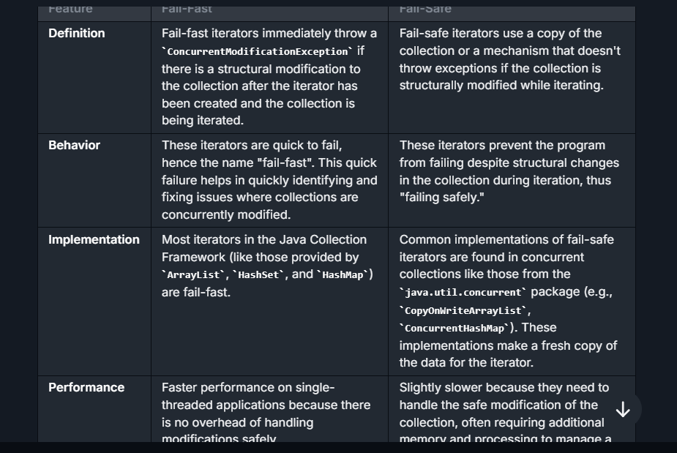

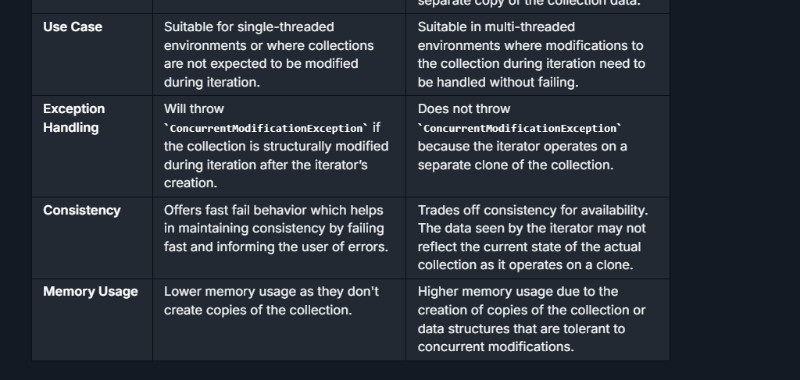

## Difference between Future and Completable future ?

| **Aspect** | **Future** | **CompletableFuture** |
| --- | --- | --- |
| **Basic Concept** | Represents the result of an asynchronous computation and is used to check if the computation is complete, wait for its completion, and retrieve the result. | An enhancement of Future that may be explicitly completed, can be used as a Promise, and supports numerous additional methods for asynchronous computation, combining tasks, and handling errors. |
| **Usability** | More limited and blocking; not easy to chain multiple asynchronous operations without blocking on **get()**. | Highly flexible, supports fluent API enabling the functional style of programming that is non-blocking. |
| **Completion** | Cannot be manually completed; you have to wait until the computation has finished. | Can be completed manually, giving more control over its lifecycle; you can also propagate outcomes of other threads or tasks directly. |
| **Error Handling** | Limited error handling capabilities. Requires you to manually manage try/catch blocks around execution logic. | Supports exceptionally powerful mechanisms for handling errors; it can propagate errors to dependent stages in a computation chain. |
| **Composability** | Does not support chaining or combining multiple future tasks directly. Each task blocks the thread until it completes or the future is cancelled. | Supports a variety of methods like **thenApply**, **thenAccept**, and **thenCompose** which help in constructing a sequence or flow of asynchronous tasks. More efficient in handling a complex web of asynchronous tasks. |
| **Methods** | Basic methods like **isDone()**, **get()**, **get(long timeout, TimeUnit unit)**, **cancel(boolean mayInterruptIfRunning)**. | Includes all methods of Future with additional ones, including **complete**, **thenApply**, **thenCombine**, **handle**, **whenComplete**, etc. |
| **Thread Handling** | Blocked or waiting state until the result is available. | Promotes reactive programming style and makes use of callbacks for tasks upon completion, hence more non-blocking in nature. |

## Difference between HashSet and HashMap class ?

|  |  |  |
| --- | --- | --- |
| **Basis** | **HashMap** | **HashSet** |
| **Definition** | Java HashMap is a hash table based implementation of Map interface. | HashSet is a Set. It creates a collection that uses a hash table for storage. |
| **Implementation** | HashMap implements **Map, Cloneable, and Serializable** interface es. | HashSet implements **Set, Cloneable, Serializable, Iterable** and **Collection** interfaces. |
| **Stores** | In HashMap we store a **key-value pair**. It maintains the mapping of key and value. | In HashSet, we store **objects**. |
| **Duplicate values** | It does not allow **duplicate keys**, but **duplicate values** are **allowed**. | It does not allow **duplicate values**. |
| **Null values** | It can contain a **single null key** and **multiple null values**. | It can contain **a single null value**. |
| **Method of insertion** | HashMap uses the **put()** method to add the elements in the HashMap. | HashSet uses the **add()** method to add elements in the HashSet. |
| **Performance** | HashMap is **faster/ than HashSet because values are associated with a unique key.** | HashSet is **slower** than HashMap because the member object is used for calculating hashcode value, which can be same for two objects. |
| **The Number of objects** | Only **one** object is created during the add operation. | There are **two** objects created during put operation, one for **key** and one for **value**. |
| **Storing Mechanism** | HashMap internally uses **hashing** to store objects. | HashSet internally uses a **HashMap** object to store objects. |

## Difference between Hashmap and Concurrent Hashmap

| **Feature** | **HashMap** | **ConcurrentHashMap** |
| --- | --- | --- |
| **Concurrency Support** | Non-synchronized, not thread-safe. Suitable for single-threaded applications. | Synchronized, thread-safe. Suitable for multi-threaded applications. |
| **Performance** | Generally faster in non-concurrent environments because it does not involve any synchronization overhead. | Generally slower than **HashMap** in single-threaded contexts due to its synchronization mechanisms, but provides significant performance advantages in multi-threaded scenarios by allowing concurrent reads and updates. |
| **Internal Working** | Stores elements (key-value pairs) in an array of buckets. When a **HashMap** is accessed by multiple threads, concurrent modifications can corrupt the data structure leading to data inconsistency and unpredictable results. | Uses a segment-locking mechanism that divides the map into different segments, each of which can be locked independently. This allows a higher degree of concurrency with fewer bottlenecks. |
| **Iterator Safety** | Iterators in **HashMap** are fail-fast. Any concurrent modification during iteration will throw a **ConcurrentModificationException**. | Iterators in **ConcurrentHashMap** do not throw **ConcurrentModificationException** if the container is modified during iteration. Instead, they operate on a snapshot of the keys in the map at the time of creation of the iterator. |
| **Null Allowance** | Allows null values and one null key. | Does not allow null keys or null values; adding a null key or value will throw a **NullPointerException**. |
| **API Coverage** | Provides all basic operations like **put**, **get**, **remove**, and operations like **containsKey**, **containsValue**, etc. | Provides all operations available in **HashMap**, plus a few additional atomic operations like **putIfAbsent**, **remove**, and **replace**, which are useful in multi-threaded environments. |
| **Locking Mechanism** | No locking mechanism; synchronization, if needed, must be handled externally using wrappers like **Collections.synchronizedMap()**. | Uses fine-grained locks for segments of the map, reducing contention and increasing throughput. |
| **Use Case** | Recommended when there are no multi-threading scenarios involved. | Recommended for high-concurrency applications, where reads are more common than writes, and thread safety is a priority. |

## Differences between Hibernate Session and EntityManager ?

| **eature** | **EntityManager** | **Hibernate Session** |
| --- | --- | --- |
| **Standard** | Part of JPA (Java Persistence API), which is a standardized Java API for object-relational mapping. | Specific to Hibernate, which is a popular implementation of JPA but also provides additional features beyond the JPA specification. |
| **Context Management** | Manages the persistence context (session cache) according to JPA specifications. It tracks entity instances, their lifecycle, and handles database synchronization. | Also manages a persistence context, handles database and session-level caching. It's similar to **EntityManager** but with additional capabilities native to Hibernate. |
| **Operations** | Provides standardized operations like **persist**, **merge**, **remove**, **find**, and supports JPQL (Java Persistence Query Language), Criteria API, and Native SQL. | Supports operations specific to Hibernate such as **save**, **update**, **delete**, **saveOrUpdate**, **merge**, etc., along with HQL (Hibernate Query Language), native SQL, and Criteria API. |
| **Transaction Management** | Typically participates in transactions managed by JPA, either through resource-local or JTA (Java Transaction API) transactions. | Transactions can be managed through Hibernate’s API either programmatically (via **Transaction** API) or using JTA in a similar manner to JPA. |
| **State Detachment** | Provides an explicit **detach** method to remove entities from the persistence context. | Uses **evict** or **clear** methods to detach entities or clear the session. |
| **Cascading Operations** | Supports cascading operations defined by JPA standards, which can be configured via annotations or **xml** mappings. | Hibernate supports cascading but also provides additional cascade types and flexibility beyond the standard JPA specifications. |
| **Session/Context Flushing** | **EntityManager** flushes the persistence context to synchronize the in-memory state with the database via the **flush** method. | Similar, the **Session** flush method ensures the session state is synchronized with the database, with additional control over flushing modes (**MANUAL**, **AUTO**, **COMMIT**, **ALWAYS**). |
| **Criteria API** | Uses JPA’s Criteria API which is more abstract and strongly typed but can be considered verbose. | Hibernate provides a Criteria API as well, which is being deprecated in favor of the JPA Criteria API, but also offers a more lenient type-checking system. |
| **Entity Graphs Usage** | Supports JPA Entity Graphs to customize fetch operations and limits what entity attributes are loaded in certain operations. | Allows fetching strategies using both JPA Entity Graphs and Hibernate-specific features like Fetch Profiles. |

## Difference between Intermediate and Terminal operation ?

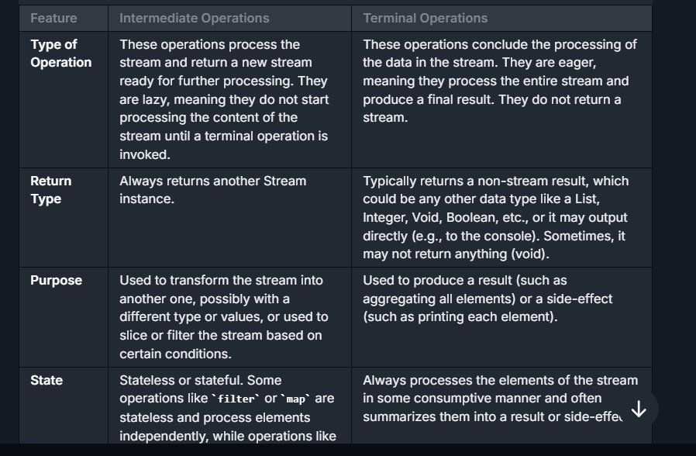

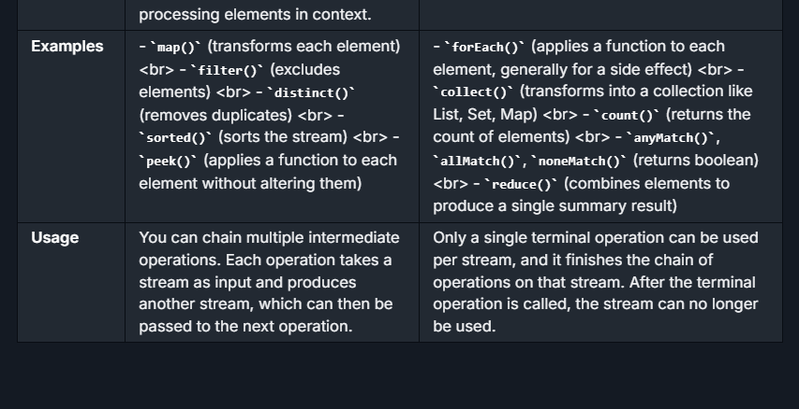

## Difference between JPA and Hibernate ?

| **Feature** | **JPA** | **Hibernate** |
| --- | --- | --- |
| **Definition** | JPA (Java Persistence API) is a **specification** for object-relational mapping (ORM) in Java. It provides guidelines and APIs for interacting with relational databases but does not provide an actual implementation. | Hibernate is a **framework** and one of the most widely used implementations of the JPA specification. It also provides many features and extensions beyond JPA. |
| **Type** | JPA is just a **specification** (a set of rules and interfaces). It needs an implementation like Hibernate or EclipseLink to work. | Hibernate is an **ORM framework** and a concrete implementation of JPA. It also includes additional functionalities beyond the JPA specification. |
| **API vs Framework** | Defines a standard API for ORM and persistence management in Java applications. | Provides both the API (when used as a JPA provider) and the implementation of JPA along with its own API for advanced features. |
| **Dependency** | JPA itself is independent of any specific implementation. Developers need to choose a provider (like Hibernate, EclipseLink, or OpenJPA) for actual functionality. | Hibernate is a standalone ORM framework, and it implements JPA but also works independently of JPA with its own API. |
| **Annotations** | Provides JPA annotations like **@Entity**, **@Id**, **@Table**, **@OneToMany**, and **@ManyToOne**. | Supports all JPA annotations (as it implements JPA). Also provides Hibernate-specific annotations like **@DynamicUpdate** and **@DynamicInsert** for advanced functionality. |
| **Standardization** | Portable across various JPA-compliant frameworks because JPA is standardized by Java. | Tight integration with Hibernate creates a potential lock-in; Hibernate-specific features are not portable to other JPA implementations. |
| **Native Features** | Limited to the features defined by the JPA specification, making it general-purpose and consistent across providers. | Offers many additional features that go beyond the JPA specification. Examples include caching, custom SQL, native query support, and advanced fetching strategies. |
| **Query Language** | Uses JPQL (Java Persistence Query Language), which is defined by the JPA specification. | Supports JPQL, HQL (Hibernate Query Language—an extension of JPQL), and native SQL queries. HQL allows additional flexibility not mandated by JPA. |
| **Caching Support** | JPA does not define caching mechanisms. It's up to the implementation (e.g., Hibernate) to provide caching support. | Hibernate comes with a built-in support for both **first-level** and **second-level caching** along with caching providers like Ehcache. |
| **Ease of Transition** | Portable across different implementations, making transitions seamless (e.g., moving from Hibernate to EclipseLink). | Not as easily portable due to Hibernate-specific features; switching to another provider may involve refactoring. |
| **Entity Lifecycle Management** | JPA defines a standard lifecycle (**persist**, **merge**, **remove**, **detach**) and callback annotations like **@PostLoad**, **@PrePersist**, and so on. | Fully supports the JPA lifecycle but also provides additional lifecycle callbacks and capabilities unique to Hibernate. |
| **Scaling and Performance** | JPA leaves performance tuning (e.g., lazy-loading, caching) to the provider's implementation. | Hibernate provides advanced performance features like batch processing, customized fetching strategies, and **built-in caching mechanisms**. |
| **Support for Advanced Features** | JPA sticks to ORM functionality as defined by the specification and avoids framework-specific behaviors. | Hibernate adds support for advanced features such as: <br>- Filters (**@Filter**) <br>- Custom SQL inserts and updates <br>- Multi-tenancy support <br>- Dynamic mapping. |
| **Usage** | JPA is ideal for applications requiring standard ORM features without the need for provider-specific benefits. Developers can remain implementation-agnostic. | Hibernate is suitable for more advanced projects where additional features (like caching, performance tuning, or specific SQL dialect features) are required. |

**When to Use What:**

* Use **JPA** if:
  + You want portability and vendor independence.
  + You need a standard ORM API and don’t require advanced features provided by Hibernate or specific optimizations.
* Use **Hibernate** if:
  + Your application requires advanced features like performance optimizations, caching, dynamic SQL, multi-tenancy, or batch processing.
  + You are building large-scale or complex systems where Hibernate’s additional capabilities are useful.

## Difference between Lamda Expression and Annonymous class in Java

| **Feature** | **Lambda Expression** | **Anonymous Class** |
| --- | --- | --- |
| Introduction | Introduced in Java 8 | Have been in Java since early versions (Java 1.1) |
| Syntax | Compact and concise, e.g., **(parameters) -> expression** or **(parameters) -> { statements; }** | Verbose, defines a class without a name, e.g., **new InterfaceName() { @Override public void method() { statements; } }** |
| Scope of **this** | Refers to the enclosing class | Refers to the anonymous class itself |
| Use of External Variables | Can capture final or effectively final variables outside of lambda | Can use and modify external variables |
| Interface Type | Can only implement functional interfaces (single abstract method) | Can implement any interface or extend a class |
| Serialization | Cannot serialize lambda expressions directly | Can serialize if the anonymous class is defined in a serializable context |
| Overhead | Generally less overhead compared to anonymous classes | Creates a class file, which means more overhead |
| Output | None (the lambda does not have an identity itself) | Generates a .class file specific to the anonymous class |
| Ease of Use | More readable and idiomatic for functional-style programming | More suitable for traditional implementations of methods or when multiple methods from an interface need to be implemented |
| Method Overriding | Limited to a single method in a functional interface | Can override multiple methods in an interface or a superclass |

## Difference between Liskov and dependency principle ?

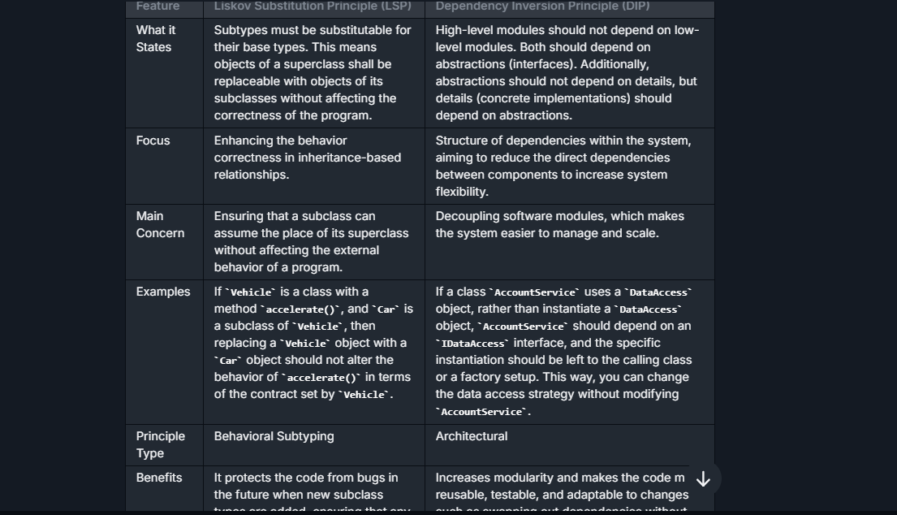

## **Difference between Persistent State vs Detached State ?**

| **Feature** | **Persistent State** | **Detached State** |
| --- | --- | --- |
| **Definition** | **An entity is in the persistent state when it is associated with a persistence context, meaning the entity is managed by Hibernate or JPA session, and any changes to the entity will be automatically persisted to the database upon transaction commit.** | **An entity is in the detached state when it is no longer associated with a persistence context. This typically happens when the session that was managing it is closed. Changes to the entity will not be automatically persisted to the database.** |
| **Synchronization with DB** | **Synchronized with the database automatically, often at the end of the transaction or when the session is flushed.** | **Not synchronized with the database automatically. Manual reattachment or merging is required to persist changes back to the database.** |
| **Lifecycle** | **Typically becomes persistent when fetched from the database or saved (persist, merge, save, or saveOrUpdate operations in Hibernate).** | **Becomes detached when the session is closed or the entity is explicitly evicted from the session.** |
| **Transactions** | **Changes are tracked within the context of a transaction. On commit, changes are flushed to the database.** | **Any changes after detaching are not tracked by the persistence context, and hence, not reflected in the database unless explicitly reattached and updated.** |
| **Use Case** | **Useful for operations within a single transaction or request, managing data consistency efficiently.** | **Useful for long-running operations or when an object's state needs to be manipulated independently of the database, then later re-persisted in a new transaction.** |
| **Memory Management** | **Can lead to higher memory consumption if the session grows too large since entities are managed and tracked.** | **Reduces memory consumption as entities are not managed by any session, reducing the overhead on the persistence context.** |
| **Examples of Operations** | **session.save(entity), session.persist(entity), entity = session.get(Entity.class, id)** | **session.evict(entity), session.close(), after session or entity manager is closed, entities become detache** |

## **Difference between Priority Queue and Deque ?**



## **Difference between Put and Patch in table form ?**

| **Feature** | **PUT** | **PATCH** |
| --- | --- | --- |
| **HTTP Specification** | The **PUT** method requests that the enclosed entity be stored under the supplied URI. If the URI refers to an already existing resource, it is modified. | The **PATCH** method is used to apply partial modifications to a resource. |
| **Idempotency** | Yes, **PUT** is idempotent. This means that making multiple identical **PUT** requests will always produce the same result. | No, **PATCH** is not necessarily idempotent, although it can be. Making multiple identical **PATCH** requests might have different effects. However, it is assumed that doing so has no side effects beyond the initial application. |
| **Usage** | Used to update a complete entity. If only a portion of data is provided, the rest might be overwritten (depending on the API) or cause an error if the API requires a complete object. | Used to update part of an entity. **PATCH** requests only need to contain the changes to the resource, not the total resource. |
| **Payload** | Typically, the full entity is sent to the server, and it replaces or transforms the entire resource. | Contains only the differences between the current resource and the parts being updated, not the complete resource. |
| **Examples** | If you have a resource—the details of a book with properties like title, author, and ISBN—a **PUT** request to this resource must include all three properties, even if you only want to change the title. If you omit a property, the server might assume it's being cleared or it might reject the request for being incomplete. | Using the same book example, a **PATCH** request could just include the title property if that's the only piece you want to update. The other properties remain unchanged. |
| **Support** | Universally understood across all HTTP clients and servers. | **PATCH** is newer and not all HTTP clients and servers support it, although support has been growing since it was standardized. |
| **Suitability** | Preferable for cases where the client is able to send a complete updated entity. Useful for replacing resources. | More efficient for large resources where only small changes need to be made. Also used where the client doesn’t know the entire resource. |

## **Difference between @Controller and @RestController ?**

| **Feature** | **@Controller** | **@RestController** |
| --- | --- | --- |
| **Definition** | **@Controller** is a class-level annotation used in Spring MVC to define a web controller. It indicates that the class handles requests and can return a view or data. | **@RestController** is a specialized version of the **@Controller** annotation that combines **@Controller** and **@ResponseBody** annotations. It simplifies the development of RESTful web services. |
| **Handling Data** | Return value from methods are typically the name of the template or the view to render, unless methods are annotated with **@ResponseBody**, in which case data is written directly to the response body. | Automatically serializes return objects into HTTP responses, mostly in JSON or XML format. All handler methods imply **@ResponseBody** semantics by default. |
| **Use Case** | Used for applications that require view technologies like JSP, Thymeleaf, or handling HTML content. | Primarily used for RESTful services where the response is data-driven (JSON/XML), not view-driven. |
| **Annotations Needed for Response** | For returning data, methods need to be annotated with **@ResponseBody** or use **ResponseEntity** to directly handle response details and status codes. | No need for **@ResponseBody** on individual methods, as the class-level **@RestController** ensures that all methods in the class include this behavior. |
| **Header Manipulation** | Response headers can be manipulated using **HttpServletResponse** or **ResponseEntity**. | Response headers can also be manipulated, but typically managed using **ResponseEntity** for REST services. |

## **Difference between Reference Types ?**

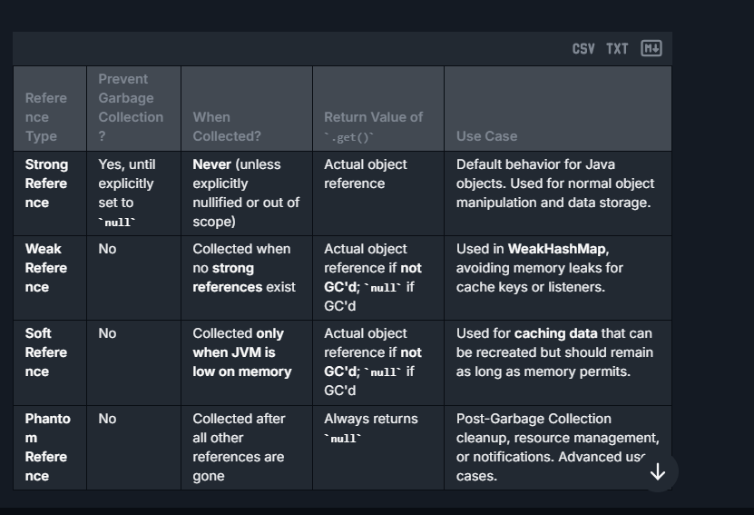

## **Difference between @RestController and @RequestMapping?**

| **Feature** | **@RestController** | **@RequestMapping** |
| --- | --- | --- |
| **Core Purpose** | **A class-level annotation that is a convenience annotation combining @Controller and @ResponseBody which indicates that the class handles web requests and response bodies are serialized into JSON or XML.** | **A method-level (or optionally type-level) annotation used for mapping web requests to specific handler classes/methods.** |
| **Return Value** | **The return type is directly written to the HTTP response body.** | **Controls where the request is mapped, but does not imply response serialization by itself.** |
| **Typical Use Case** | **Used for making RESTful controllers with automatic serialization of return types.** | **Used to map HTTP requests to different URL patterns and HTTP methods to handler methods.** |
| **Dependency** | **It is a standalone declaration that implicitly declares controller semantics.** | **Often used in combination with @Controller at the class level, and can be combined with @ResponseBody for serialization.** |
| **ResponseBody** | **No need to use @ResponseBody on each method, as it's implied by @RestController.** | **@ResponseBody needs to be added explicitly to each handler method if response serialization is desired.** |

## **Difference between @Requestmapping and @GetMapping ?**

| **Feature** | **@RequestMapping** | **@GetMapping** |
| --- | --- | --- |
| **Annotation Definition** | **@RequestMapping** is a general-purpose request mapping annotation that can be used to map various HTTP request types (GET, POST, PUT, DELETE, etc.) to handler methods. | **@GetMapping** is a specialized version of **@RequestMapping** specifically for HTTP GET requests. It serves as a shortcut for **@RequestMapping(method = RequestMethod.GET)**. |
| **Supported HTTP Methods** | Supports configuring handler methods for any HTTP method by specifying the **method** attribute. | Restricted to handling only HTTP GET requests. |
| **Use Case** | Ideal for handling multiple types of HTTP methods within the same controller or even within the same method (when the HTTP method is determined at runtime). This flexibility makes it versatile for general use. | Best suited for defining handlers that only need to respond to HTTP GET requests, commonly used for fetching data. |
| **Verbosity** | Can be more verbose as it requires specifying the HTTP method if it's not intended to handle all methods. E.g., **@RequestMapping(value = "/example", method = RequestMethod.GET)** | Less verbose and more declarative for GET actions. Straightforward usage: **@GetMapping("/example")** simplifies mapping declarations. |

## **Difference between Runnable and Callable interface ?**

| **Sr. No.** | **Key** | **Runnable** | **Callable** |
| --- | --- | --- | --- |
| 1 | Package | It belongs to Java.lang | It belongs to java.util.concurrent |
| 2 | Thread Creation | We can create thread by passing runnable as a parameter. | We can’t create thread by passing callable as parameter |
| 3 | Return Type | Ruunable does not return anything | Callable can return results |
| 4. | Method | It has run() method | It has call()method |
| 5 | Bulk Execution | It can’t be used for bulk execution of task | It can be used for bulk execution of task by invoking invokeAll(). |

## Difference between **Serialization vs Deserialization**

| **Feature** | **Serialization** | **Deserialization** |
| --- | --- | --- |
| Definition | Process of converting an object into a byte stream | Process of converting a byte stream back into an object |
| Purpose | To save the state of an object to a file, send it across a network, or store it in a database | To recreate an object from a byte stream, typically after it has been sent over a network, read from a file, or pulled from a database |
| When Used | When needing to persist the state of an object or send it to another application | When needing to restore or use the persisted data |
| Output/Input | Generates a byte stream from an object | Produces an object from a byte stream |
| Key Java Classes | ObjectOutputStream | ObjectInputStream |
| Primary Method | writeObject() | readObject() |
| Exception Handling | Throws IOException | Throws IOException, ClassNotFoundException |
| Common Issues | Requires all objects to be serializable, issues with object graphs | Version control of classes, ensuring all parts of an object graph are available |

## Difference between SessionFactory and Entitymanagerfactory ?

| **Feature** | **SessionFactory** | **EntityManagerFactory** |
| --- | --- | --- |
| **Framework** | Part of Hibernate, which is an ORM (Object-Relational Mapping) framework for Java. | Part of JPA (Java Persistence API), which is a Java API specification for relational data management in applications. |
| **Purpose** | Used to create **Session** instances which are used to interact with the database. Allows applications to establish and manage sessions with the database. | Used to create **EntityManager** instances which manage entity objects' lifecycle and interact with the persistence context. |
| **Lifecycle Management** | **SessionFactory** is a thread-safe object that needs to be instantiated once per application. It is generally expensive to create because it involves reading and interpreting the mapping data and connecting to the database. | Similar to **SessionFactory**, **EntityManagerFactory** is thread-safe and designed to be shared across threads. It is also expensive to create and typically created only once when the application starts. |
| **Session vs. Entity Manager** | **Session** provides an interface between the application and the database, allowing operations like **save**, **update**, **delete**, and **fetch**. **Session** is not thread-safe. | **EntityManager** works within the scope defined by JPA and controls the lifecycle of entities (e.g., persist, merge, remove). **EntityManager** itself is not thread-safe. |
| **Transactions** | Manages transactions explicitly through the **Transaction** API. Support is provided for both programmatic and declarative transaction management. | Transactions can be managed through the **EntityTransaction** interface or via container-managed transactions (in a J2EE environment using JTA). |
| **Query Language** | Uses Hibernate Query Language (HQL) or Native SQL for database operations. | Uses Java Persistence Query Language (JPQL) or Native SQL. JPA also supports the Criteria API for building type-safe queries programmatically. |
| **Scalability and Configuration** | Offers more configuration options related to caches, fetch strategies, and connection management, tailored for both small and large applications. | Primarily configured via **persistence.xml** or programmatically through a **Persistence** utility class. Aimed to be compatible across different ORM providers. |
| **Interchangeability** | Specific to Hibernate. Not intended to be compatible with other ORM frameworks directly. | Designed to be provider-independent. Any JPA-compliant ORM provider like Hibernate, EclipseLink, etc., can implement **EntityManagerFactory**. |

## Difference between Set and List in Java



## **Difference between Singleton vs Prototype?**

| **Feature** | **Singleton** | **Prototype** |
| --- | --- | --- |
| **Definition** | In a Singleton scope, the container creates a single instance of a bean per Spring IoC container and it is cached for all future requests for that bean. | In Prototype scope, the container creates a new instance every time a bean is requested. |
| **Instance Management** | Only one instance is created no matter how many times it is requested. This instance is stored in the Spring Container and shared among the beans requesting it. | A new instance is created each time a bean is requested from the Spring container. |
| **Memory Consumption** | Lower memory footprint since only one instance is created. | Higher memory consumption as more instances are created. |
| **Use Case** | Useful for stateless beans where shared state is not modified, ensuring consistent behavior across all uses of the bean. | Suitable for stateful beans where each consumer might change the state of the bean without affecting others. |
| **Configuration in Spring** | By default, all Spring beans are Singleton scope if not explicitly specified otherwise. | Must be explicitly configured in the Spring bean definition by setting the scope to **prototype**. |
| **Thread Safety** | Needs special consideration in multi-threaded environments since the single instance is used by all threads. State should not be stored in instance variables. | Safer in multi-threaded environments as each thread will use a separate bean instance. |
| **Lifecycle Management** | Managed by Spring IoC container extensively, including the full lifecycle from creation to destruction. | Spring manages the instantiation, but management of the complete lifecycle (like destruction) is left to the coder since the Spring cannot know when the prototype-scoped bean is no longer in use. |

## **Difference between Spring vs Spring Boot in table form**

| **Feature** | **Spring** | **Spring Boot** |
| --- | --- | --- |
| **Core Concept** | Spring is a framework used for developing enterprise applications with extensive infrastructure support such as Dependency Injection, Aspect-Oriented Programming, transaction management, etc. | Spring Boot is built on top of Spring and simplifies the configuration and deployment of Spring applications. It focuses on convention over configuration to reduce developer effort. |
| **Configuration** | Requires detailed setup and configuration (XML or annotation-based). Developers need to spend more time on configuration aspects. | Minimal configuration needed. Spring Boot uses auto-configuration and starters to simplify the use of the Spring framework. |
| **Project Setup** | Typically involves manually setting up and configuring each aspect of the Spring framework (data, MVC, security, etc.). | Provides a suite of tools for quick setup, including the Spring Initializr web tool for easy bootstrapping of a project. |
| **Embedded Servers** | Does not include embedded servers; requires manual setup to deploy to web servers like Tomcat, Jetty, or others. | Comes with embedded servers (like Tomcat, Jetty) for ease of development and testing. Allows running standalone applications using **java -jar**. |
| **Microservices Ready** | Can be used to build microservices but requires manual configurations and setup for things like service registries, configuration servers, etc. | Provides native support for microservices patterns with easy integration of Spring Cloud for handling service discovery, configuration, and resilience. |
| **Dependency Management** | Manages dependencies explicitly; developers must define all required frameworks and libraries. | Uses starters to manage dependencies - a collection of dependency descriptors that can be included in the application to enable specific features. |
| **Standalone Usage** | Primarily designed for integration into larger systems or server environments. | Designed to develop standalone, production-grade applications quickly and easily. |
| **Time to Production** | Takes more time from concept to production due to configuration and integration complexities. | Faster development to production time due to the convention over configuration approach and automated setup. |
| **Community and Support** | Well-established community, extensively documented with a large number of users. | Inherits Spring’s solidity and community, while increasingly becoming the default for new Spring applications due to its ease of use. |
| **Use Case Examples** | Appropriate for large-scale enterprise applications where fine-grained configuration control is needed. | Ideal for microservices, cloud-based applications, and for developers looking for a quick entry into Spring applications. |

## Difference between Static Binding and dynamic binding?

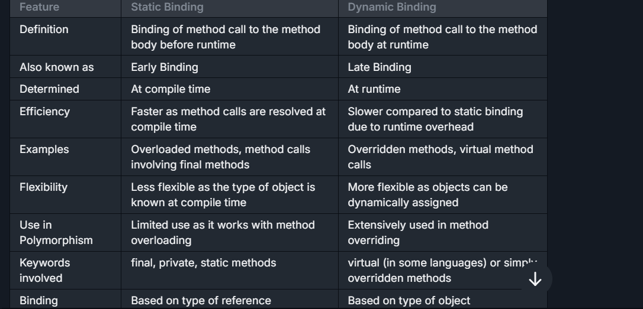

## Difference between Stream and Collection?

| **Criteria** | **Collection** | **Stream** |
| --- | --- | --- |
| **Main Purpose** | Designed primarily for storing and managing groups of data elements. Collections can be modified and accessed extensively. | Used for expressing complex data processing operations like filtering, mapping, and reducing elements in a declarative way. Streams are not for data storage. |
| **Mutability** | Mutable; elements can be added, removed, or updated directly. | Immutable; stream operations do not modify the source collection and instead return a new stream. |
| **Iteration** | Requires manual iteration, such as using for-loops or iterators. | Automatically handles iteration internally during operations. Users do not control the iteration process directly. |
| **Data Handling** | Collections hold and manage data directly, allowing direct access and manipulation of their elements. | Streams do not hold data; they compute on the provided source data through a pipeline of operations. |
| **Memory Usage** | Consumes more memory when handling large datasets since all elements must typically be stored in memory. | Generally more memory-efficient for large datasets as they process items on-demand without storing all of them. |
| **Concurrency** | Not inherently thread-safe; synchronization or concurrent collections are needed for safe multi-threaded access. | Designed to easily support parallel processing, simplifying concurrency with methods like **parallelStream()**. |
| **Typical Use Case** | Ideal when you need to frequently add, remove, or access elements directly. For example, manipulating a list of user objects. | Best for filtering, sorting, or aggregating data without altering the original data source. Suitable for chaining operations in queries. |
| **Example Operations** | **add()**, **remove()**, **get()**, **set()** | **filter()**, **map()**, **collect()**, **reduce()** |

## **Difference between String, Stringbuilder, buffer ?**

| **Aspect** | **String** | **StringBuilder** | **StringBuffer** |
| --- | --- | --- | --- |
| **Definition** | Immutable sequence of characters (cannot be changed once created). | Mutable sequence of characters (can be changed). | Mutable sequence of characters (can be changed). |
| **Mutability** | Immutable. Once a **String** is created, it cannot be modified. Every modification creates a new **String** object. | Mutable. Allows changes to the content without creating a new object. | Mutable. Allows changes to the content without creating a new object. |
| **Thread-Safety** | Not thread-safe. No synchronization. | Not thread-safe. No synchronization. | Thread-safe. Synchronization is used, making it safe for multi-threaded operations. |
| **Performance** | Relatively slower for heavy modifications because a new object is created every time. | Faster because it doesn't involve synchronization, and content can be modified directly. | Slower because it uses synchronization, which adds overhead. |
| **Usage** | Used when a constant value is needed or for non-modifiable operations. | Used for single-threaded scenarios where string manipulation or heavy modifications are required. | Used for multi-threaded scenarios where thread-safe string manipulation is required. |
| **Synchronization** | No synchronization. | No synchronization. | Synchronized, making it thread-safe but slower in performance. |
| **Memory Efficiency** | Less efficient for string modifications due to multiple object creation. | More efficient for string modifications as it directly modifies the same object. | More efficient than **String** for modifications but less efficient than **StringBuilder** due to synchronization overhead. |
| **Example of Use Case** | Creating a constant like **String name = "John";** | Performing frequent updates to strings in single-threaded applications, like **StringBuilder sb = new StringBuilder("Hello"); sb.append(" World");** | Performing updates to strings in multi-threaded applications, like **StringBuffer sb = new StringBuffer("Hello"); sb.append(" World");** |
| **Available Since** | Java 1.0 | Java 1.5 | Java 1.0 |

## **Difference between Synchronized and reentrant lock ?**

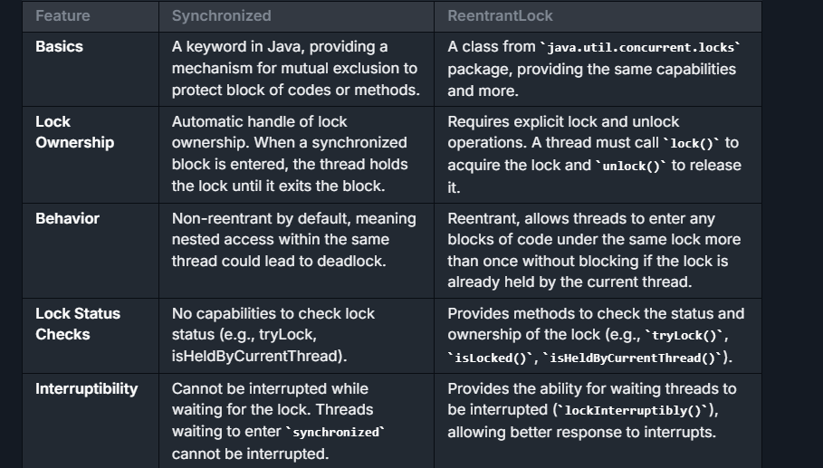

## **Difference Between This and Super Keyword?**

| **Feature** | **this** | **super** |
| --- | --- | --- |
| **Reference** | Refers to the current instance of the class. | Refers to the superclass (parent class) of the current instance. |
| **Usage** | Commonly used to refer to current class instance variables, methods, and constructors. | Used to refer to superclass instance variables, methods, and constructors. |
| **Constructors** | Used to call constructors of the same class, typically seen in overloaded constructors. | Used to call constructors of the parent class. Must be the first statement in the subclass constructor. |
| **Method Overriding** | Can be used to call another method within the same class. | Often used to call a method in the superclass that has been overridden in the current class. |
| **Variables** | Accesses an instance variable of the current object. This helps to distinguish between local variables (parameters) and instance variables when they have the same name. | Accesses an instance variable from the superclass that might be hidden by a field in a subclass with the same name. |
| **Accessibility** | Cannot be used from a static context as it does not reference a static object. | Similar to **this**, it cannot be used from a static context since **super** also refers to a current superclass instance which does not exist statically. |
| **Inheritance** | Does not imply any form of inheritance. It's self-referential. | Directly implies and relies on inheritance, as it is used to interact with the parent class structure. |
| **Use in Constructors** | **this()** invokes another constructor of the same class. Often used for constructor chaining within the same class. | **super()** invokes a constructor of the base class and is used for initializing a parent class before the child class. |

## **Difference between Thread and runnable**

| **Feature** | **Thread** | **Runnable** |
| --- | --- | --- |
| Basic Definition | A thread of execution in a program. It is an instance of **Thread** class. | An interface that defines a single method **run()** which is intended to contain the code executed in the thread. |
| How to Use | Subclass **Thread** and override the **run()** method. | Implement the **Runnable** interface and pass an instance of the implementing class to a **Thread** object. |
| Inheritance Limitation | Extending **Thread** class means you can't extend any other class. | Implementing **Runnable** allows you to extend from another class. |
| Object Sharing | Each thread creates a unique object and associated with it. | Multiple threads can share the same instance of an object implementing **Runnable**, facilitating a lightweight way to achieve thread creation. |
| Construction Flexibility | Constraining, as it involves subclassing. | More flexible, allows more diverse behavior modifications and inherits properties from another class. |
| Use Case Simplicity | Simple use cases just involving overriding of **run()**. | Better suits complex applications where multiple threads require to share data or resources. |
| Resource Usage | More resource-intensive as each thread is a unique object. | More efficient in resource usage since it can work with existing objects. |

## Difference between Throw and Throws in Java

|  |  |  |  |
| --- | --- | --- | --- |
| **Basis of Differences** | **throwwwwwwwwwwwww** | | **throwssssssssssssssssssssssssssssssssss** |
| ttt1. | Definition | Java throw keyword is used throw an exception explicitly in the code, inside the function or the block of code. | Java throws keyword is used in the method signature to declare an exception which might be thrown by the function while the execution of the code. | |
| 2. | Usage | Type of exception Using throw keyword, we can only propagate unchecked exception i.e., the checked exception cannot be propagated using throw only. | Using throws keyword, we can declare both checked and unchecked exceptions. However, the throws keyword can be used to propagate checked exceptions only. | |
| 3. | Syntax | The throw keyword is followed by an instance of Exception to be thrown. | The throws keyword is followed by class names of Exceptions to be thrown. | |
| 4. | Declaration | throw is used within the method. | throws is used with the method signature. | |
| 5. | Internal implementation | We are allowed to throw only one exception at a time i.e. we cannot throw multiple exceptions. | We can declare multiple exceptions using throws keyword that can be thrown by the method. For example, main() throws IOException, SQLException. | |

## Difference between Transient and Volatile ?

| **Feature** | **Transient** | **Volatile** |
| --- | --- | --- |
| **Purpose** | The **transient** keyword is used to indicate that a variable should not be serialized. This is useful when you don't want sensitive data to be part of serialization. | The **volatile** keyword is used to indicate that a variable's value will be modified by different threads and ensures visibility and ordering of values across threads. |
| **Usage Context** | Used in the context of object serialization. | Used in the context of multi-threaded programming. |
| **Effect on Variable** | When an object is serialized, **transient** variables are ignored, i.e., their values are not saved in the persistent storage. | A **volatile** variable's value is always read from and written to the main memory, not cached locally in a thread's stack. |
| **Memory Consistency Effects** | None regarding memory consistency. Just affects serialization. | Guarantees visibility: changes made in one thread to a **volatile** variable are immediately observable by other threads. |
| **Concurrency Impact** | No direct impact on concurrency or multi-threading. | Used to prevent memory consistency errors, ensuring that a read always returns the most recently written value. It does not lock or block accessing threads, but provides a lighter synchronization mechanism. |
| **Typical Use Case** | Used to prevent temporary or sensitive data from being persisted or exposed through serialization processes. | Used when reading from and writing to a variable across multiple threads, without using synchronized, to keep the code simple and potentially increase performance. |
| **Keyword Type** | Modifier on a variable. | Modifier on a variable. |

## Difference between Upper Bound and Lower Bound ?

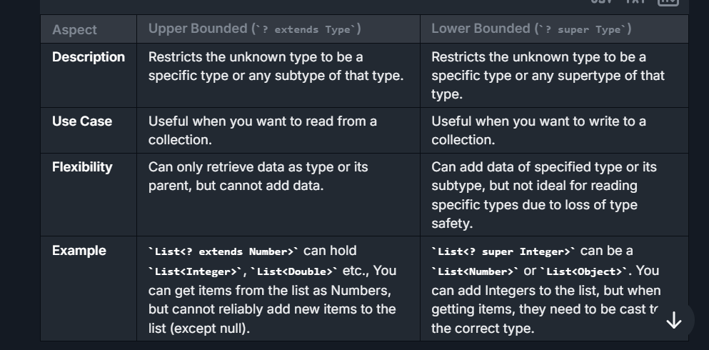

## Difference between Young generation and Old generation?

| **Feature** | **Young Generation** | **Old Generation** |
| --- | --- | --- |
| **Definition** | The memory area where newly created objects are allocated. It is part of the heap memory used for short-lived objects. | The memory area that stores long-lived objects that have survived multiple garbage collection cycles in the Young Generation. |
| **Purpose** | Designed to quickly allocate and reclaim memory for objects that are no longer needed soon after creation (short-lived). | Designed to retain objects that have a longer lifecycle and are in use for a significant part of the application lifecycle. |
| **Subdivisions** | The Young Generation is divided into: <br>- **Eden Space**: Where new objects are initially allocated. <br>- **Survivor Spaces** (**S0** and **S1**): Where objects are promoted before being moved to the Old Generation. | The Old Generation isn't further divided, but it contains objects that survived multiple garbage collection cycles from the Young Generation. |
| **Garbage Collection Type** | Garbage collection in the Young Generation is referred to as **Minor GC**. It happens more frequently and is optimized to occur quickly. | Garbage collection in the Old Generation is referred to as **Major GC** (or **Full GC**). It is less frequent but takes more time as it scans a larger memory space. |
| **Frequency of GC** | Collection occurs frequently, as most objects in this region have a short lifespan. | Collection occurs less frequently because objects in this region typically have longer lifespans. GC here is more computationally expensive. |
| **Object Promotion** | Objects that survive multiple GC cycles in the Young Generation are promoted to the Old Generation based on the JVM’s promotion policy. | Objects remain in the Old Generation until they are no longer referenced and can be cleared during a Major/Full GC. |
| **Efficiency** | GC in the Young Generation is designed to be fast and efficient as it works on small memory spaces (most objects are quickly identified as garbage). | GC in the Old Generation is slower and more expensive, as it works on larger memory spaces and considers objects with complex references. |
| **Memory Reclamation** | Easier and faster to reclaim because most objects are short-lived and quickly become eligible for garbage collection. | Slower to reclaim because objects might have complex relationships and references, and tracing them takes more effort. |
| **Impact on Application Performance** | Minor GC is generally quick and has a negligible impact on application performance. | Major GC can pause the application (Stop-The-World), and if not tuned properly, it can result in performance degradation. |
| **Typical Objects in Region** | Objects recently created (e.g., short-lived variables like loop counters, method call objects, etc.). | Objects that are long-lived or continually referenced (e.g., cached data, session information, application constants, etc.). |

# Enum

## **What is Enum?**

An enum in Java that enables for a variable to be a set of predefined constants. The variable must be equal to one of the values that have been predefined for it. Commonly used in scenarios where a variable can only take one out of a small set of possible values.

**Enums are used for the following reasons:**

1. Safety: By using enum, you can prevent invalid values being used in the code because it defines exactly what values are acceptable.
2. Expressiveness: Enum values can have meaningful names that provide clarity about what they represent, making the code more self-explanatory.

Maintenance: If the values need to be changed or new values need to be added, enums make it easier to update them in a centralized location rather than modifying multiple occurrences throughout the codebase

## **How Enum Works internally?**

1. **Basic Understanding**: When you define an enum in Java, Java creates a class that extends **java.lang.Enum**.
2. **Enum Class**: Each defined enum type implicitly extends the **java.lang.Enum** class, means that your enum type cannot extend any other class.
3. **Instances**: Each of the values defined in the enum type is an instance of that enum type. These instances are static and final (implicitly) and are public members of the enum type.
4. **Construction**: Enums can have constructors, but they typically have package-local access or are private. This ensures that the enum cannot be instantiated from outside its definition.
5. **Methods**: Enums can have methods like regular classes, and they can override methods from the **java.lang.Enum** class, such as **toString()** or **compareTo()**.
6. **Collections of Enums**: The **values()** method returns an array containing all the values of the enum in the order they are declared. The **valueOf(String name)** method returns the enum constant with the specific name.

## **How Enum Compile and Exceute?**

1. **Compilation**: When a Java source file containing an enum is compiled, the compiler converts the source code into a class file that contains static and final fields for each enum constant. Each enum type also has a static **values()** method that returns an array of its values in the order they were declared, and a static **valueOf(String name)** method that returns the enum constant of that specific name.
2. **Execution**: During runtime, each enum constant is instantiated as an object of its enum type when the enum class is referenced for the first time. These objects are then utilized wherever necessary in the code

## **Methods of Enum?**

some of the key methods provided by the **java.lang.Enum** class:

1. **values()**:
   * This method is not in **java.lang.Enum** but is added by the Java compiler to every enum type. It returns an array containing all of the values of the enum in the order they're declared.
   * Signature: **public static <EnumType>[] values()**
2. **valueOf(String name)**:
   * Returns the enum constant of the specified enum type with the specified name.
   * The name must match exactly an identifier used to declare an enum constant in this type.
   * Signature: **public static <EnumType> valueOf(Class<EnumType> enumType, String name)**
3. **ordinal()**:
   * Returns the ordinal of this enumeration constant, which is its position in the enum declaration (zero-based).
   * Signature: **public final int ordinal()**
4. **name()**:
   * Returns the name of this enum constant, exactly as declared in its enum declaration.
   * Signature: **public final String name()**
5. **compareTo(E o)**:
   * Compares this enum constant with the specified enum constant for order. They are ordered by their ordinal values.
   * Signature: **public final int compareTo(E o)**
6. **equals(Object other)**:
   * Returns true if the specified object is equal to this enum constant.
   * Signature: **public final boolean equals(Object other)**

## **Implement singleton pattern using enums??**

Yes, using enums is actually one of the simplest and most effective ways to implement the Singleton pattern in languages like Java. This method provides inherent thread-safety and handles serialization automatically.

## **How Enum Singleton Works ?**

Declaration: By declaring INSTANCE in the enum Singleton, Java ensures there is a single instance of Singleton.

Construction: The Java VM handles the creation and ensures the thread safety of the enum instance. The constructor is called when the enum class is referenced for the first time, which in a Singleton pattern would be when Singleton.INSTANCE is first accessed.

Singleton Guarantee: Since enums are inherently serializable, Java ensures that serializing and deserializing the enum instance doesn't result in multiple instances. Also, Java’s reflection API will not allow the creation of another enum instance.

# Exception Handling

## **What is Exception Handling?**

It is an event that disrupts the normal flow of the program. It is an object which thrown at runtime.JVM throw the except in the form of objectException handling in Java is a mechanism to handle runtime errors so that the normal flow of the application can be maintained. Exception handling is done using the try, catch, and finally blocks.

## **Hierarchy Of Exception?**

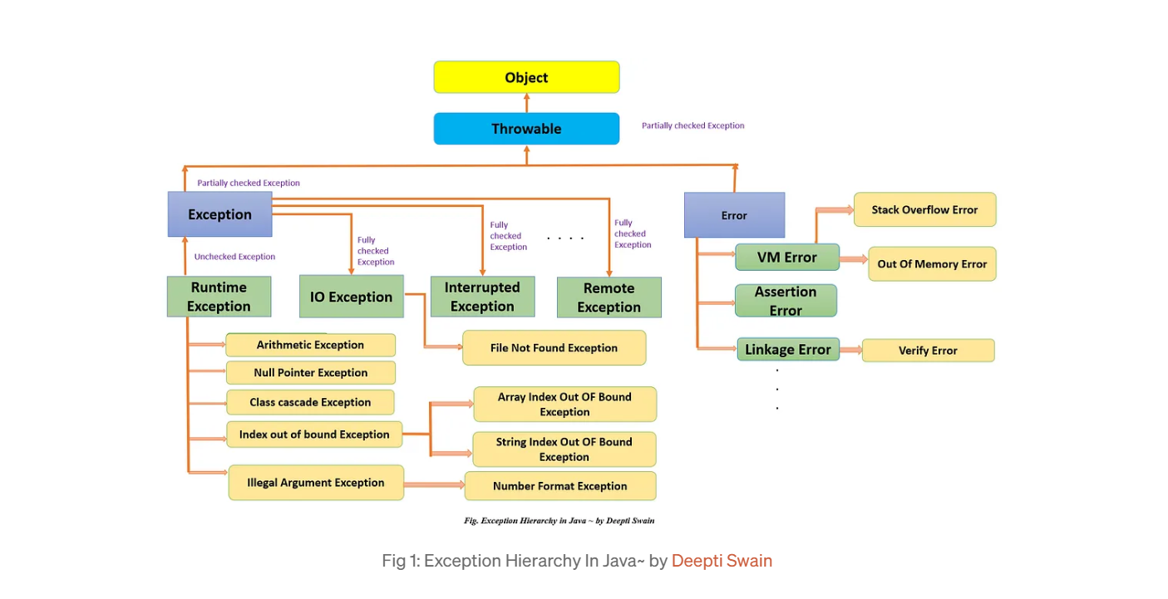

## **How you can create your own exception and handle this in controller?**

**Step 1: Define a Custom Exception**

First, you'll need to create your custom exception class. Generally, you might want to create this exception as a subclass of **RuntimeException** or **Exception** depending on whether you want it to be a checked or unchecked exception

**Step 2: Use the Custom Exception**

Throw your custom exception from within your business logic or service layer when a specific error condition occurs (e.g., when a requested record is not found in the database)

**Step 3: Handle the Exception Globally with @ControllerAdvice**

Using **@ControllerAdvice** allows you to handle exceptions globally across multiple controllers. This means you don't have to repeatedly handle the same exception in each controller. We can manage it centrally

## **What is Null pointer, ClassNotFound and NoClassDef ?**

**1. NullPointerException**

It is a **runtime exception** in Java that occurs when the program attempts to perform an operation on a reference that is **null**. Specifically, it’s thrown when:

* Accessing or modifying a field of a **null** object.
* Calling a method using a **null** object reference.
* Accessing items in a collection (e.g., **List**, **Map**) using a **null** key.
* Array access where the array itself is **null**.
* It is type of **Unchecked Exception**

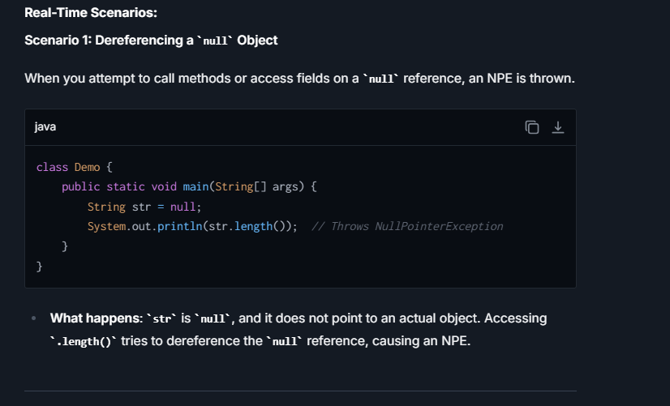

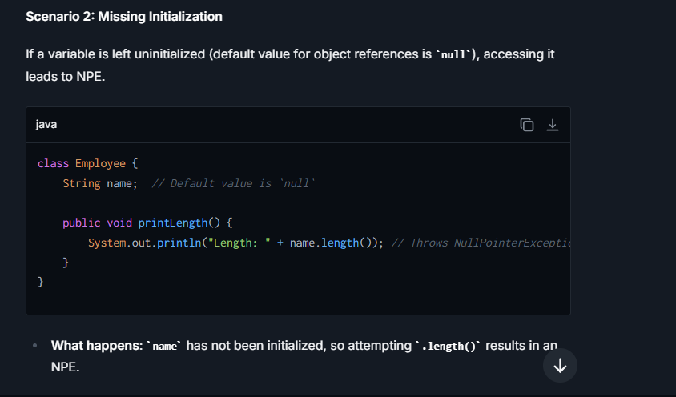

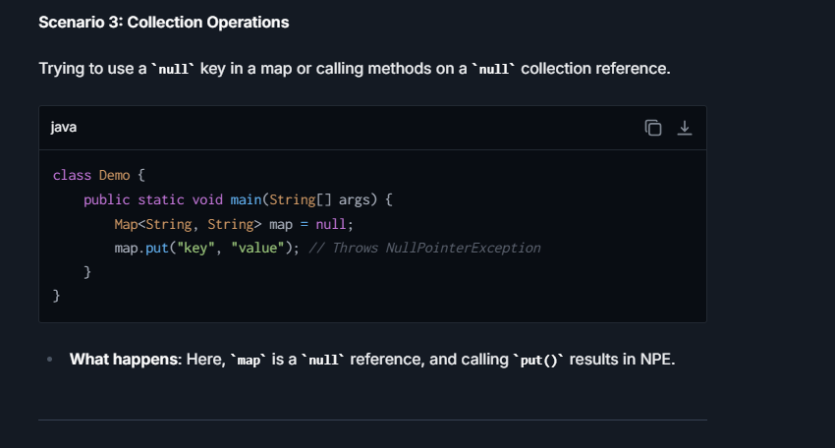

How to avoid Null Pointer Exception

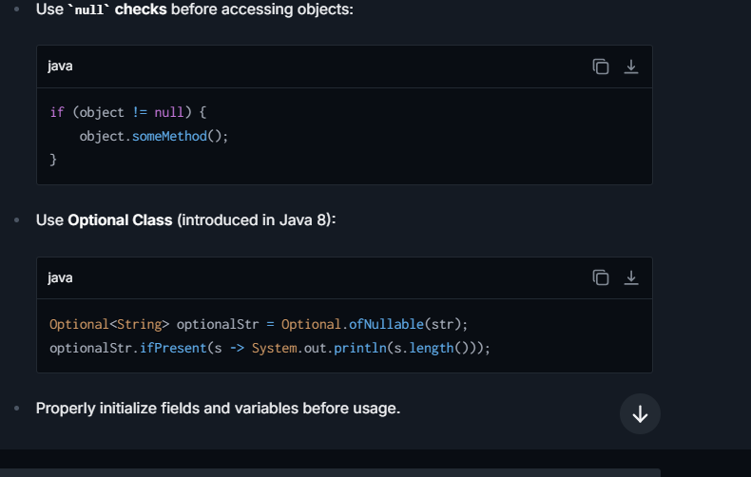

**2. ClassNotFoundException**

**Explanation:**

A **ClassNotFoundException** is a **checked exception** in Java that occurs when:

* The JVM is asked to **load a class** (using methods like **Class.forName()** or **ClassLoader.loadClass()**), but the class cannot be found at runtime in the specified classpath.

It is the **Checked type Exception.**

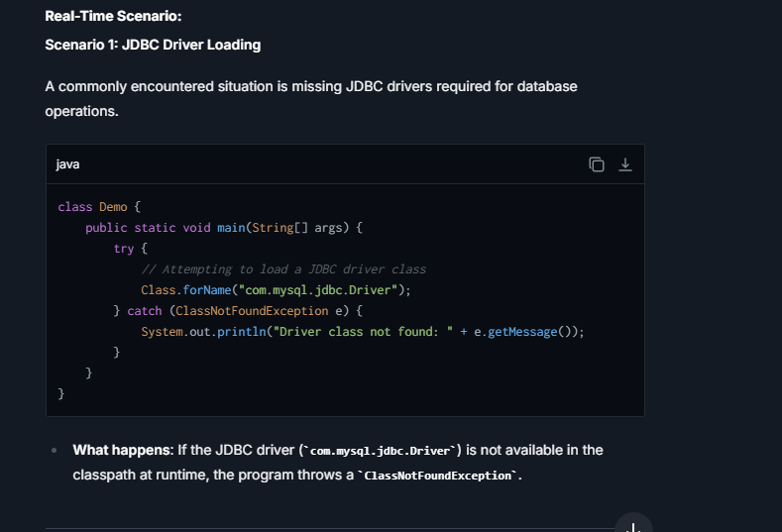

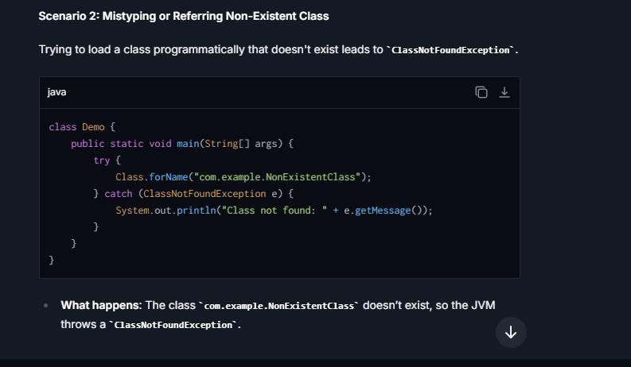

**How to Avoid ClassNotFoundException:**

* **Ensure the class is available in the classpath** during runtime.
* Validate the classname before programmatically attempting to load it.
* For JDBC-related issues, ensure proper driver installation and inclusion in the project dependencies (e.g., Maven/Gradle).

**Common Reasons for ClassNotFoundException:**

1. **Incorrect CLASSPATH Configuration:**
   * The **.class** file, jar, or library containing the target class is missing from the classpath.
   * Example: You forgot to include **mysql-connector.jar** for a database application.
2. **Case Sensitivity:**
   * The Java ClassLoader is **case-sensitive**.
   * If the code refers to **MyClass** but the file is named **myclass.class**, this exception will occur.
3. **Missing Dependency (Third-Party Library):**
   * A required external library or framework is not available at runtime.
   * Typically seen in Maven/Gradle projects where dependencies are not downloaded properly.

**3. NoClassDefFoundError**

It occurs when a **class was available during compile-time**, but the JVM cannot find its definition **at runtime**. This happens if:

* The class exists in the classpath at compile-time but is missing or inaccessible during runtime execution.
* A dependency issue (such as JAR files missing at runtime) arises.

It is of Error type (not Exception).

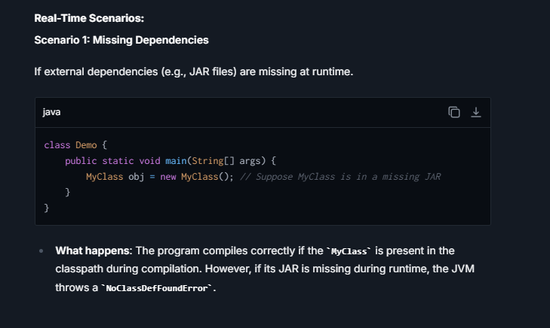

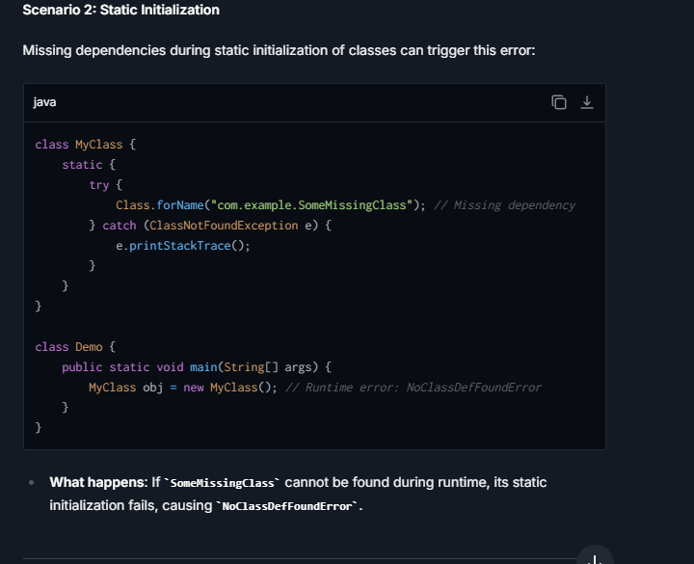

**How to Avoid NoClassDefFoundError:**

* Always ensure runtime dependencies are present in the **classpath**.
* Use a proper dependency manager like **Maven** or **Gradle** to avoid missing JAR files.

## **What is optional Class, Explain all the methods?**

Introduced in **Java 8** as a part of the **java.util** package. It is a **container class** designed to represent **optional values**, i.e., a value that may be present or absent (**null**). The main goal of **Optional** is to eliminate risks associated with **NullPointerException** (NPE) in your code by providing methods to deal with the absence of values in a more expressive and robust manner.

* **Optional is immutable**: The value inside it cannot be changed once it is set.
* It is particularly useful in **method return types** to signify that the method might or might not return a value.
* Encourages **null-safe programming** by forcing developers to think about cases when a value might be absent.

**Why Optional?**

In Java, **Null** is used to represent the absence of a value. However:

* Using **null** can lead to **NullPointerException** if the programmer forgets to check for **null** before accessing the object.
* Checking for **null** repeatedly can make the code verbose and error-prone.

The **Optional** class addresses these problems by:

1. Avoiding **null** checks.
2. Providing a more readable and functional way to represent the presence/absence of values.
3. Facilitating **functional programming operations** over values.

How to Create the Optional?

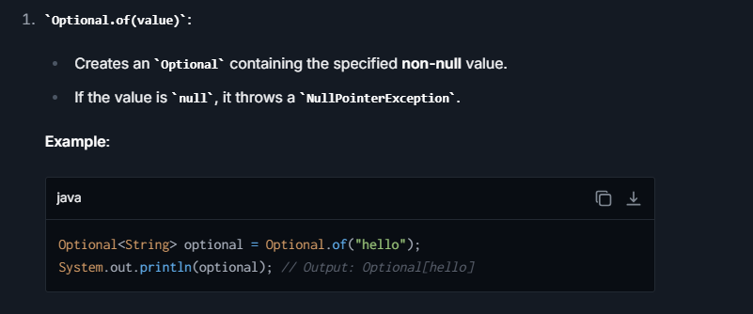

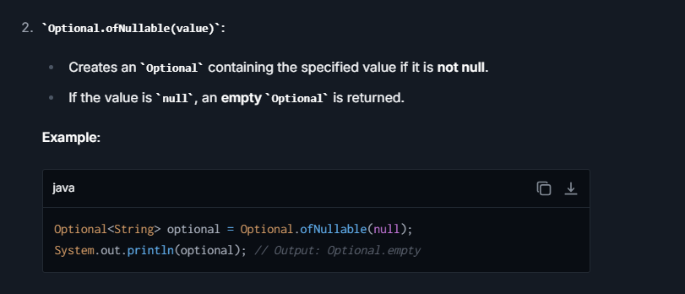

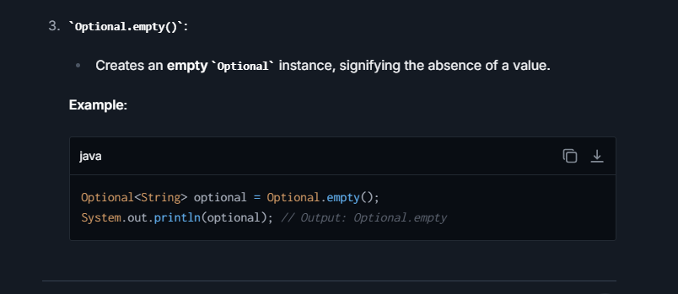

Common Methods of Optional Class:-

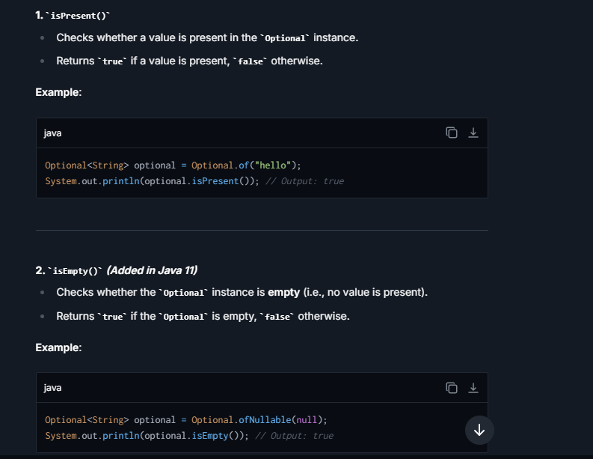

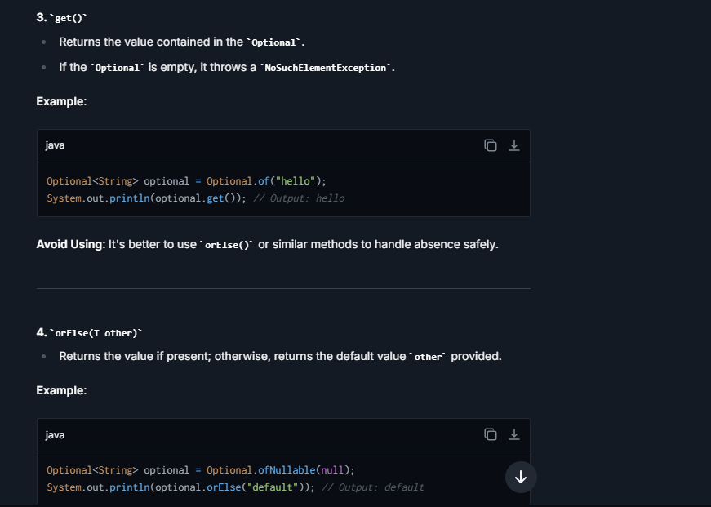

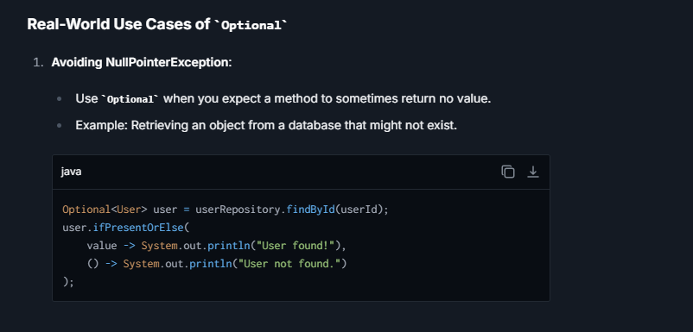

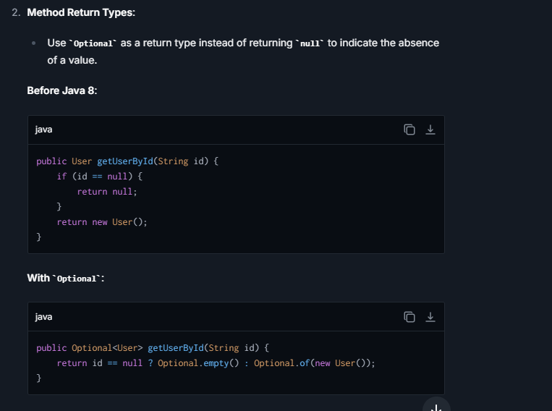

## **What are the rules of overriding?**

If superclass method declares **checked exception** and child class declare **checked**/**unchecked** exception, is it acceptable =**Yes**   
If superclass method declares **unchecked exception** and child class declare **unchecked exception,** acceptable =**Yes**   
If superclass method declare **unchecked exception** and child class declare **checked exception**, acceptable = **No**

If superclass method does not declare **checked/unchecked exception** and child class declare **unchecked** exception,

acceptable =**Yes**

1. **Overridden method in child class** cannot throw new **checked exceptions** that are **not declared** by the corresponding superclass method.
2. Yadi superclass method ek **unchecked exception** declare karta hai (matlab, **RuntimeException** ke subclasses ka use karta hai), aur aap child class method mein ek checked exception ko declare kar rahe ho, toh Java isko allow nahi karega! Kyunki:
   * Superclass method ke caller ko pata hota hai ki use koi **unchecked exception handle karne ki zarurat nahi** hogi. Unchecked exceptions ko Java runtime pe handle karta hai, aur unka declaration zaruri nahi hota.
   * Lekin agar child class method ek **checked exception** introduce karta hai, toh yeh caller ke expectation ko badal deta hai. Checked exception ko **compile-time pe handle karna zaruri hota hai** (via try-catch ya **throws** declaration), aur yeh superclass ka behavior change karta hai.  
     If superclass method does not declare **unchecked exception** and child class declare **checked exception**, acceptable = **No**

## **What is Try-With-Resources? Explain**

It simplifies the handling of resources, such as files, sockets, or database connections, which require closing after their operations are done. Introduced in Java 7, it enhances the traditional try-catch-finally exception handling mechanisms by automating the resource closure process, reducing boilerplate code, and minimizing the possibilities of resource leaks.

**How Does Try with Resources Work?**

In try with resources, resources that need to be closed are declared within the parentheses immediately following the **try** keyword. Each resource must be a class that implements **java.lang.AutoCloseable** (or its sub-interface **java.io.Closeable**, which is specific to I/O streams). The Java runtime automatically calls the **close()** method on these resources in reverse order of their declaration when the try block exits. This exit could be due to successful completion of the block, or due to an exception being thrown.

## **What is Try, Catch and Finally in Java?**

1. **try Block**: This is the first block in the structure and is used to wrap code that may potentially throw an exception. A **try** block must be immediately followed by either a **catch** block or a **finally** block or both.
2. **catch Block**: This block catches exceptions thrown from the **try** block. Multiple **catch** blocks can be used to handle different types of exceptions. A **catch** block must directly follow the **try** block or another **catch** block if multiple exceptions are being caught.
3. **finally Block**: This block executes after the **try** and **catch** blocks, but before control transfers back to its outer block, regardless of whether an exception was thrown or caught. The **finally** block is optional but when present, it must follow all the **catch** blocks.

## **You write Try-Finally Block Without Catch, what happens When?**

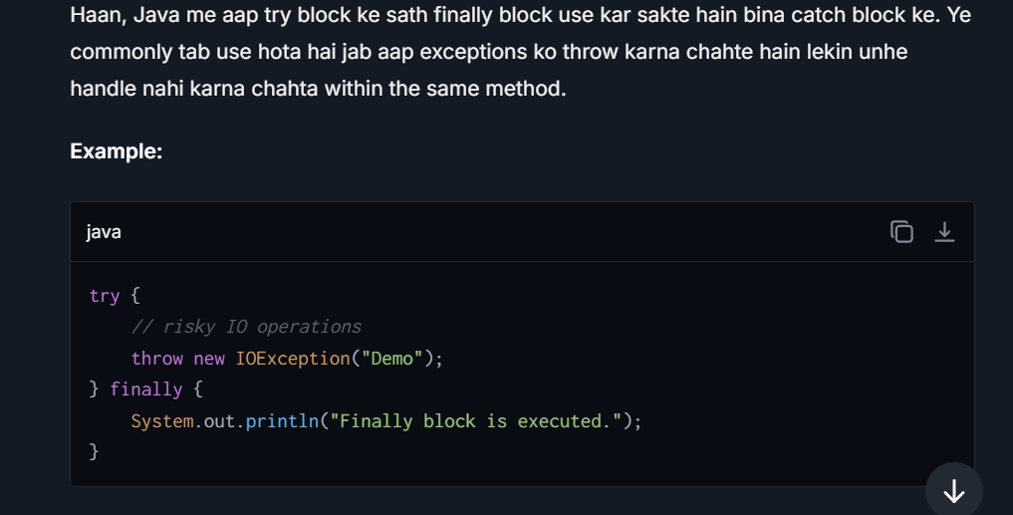

## **Can we write only try block without catch and finally blocks?**

No. either catch or finally is must,If no then what error will come?

Compile time error saying "insert finally to complete try statement".

## **When We Don’t use Catch block in exception? Explain**

1. **Unhandled Exceptions**: If a **try** block is not followed by a **catch** block and an exception occurs, that exception is not handled at that specific point in the code. This means the exception will propagate upwards in the call stack to the caller of the current method.
2. **Searching for a Handler**: As the exception propagates, the Java runtime looks for a **catch** block that can handle that specific type of exception in each subsequent method up the call stack.
3. **Global Exception Handling**: If no appropriate **catch** block is found in the entire call stack, the exception reaches the top of the stack. At this point, the default exception handler takes over, which typically logs the exception details and terminates the program.

## **Can we write any other statements between try catch or finally block?**

No, you cannot write any statements directly between the **try**, **catch**, and **finally** blocks. Doing so would break the program’s syntax and result in a compilation error. These blocks must be contiguous, without any intervening code that isn't enclosed in either of the blocks themselves.

## **If we have return statement in try block, finally block will execute or not? If not then why If execute then why?**

Yes,The **finally** block will **still execute** before the method actually returns to the caller. This is a part of the Java language specification that ensures the **finally** block is executed if the try block is entered, regardless of how the try block exits—even if it exits due to a **return** statement.

**Reason for Execution**

The purpose of the **finally** block is to allow the release of resources or to allow clean-up operations that must happen regardless of whether an exception was thrown or not.   
**For instance:-** If you have opened a file or acquired a lock in the **try** block, you would typically release those resources in the **finally** block. This setup ensures that resources are always properly released, even if the method exits by encountering a **return** statement, or even an uncaught exception.

## **What are the cases where we can use finally block ?**

**Cases Where We Use Finally Block:**

1. **Ensuring Resource Cleanup**
   * When dealing with files, database connections, or network sockets, we must ensure they are closed properly.
2. **Closing Database Connections**

* Ensuring that database connections are closed to prevent memory leaks.
* Example (Java - JDBC):

1. **Releasing Locks in Multithreading**

* Used to ensure that a **lock is released** even if an exception occurs.
* Example (Java - Thread synchronization)

1. **Handling Exception Logging and Cleanup**

* Used for logging errors before exiting the program.
* Example (Python):

## **Does remaining statements in try block executes after exception occurs ?**

No. if exception occurs at a particular point in try block then all statements after that statement where exception is occurred will not be execute and the flow goes directly to either catch block if there is any or else program terminates. Hence, we need finally block to do all clean up like closing files or removing locks.

## **What exception will we get if @qualifer is not there?**

**@Qualifier** is used in Spring to specify which bean to inject when multiple beans of the same type exist. If missing and required, Spring throws a **NoSuchBeanDefinitionException**.

Without **@Qualifier**, if multiple **MyBean** implementations are found, Spring wouldn't know which to inject, causing an error.

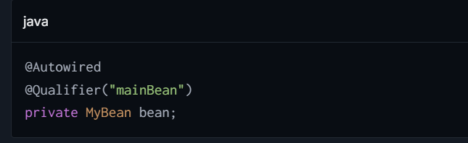

## **How to Write a custom Exception in Java?**

Writing a custom exception in Java is a straightforward process that allows you to create an exception that is specific to your application's requirements. Custom exceptions can help make your code more readable and easier to debug by providing more specific error information.

**Step 1: Decide on the Exception Type**

First, decide whether your custom exception should be checked or unchecked:

* **Checked exceptions** are subject to the Catch or Specify Requirement (must be caught or declared to be thrown).
* **Unchecked exceptions** are not subject to the Catch or Specify Requirement.

For a checked exception, extend **Exception**. For an unchecked exception, extend **RuntimeException**.

**Step 2: Create the Exception Class**

Create a new class and extend it from either **Exception** or **RuntimeException**, depending on the type of custom exception you need.

**Step 3: Add Constructors**

You can provide several constructors that mimic those of the superclass. Commonly used constructors are:

* A no-argument constructor.
* A constructor that accepts a message (string) that describes the exception.
* A constructor that takes a message and a cause.
* A constructor that takes a cause.

## **Steps to handle exception handling in spring boot ?**

The most widely-used methods involve using controller-based exception handlers using **@ExceptionHandler**, creating global exception handlers with **@ControllerAdvice** or **@RestControllerAdvice**, and using **ResponseEntityExceptionHandler**.

Below are step-by-step processes to approach each method :-

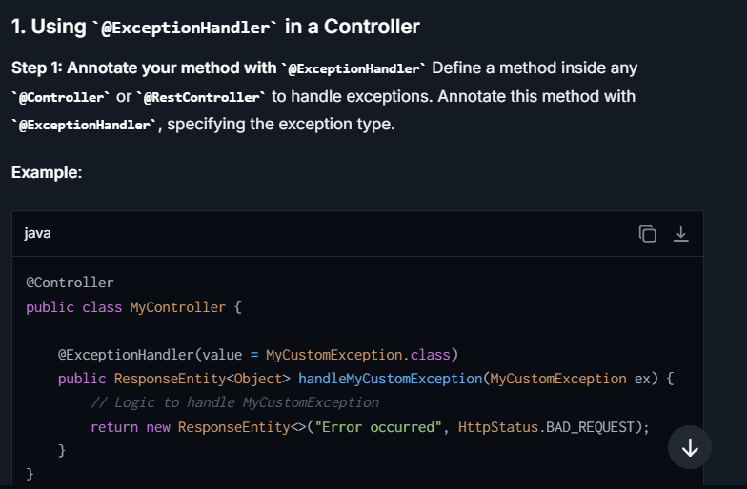

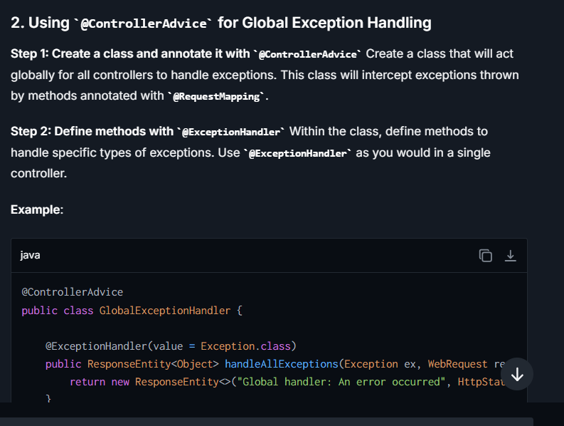

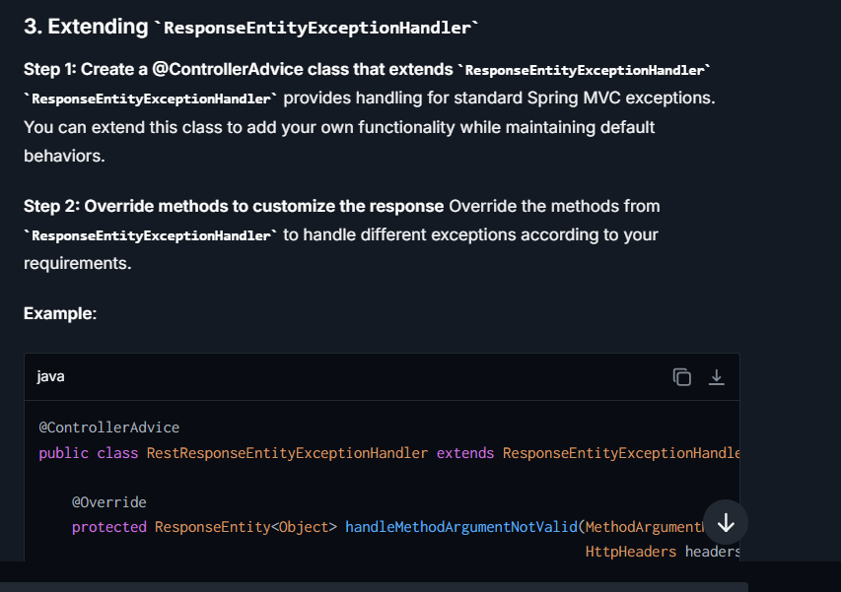

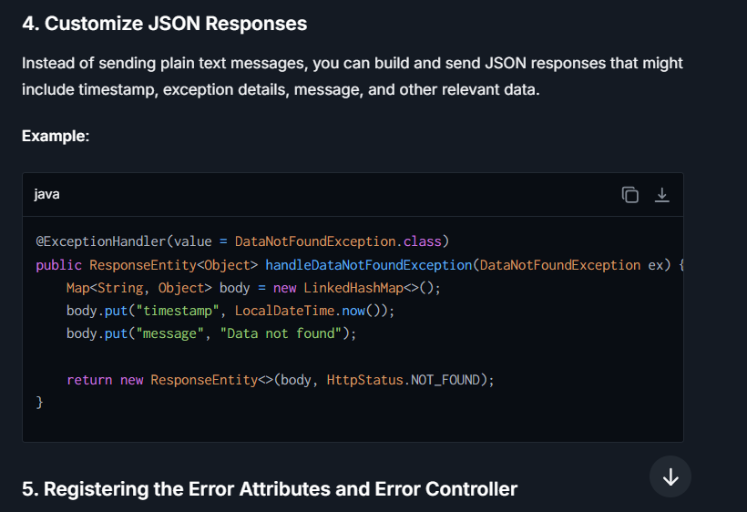

## **When We insert null value in treeset internally other than exception?**

"When you attempt to insert a null value into a **TreeSet** that is using natural ordering (e.g., the elements implement the **Comparable** interface), Java will throw a **NullPointerException**. This occurs because the **compareTo()** method, which the **TreeSet** uses to maintain order, is invoked on the inserted element, passing the existing elements as the argument. Since the **Comparable** contract does not typically support null arguments, trying to invoke a comparison with or on a null value results in a **NullPointerException**.

To avoid this, when designing a **TreeSet** that needs to handle null values, you would use a custom **Comparator** that explicitly checks for nulls before comparing values. For instance, you could treat null as less than any non-null value, or vice versa, depending on your specific business logic. However, if your custom comparator does not account for nulls, inserting a null would still lead to exception.”

## **What is Final, Finally and Finalize in Java?**

**final**: It's a keyword is used to apply restrictions on the class, method, and variable. The final class can't be inherited final method can it be overridden and final variable cant be changed.

**finally**: this keyword is used with the try-catch block to provide statements that will always get executed even if some exception arises. Usually, finally is used to close resources.

**finalize**: is used to perform clean up processing just before the object is garbage collected

## **Difference between Compile time and Run time Exception**



## Difference between Exception and Error ?

|  |  |  |
| --- | --- | --- |
| **Basis of Comparison** | **Exception** | **Error** |
| **Recoverable/ Irrecoverable** | Exception can be recovered by using the try-catch block. | An error cannot be recovered |
| **Type** | It can be classified into two categories i.e. checked and unchecked. | All errors in Java are unchecked. |
| **Occurrence** | It occurs at compile time or run time. | It occurs at run time. |
| **Package** | It belongs to java.lang.Exception package. | It belongs to java.lang.Error package. |
| **Known or unknown** | Only checked exceptions are known to the compiler. | Errors will not be known to the compiler. |
| **Causes** | It is mainly caused by the application itself. | It is mostly caused by the environment in which the application is running. |
| **Example** | **Checked Exceptions:** SQLException, IOException **Unchecked Exceptions:** ArrayIndexOutOfBoundException, NullPointerException, ArithmaticException | Java.lang.StackOverFlow, java.lang.OutOfMemoryError |

## Difference between Fail Fast and Fail Safe ?



## Difference between Throw and Throws in Java

|  |  |  |  |
| --- | --- | --- | --- |
| **Basis of Differences** | **throwwwwwwwwwwwww** | | **throwssssssssssssssssssssssssssssssssss** |
| ttt1. | Definition | Java throw keyword is used throw an exception explicitly in the code, inside the function or the block of code. | Java throws keyword is used in the method signature to declare an exception which might be thrown by the function while the execution of the code. | |
| 2. | Usage | Type of exception Using throw keyword, we can only propagate unchecked exception i.e., the checked exception cannot be propagated using throw only. | Using throws keyword, we can declare both checked and unchecked exceptions. However, the throws keyword can be used to propagate checked exceptions only. | |
| 3. | Syntax | The throw keyword is followed by an instance of Exception to be thrown. | The throws keyword is followed by class names of Exceptions to be thrown. | |
| 4. | Declaration | throw is used within the method. | throws is used with the method signature. | |
| 5. | Internal implementation | We are allowed to throw only one exception at a time i.e. we cannot throw multiple exceptions. | We can declare multiple exceptions using throws keyword that can be thrown by the method. For example, main() throws IOException, SQLException. | |

# **Java 8**

## Why java 8 is introduced and what is the purpose of java 8 in points?

Java 8 was introduced to bring several significant improvements and features to the language. The purpose of Java 8 includes:

1. **Lambda Expressions:** Java 8 introduced lambda expressions, which allow developers to write more concise and readable code by treating functions as first-class citizens.
2. **Stream API:** Java 8 added the Stream API to enable developers to work with collections more effectively by allowing bulk operations on elements using functional-style operations such as map, filter, and reduce.
3. **Date and Time API:** A new Date and Time API was introduced in Java 8, which is thread-safe and easier to use compared to the older java.util.Date and java.util.Calendar classes.
4. **Optional:** The Optional class was introduced to better handle null values and avoid NullPointerExceptions by providing a container that may or may not contain a non-null value.
5. **Default Methods:** Java 8 allows developers to add new methods to existing interfaces without breaking the existing implementations by using default methods.

## **What are Functional Interfaces explain with an example**

A functional interface in Java is an interface that has exactly one abstract method. Despite having only one abstract method, functional interfaces can have any number of default or static methods. This concept is crucial in Java, especially with the advent of Lambda Expressions in Java 8, as it provides a target type for lambda expressions and method references.

**Characteristics of Functional Interfaces:**

1. **Single Abstract Method**: They must have exactly one abstract method.
2. **SAM Interface**: They are also known as Single Abstract Method interfaces.
3. **@FunctionalInterface Annotation**: This annotation is used to ensure that the interface meets the requirements of a functional interface. Although not mandatory, this annotation helps in clarity and ensures the interface remains functional in case modifications happen later.

## **Any idea about java anonymous class? Any idea why we use it? Explain**

an anonymous class is a class not explicitly declared with the **class** keyword. Instead, it is declared and instantiated in a single expressive statement using a constructor of an existing class or by implementing an interface. Anonymous classes are useful when you need to create a quick one-time use subclass of an existing class or an implementation of an interface without explicitly declaring a separate new class.

**Why Use Anonymous Classes?**

Anonymous classes are particularly useful in scenarios where:

1. **Local Details**: You need to implement functionality that won't be reused and doesn't justify the overhead of a separate class declaration.
2. **Simplicity**: They help in keeping the code simple and clear, especially for quick implementations of small interface methods

## **Can we add more than one abstract method in the functional interface Explain?**

No, a functional interface in Java is defined as an interface with exactly one abstract method. This restriction is crucial as it allows functional interfaces to be used with lambda expressions, ensuring that there is a clear contract for what the lambda expression implements.

**public interface Vehicle {**

**int getNumberOfWheels();**

**// Adding a default method**

**default void printType() {**

**System.out.println("Vehicle type: Unknown");**

**} }**

This interface declares one abstract method, **execute()**, which perfectly qualifies as a functional interface. If we attempted to add another abstract method, it would no longer be valid:

**java**

**@FunctionalInterface**

**public interface InvalidFunction {**

**void execute();**

**void doSomethingElse(); *// This will cause a compile-time error***

}

Adding **doSomethingElse()** makes the interface have more than one abstract method, which contradicts the definition of a functional interface, and Java will throw a compile error, especially if **@FunctionalInterface** annotation is used.

## **Why do we need default methods? Explain with an example**

Default methods were introduced in Java 8 as a means to enhance the interfaces in Java without breaking the existing implementations of these interfaces. Before Java 8, interfaces could only have abstract methods

* **Backward compatibility:**

Prior to Java 8, adding new methods to an interface would break existing implementations of that interface because all implementing classes would need to provide an implementation for the new methods. Default methods allow you to add new methods to an interface with a default implementation, preserving backward compatibility with existing code.

* **Support for Lambda Expression:**  
  With default methods, you can have a functional interface that also provides utility methods without affecting the ability to use lambda expressions.
* **Providing Common Functionality:**

Default methods allow you to define common methods that can be shared across all implementations of an interface. This can reduce code duplication and make it easier to implement common behaviour in a standardized way.

It also solves the problem of multiple inheritance ambiguity using default methods in more flexible way.

1. **Adding New Methods to Interfaces without Breaking Existing Implementations**

Prior to Java 8, if a new method was added to an interface, all the classes that implemented this interface had to be changed to implement the new method. This was often impractical, especially for widely used interfaces in large codebases. Default methods enable developers to add new methods to interfaces with a default implementation, which means implementing classes are not forced to implement these methods unless necessary.

2. **Enhancing the Interfaces with Optional Methods**

Default methods make it possible for interfaces to have methods that do not need to be implemented in the implementing classes, effectively providing an "optional" method implementation. This feature can be particularly useful when an interface needs to provide a common behavior that can be shared among different implementing classes.

3. **Supporting Multiple Inheritance of Behavior**

Java does not allow multiple inheritance of classes, but with default methods, it effectively supports the multiple inheritances of behavior. This feature enables a class to inherit behavior from multiple interfaces.

## **Why do we need static methods? Explain with an example**

Static methods in interfaces were introduced in Java 8 to enhance the interfaces' capabilities without compromising backward compatibility and to promote functional programming practices

* This is actually like static methods. Using default methods we can override explicitly in the subclasses, but if you have an static method in interface that restricts to override or not able to change the definition of a method. You need to call this static method using the interface name itself.

1. **Utility Methods**: Prior to Java 8, interfaces couldn’t provide an actual implementation. If there was a need for utility methods associated with an interface, separate utility classes were often created. By allowing static methods in interfaces, Java 8 enables these utility methods to be kept together with the interface, promoting cohesion.
2. **Convenience and Clarity**: By keeping utility methods within the same interface, it becomes clearer and more intuitive for developers to understand and use these utilities in the context of the interface.
3. **Avoiding Redundant Implementations**: Static methods help avoid duplicate implementations that might otherwise be repeated in each implementation of the interface.

## **Can I have default and static methods in a functional interface? Explain example.**

Yes, you can include both default and static methods in a functional interface. The presence of default and static methods does not affect the status of an interface as 'functional' because they do not abstract methods. The key requirement of a functional interface is having exactly one abstract method

## **What are the streams API/methods? Explain**

Streams in Java 8 provide a high-level abstraction for sequences of elements supporting sequential and parallel aggregate operations. Here are some of the key methods categorized by their function:

* **Creation**: Methods to create a stream from varied data sources. Examples include **Stream.of()**, **Arrays.stream()**, and **Collection.stream()**.
* **Intermediate operations**: These transform a stream into another stream. Examples include:
  + **filter(Predicate)**: Returns a stream including elements that match the given predicate.
  + **map(Function)**: Transforms each element via the given function.
  + **flatMap(Function)**: Flattens multiple streams into a single stream.
  + **distinct()**: Filters unique elements based on **equals()** method.
  + **sorted()**: Sorts elements according to natural order or a provided comparator.
* **Terminal operations**: These operations collect or consume the stream. Examples include:
  + **forEach(Consumer)**: Performs an action for each element of the stream.
  + **collect(Collectors)**: Transforms the stream into different types of result containers.
  + **reduce(BinaryOperator)**: Combines stream elements into a single summary result by repetitive application of a combining operation.
  + **anyMatch(Predicate)**, **allMatch(Predicate)**, **noneMatch(Predicate)**: Return a boolean result based on the elements of the stream and the given predicate.

## **What is Key Characteristics of the Stream API ?**

* **No Storage**: A stream does not store elements. It instead conveys elements from a source such as a collection, array, or an input/output operation.
* **Functional in Nature**: Streams operate on a source using lambda expressions, enabling functional-style programming.
* **Lazy Execution**: Stream operations are lazy, meaning that computation on the source data is only performed when absolutely necessary (usually at the terminal operation).
* **Consumable**: Streams are designed to be traversed (consumed) only once. Once a traversal operations has been performed, it cannot be reused.

## **Explain the Predicate, Consumer, and Supplier?**

In Java 8, **Predicate**, **Consumer**, and **Supplier** are three key functional interfaces provided in the **java.util.function** package. They are used widely with lambda expressions and the Stream API to create clean, concise, and functional-style code. Below is a detailed explanation of each functional interface with examples.

**1. Predicate<T>**

* **Definition**:
  + **Predicate<T>** represents a condition or a rule to test whether a given input satisfies it or not.
  + It checks the condition and returns either **true** or **false** (i.e., boolean result).
  + It is most commonly used in filtering operations.
* **Functional Method**:
  + **boolean test(T t)** – accepts an input of type **T** and returns a boolean (**true** or **false**).
* **Common Use Cases**:
  + Filtering elements in a stream.
  + Testing conditions.

**2. Consumer<T>**

* **Definition**:
  + **Consumer<T>** represents an operation that accepts a single input of type **T** and performs an action on it without returning any result.
  + Unlike most other functional interfaces, **it operates through side effects** (e.g., modifying external state, logging, printing to the console).
* **Functional Method**:
  + **void accept(T t)** – performs an operation on the given argument.
* **Common Use Cases**:
  + Printing to the console.
  + Logging or performing actions on objects.
  + Iterating over a stream to process individual elements.

**3. Supplier<T>**

* **Definition**:
  + **Supplier<T>** represents a supplier of results or values.
  + It does not take any input and only **supplies (produces)** a result of type **T**.
  + It is commonly used to generate or supply data when invoked.
* **Functional Method**:
  + **T get()** – Supplies a result of type **T**.
* **Common Use Cases**:
  + Generating values, such as random numbers.
  + Lazy-loading values.
  + Fetching external resources (e.g., reading configuration, database, or file).

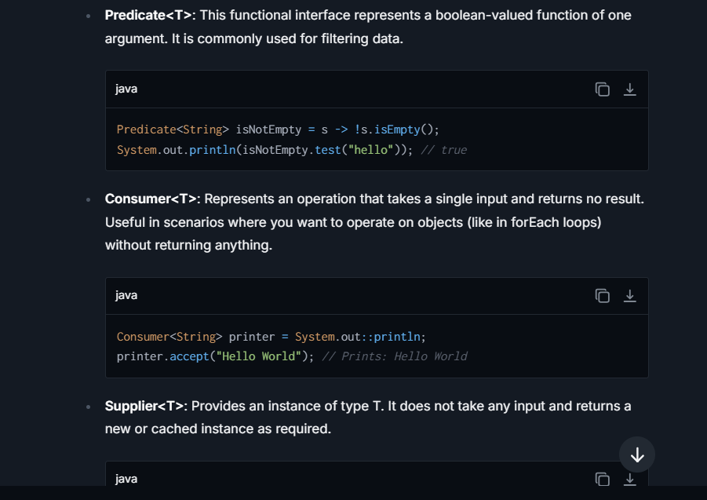

## **What is a map() in streams API?**

The **map()** method is an **intermediate** operation that transforms elements of a stream from one form to another using a provided function. This method is used when you want to apply a specific transformation to each element in the stream. The transformation is defined within a function passed to **map()** as an argument. The function takes an input of one type and returns another (possibly the same) type, effectively "mapping" the original stream to a new stream of elements that have been transformed.

**Characteristics of map()**

* It is a **non-terminal operation**, meaning it returns a new stream as a result, allowing further operations such as filtering, sorting, or additional mappings.
* It operates one-to-one, processing each element independently and applying the function to each element.

## **What is Marker Interface and Why Use it, with explain ?**

A marker interface is a design pattern in Java where an interface does not contain any methods or fields; it serves solely to convey metadata about a class that implements it. Marker interfaces are used for logical tagging or marking certain functionality to an object, allowing developers to enable or access specific features based on a class's type at runtime. Essentially, they are empty interfaces used to indicate that a class implementing this interface has or should be treated as having a specific property.

**Why Use Marker Interfaces?**

Marker interfaces are primarily used to:

1. **Indicate that a class has a certain capability or should be treated in a certain way.**
2. **Control behavior through polymorphic methods, allowing code to adjust dynamically based on whether an object implements a marker interface.**
3. **Enable safe type casting, confirming the object’s contract just by checking its type.**

**Example: Serializable Interface**

One of the most well-known examples of a marker interface in Java is the **Serializable** interface in the **java.io** package. The **Serializable** interface does not contain any methods but indicates that a class can be serialized — that is, its state can be converted into a stream of bytes so that the object can be saved to a file or sent over a network.

## **What are the parallel streams? Explain.**

* Parallel stream is one of the feature in Stream API that allows you to process data concurrently using multiple threads.
* Parallel stream divides the data into multiple parts and process them in parallel across multiple threads.
* This can lead to faster execution, especially on large data sets.

**Why:**

* **Improved performance:** The primary reason for using the parallel stream is to improve the performance by leveraging the large datasets into multiple parts and process them parallelly through multiple threads.
* **Simplified Concurrency:** developers doesn’t need to manage the thread pools, synchronization, other concurrency mechanisms etc. Stream API handles all these things for you and simplify the concurrency.
* **CPU intensive performances:** if each operation in stream is computationally very expensive such as complex math operations, image processing operations etc. Stream API takes advantage of these CPU cores and process the data in simultaneously using the multiple cores in CPU.

**Limitations:**

* Overhead parallelization- creation of threads, synchronization, switching context even for the small computations or datasets.
* Nondeterministic order – the proper order is not guaranteed, debugging and testing have the difficulty.
* Not suitable for all computations, some computations need sequential only because of shared memory or dependencies.
* Side effects, if we use lambda expressions in parallel there might be chance of unpredictable results because of concurrent modifications.

**Real Time Usage of Parallel Stream:**

* Large data sets.
* Batch processing ETL operations
* Processing large log files**.**

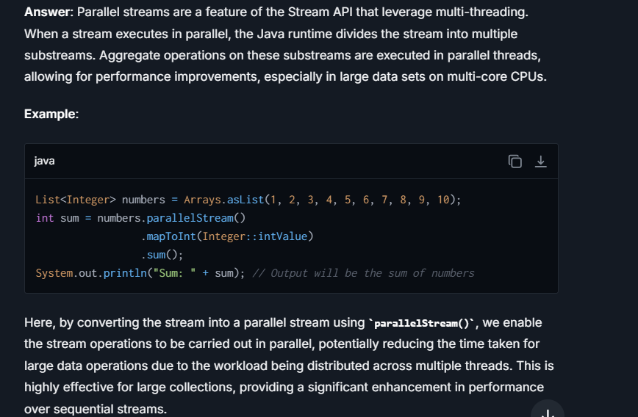

## Difference between Intermediate and Terminal operation ?



## Difference between Stream and Collection?

| **Criteria** | **Collection** | **Stream** |
| --- | --- | --- |
| **Main Purpose** | Designed primarily for storing and managing groups of data elements. Collections can be modified and accessed extensively. | Used for expressing complex data processing operations like filtering, mapping, and reducing elements in a declarative way. Streams are not for data storage. |
| **Mutability** | Mutable; elements can be added, removed, or updated directly. | Immutable; stream operations do not modify the source collection and instead return a new stream. |
| Lazy Loading | Eager evaluation is used: operations on a collection (like transforming or filtering elements) are performed immediately and stored explicitly. For instance, when you filter a list, a new list containing only the filtered elements is immediately created. | Lazy evaluation: Stream operations are performed only when it's necessary, usually at the termination point (like when collecting results or reducing them). This means that intermediate operations can set up pipelines of operations that aren't run until a terminal operation is invoked. |
| **Data Handling** | Collections hold and manage data directly, allowing direct access and manipulation of their elements. | Streams do not hold data; they compute on the provided source data through a pipeline of operations. |
| **Memory Usage** | Consumes more memory when handling large datasets since all elements must typically be stored in memory. | Generally more memory-efficient for large datasets as they process items on-demand without storing all of them. |
| **Concurrency** | Not inherently thread-safe; synchronization or concurrent collections are needed for safe multi-threaded access. | Designed to easily support parallel processing, simplifying concurrency with methods like **parallelStream()**. |
| **Typical Use Case** | Ideal when you need to frequently add, remove, or access elements directly. For example, manipulating a list of user objects. | Best for filtering, sorting, or aggregating data without altering the original data source. Suitable for chaining operations in queries. |
| **Example Operations** | **add()**, **remove()**, **get()**, **set()** | **filter()**, **map()**, **collect()**, **reduce()** |

## Difference between Lamda Expression and Annonymous class in Java

| **Feature** | **Lambda Expression** | **Anonymous Class** |  |
| --- | --- | --- | --- |
| Introduction | Introduced in Java 8 | Have been in Java since early versions (Java 1.1) |  |
| Syntax | Compact and concise, e.g., **(parameters) -> expression** or **(parameters) -> { statements; }** | Verbose, defines a class without a name, e.g., **new InterfaceName() { @Override public void method() { statements; } }** |  |
| Scope of **this** | Refers to the enclosing class | Refers to the anonymous class itself |  |
| Use of External Variables | Can capture final or effectively final variables outside of lambda | Can use and modify external variables |  |
| Interface Type | Can only implement functional interfaces (single abstract method) | Can implement any interface or extend a class |  |
| Serialization | Cannot serialize lambda expressions directly | Can serialize if the anonymous class is defined in a serializable context |  |
| Overhead | Generally less overhead compared to anonymous classes | Creates a class file, which means more overhead |  |
| Output | None (the lambda does not have an identity itself) | Generates a .class file specific to the anonymous class |  |
| Ease of Use | More readable and idiomatic for functional-style programming | More suitable for traditional implementations of methods or when multiple methods from an interface need to be implemented |  |
| Method Overriding | Limited to a single method in a functional interface | Can override multiple methods in an interface or a superclass |  |



## Java 17

### **What is a record class in Java?**

A record class (introduced in Java 14 and finalized in Java 16) is a special kind of class designed to represent immutable data structures. It automatically generates:

* + Constructor.
  + **equals()**, **hashCode()**, and **toString()** methods.

### **What are the main features of a record class?**

* Compiler automatically generates:
  + A canonical constructor to initialize all defined fields.
  + **equals()**, **hashCode()**, and **toString()** methods based on the declared fields.
* Fields are implicitly **final** (immutable).
* Eliminates boilerplate code for data-carrying classes.

### **Features in java 17 Introduced ?**

**1. Sealed Classes (Finalized)**

* **Feature**: Sealed classes, a preview feature in Java 15 and 16, became a full-fledged, finalized feature in Java 17.
* **Purpose**: Sealed classes allow developers to restrict which classes or interfaces can extend a particular class or implement an interface.
* **Use Case**: This enables better control over class hierarchies and exhaustive type checking in **switch** statements.

**2. Pattern Matching for switch (Preview)**

* **Feature**: Pattern matching in **switch** statements simplifies complex conditional logic by introducing type patterns (and potentially other patterns) for use in **switch** cases.
* **Status**: Available as a **preview feature** in Java 17 (third preview).
* **Use Case**: Makes **switch** constructs more expressive and reduces boilerplate code when using type-sensitive operations

Java 17, released on **September 14, 2021**, is a **Long-Term Support (LTS)** release by Oracle. This means it will receive extended support (until at least 2029) compared to non-LTS versions (which receive support for 6 months). Java 17 introduced several key enhancements and features to improve developer productivity, security, and performance. Here is a list of the **major new features** and changes introduced in Java 17:

**1. Sealed Classes (Finalized)**

* **Feature**: Sealed classes, a preview feature in Java 15 and 16, became a full-fledged, finalized feature in Java 17.
* **Purpose**: Sealed classes allow developers to restrict which classes or interfaces can extend a particular class or implement an interface.
* **Use Case**: This enables better control over class hierarchies and exhaustive type checking in **switch** statements.

**Example**:

java

public sealed class Vehicle permits Car, Truck {}

public final class Car extends Vehicle {}

public final class Truck extends Vehicle {}

* With sealed classes, the compiler ensures that only the permitted subclasses (defined via the **permits** keyword) can extend the **Vehicle** class.

**2. Pattern Matching for switch (Preview)**

* **Feature**: Pattern matching in **switch** statements simplifies complex conditional logic by introducing type patterns (and potentially other patterns) for use in **switch** cases.
* **Status**: Available as a **preview feature** in Java 17 (third preview).
* **Use Case**: Makes **switch** constructs more expressive and reduces boilerplate code when using type-sensitive operations.

**Example**:

java

static String formatter(Object obj) {

return switch (obj) {

case String s -> "String: " + s;

case Integer i -> "Integer: " + i;

case null -> "null";

default -> "Unknown";

};

}

***Note****: This feature builds on Pattern Matching for****instanceof****, finalized in Java 16.*

**3. JEP 356: Enhanced Pseudo-Random Number Generators**

* **Feature**: Introduced new interfaces and implementations for **random number generation**.
* **Purpose**: Provides more flexibility and customizable random number generators (RNGs) for use in security, simulation, and gaming.
* **Enhancements**:
  + New interface: **RandomGenerator**.
  + Predefined implementations: **SplittableRandom**, **Xoroshiro128Plus**, and others.

**4. JEP 382: New macOS Rendering Pipeline**

* **Feature**: Replaced the existing rendering pipeline for macOS with the **Metal rendering pipeline**.
* **Purpose**: Improves the rendering performance of Java applications on macOS platforms.
* **Details**: Uses Apple's **Metal API** (instead of the deprecated OpenGL), which ensures compatibility with modern macOS versions.

**5. Stronger Encapsulation of JDK Internals (JEP 403)**

* **Feature**: By default, access to **internal JDK APIs** is strongly encapsulated.
* **Purpose**:
  + Prevents misuse of internal APIs.
  + Prepares developers to transition fully to public APIs.
* **Impact**:
  + Reflective access to internal APIs is **prohibited by default**.
  + If you're trying to use unsupported or deprecated internal APIs, you need to explicitly enable them using JVM flags (not recommended).

**6. Deprecating and Removing Features**

**a. Deprecated for Removal: Applet API (JEP 398)**

* **Feature**: The **Applet API**, once used to embed Java in web browsers, is now deprecated for removal.
* **Reason**: Applets are obsolete due to modern browser security restrictions and advancements in web application technologies.
* **Effect**:
  + You may still use applets in Java 17, but they are marked for removal in a future release.

### **What is a sealed class in Java, and why is it used?**

A sealed class is a type of class introduced in Java (finalized in Java 17) to restrict which classes can extend it. It explicitly defines permitted subclasses using the **permits** clause.

* **Purpose**:
  + Controlled inheritance hierarchy.
  + Enhanced type safety through exhaustive checks.
  + Improves maintainability by defining a clear extension contract.

**Rules for creating sealed classes in Java?**:

* + A sealed class must specify its permitted subclasses using the **permits** clause.
  + Subclasses of a sealed class must use one of the following modifiers:
    - **final**: No further subclassing is allowed.
    - **sealed**: Allows controlled subclassing further.
    - **non-sealed**: Removes restrictions, allowing unrestricted subclassing.
  + Permitted subclasses must belong to the same module or package as the sealed class.

# Multithreading

## **What is Multl threading and explain in detail?**

Multithreading is a programming concept used to run multiple threads, or tasks, concurrently within a single program or process. This is particularly powerful because it allows a program to perform multiple operations simultaneously, making better use of the available hardware resources, especially on multi-core processors.

**Basics of Multithreading**

1. **Thread**: It's the smallest unit of processing that can be performed in an OS. In most modern operating systems, a thread runs within a process and shares the process's resources (including its heap space). Multiple threads within the same process share the same memory and resources but operate independently.
2. **Concurrency**: It refers to the system executing more than one task at the same time within a single application. Concurrency through multithreading helps in performing several tasks in parallel, aiming to improve the throughput and performance of the system.

**How Multithreading Works**

In a multithreaded application, the CPU switches between the different threads to give the illusion of parallelism, but in single-core CPUs, this is just rapid switching (context switching). In multi-core CPUs, threads can truly execute in parallel, with each core processing a different thread.

## **What is Thread?**

It's the smallest unit of processing that can be performed in an OS. In most modern operating systems, a thread runs within a process and shares the process's resources (including its heap space). Multiple threads within the same process share the same memory and resources but operate independently

## **How to Create thread ?**

**Method 1: Extending the Thread Class**

1. **Extend the Thread class**: Your class will inherit **Thread** class methods, and you'll need to override the **run()** method where you define the code that constitutes the new thread's task.
2. **Instantiate and start the thread**: Create an instance of your class and call the **start()** method on this instance to launch the new thread

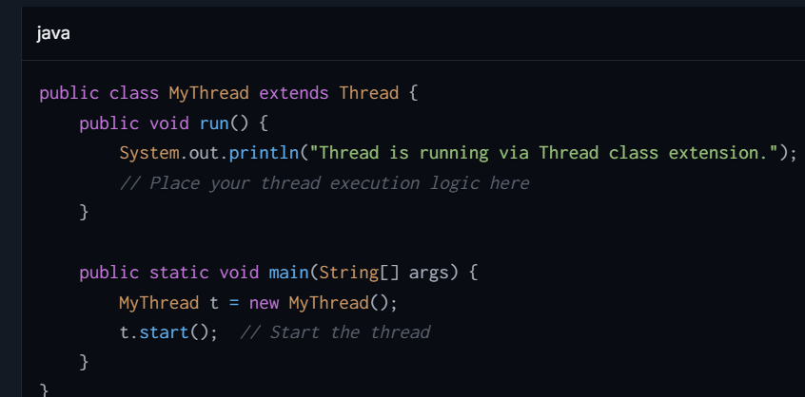

**Method 2: Implementing the Runnable Interface**

1. **Implement the Runnable interface**: Define a class that implements the **Runnable** interface and provide an implementation for the **run()** method. The **run()** method will contain the code that runs in the new thread.
2. **Instantiate Thread with Runnable**: Create an instance of **Thread** by passing an instance of your **Runnable** class to its constructor.
3. **Start the thread**: Call **start()** on the **Thread** instance to begin its execution.

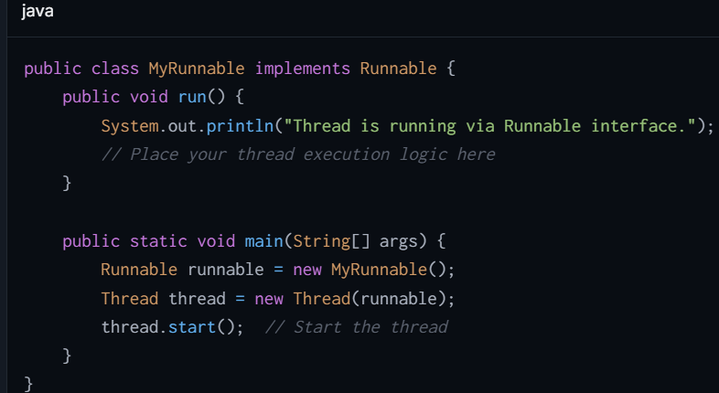

## **What is Thread life-Cycle?**

The thread lifecycle, in the context of multithreading in computing, refers to the various states a thread can exist in during its lifetime. This is an essential concept in understanding how concurrent programming works because it helps developers manage thread behavior more effectively

**Life Cycle of a Thread  :-**

1. ***New Thread:*** *When a new thread is created, it is in the new state. The thread has not yet started to run when the thread is in this state. When a thread lies in the new state, its code is yet to be run and hasn’t started to execute.*
2. ***Runnable State:*** *A thread that is ready to run is moved to a runnable state. In this state, a thread might actually be running or it might be ready to run at any instant of time. It is the responsibility of the thread scheduler to give the thread, time to run.*
3. ***Blocked:*** *The thread will be in blocked state when it is trying to acquire a lock but currently the lock is acquired by the other thread. The thread will move from the blocked state to runnable state when it acquires the lock.*
4. ***Waiting state:*** *The thread will be in waiting state when it calls wait() method or join() method. It will move to the runnable state when other thread will notify or that thread will be terminated.*
5. ***Timed Waiting:*** *A thread lies in a timed waiting state when it calls a method with a time-out parameter. A thread lies in this state until the timeout is completed or until a notification is received. For example, when a thread calls sleep or a conditional wait, it is moved to a timed waiting state.*
6. ***Terminated State:*** *A thread terminates because of either of the following reasons:*
   * *Because it exits normally. This happens when the code of the thread has been entirely executed by the program.*
   * *Because there occurred some unusual erroneous event, like a segmentation fault or an unhandled exception.*

## **What is the Purpose of a 𝐝𝐚𝐞𝐦𝐨𝐧 𝐭𝐡𝐫𝐞𝐚𝐝?**

Daemon threads serve a supportive role to the user (or non-daemon) threads within a Java application. They are typically used to perform background tasks and housekeeping services that are not part of the main workflow but support functionality required by user threads.

1. **Nature of Daemon Threads**:
   * **Lifetime**: Daemon threads continue to run so long as there are non-daemon threads running in the same process. When all non-daemon threads have finished execution, the Java Virtual Machine (JVM) will automatically terminate all daemon threads.
   * **Low Priority**: Typically, daemon threads have lower priority compared to user threads. This is because they usually perform background tasks such as garbage collection, releasing resource locks, or periodic status checks.
2. **Usage Consideration**:
   * Due to their nature, daemon threads should not be used for tasks that demand reliability and integrity, such as file operations, data processing, or database transactions. This is because they might terminate mid-operation when the JVM shuts down on the completion of non-daemon threads.
3. **Creating a Daemon Thread**: You can set a thread as a daemon by invoking the **setDaemon(true)** method in the **Thread** class before starting the thread with **start()**.

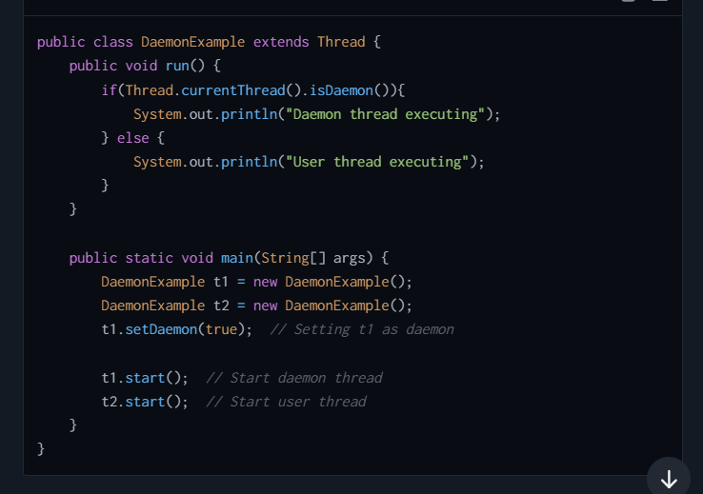

## **What is the priority of garbage thread ?**

The **Garbage Collection (GC) thread** in Java is a **daemon thread** that runs in the background to manage memory by reclaiming unused objects and freeing heap space. However, the **priority** of the garbage collection thread is **lower than the priority of normal application threads**.

This means:

* The JVM gives more importance to user threads (main program execution) over garbage collection.
* The garbage thread will typically execute only when CPU resources are available, or when the memory demands necessitate immediate garbage collection.

**Key Points about GC Thread Priority:**

1. **Daemon Thread**:
   * The garbage collection thread is a **daemon thread**, meaning it runs in the background and does not block the application from terminating. If all non-daemon threads finish execution, JVM will terminate, even if the GC thread is still running.
2. **Background Execution**:
   * GC threads run as background tasks and do not interrupt high-priority tasks (like the application's main execution).
3. **Dynamic Behavior**:
   * Although GC typically has a lower priority, the JVM dynamically adjusts this based on the state of the heap:
     + **If memory is low**, GC threads may become more aggressive (run more frequently) to prevent **OutOfMemoryError**.

## **If the 𝐫𝐮𝐧() method is called directly on a running thread?**

1. **No New Thread Created**: When you invoke the **run()** method directly, it does not start a new thread. Instead, the **run()** method call behaves just like a normal method call and executes in the current thread’s call stack. This means the method will run synchronously, i.e., the code in the **run()** method will block and execute in the same thread from which **run()** was called.
2. **Defeats Multithreading Purpose**: The purpose of using a thread is to perform tasks asynchronously and concurrently. By directly calling **run()**, the method does not execute in a separate, parallel thread; instead, it runs in the same thread, thus making it a regular method call rather than an asynchronous task.

## **What is Atomic variable ?**

Atomic variables in Java are part of the **java.util.concurrent.atomic** package and are specifically designed to handle **thread-safe operations** on shared variables in a **non-blocking way**. These variables allow atomic (indivisible) updates to a single value, providing **lock-free synchronization** for operations like increment, decrement, and compare-and-swap.

**Key Characteristics of Atomic Variables**

1. **Atomicity**:
   * Atomic variables ensure that the **read-modify-write** operations (e.g., incrementing or updating a value) are performed atomically. This means that the variable is updated in one single step without any interference by other threads.
2. **Thread-Safe without Synchronization**:
   * Unlike traditional synchronization mechanisms like **synchronized** blocks or **ReentrantLock**, atomic variables **do not block threads**. They utilize **CPU-level atomic instructions** (like compare-and-swap) internally for safe updates.
3. **Non-blocking**:
   * While locks cause threads to block and wait for the critical section, atomic variables avoid this by leveraging **hardware instructions** to handle concurrent modifications.
4. **Lightweight and Fast**:
   * Atomic variables are more lightweight compared to locks (e.g., **synchronized**). They provide high performance as there is no context-switching or thread contention.

**Why Were Atomic Variables Introduced?**

Atomic variables were introduced to **overcome the limitations of locks** in multithreaded programming:

1. **Locks cause blocking**:
   * Traditional locks (e.g., **synchronized**, **ReentrantLock**) require threads to wait, leading to unnecessary overhead and contention.
2. **Race Conditions**:
   * Incrementing or modifying shared variables is not atomic in nature, leading to race conditions when accessed by multiple threads.
3. **Performance**:
   * Atomic variables offer faster performance in cases of frequent read-modify-write operations, especially when updates are frequent but contention is low.

**Types of Atomic Variables in Java**

Java provides several atomic classes to handle different types of variables:

1. **AtomicInteger**:
   * Provides atomic operations on **int** values.
   * Example: Incrementing (**incrementAndGet**), decrementing (**decrementAndGet**), or swapping (**compareAndSet**).
2. **AtomicLong**:
   * Provides atomic operations on **long** values.
3. **AtomicBoolean**:
   * Provides atomic operations on **boolean** values.
4. **AtomicReference<T>**:
   * Allows atomic operations on object references. Useful when you need to update object references atomically.

**How Atomic Variables Operate Internally**

Atomic variables rely on **atomic instructions provided by the CPU**, such as:

1. **CAS (Compare-And-Swap)**:
   * A low-level, hardware-based instruction used to atomically update a value.
   * CAS reads a value and attempts to update it if the currently stored value is the expected value. If another thread has already updated the value, CAS fails, and the operation retries.

**Steps of CAS**:

* + Read the current value.
  + Check if the value has changed while performing the operation.
  + If unchanged, update the value.
  + If changed, retry until successful.

## **What are locking system in multithreading explain?**

A locking system is a mechanism that synchronizes access to a shared resource between multiple threads. The primary goal of a locking system is to prevent "race conditions," which occur when two or more threads attempt to modify shared data at the same time, potentially leading to inconsistent or unpredictable outcomes.

**Types of Locks**

1. **Mutex (Mutual Exclusion):**
   * A mutex is a lock that allows only one thread to access a resource at a time. When a thread acquires a mutex, other threads must wait until the mutex is released by the owning thread.
2. **Semaphore:**
   * A semaphore restricts the number of threads that can access a part of the code or resources simultaneously. It does this by maintaining a set of permits. For accessing the resource, a thread must obtain a permit, and it releases the permit when it's done.
3. **Read/Write Locks:**
   * These locks allow multiple threads to read data concurrently but ensure exclusive access for writing. Thus, while one thread is writing data, no other thread can read or write. This is useful in scenarios where read operations are more frequent than write operations.
4. **Reentrant Locks:**
   * A reentrant lock is a mutex that can be safely acquired multiple times by the same thread. This is particularly useful when a function called within a block already secured by the same thread needs to acquire the same lock.

## **What are the Advantages of Locking ?**

1. **Safety:**
   * Locks prevent data corruption and ensure data integrity by serializing access to shared resources.
2. **Deadlock Prevention:**
   * Sophisticated locking mechanisms can help prevent deadlocks, which occur when multiple threads are waiting on each other to release locks, by using strategies like lock ordering or timeouts.
3. **Increased Efficiency:**
   * By controlling the execution order and timing, locks can help maintain a high level of concurrency, thereby increasing the efficiency of multithreaded applications.

## **Which one is best way to prevent race condition and why ?**

A **race condition** occurs in a multithreaded environment when two or more threads access shared data at the same time, and at least one thread modifies the shared data. The final outcome depends on the **timing** or **execution order** chosen by the thread scheduler, leading to **unpredictable and inconsistent results**.

This happens because operations like **read-modify-write** on shared variables are not **atomic** (indivisible) and multiple threads can interfere with one another, causing **data corruption** or unexpected behavior.

**How to Fix a Race Condition**

To fix race conditions, **proper synchronization mechanisms** or **thread-safe constructs** must be used to ensure that only one thread at a time can access or modify the shared resource. Below are the **ways to fix a race condition**:

**1. Use synchronized (Locks)**

The simplest way to fix a race condition is to use the **synchronized** keyword in Java, which ensures that only one thread can access the critical section (shared code or resource) at a time.

**How It Works:**

* When a thread enters a **synchronized** block/method, it acquires the lock associated with the object (or class). Other threads trying to execute the same block/method are **blocked** until the lock is released.

**2. Use ReentrantLock**

**ReentrantLock** is part of Java's **concurrency utilities** (**java.util.concurrent.locks**) and provides a more flexible and explicit way to manage thread synchronization compared to **synchronized**.

**How It Works:**

* A **ReentrantLock** must be **explicitly locked and unlocked** using **lock()** and **unlock()**. It allows precise control and supports features like **tryLock()** (non-blocking lock attempts) and interruptible locks.

**3. Use Atomic Variables**

Atomic variables reside in the **java.util.concurrent.atomic** package and are designed for lightweight, thread-safe operations like incrementing, reading, or comparing values. They internally use **compare-and-swap (CAS)** operations to achieve thread safety without locks.

**How It Works:**

* Incrementing or updating values is done atomically by the variable itself. No explicit synchronization is required.

**6. Use High-level Concurrency Tools**

Java provides utilities like:

* **ExecutorService**:
  + Offload thread management to executors.
  + Ensure tasks are executed by dedicated threads with proper synchronization.
* **BlockingQueue**:
  + Thread-safe queue ensures threads work in producer-consumer fashion, removing race conditions.

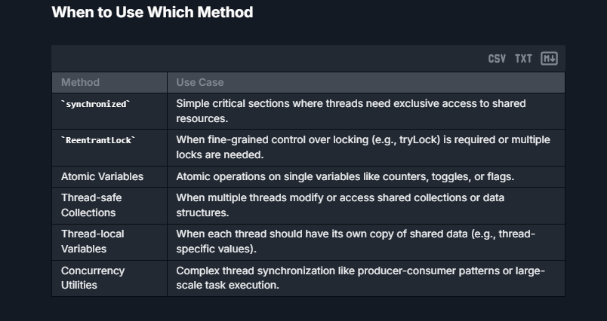

## **What is Synchronized and reentrant lock?**

**Synchronized**

The **synchronized** keyword is a built-in feature in Java that provides a simple and convenient mechanism for mutual exclusion (mutex). It is used to lock an object for any critical section so that only one thread can execute that section at a time.

* **Syntax**:
  + You can declare any method as synchronized, making the method an atomic operation in terms of concurrency. When a method is synchronized, the lock is held on the method's object ('this' if it’s an instance method or the class's Class object if it’s a static method).
  + Alternatively, you can use synchronized blocks within methods to synchronize only part of the method.

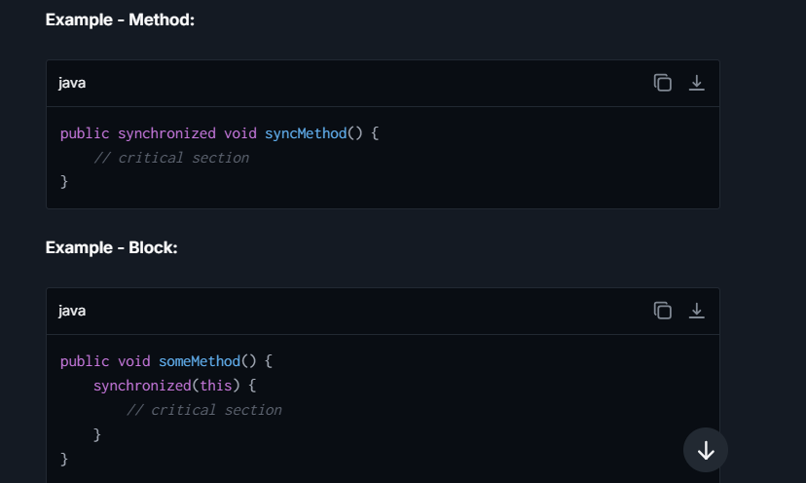

* **Characteristics**:
  + **Intrinsic Locking**: Uses the object's intrinsic lock (or monitor lock).
  + **Reentrant**: If a thread holds the lock, it can re-enter any block synchronized on the same lock without any issues.
  + **No Explicit Lock Release**: Locks are automatically released when the synchronized block or method completes.

**ReentrantLock**

**ReentrantLock** is a class from the **java.util.concurrent.locks** package introduced in Java 5. It offers a capability similar to the **synchronized** keyword but with extended features and greater flexibility.

* **Syntax**: You have to explicitly define **ReentrantLock** objects, lock them, and unlock them within your code.

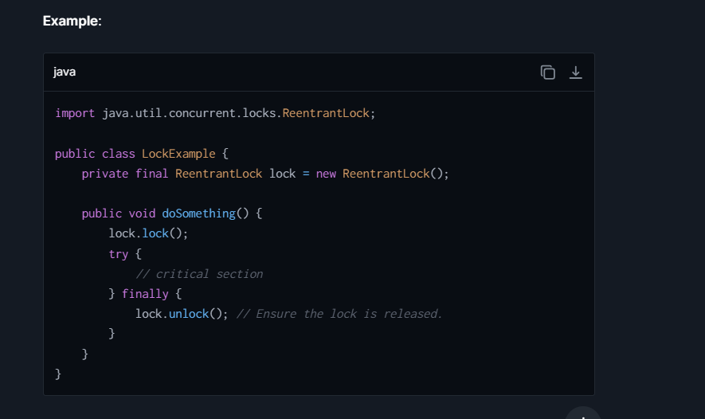

* **Characteristics**:
  + **Reentrant**: Like synchronized, a thread can hold the same lock multiple times.
  + **Manual Lock Management**: Provides methods for locking and unlocking, which gives more control over the lock.
  + **Try Locking**: Offers the ability to attempt to acquire a lock without blocking using **tryLock()** methods.
  + **Interruptible Lock Acquisitions**: Provides a mechanism (**lockInterruptibly()**) that allows locking that can be interrupted by another thread via interrupt.
  + **Fairness Parameter**: Optionally, fairness can be set, so longest-waiting threads get preference when acquiring a lock.

**Use Cases**

* **Use synchronized when**:
  + You need simplicity and no extra features.
  + Scope of locking is just method or small statement blocks.
* **Use ReentrantLock when**:
  + You need advanced locking features like timed waits, interruptible locks, or try locks.
  + Fairness, or a specific locking sequence, is important.
  + Greater control over locking is required.

## **What is synchronized key, then what does it means?**

When a method is declared with the **synchronized** keyword in Java, it means that the method is thread-safe, which ensures that only one thread can execute it at a time for an instance of a class. This is a form of explicit locking that helps prevent multiple threads from executing certain sections of code that interact with shared data concurrently, which could otherwise lead to data inconsistency or corruption due to race conditions.

**Detailed Explanation**

1. **Scope of Synchronization**:
   * **For instance methods:** When a method is declared as synchronized, the lock is on the instance (**this**) for which the method was called. This means if one thread is executing the synchronized method for an instance, no other thread can execute any synchronized method on the same instance. However, they can still access other non-synchronized methods of the instance or synchronized methods of other instances of the same class.
   * **For static methods**: If a static method is synchronized, the lock is on the Class object itself, not on any instance. This means while one thread is executing a synchronized static method, no other thread can execute any synchronized static method of the same class.
2. **Lock Mechanism**:
   * **Intrinsic Locks (Monitor Locks)**: Java uses an internal entity known as an intrinsic lock or monitor lock to implement synchronization. Every object in Java has an intrinsic lock associated with it. When a synchronized method is called, the thread executing that method automatically acquires the lock associated with the instance or the class (depending on whether the method is an instance method or a class method). The lock is released when the method execution completes, either normally or abruptly (due to an exception).

## **How Sychronized key Works ?**

* **Acquiring the Lock**: When a thread enters a synchronized method, it tries to acquire the lock. If the lock is available (i.e., no other thread holds the lock), the thread acquires the lock and enters the method.
* **Executing the Method**: The thread executes the method. During its execution, no other thread can enter any of the synchronized methods of the locked object.
* **Releasing the Lock**: After the method execution is complete, the thread releases the lock, making it available to other threads

## **What is deadlock in multithreading?**

It is a situation in multithreading where 2 or more threads are blocked forever, waiting for each other to release a resource. This typically occurs when 2 or more threads have circular dependencies on a set of locks

**How Does a Deadlock Happen?**

Imagine a scenario where you have two threads and two resources (let's say A and B):

* Thread 1 holds Resource A and needs Resource B to complete its task.
* Thread 2 holds Resource B and needs Resource A to complete its task.

If both threads hold onto their resources while waiting for the other resource to be released by the other thread, they will end up waiting forever. This is known as a deadlock.

**Conditions for Deadlock**

Deadlocks occur when the following four conditions are true simultaneously:

1. **Mutual Exclusion**: At least one resource must be held in a non-sharable mode; that is, only one thread can use the resource at any time.
2. **Hold and Wait**: Threads already holding resources can request new resources.
3. **No Premption**: Resources cannot be forcibly removed from the threads that are holding them; the thread must release resources voluntarily.
4. **Circular Wait**: There exists a set of waiting threads such that one of the threads is waiting for a resource held by the next thread in the set, which forms a circular chain.

**How to Avoid Deadlocks**

1. **Avoid Nested Locks**: Don't acquire a lock when you already hold one if you're not absolutely sure it's safe.
2. **Acquire Locks in Order**: Define a natural or consistent order for acquiring locks and ensure that all threads acquire locks in this order.
3. **Use Lock Timeout**: Using timeouts when trying to acquire locks can help detect problems early. A thread tries to acquire a lock for a specific period and if it can't, it releases any locks it holds and retries after a random delay.
4. **Use a Lock-Free Programming approach**: Where possible, use concurrent programming mechanisms like the ones provided in **java.util.concurrent** which lessen your need for traditional locking.
5. **Break Circular Wait**: You can break the circular wait by ensuring that there is a linear ordering of resources and requiring that processes request resources only in an ordered sequence.

## **What Is Thread Pool?**

It is a collection of pre-initialized threads that are ready and waiting to handle tasks. By using a thread pool, you manage a limited number of threads to handle a potentially large number of tasks, which can help to improve the performance of program execution, reduce the overhead of thread creation and destruction, and manage resource consumption.  
**How it works :-** When a new task is assigned, it is executed by an idle thread in the thread pool. After completing the task, the thread returns to the pool ready to handle another piece of work, instead of being destroyed. This reuse of threads reduces the overhead associated with thread lifecycle.

## **What is Exceutor Framework?**

The Executor Framework is a high-level API provided by Java for managing and controlling thread execution in concurrent programming. It simplifies thread management by abstracting away the low-level details of thread life-cycle management, task submission, and execution. The framework primarily centers around the class **Executors and** interfaces **like** the **Executor**, **ExecutorService**, and **ScheduledExecutorService**.

## **Problems to prior Executor Framework :-**

**Manual Thread Management**

**Resource Management**

**Scalabitiy**

**Thread Reuse**

## **What is Executors class and Methods ?**

The **Executors** class in Java provides a set of factory methods that make it simple to create and manage different types of **ExecutorService** implementations. This class is part of the Java Concurrency Utilities in the **java.util.concurrent** package. It helps simplify the creation of thread pools, which are groups of worker threads that efficiently execute tasks asynchronously.

1. **Methods** :-  
   **newFixedThreadPool(int nThreads)**
   * **Purpose**: Creates a thread pool with a fixed number of threads. All threads are active and handle tasks concurrently until the pool is explicitly shutdown.
   * **Use**: Ideal when you have many short-lived tasks and want to limit the number of concurrent threads due to resource constraints.
2. **newCachedThreadPool()**
   * **Purpose**: Creates a thread pool that dynamically adjusts the number of threads as needed. It creates new threads as tasks are submitted, and reuses previously constructed threads when they become available.
   * **Use**: Useful when each task is short-lived and you need a flexible system that can grow or shrink dynamically based on current tasks volumes.
3. **newSingleThreadExecutor()**
   * **Purpose**: Creates an executor that uses a single worker thread operating from an unbounded queue, ensuring that tasks are executed sequentially in the order they are submitted.
   * **Use**: Best for scenarios where you need to ensure tasks are processed in order, without overlapping execution.
4. **newScheduledThreadPool(int corePoolSize)**
   * **Purpose**: Creates a thread pool that can schedule tasks to run after a given delay, or to execute repeatedly with fixed intervals.

## **What is Executor Interface and Methods ?**

The **Executor** interface in Java serves as a simplified way to manage thread execution. It's part of Java’s Concurrency API, which helps in running code concurrently (or in parallel) across multiple threads. The primary role of this interface is to abstract, or hide, the complexities of thread management and execution from the developer. You, as the developer, just hand over tasks to be executed, and the **Executor** takes care of running these tasks using threads according to the specific implementation it has.

**Void execute(Runnable command)**:- It is the single method in this interface. When you call **execute** and pass it a **Runnable**, you are basically saying, "Hey, run this task at some point in the future." The **Executor** will take care of using a thread to run the **run()** method of that **Runnable**.

## **What is ExecutorService Interface and Methods ?**

It extends the **Executor** interface, adding functionalities to manage lifecycle, both of the individual tasks and of the executor itself. It handles a pool of threads and offers several methods for task submission, including those that return a **Future** representing the pending results of the tasks

**Methods** :-

* **submit(Callable<T> task)**: Accepts a Callable task for execution to the thread pool and returns a **Future** representing the pending results of the task. The **Callable** can return a result.
* **submit(Runnable task)**: Accepts a **Runnable** task for execution and returns a **Future** representing that task. Since **Runnable** does not return a result, the returned **Future** gets **null** upon successful completion.
* **invokeAll(Collection<? extends Callable<T>> tasks)**: It takes Collection of task, Executes the tasks, blocking until all are completed. Returns a list of **Future** objects representing the tasks, in the same sequential order as produced by the iterator for the given task list.
* **invokeAny(Collection<? extends Callable<T>> tasks)**: Executes the given collection of Callable tasks, returning the result of one (any) Which will successfully executed task (i.e., one that did not throw an exception). It typically does not return until at least one result or exception has been obtained.

**E.g :-** querying multiple mirror servers for data where receiving just one response is sufficient.

* **shutdown()**: Initiates an orderly shutdown in which previously submitted tasks are executed, but no new tasks will be accepted. This method does not wait for previously submitted tasks to complete execution; use **awaitTermination** to do that.
* **shutdownNow()**: Attempts to stop all actively executing tasks and halts the processing of waiting tasks.
* **awaitTermination(long timeout, Timeunit unit ) :** Blocks until all tasks have completed execution after a shutdown request, or the timeout occurs, or the current thread is interrupted, whichever happens first.

## **What is Blocking and Non Blocking calls ?**

**Blocking calls** :- prevent the execution of additional code until the current operation completes. In simpler terms, when a thread makes a blocking call, it must wait for an event (like I/O operation) to complete before it can proceed with further execution.

**Non-Blocking Calls** :- It allow a thread to initiate a request and then continue doing other tasks without waiting for the response. If the necessary data isn't available yet, the call typically returns immediately with an indication that no data is currently available rather than waiting for it.

## **What is Future and Methods of Future?**

The **Future** interface represents the result of an asynchronous computation. When you submit a callable task (which returns a result) to an executor service, you get a **Future** object through which you can obtain the result of the callable after its execution. It provides methods to check if the computation is complete, to wait for its completion, and to retrieve the result.

**Methods**

**boolean isDone() :**

* if the computation has completed. It returns true if the computation is completed, including normal termination, an exception, or cancellation; otherwise, it returns false.
* Usage: This method is non-blocking and can be used to poll the status of the Future without preventing the current thread from executing other tasks

**isCancelled() :**

* if the computation was cancelled before it completed normally.
* **Usage**: Similar to **isDone()**, this is also non-blocking. It allows you to determine if the task associated with the **Future** was cancelled. If it returns **true**, then subsequent calls to **isDone()** will also return **true**

**V get() :**

To retrieve the result of the computation, waiting indefinitely if necessary until the computation has completed.

* Usage: This method is blocking and will cause the current thread to wait until the task is completed, whether it completes normally or through an exception. If the task completed with an exception, calling get() will throw an ExecutionException with the underlying exception as its cause. If the task was cancelled, get() will throw a CancellationException

**V get(long timeout, TimeUnit unit)**

* **Purpose**: To retrieve the result of the computation but waits only for the specified amount of time. It takes two arguments: a timeout value and a **TimeUnit** for how the timeout is denoted.
* **Usage**: This is a timed, blocking method allowing the current thread to wait for the result for a limited period. If the result is not available within the timeout, a **TimeoutException** is thrown. Like **get()**, this method will also throw **ExecutionException** if the computation threw an exception, and **CancellationException** if the task was cancelled.

## **What is Completable Future and methods?**

It is an enhancement of Future that may be explicitly completed (setting its value and status), and may be used as a **Future**, supporting non-blocking and asynchronous operations. It also supports dependent functions and actions that trigger upon the completion of the CompletableFuture's task. Unlike Future, **CompletableFuture** supports many triggers and callbacks, and you can combine several futures in a chain of computation steps.

**CompletableFuture** is part of Java’s **java.util.concurrent** package and provides a way to write asynchronous, non-blocking, and event-driven code. It was introduced in Java 8 to enhance the capabilities of **Future**, allowing more complex and fluent asynchronous operations

**Creation Methods**

1. **runAsync(Runnable runnable)**
   * Executes a **Runnable** task asynchronously (no return value).
2. **supplyAsync(Supplier<U> supplier)**
   * Executes a **Supplier<U>** task asynchronously that returns a result of type **U**.

**Transformation Methods (return CompletableFuture)**

These methods apply a function to the result of the future and return a new **CompletableFuture** that will be completed with the result of the function.

1. **thenApply(Function<? super T,? extends U> fn)**
   * Applies a function to the result of this future when it completes.
2. **thenApplyAsync(Function<? super T,? extends U> fn)**
   * Same as **thenApply** but operates asynchronously.
3. **thenCompose(Function<? super T, ? extends CompletionStage<U>> fn)**
   * Chains the future to the next future. The given function is applied to the result of the current future.
4. **thenComposeAsync(Function<? super T, ? extends CompletionStage<U>> fn)**
   * Same as **thenCompose** but the function is applied asynchronously.

**Consumer Methods (handle results)**

1. **thenAccept(Consumer<? super T> action)**
   * Receives the result of this future (cannot return a result).
2. **thenAcceptAsync(Consumer<? super T> action)**
   * Asynchronous version of **thenAccept**.
3. **thenRun(Runnable action)**
   * Takes a **Runnable** that runs after the future completes (does not have access to the future's result).
4. **thenRunAsync(Runnable action)**

* Asynchronous version of **thenRun**.

**Combining Futures Methods**

1. **thenCombine(CompletionStage<?> other, BiFunction<? super T,? super U,? extends V> fn)**

* Combines this future with another and applies a BiFunction on the results of both.

1. **thenCombineAsync(CompletionStage<?> other, BiFunction<? super T,? super U,? extends V> fn)**

* Asynchronous version of **thenCombine**.

1. **allOf(CompletableFuture<?>... cfs)**

* Returns a new **CompletableFuture** that is completed when all of the given futures complete.

1. **anyOf(CompletableFuture<?>... cfs)**

* Returns a new **CompletableFuture** that is completed when any of the given futures complete.

**Exception Handling Methods**

1. **exceptionally(Function<Throwable, ? extends T> fn)**

* Handles exceptions of the current future.

1. **handle(BiFunction<? super T, Throwable, ? extends U> fn)**

* Handles both the result and the exception of the current future.

1. **whenComplete(BiConsumer<? super T, ? super Throwable> action)**

* Invoked with the result (or exception if an exception was thrown) upon completion.

1. **whenCompleteAsync(BiConsumer<? super T, ? super Throwable> action)**

* Asynchronous version of **whenComplete**.

**Utility Methods**

1. **isDone()**

* Returns **true** if completed in any fashion: normally, exceptionally, or via cancellation.

1. **cancel(boolean mayInterruptIfRunning)**

* Attempts to cancel the execution of this task.

1. **join()**

* Returns the result value when complete, or throws an (unchecked) exception if completed exceptionally.

1. **get()**

* Similar to **join()** but throws checked exceptions.

## **What is Benefits of Completable Future ?**

There are the Certain Benefits of Completable future.  
**1. Non-blocking Asynchronous Computation**

**CompletableFuture** allows the execution of asynchronous processing in a non-blocking manner. This means the main thread, or any producing thread, doesn't wait or block for the task to complete. Instead, it can continue with other tasks, or terminate, which can significantly improve the performance and responsiveness of your applications.

**2. Chaining Multiple Asynchronous Tasks**

One powerful feature of **CompletableFuture** is the capability to chain multiple stages, or dependent tasks, using fluent API methods like **thenApply**, **thenAccept**, and **thenCompose**. This allows you to create a pipeline of asynchronous tasks, where the output of one stage can be seamlessly passed to the next stage. Errors are also propagated from one stage to another unless explicitly handled.

**3. Combining Multiple Asynchronous Tasks**

**CompletableFuture** also provides ways to combine multiple asynchronous computations either by waiting for all of them to complete or only for the quickest one. Methods like **allOf** can be used to create a new **CompletableFuture** that completes when all of the combined **CompletableFutures** complete. Conversely, **anyOf** will complete when any of the futures completes. This is particularly useful when you need to trigger tasks that can run in parallel and then proceed when they have all completed, or when you are looking for a result from multiple alternatives (race condition).

**4. Exception Handling**

Exception handling is more robust and flexible in **CompletableFuture**. Methods like **exceptionally** provide a way to handle exceptions in any stage of the computation pipeline, allowing you to recover from exceptions by returning a default value or by throwing a custom exception. The **handle** method can both handle an exception and transform the result.

**5. Asynchronous Programming with Custom Executors**

**CompletableFuture** allows specifying an **Executor** that controls the thread on which the asynchronous operations are executed. This gives you control over the thread execution environment, letting you manage resources more effectively, especially in scenarios involving a large number of asynchronous tasks or multi-threaded workloads. You can choose to use an existing executor (like leveraging the **ForkJoinPool**), or create a specific configuration tailored to your application's needs.

**6. Increased Throughput and Scale**

By efficiently managing asynchronous tasks without blocking threads unnecessarily, **CompletableFuture** can help applications achieve better throughput and scale more effectively. This is crucial for I/O heavy operations or when service latencies are variable and generally in scenarios where resources must be used judiciously.

**7. Better Responsiveness and User Experience**

Applications handling user requests can respond more efficiently by offloading longer-wait tasks to **CompletableFuture** mechanisms, allowing critical user interface operations to remain snappy and responsive.

**8. Concurrency Made Simpler**

Despite the complexity that inherently comes with asynchronous programming and concurrent tasks, **CompletableFuture** provides a relatively simpler and more readable way to handle concurrency compared to manual synchronization primitives like **wait/notify** or even using **Future** directly.

## Problems in future and resolved in Completable future ?

**Problems with Future and How CompletableFuture Solves Them**

**1. Blocking get()**

* **Problem (with Future)**: To retrieve the result, you must call get(), which **blocks** the calling thread until the computation is complete.
* **Solution (CompletableFuture)**: Supports **non-blocking** programming through methods like thenApply(), thenAccept(), and thenRun(), allowing asynchronous callbacks.

**2. No way to chain multiple tasks**

* **Problem**: Future does not support chaining or combining multiple tasks.
* **Solution**: CompletableFuture allows **functional chaining**, making it easier to build asynchronous pipelines using methods like thenCompose(), thenCombine(), etc.

**3. No exception handling**

* **Problem**: Future doesn’t provide built-in mechanisms to handle exceptions.
* **Solution**: CompletableFuture offers methods like exceptionally(), handle(), and whenComplete() for **fine-grained exception handling**.

**4. Manual thread management**

* **Problem**: With Future, you often have to manage threads via ExecutorService.
* **Solution**: CompletableFuture can use the **common ForkJoinPool** by default or a custom executor, reducing boilerplate.

**5. No support for combining multiple futures**

* **Problem**: No built-in support in Future to wait for **multiple asynchronous tasks** to complete.
* **Solution**: CompletableFuture provides allOf() and anyOf() to combine multiple futures elegantly.

**6. Difficult to create a completed Future manually**

* **Problem**: If you want to create a pre-completed Future, it's not straightforward.
* **Solution**: CompletableFuture.completedFuture(value) easily creates a **completed** future.

## What is CountDownLatch and CyclicBarrier? Explain.

**1. CountDownLatch**

**CountDownLatch** is a **synchronization tool** that allows one or more threads to wait until a set of operations being performed by other threads are complete. Essentially, it works as a **countdown mechanism**.

**How It Works:**

* A **CountDownLatch** is initialized with a count (**N**), which represents the number of times **countDown()** must be invoked before the threads waiting on the latch (via **await()**) are allowed to proceed.
* Each time a thread completes a specific task, it calls **countDown()**, decrementing the value of the latch by 1.
* Threads calling **await()** will block until the latch's count reaches zero.

**Key Methods:**

* **await()**: Causes the current thread to wait until the latch count reaches zero.
* **countDown()**: Decrements the count by 1. When the count reaches zero, all waiting threads are unblocked.

**Important Points:**

1. The count of the latch **cannot** be reset once it reaches zero (one-time use only).
2. It is useful for scenarios where threads need to wait for the completion of certain tasks before proceeding.

**Use Case for CountDownLatch**

* **Waiting for Multiple Threads to Complete**:
  + For example, suppose we have 5 threads each performing file downloads, and the main thread should start processing the data only after all files are downloaded.

**Example of CountDownLatch**

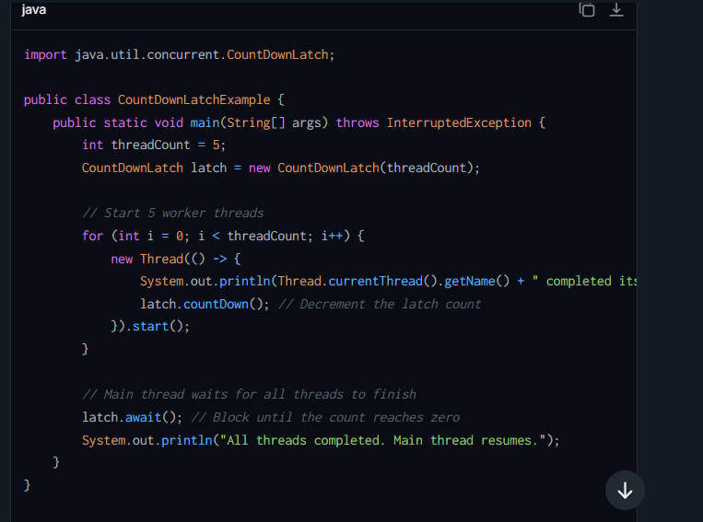

**2. CyclicBarrier**

**CyclicBarrier** is a **synchronization tool** that allows a group of threads to wait for each other at a common barrier point. Once all threads in the group have reached this barrier point, all of them proceed together.

**How It Works:**

* A **CyclicBarrier** is initialized with a count (**N**), representing the number of threads that must call **await()** before they are allowed to continue.
* Once all **N** threads reach the barrier (call **await()**), the barrier is **reset**, and all threads proceed.
* Additionally, an optional **barrier action** can be specified during initialization. This action will be executed exactly once, after all threads have reached the barrier but before they proceed.

**Key Methods:**

* **await()**: Used by threads to signal that they have reached the barrier point. Blocks until all threads have called **await()**.

**Important Points:**

1. The barrier is **reusable** after being triggered, making it suitable for scenarios involving repeated phases or iterations of execution.
2. It ensures that a group of threads proceeds together after reaching the barrier.

**Use Case for CyclicBarrier**

* **Splitting Work into Phases**:
  + For example, a group of threads could represent workers performing a multi-phase computation (e.g., processing data row by row). At the end of each phase, they wait for each other, synchronizing before proceeding to the next phase.

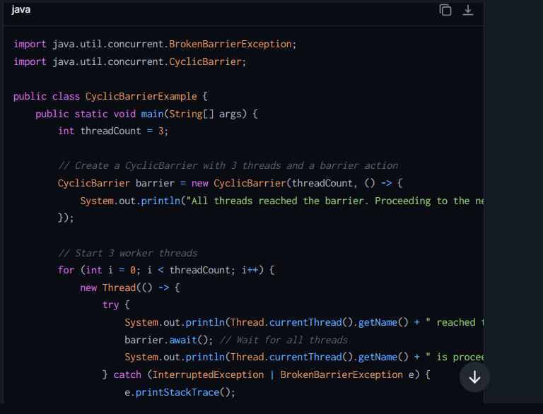

**When to Use What**

* **Use CountDownLatch when**:
  + You want a thread to wait for a set of tasks to complete (e.g., waiting for worker threads to finish).
  + The latch is used as a **one-time event** (i.e., it does not need to be reused).
* **Use CyclicBarrier when**:
  + You need a group of threads to synchronize at **multiple barriers** (i.e., the barrier is reused across multiple phases).
  + Threads should coordinate before proceeding to the next phase of execution (e.g., parallel computations)

## What is ThreadPoolExecutor ? How It Works Internally ?

It is the core implementation of a **Thread Pool**. It resides in the **java.util.concurrent** package and allows you to efficiently manage a pool of threads for executing tasks. Instead of creating new threads manually for each task, it reuses a fixed number of threads to reduce the overhead of thread creation and destruction.

A **thread pool** provides a collection of reusable threads that can execute multiple tasks submitted by the application. With the **ThreadPoolExecutor**, you have better control over thread management and the tasks being executed.

**How ThreadPoolExecutor Works Internally ?**

1. **Core Components**:
   * **Core Pool Size (corePoolSize)**: This is the minimum number of threads that are always kept alive in the thread pool, even if they are idle and waiting for new tasks.
   * **Maximum Pool Size (maximumPoolSize)**: This is the maximum number of threads that the pool can create during peak demand.
   * **Work Queue (BlockingQueue<Runnable>)**: A queue where tasks are stored before being executed by a thread in the pool.
   * **Thread Factory**: An optional mechanism for customizing how threads are created for the pool.
   * **Rejection Handler (RejectedExecutionHandler)**: A strategy for handling tasks when the thread pool is full or unable to accept new tasks.
2. **How It Executes Tasks**:
   * When a new task is submitted to the pool using **execute()** or **submit()**:
     1. If the number of threads is below the **corePoolSize**, a new thread is created to execute the task.
     2. If the number of threads is greater than or equal to **corePoolSize**, the task is added to the queue for later execution.
     3. If the queue is full and the number of threads is less than **maximumPoolSize**, a new thread is created to handle the task.
     4. If the queue is full and the number of threads has reached **maximumPoolSize**, the task is **rejected** and handled by the **RejectedExecutionHandler**.
3. **Idle Threads**:
   * Any threads above the **corePoolSize** created during busy times are terminated when they remain idle for a specified **keepAliveTime** (if allowed by the pool configuration).

**Type of ThreadPoolExecutor :-**

**ThreadPoolExecutor** itself is a highly customizable class for managing thread pools. Instead of creating it directly, Java provides factory methods from the **Executors** class that configure various types of thread pools:

1. **FixedThreadPool**:
   * Creates a pool with a fixed number of threads (**corePoolSize = maximumPoolSize**).
   * Useful when you have a fixed number of tasks.

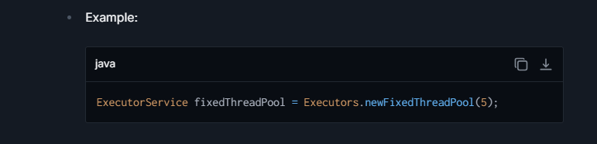

1. **CachedThreadPool**:
   * Creates a pool with no upper bound for the number of threads (**corePoolSize = 0**, **maximumPoolSize = Integer.MAX_VALUE**).
   * Suitable for handling a large number of short-lived tasks.

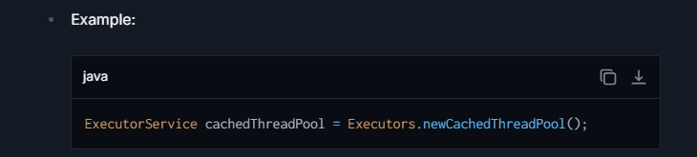

1. **SingleThreadExecutor**:
   * Creates a single-threaded executor (**corePoolSize = 1**, **maximumPoolSize = 1**).
   * Ensures tasks are executed sequentially in the order they are submitted.

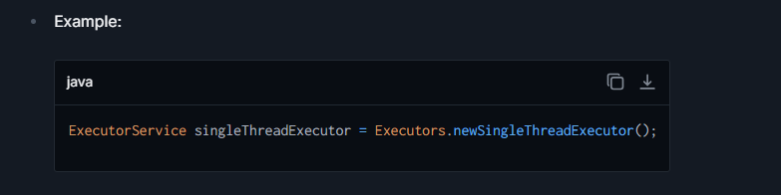

1. **ScheduledThreadPool**:
   * A pool designed for executing tasks after a delay or periodically.

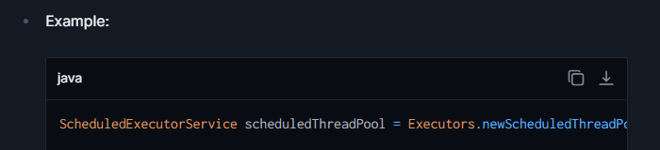

## **What is Fork Join Pool ? Explain Internally.**

It is introduced in **Java 7** (**java.util.concurrent**) is a framework designed to take full advantage of **multicore processors** by **parallelizing** tasks into smaller subtasks and executing them concurrently. It is particularly useful for **divide-and-conquer** algorithms where a task can be recursively divided into smaller subtasks, which are then processed independently and combined to produce the final result.

The framework is built around the concept of a **ForkJoinPool**, which manages and schedules the execution of **ForkJoinTask** objects. These tasks can split themselves ("fork") into subtasks, which are then executed concurrently, and finally **join** their results to produce a cumulative output.

**Key Concepts in Fork/Join Framework**

1. **Fork/Join Pool**:
   * A **ForkJoinPool** is a special thread pool designed to work efficiently with divide-and-conquer algorithms.
   * It automatically manages a pool of **worker threads** and implements **work-stealing** to optimize task execution.
2. **ForkJoinTask**:
   * The base class for tasks executed in the Fork/Join framework. There are two concrete implementations:
     + **RecursiveAction**: Used for tasks that do not return a result.
     + **RecursiveTask**: Used for tasks that return a result.
3. **Divide-and-Conquer Approach**:
   * Tasks are recursively broken down (divided) into smaller tasks until they are small enough to be executed directly.
   * Results from subtasks are combined (joined) to produce the final result.
4. **Work Stealing**:
   * When a **worker thread** finishes executing its tasks, it can go to another thread's task queue and "steal" tasks to keep itself busy, improving CPU utilization and minimizing idle threads.

**How Fork/Join Pool Works**

1. **Task Submission**:
   * A task is submitted to the **ForkJoinPool** and executed by a worker thread.
2. **Task Splitting (Fork)**:
   * If the task is too big, it is split into smaller subtasks using the **fork()** method. Each subtask is submitted back to the pool for processing.
3. **Solving Base Case**:
   * When a task becomes small enough (doesn't need further splitting), it is executed directly.
4. **Result Aggregation (Join)**:
   * The results from the subtasks are aggregated or combined using the **join()** method to produce the final result.

## **What is a Dirty Read in Java (or Databases)?**

A **Dirty Read** occurs in multi-threaded or transactional systems (like databases), where one thread (or transaction) reads data that has been **modified but not yet committed** by another thread (or transaction). If the modifying thread later rolls back its changes, the data read by the first thread becomes invalid or inconsistent. This scenario leads to **data inconsistency**, which is undesirable in most systems.

**Example Scenario of Dirty Read**

1. **Thread 1**: Updates a shared resource (e.g., a database row or a variable) but has not yet committed those changes.
2. **Thread 2**: Reads the same resource before the changes are committed.
3. **Thread 1**: Rolls back the changes, meaning the changes are not finalized.
4. **Outcome**: Thread 2 has read a **dirty, uncommitted state** that no longer reflects the true state of the resource. **T2** has read invalid data, leading to **data inconsistency**.

This issue arises because the second thread reads data that wasn’t "finalized" (committed).

**When Does Dirty Read Occur?**

A dirty read occurs primarily in two scenarios:

1. **Database Transactions**:
   * If the **isolation level** of a database is set to a **low level** like **READ UNCOMMITTED**, which allows one transaction to read data that another transaction has modified but not yet committed.
2. **Multi-threaded Applications**:
   * When multiple threads read and write **shared variables** without proper synchronization or thread safety mechanisms, dirty reads can occur. One thread may see an intermediate, inconsistent value written by another thread.

**How to Prevent Dirty Reads**

1. **In Databases**:
   * Increase the **transaction isolation level**:
     + Use **READ COMMITTED** or higher isolation levels like **REPEATABLE READ** or **SERIALIZABLE**.
     + These levels ensure that a transaction cannot read the intermediate state of another ongoing transaction.

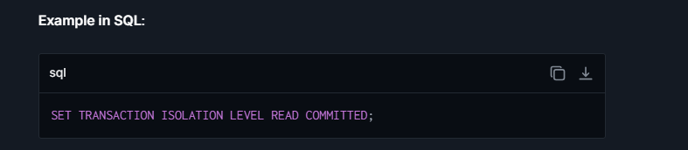

1. **In Multi-threaded Applications**:
   * Use **synchronization** or **locks** to ensure that reads and writes to shared variables are atomic and thread-safe.
   * Properly use tools like **ReentrantLock**, **synchronized**, or **volatile** in Java to eliminate data visibility and race condition issues.

## What is Producer-consumer problem in concurrency ?

The **Producer-Consumer Problem** is a classic example in concurrency programming, often used to illustrate synchronization between threads. It deals with a scenario where two types of threads (producers and consumers) share a **finite buffer** and coordinate with each other to avoid race conditions, buffer overflows, and buffer underflows.

**Understanding the Producer-Consumer Problem**

1. **Producer**:
   * The producer thread generates data (or items) and adds it to a shared buffer.
   * If the buffer is full, the producer must wait until there is space available in the buffer.
2. **Consumer**:
   * The consumer thread consumes the data (or items) from the shared buffer.
   * If the buffer is empty, the consumer must wait until new data is produced and available in the buffer.
3. **Shared Buffer**:
   * The shared buffer is used to hold the items produced by the producer and consumed by the consumer.
   * The size of the buffer is finite, leading to the possibility of a producer waiting when the buffer is full or a consumer waiting when the buffer is empty.
4. **Key Problems**:
   * **Buffer Overflow**: The producer tries to add items to a full buffer, leading to potential data loss or corruption.
   * **Buffer Underflow**: The consumer tries to consume from an empty buffer, leading to errors or incorrect results.
   * **Race Conditions**: Without proper synchronization, multiple producer or consumer threads may interfere with each other, resulting in corrupted data.

**Core Concepts in the Problem**

To solve the problem, we need to address:

1. **Synchronization**:
   * Ensures proper coordination between producer and consumer threads, so they don't interfere with each other or access the shared buffer simultaneously.
2. **Resource Contention**:
   * Prevents the consumer from consuming when the buffer is empty and prevents the producer from producing when the buffer is full.
3. **Thread Communication**:
   * The producer and consumer must communicate efficiently to know when they can proceed (e.g., when the buffer has space or when new items are available).

**How to Solve the Producer-Consumer Problem**

The problem can be solved using **thread synchronization mechanisms** provided in Java:

1. **wait() / notify()**: Allow threads to communicate and coordinate with each other.
2. **Locks and Conditions**: **ReentrantLock** with **Condition** is more flexible for solving this problem.
3. **BlockingQueue** (Preferred in Modern Java): A high-level concurrency utility that provides an out-of-the-box solution.

**1. wait() / notify()**

**How It Works**

* **wait()** allows a thread to release a lock on an object and pause its execution until it is notified by another thread (via **notify()** or **notifyAll()**).
* **notify()** wakes up one waiting thread, while **notifyAll()** wakes up all waiting threads sharing the object's monitor lock.

**Advantages**

1. **Core Java Mechanism**:
   * Works directly with intrinsic locks (**synchronized**) provided by the Java language.
   * Does not require external dependencies or additional utilities.
2. **Fine-grained Control**:
   * Allows explicit control over thread communication and synchronization.

**Disadvantages**

1. **Low-level Complexity**:
   * Requires careful implementation and debugging as threads could end up in improper states (e.g., missed notifications or deadlocks).
2. **Lacks Readability**:
   * Code becomes harder to understand and maintain when implementing complex scenarios.
   * Requires meticulous handling of the condition checks (e.g., using **while()** loops).
3. **Error-prone**:
   * Improper ordering of **wait()** and **notify()** calls can lead to bugs (e.g., threads unintentionally staying in a waiting state).

**When To Use**:

* Suitable for simple examples or learning purposes.
* Not ideal for large-scale applications due to its challenges in debugging and maintenance.

**2. Locks and Conditions**

**How It Works**

* Uses **ReentrantLock**, a more flexible lock compared to intrinsic **synchronized**.
* Conditions (**Condition** objects) allow finer control over thread signaling:
  + Instead of an intrinsic monitor lock, conditions provide methods like **await()** (similar to **wait()**) and **signal()** (similar to **notify()**).

**Advantages**

1. **Better Than synchronized (Highly Flexible)**:
   * Provides explicit and fine-grained lock control (e.g., ability to interrupt waiting threads with **lockInterruptibly()**).
   * Multiple **Condition** objects can be created, enabling different producers to signal different consumers.
2. **No Intrinsic Monitor Dependency**:
   * Conditions don’t require an intrinsic monitor, so it supports greater flexibility in multithreaded code.
3. **Non-blocking**:
   * You can use **tryLock()** or time-based locking, which avoids indefinite waiting for resources.
4. **Scalability**:
   * More scalable and extensible for complex applications compared to **wait()** and **notify()**.

**Disadvantages**

1. **Complexity**:
   * More verbose and complex to implement than **synchronized** blocks with intrinsic locks.
2. **Boilerplate Code**:
   * Requires manual lock acquisition (**lock()**) and release (**unlock()**), which must be handled carefully (usually in **try-finally** blocks).

**When To Use:**

* Preferred for complex synchronization scenarios requiring fine-grained control.
* Useful when implementing a scalable or flexible design, especially for multi-condition synchronization.

**3. BlockingQueue**

**How It Works**

* **BlockingQueue** is a thread-safe queue designed for producer-consumer scenarios, provided by the **Java Concurrency API** (**java.util.concurrent**).
* It automatically handles synchronization:
  + **put()** method blocks the producer if the queue is full.
  + **take()** method blocks the consumer if the queue is empty.

**Advantages**

1. **Built-in Synchronization**:
   * Handles all the producer-consumer synchronization internally. No need to write explicit locks, conditions, or **wait()** / **notify()** mechanisms.
2. **Readable and Maintainable Code**:
   * Simplifies implementation, and the code is easier to understand and maintain compared to low-level options.
3. **Scalable and Efficient**:
   * Designed for concurrent programming; works seamlessly even with larger volumes of tasks and thread pools.
4. **Ensures Thread Safety**:
   * Handles thread-safe access to the queue.
5. **Queue Types**:
   * Supports multiple queue implementations like **ArrayBlockingQueue**, **LinkedBlockingQueue**, and **PriorityBlockingQueue** for different needs.

**Disadvantages**

1. **Limited Flexibility**:
   * Not as configurable as **Locks and Conditions** in scenarios requiring complex workflows.
2. **Dependency on Java Concurrency API**:
   * Requires familiarity with Java’s high-level concurrency utilities.

**When To Use:**

* Preferred for modern applications with minimal synchronization complexity.
* Ideal for implementing scalable producer-consumer models for concurrent systems (e.g., message queues, real-time processing pipelines).

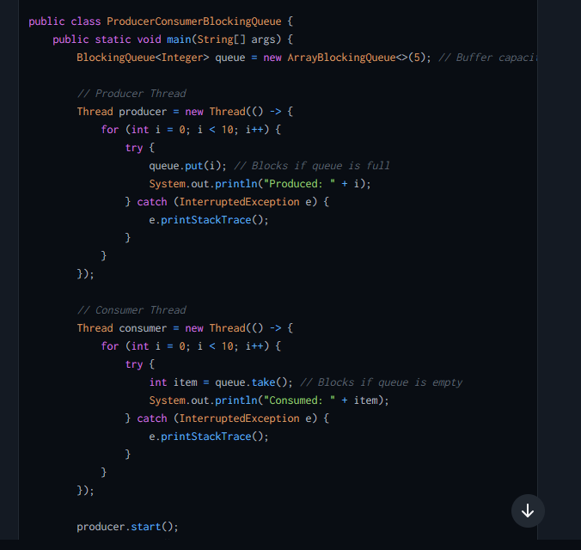

**Which One Is Better: BlockingQueue**

Among the three approaches, **BlockingQueue** is often considered better for modern Java applications. Here's why:

1. **Ease of Use**:
   * **BlockingQueue** eliminates the need for manual thread synchronization. Producers and Consumers block automatically without you needing **wait() / notify()** logic or locks.
2. **Efficiency**:
   * Internally optimized for thread-safe access, reducing the chances of bugs like race conditions or missed notifications.
3. **Scalability**:
   * Works seamlessly for high-volume concurrent systems. For example, you can easily integrate **BlockingQueue** with **ExecutorService** and thread pools.
4. **Readable and Maintainable Code**:
   * Code becomes much simpler and easier to debug, making it suitable for both small projects and large-scale systems.

## **Difference between Atomic and Volatile Variable ?**

| **Feature** | **Atomic Variables** | **Volatile Variables** |
| --- | --- | --- |
| **Definition** | Atomic variables are provided by the **java.util.concurrent.atomic** package and offer atomic operations on single variables. These operations are thread-safe and performed without using locks. | The **volatile** keyword is used to ensure visibility of variable changes across threads. It does not provide atomicity for compound actions (e.g., increment). |
| **Purpose** | Designed for **atomic operations** (like **increment**, **decrement**, **compare-and-swap**), allowing threads to perform these operations safely without explicit synchronization. | Ensures **visibility** of changes to a variable across threads. It guarantees that changes made by one thread are immediately visible to others. |
| **Thread Safety** | Provides thread-safe operations for accessing, updating, or modifying a variable without locks. | Provides thread-safe visibility but **does not guarantee atomicity** for compound operations (e.g., **count++**). |
| **Type of Operations** | Atomic operations like **getAndIncrement()**, **compareAndSet()**, and **addAndGet()** are inherently thread-safe. | No operations are atomic inherently. For compound actions (e.g., **value++**), external synchronization is needed. |
| **Compound Actions** | Supports compound atomic actions, such as increment or conditional updates (**compare-and-swap**). | Does not support compound actions atomically. For example, **x = x + 1** needs additional synchronization. |
| **Performance** | High-performance as it avoids explicit locks. Typically faster than synchronized methods or blocks for atomic operations. | Lightweight and faster than synchronizing for visibility but slower for scenarios involving complex operations as it requires external synchronization. |
| **Usage Context** | Suitable for counters, flags, and other variables that require atomic updates. Used in scenarios where multiple threads update shared variables without locks. | Suitable for flags, configuration parameters, or state variables that need visibility across threads, but where atomicity is not necessary. |
| **Provided By** | Classes in the **java.util.concurrent.atomic** package, such as **AtomicInteger**, **AtomicLong**, **AtomicBoolean**, **AtomicReference**, etc. | **volatile** is a keyword provided by the Java language. |
| **Visibility Guarantee** | Guarantees both visibility (changes are seen by all threads) and atomicity for supported operations. | Guarantees visibility but does **not guarantee atomicity** unless accessed using synchronized methods or locks. |
| **Synchronization Mechanism** | Atomic variables internally use Compare-And-Swap (CAS) operations to achieve atomicity and thread-safety. | Relies on the Java Memory Model to ensure visibility of changes in variables without explicit locking but requires manual synchronization for atomicity. |
| **Example Use Case** | Used for counters or variables on which atomic arithmetic or conditional updates are required. Example: A thread-safe counter for tracking events or requests. | Used for flags or variables where visibility between threads is needed, such as a **shutdownFlag** variable for controlling worker threads. |

## **Difference** b**/w Fork join Pool and Thread Pool Executor ?**

| **Feature** | **ForkJoinPool** | **ThreadPoolExecutor** |
| --- | --- | --- |
| **Focus** | Best for **divide-and-conquer** problems. | Best for managing independent tasks. |
| **Work-stealing** | Supports **work stealing** to maximize CPU usage. | No built-in work stealing. |
| **Task Type** | Designed for **ForkJoinTasks** (**RecursiveTask**, **RecursiveAction**). | Works with **Runnable** and **Callable**. |
| **Parallelism** | Utilizes all available CPUs for parallel execution. | Limited to the number of threads in the pool. |
| **When to Use** | Use for recursive, parallel divide-and-conquer problems. | Use for non-divisible, independent, and parallel tasks. |

## **Difference between Future and Completable future ?**

| **Aspect** | **Future** | **CompletableFuture** |
| --- | --- | --- |
| **Basic Concept** | Represents the result of an asynchronous computation and is used to check if the computation is complete, wait for its completion, and retrieve the result. | An enhancement of Future that may be explicitly completed, can be used as a Promise, and supports numerous additional methods for asynchronous computation, combining tasks, and handling errors. |
| **Usability** | More limited and blocking; not easy to chain multiple asynchronous operations without blocking on **get()**. | Highly flexible, supports fluent API enabling the functional style of programming that is non-blocking. |
| **Completion** | Cannot be manually completed; you have to wait until the computation has finished. | Can be completed manually, giving more control over its lifecycle; you can also propagate outcomes of other threads or tasks directly. |
| **Error Handling** | Limited error handling capabilities. Requires you to manually manage try/catch blocks around execution logic. | Supports exceptionally powerful mechanisms for handling errors; it can propagate errors to dependent stages in a computation chain. |
| **Composability** | Does not support chaining or combining multiple future tasks directly. Each task blocks the thread until it completes or the future is cancelled. | Supports a variety of methods like **thenApply**, **thenAccept**, and **thenCompose** which help in constructing a sequence or flow of asynchronous tasks. More efficient in handling a complex web of asynchronous tasks. |
| **Methods** | Basic methods like **isDone()**, **get()**, **get(long timeout, TimeUnit unit)**, **cancel(boolean mayInterruptIfRunning)**. | Includes all methods of Future with additional ones, including **complete**, **thenApply**, **thenCombine**, **handle**, **whenComplete**, etc. |
| **Thread Handling** | Blocked or waiting state until the result is available. | Promotes reactive programming style and makes use of callbacks for tasks upon completion, hence more non-blocking in nature. |

## **Difference between Runnable and Callable interface ?**

| **Feature** | **Runnable** | **Callable** |
| --- | --- | --- |
| **Introduced In** | Available since Java 1.0. | Introduced in Java 5 as part of the **java.util.concurrent** package. |
| **Return Value** | Does not return any result; the **run()** method has a **void** return type. | Returns a result; the **call()** method has a generic return type (**T**) and can return a value of any type. |
| **Method** | Defines a single method: **void run()**. | Defines a single method: **T call()** (where **T** is the return type). |
| **Checked Exceptions** | The **run()** method cannot throw checked exceptions (only **RuntimeExceptions** can be thrown). | The **call()** method can throw checked exceptions. |
| **Future Integration** | Used with the **Thread** class or executors. **Runnable** tasks do not return results directly, so you cannot retrieve their output. | Typically used with **ExecutorService** or **Future** objects to retrieve results and handle exceptions after execution. |
| **Purpose** | Suitable for tasks that do not require returning a result or throwing checked exceptions. Commonly used for background tasks or independent units of work. | Designed for tasks that require a return value after completion or need to handle checked exceptions. Ideal for computations or operations returning a result. |
| **Threading Model** | Can be directly executed on a thread using **Thread t = new Thread(runnableObj);**. | Cannot be executed directly on a thread; needs to be submitted to an **ExecutorService**. |
| **Example Scenario** | Suitable for logging, event processing, or tasks that run asynchronously without needing a result. | Suitable for computational tasks like performing calculations, fetching data from an API, or file processing where a result is needed. |
| **Usage With Executors** | Used with **ExecutorService.submit()** but returns a **Future<?>** with a null result since **Runnable** does not return any value. | Used with **ExecutorService.submit()** where **Callable** tasks return a **Future<T>** object holding the result of their computation. |
| **Common Use Case** | Performing a task such as updating a UI or processing an event where the task does not compute or return a value. | Performing tasks such as fetching data from a service, performing computations, processing a file, or database operations where the result is required. |

## Difference between **Serialization vs Deserialization**

| **Feature** | **Serialization** | **Deserialization** |
| --- | --- | --- |
| Definition | Process of converting an object into a byte stream | Process of converting a byte stream back into an object |
| Purpose | To save the state of an object to a file, send it across a network, or store it in a database | To recreate an object from a byte stream, typically after it has been sent over a network, read from a file, or pulled from a database |
| When Used | When needing to persist the state of an object or send it to another application | When needing to restore or use the persisted data |
| Output/Input | Generates a byte stream from an object | Produces an object from a byte stream |
| Key Java Classes | ObjectOutputStream | ObjectInputStream |
| Primary Method | writeObject() | readObject() |
| Exception Handling | Throws IOException | Throws IOException, ClassNotFoundException |
| Common Issues | Requires all objects to be serializable, issues with object graphs | Version control of classes, ensuring all parts of an object graph are available |

## **Difference between Synchronized and reentrant lock ?**



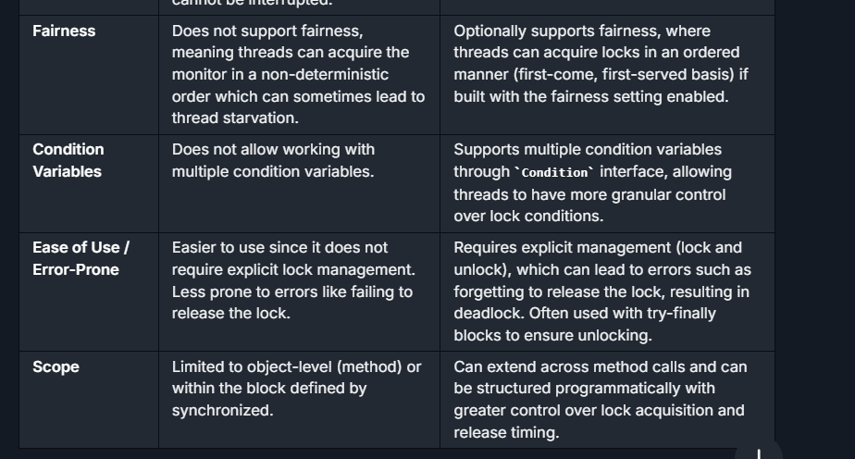

## **Difference between Thread and runnable**

| **Feature** | **Thread** | **Runnable** |
| --- | --- | --- |
| Basic Definition | A thread of execution in a program. It is an instance of **Thread** class. | An interface that defines a single method **run()** which is intended to contain the code executed in the thread. |
| How to Use | Subclass **Thread** and override the **run()** method. | Implement the **Runnable** interface and pass an instance of the implementing class to a **Thread** object. |
| Inheritance Limitation | Extending **Thread** class means you can't extend any other class. | Implementing **Runnable** allows you to extend from another class. |
| Object Sharing | Each thread creates a unique object and associated with it. | Multiple threads can share the same instance of an object implementing **Runnable**, facilitating a lightweight way to achieve thread creation. |
| Construction Flexibility | Constraining, as it involves subclassing. | More flexible, allows more diverse behavior modifications and inherits properties from another class. |
| Use Case Simplicity | Simple use cases just involving overriding of **run()**. | Better suits complex applications where multiple threads require to share data or resources. |
| Resource Usage | More resource-intensive as each thread is a unique object. | More efficient in resource usage since it can work with existing objects. |

## **Difference between Transient and Volatile ?**

| **Feature** | **Transient** | **Volatile** |
| --- | --- | --- |
| **Purpose** | The **transient** keyword is used to indicate that a variable should not be serialized. This is useful when you don't want sensitive data to be part of serialization. | The **volatile** keyword is used to indicate that a variable's value will be modified by different threads and ensures visibility and ordering of values across threads. |
| **Usage Context** | Used in the context of object serialization. | Used in the context of multi-threaded programming. |
| **Effect on Variable** | When an object is serialized, **transient** variables are ignored, i.e., their values are not saved in the persistent storage. | A **volatile** variable's value is always read from and written to the main memory, not cached locally in a thread's stack. |
| **Memory Consistency Effects** | None regarding memory consistency. Just affects serialization. | Guarantees visibility: changes made in one thread to a **volatile** variable are immediately observable by other threads. |
| **Concurrency Impact** | No direct impact on concurrency or multi-threading. | Used to prevent memory consistency errors, ensuring that a read always returns the most recently written value. It does not lock or block accessing threads, but provides a lighter synchronization mechanism. |
| **Typical Use Case** | Used to prevent temporary or sensitive data from being persisted or exposed through serialization processes. | Used when reading from and writing to a variable across multiple threads, without using synchronized, to keep the code simple and potentially increase performance. |
| **Keyword Type** | Modifier on a variable. | Modifier on a variable. |

# OOPS

## Java version from Java 8 to Java 21 :

**Java 8 (March 2014):**

* **Lambda Expressions**: Anonymous functions which enable functional programming.
* **Streams API**: A new abstract layer to enable functional-style operations on streams of elements.
* **Date and Time API**: An enhanced, immutable date and time API within **java.time**.package.
* **Default Methods**: New feature in interfaces to define implementation by using the **default** keyword.

**Java 9** :  
**-> Private Methods in Interfaces :-** Java 9 allowed **private methods in interfaces**. This feature enables developers to define helper methods inside interfaces, improving code reuse and reducing duplication

**-> Reactive Streams (JEP 266)**

* Java 9 introduced **Reactive Streams**, an API to support asynchronous stream processing with non-blocking back pressure. This is useful in building highly scalable applications, particularly for systems that need to handle large volumes of data

**Java 10 (March 2018):**

* **Local-Variable Type Inference**: var keyword that can be used to declare local variables with the compiler inferring their types.

**Java 11 (September 2018):**

**New var Keyword in Lambda Parameters**

* Java 11 introduced support for using the var keyword in lambda expressions for local variables in lambda parameter

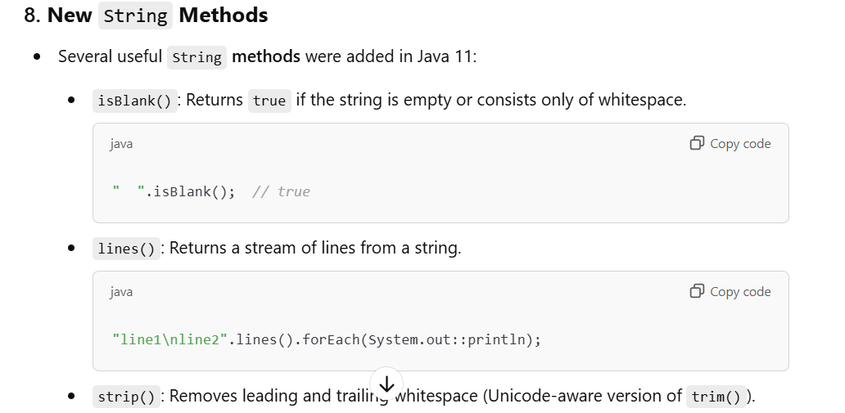

**Java 13 (September 2019):**

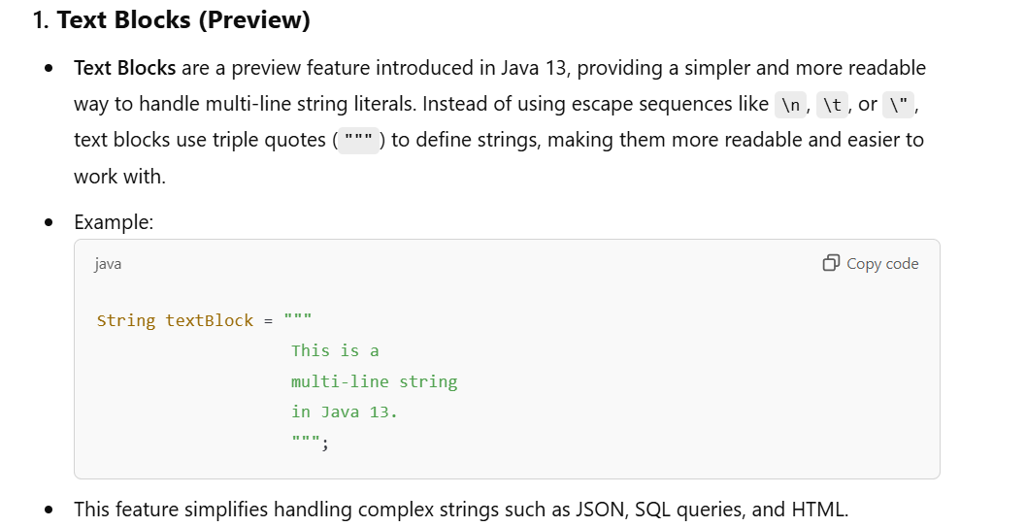

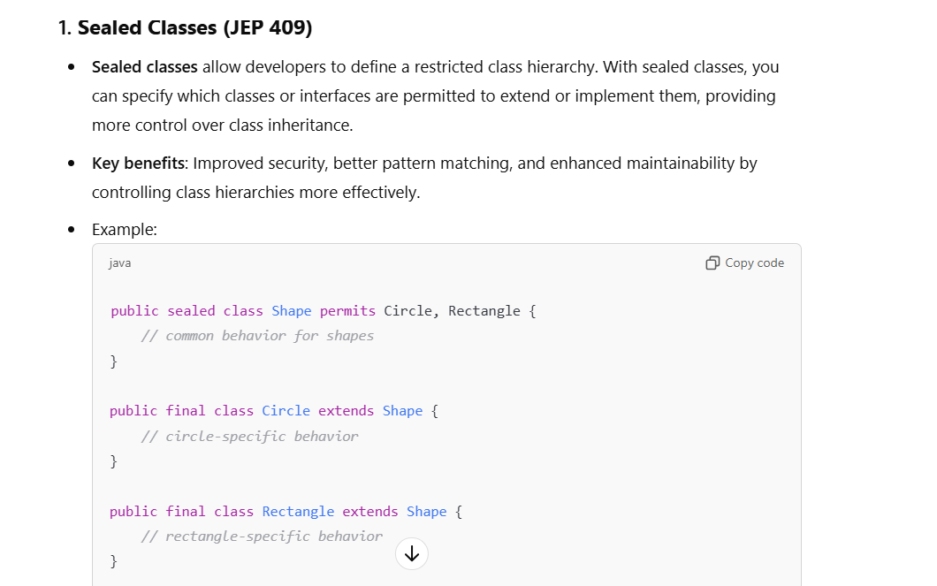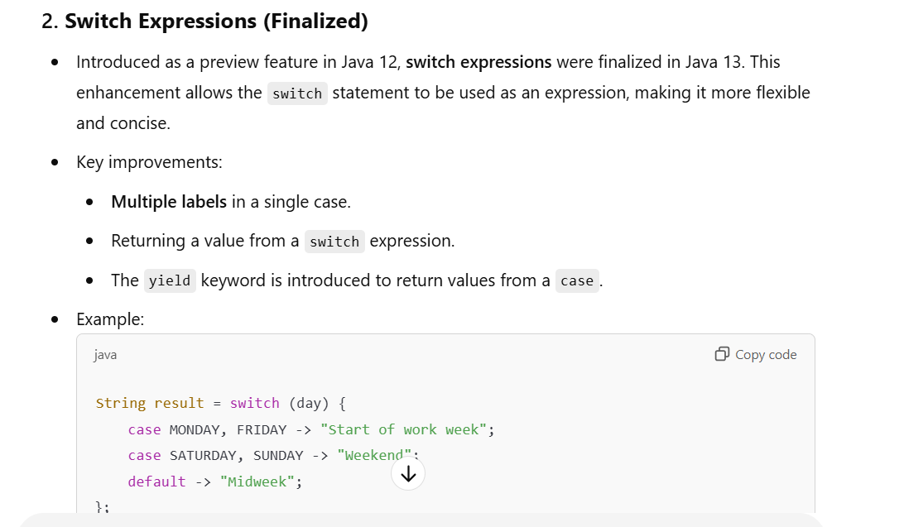

**Java 17 (September 2021 - LTS Release):**

* **Sealed Classes**: Classes or interfaces that restrict which other classes or interfaces may extend or implement them.
* **Pattern Matching for switch (Preview)**: Allows pattern matching within a **switch** expression.

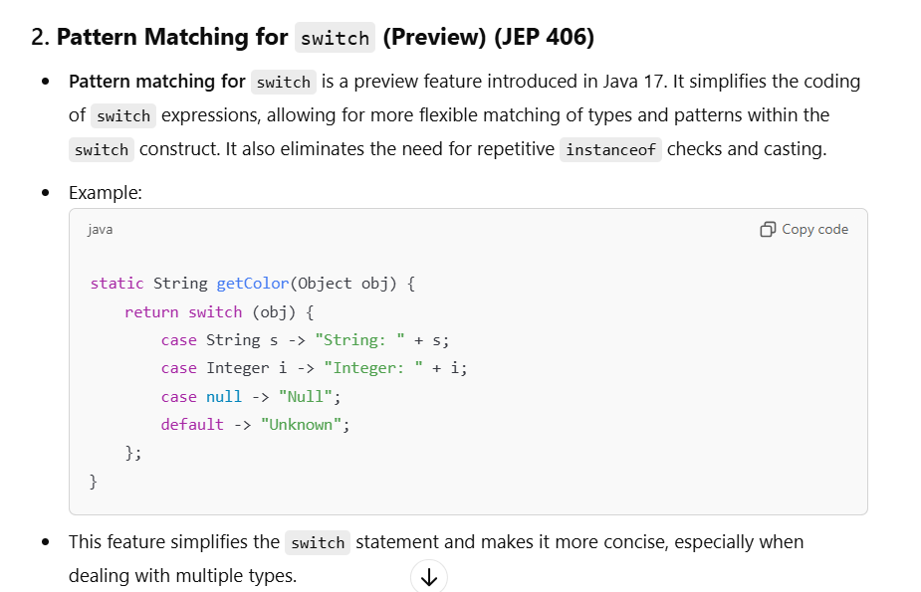

**Java 21 (Sep 2023):**

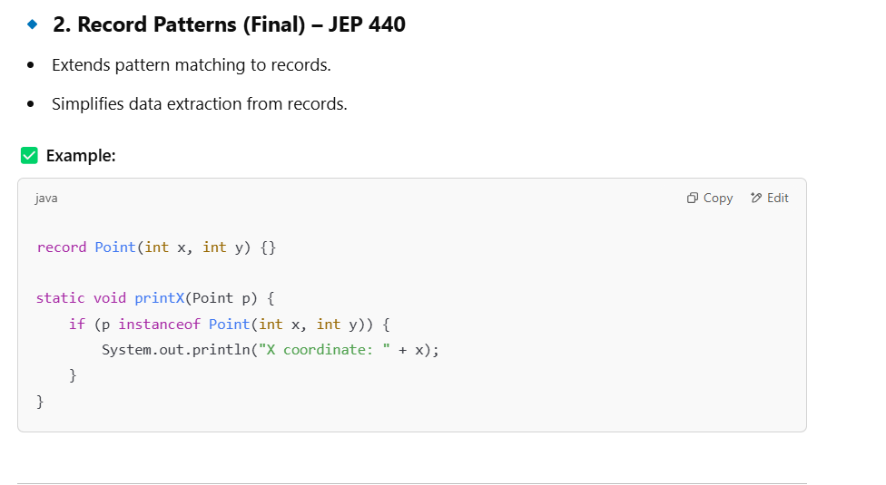

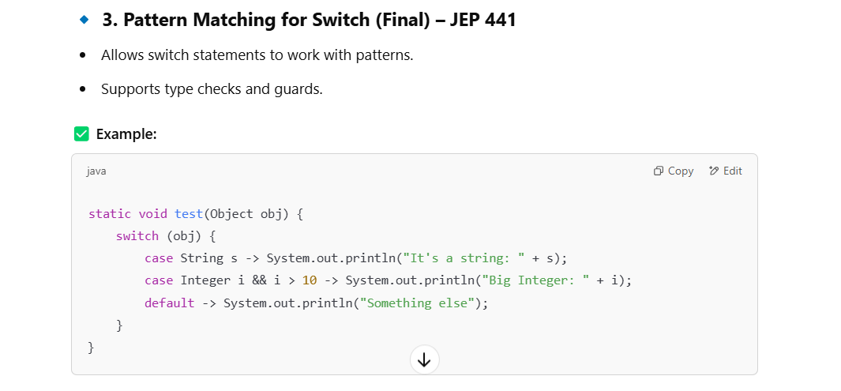

## **What are the Covariant and Covariance types?**

**1. Covariant: -**

The return type of the overriding method (in the subclass) is a subtype of the return type in the overridden method (in the superclass). It refers to the ability to **change the return type of a method when overriding it in a subclass**, as long as the new return type is a **subtype** of the original return type.

In simpler terms:

* **In Method Overriding**: A derived class can return a more specific type than the return type of the method in its parent class (as long as they follow an "is-a" relationship).
* **In Assignment**: Covariance allows variable references of a parent type to refer to objects of a child type.

**2. Covariance**

Covariance describes the general concept where types vary or change **together consistently**. In Java, this usually applies to:

* **Return Type Covariance in Method Overriding**
* **Array Covariance**
* **Generics** (Covariance in Wildcards using **? extends**)

**Types of Covariance in Java**

1. **Covariant Return Types in Method Overriding**
2. **Array Covariance**
3. **Generic Covariance (? extends)**

**1. Covariant Return Type in Method Overriding**

In Java, a method in a subclass can override a method in its superclass, and it is allowed to return a more specific type (subclass of the original return type). This is possible due to covariant return types.

**Rules for Covariant Return Types:**

* The overridden method must follow the **is-a relationship**.
* The return type in the subclass must be a **subclass** of the return type in the parent class.
* Works only with **non-primitive types** (as primitives cannot follow inheritance).

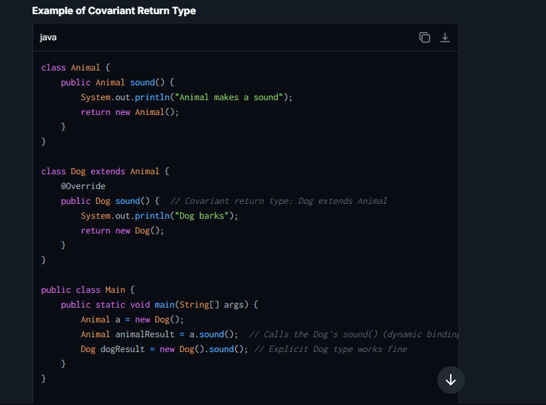

**2. Array Covariance**

Java supports **covariance in arrays**, meaning you can assign an array of a subtype to a reference type of the parent class.

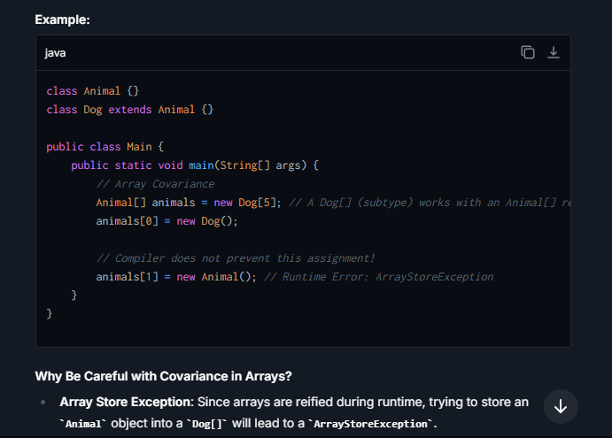

**Why Be Careful with Covariance in Arrays?**

* **Array Store Exception**: Since arrays are reified during runtime, trying to store an **Animal** object into a **Dog[]** will lead to a **ArrayStoreException**.

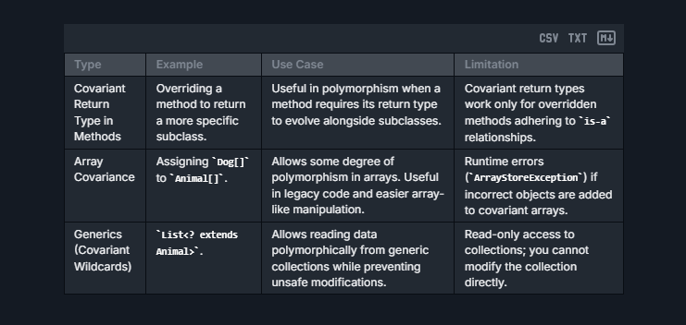

## **What are the 4 pillar for OOPS Concept ?**

**1. Abstraction**

Data Abstraction is the property by virtue of which only the essential details are displayed to the user. The trivial or non-essential units are not displayed to the user. Ex: A car is viewed as a car rather than its individual components.  
Data Abstraction may also be defined as the process of identifying only the required characteristics of an object, ignoring the irrelevant details. The properties and behaviors of an object differentiate it from other objects of similar type and also help in classifying/grouping the object.

**Example** :-Consider a real-life example of a man driving a car. The man only knows that pressing the accelerators will increase the car speed or applying brakes will stop the car, but he does not know how on pressing the accelerator, the speed is actually increasing. He does not know about the inner mechanism of the car or the implementation of the accelerators, brakes etc. in the car. This is what abstraction is.

**2. Encapsulation**

It is defined as the wrapping up of data under a single unit. It is the mechanism that binds together the code and the data it manipulates. Another way to think about encapsulation is that it is a protective shield that prevents the data from being accessed by the code outside this shield.

* Technically, in encapsulation, the variables or the data in a class is hidden from any other class and can be accessed only through any member function of the class in which they are declared.
* In encapsulation, the data in a class is hidden from other classes, which is similar to what **data-hiding** does. So, the terms “encapsulation” and “data-hiding” are used interchangeably.
* **Encapsulation can be achieved by declaring all the variables in a class as private and writing public methods in the class to set and get the values of the variables.**

E.G :-

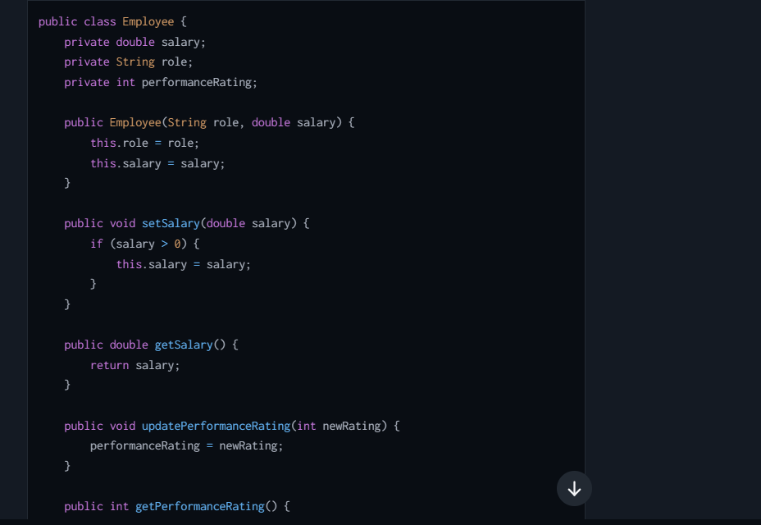

**3. Inheritance**

Inheritance is an important pillar of OOP (Object Oriented Programming). It is the mechanism in Java by which one class is allowed to inherit the features (fields and methods) of another class. We are achieving inheritance by using **extends** keyword. Inheritance is also known as “**is-a**” relationship.

Let us discuss some frequently used important terminologies:

* **Superclass:**The class whose features are inherited is known as superclass (also known as base or parent class).
* **Subclass:** The class that inherits the other class is known as subclass (also known as derived or extended or child class). The subclass can add its own fields and methods in addition to the superclass fields and methods.
* **Reusability:**Inheritance supports the concept of “reusability”, i.e. when we want to create a new class and there is already a class that includes some of the code that we want, we can derive our new class from the existing class. By doing this, we are reusing the fields and methods of the existing class.

**Types of Inheritance:**

* **Single Inheritance**: A subclass inherits from one superclass only.
* **Multiple Inheritance (through interfaces in Java)**: A class can implement multiple interfaces, thus inheriting from multiple sources. Java doesn't support multiple inheritance with classes to avoid complexity and ambiguity (known as the Diamond Problem).
* **Multilevel Inheritance**: A class can inherit from a subclass making it a multilevel hierarchy. For example, **Class C** inherits from **Class B** which in turn inherits from **Class A**.
* **Hierarchical Inheritance**: A single class serves as a superclass for more than one subclass.

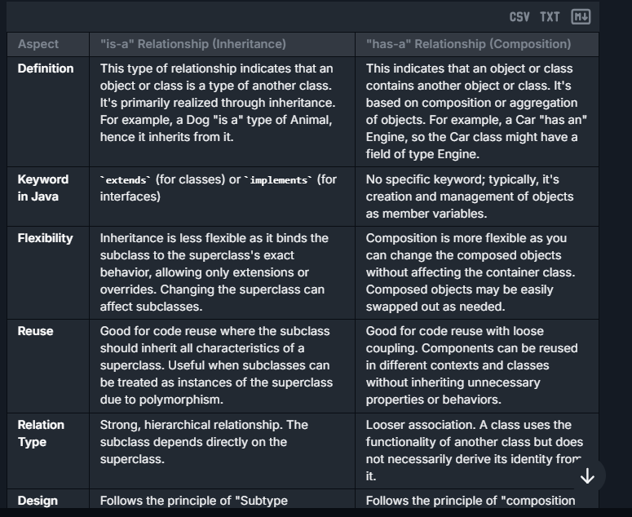

1. **Polymorphism**

**Polymorphism in Java is a concept by which we can perform a *single action in different ways*.**

**Polymorphism** is one of the four fundamental object-oriented programming (OOP) principles (along with inheritance, abstraction, and encapsulation). Polymorphism allows a **single interface to represent multiple behaviors**. The term "polymorphism" is derived from two Greek words: **poly** (many) and **morphs** (forms), meaning "many forms."

In Java, polymorphism is achieved through **method overloading** and **method overriding**. It helps in writing **flexible and reusable code** by allowing objects to behave differently based on their type or context.

**Key Types of Polymorphism in Java**

1. **Compile-Time Polymorphism (Static Binding)**:
   * Happens during the compilation of the code.
   * Achieved through **method overloading** or **constructor overloading**, where multiple methods or constructors share the same name but differ in **parameters**.
2. **Run-Time Polymorphism (Dynamic Binding)**:
   * Happens during the execution of the program.
   * Achieved through **method overriding**, where a subclass redefines a method from its superclass.

**1. Compile-Time Polymorphism**

**Method Overloading**

Method overloading occurs when multiple methods in a single class share the same name but differ in:

* Number of parameters.
* Type of parameters.
* Order of parameters.

**Constructor Overloading**Constructor overloading allows a class to have multiple constructors with the same name (the class name) but with different parameter lists.

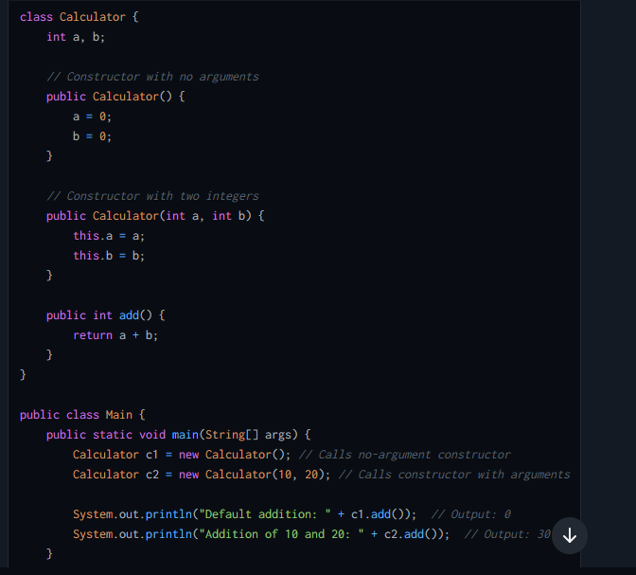

**2. Run-Time Polymorphism**

Run-time polymorphism occurs when a method in a subclass overrides a method in its superclass. Here, the overridden method in the subclass is executed based on the actual object type, **not the reference type**.

**Method Overriding**

Method overriding occurs when:

1. A subclass redefines a method already defined in its parent class.
2. The method in the subclass should have:
   * The **same name**
   * The **same parameter list**
   * A **compatible return type**

E.G :- **Scenario: Payment Processing System**

In a payment processing system for an e-commerce platform, you might have multiple payment methods—credit cards, PayPal, and Apple Pay, for example. Each payment method processes payments differently; however, from the perspective of the e-commerce platform, it just needs to initiate a payment and possibly refund a payment without caring about the details of each payment method.

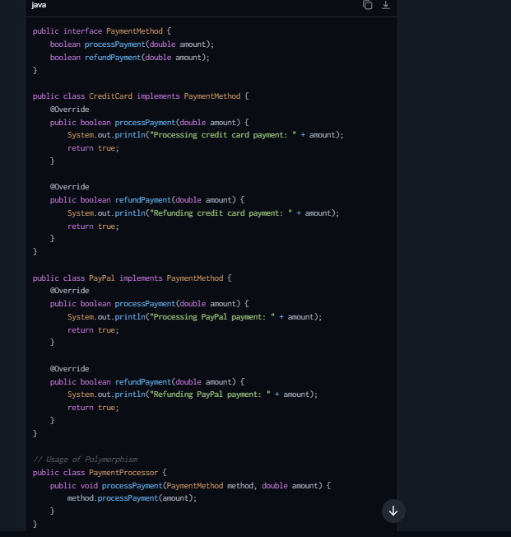

## What are the 4 Access Modifier ?

Access modifiers in Java (similar concepts exist in other languages) define the scope of visibility of classes, methods, and other members. The primary access modifiers are:

1. **Public**: Members defined as public are accessible from any other class anywhere, even from different packages.
2. **Private**: Members defined as private are accessible only within the class they are declared. They are not visible outside of the class.
3. **Protected**: Members defined as protected are accessible within the same package or subclasses in different packages.
4. **Default** (no modifier): If no access modifier is specified, the default visibility is package-private. It means the members are only visible within the same package.

| **Access Modifier** | **Same Class** | **Same Package** | **Subclass (same package)** | **Subclass (different package)** | **World** |
| --- | --- | --- | --- | --- | --- |
| Public | Yes | Yes | Yes | Yes | Yes |
| Protected | Yes | Yes | Yes | Yes | No |
| Default (none) | Yes | Yes | Yes | No | No |
| Private | Yes | No | No | No | No |

**Where you can access the protected variables**

Protected variables can be accessed:

* Within the same class.
* From any class in the same package.
* From any subclass (even if the subclass is in a different package).

## **How can we access package private variable from outside ?**

1st way :-

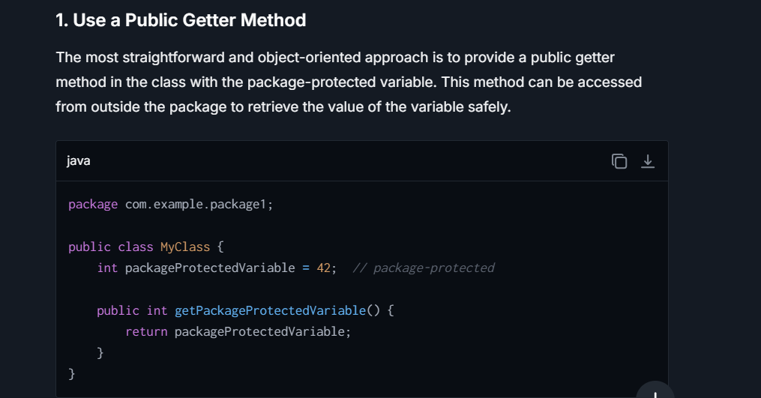

2nd way :-

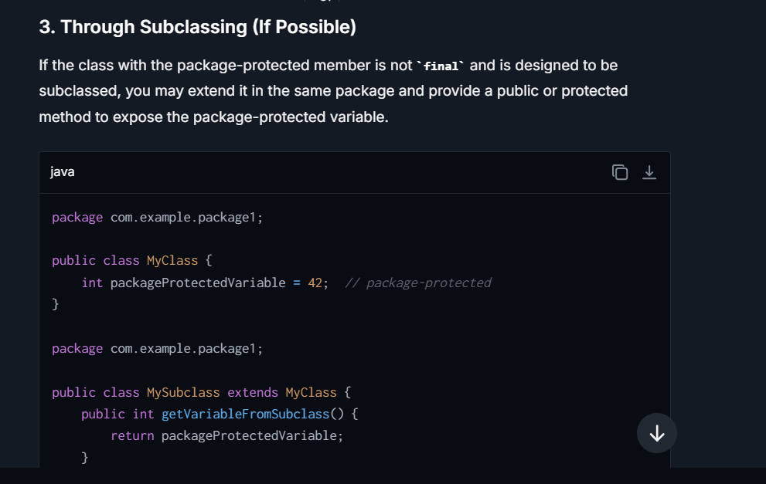

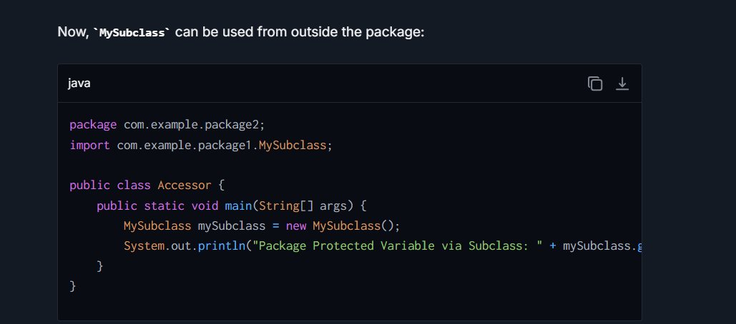

## **What are the rules of method overriding?**

Method overriding is a core concept in object-oriented programming that enables a subclass to offer a specific implementation of a method that is already defined in its superclass :-

**1. Same Method Signature**

The method in the subclass that is overriding must have the same name and the exact same parameter list (types and order) as the method in the superclass.

**2. Covariant Return Type**

The return type of the overriding method must be the same as or a subclass (covariant) of the return type declared in the original method of the superclass. This feature was added in Java 5 to enhance flexibility in the use of return types.

**3. Access Modifier**

The access level modifier of the overriding method must provide at least as much visibility as the method of the superclass. For example, if the method in the superclass is **protected**, the method in the subclass overriding it must be either **protected** or **public**, but not **private**.

**4. Exception Handling**

The overriding method cannot throw a broader checked exception than the method it overrides. However, it can throw narrower checked exceptions or not throw any exception at all, even if the overridden method does.

**5. Non-static to Static and Vice Versa**

A static method cannot be overridden as a non-static method (instance method), and a non-static method cannot be overridden as a static method. Attempting to do so leads not to overriding but to what is known as method hiding.

**6. Final Methods Cannot Be Overridden**

If a method in a superclass is declared as **final**, it cannot be overridden in any subclass. The **final** keyword prevents alteration of the method's implementation, ensuring that its functionality remains unchanged.

**7. Abstract Methods**

If an abstract class contains an abstract method, any concrete subclass of this abstract class must either override the abstract method or be declared abstract as well.

**8. Use of @Override Annotation**

While not mandatory, it is a good practice to use the **@Override** annotation when overriding a method. This helps the compiler verify that you are indeed overriding a method as intended and not accidentally creating a new method due to a typo or incorrect method signature.

## **What is Method Overloading and Method Overriding ?**

**Method Overloading and Method Overriding**

**1. Method Overloading:** Also, known as compile-time polymorphism, is the concept of Polymorphism where more than one method share the same name with different signature(Parameters) in a class. The return type of these methods can or cannot be same.

**2. Method Overriding:**Also, known asrun-time polymorphism**,**is the concept of Polymorphism where method in the child class has the same name, return-type and parameters as in parent class. The child class provides the implementation in the method already written.

## **What all are possible ways to achieve abstraction in Java?**

Java provides two main ways to achieve abstraction: abstract classes and interfaces.

**Abstract Classes**:

* An abstract class in Java is declared using the **abstract** keyword.
* It can have both abstract methods (without an implementation) and concrete methods (with an implementation).
* An abstract class cannot be instantiated directly, which means you cannot create objects of an abstract class. Instead, it must be extended by another class.
* Any class that extends an abstract class must implement all its abstract methods, unless the subclass is also abstract.
* Abstract classes are used when you want to share a base implementation with derived classes while also enforcing certain methods to be implemented in the subclasses.

**Interfaces**:

* An interface in Java is a reference type, similar to a class, that can contain only constants, method signatures, default methods, static methods, and nested types.
* Methods in interfaces are implicitly abstract and public.
* Interfaces cannot contain instance fields. The only fields that can appear in an interface must be declared both **static** and **final**.
* A class implements an interface, inheriting the abstract methods of the interface.
* With interfaces, you can achieve full abstraction and multiple inheritances because a class can implement multiple interfaces.

**Key Differences and Use Cases**:

* Use an abstract class when you need a base class that provides some implemented functionality (non-abstract methods) and plan to invoke these methods or access the non-abstract fields.
* Use an interface when you want to specify a contract for what a class can do without dictating how it should do it. This is especially useful when various unrelated classes need to be grouped based on what they can do (e.g., Comparable, Serializable).

## **Where choosing between abstract class and an interface might be pivotal?**

**Real-Life Scenario for Abstract Classes and Interfaces:**

Let’s consider a system for managing different types of vehicles in a transportation company. Here we have common operations like starting the engine, stopping the engine, and fueling up, but specific vehicles might have additional behaviors and different implementations for these operations.

**Using an Abstract Class:**

Suppose you have a basic categorization of vehicles into **LandVehicle** and **Watercraft**. Each category shares some common properties and methods but also has unique attributes and behaviors.

**Abstract Example :-**

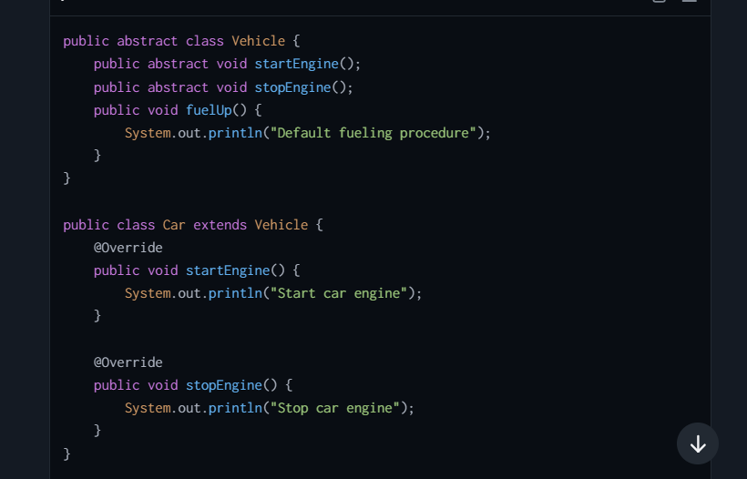

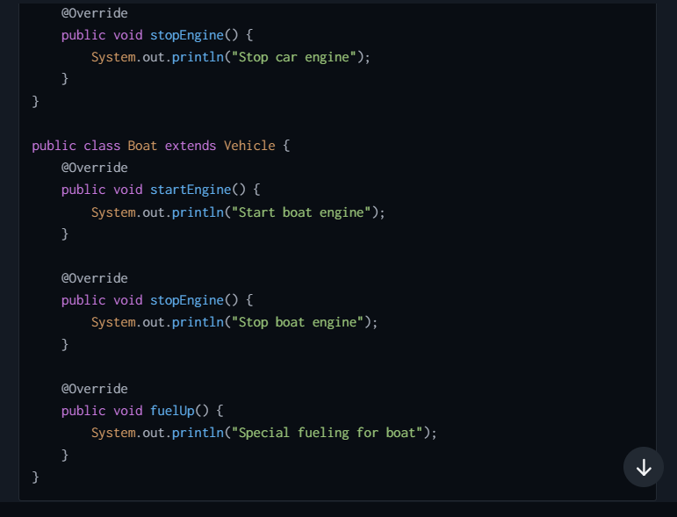

**When to Use Abstract Class**:

* When you have a base/common class (like **Vehicle**) that should provide some default behavior (like **fuelUp** method), while also enforcing subclasses (**Car**, **Boat**) to implement certain behaviors (**startEngine**, **stopEngine**).

**Using Interfaces:**

Now, let’s say these vehicles can implement additional functionalities like GPS tracking, auto-pilot (for autonomous navigation), and safety checks.

**Interface Example:**

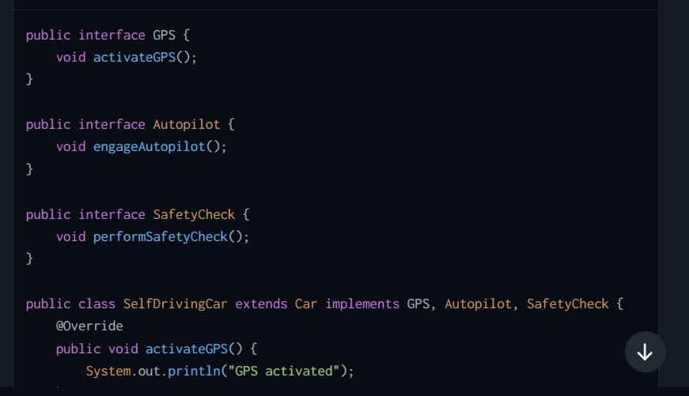

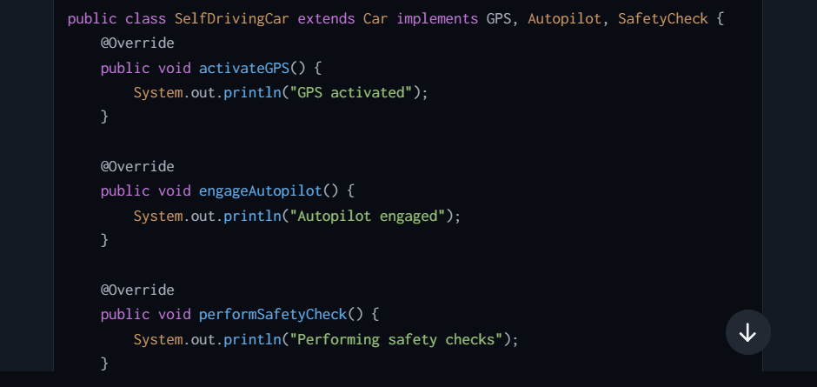

**When to Use Interfaces**:

* When you need to specify that certain classes must implement certain behaviors (like **SelfDrivingCar** must be able to perform **activateGPS**, **engageAutopilot**, and **performSafetyCheck**), but how they do so isn’t the concern of the interface.
* To allow classes to belong to more than one type (e.g., a **SelfDrivingCar** can be both a **Vehicle** and have **GPS**, **Autopilot**, **Safety** functionalities).

**Conclusion**

Use abstract classes when you need to share code among several closely related classes and when you require access to a base class to inherit from that can also hold some default implementations.

## **Why We need abstract and Interface explain ?**

**1. Abstract Classes**

**Purpose:**

* Abstract classes are introduced to allow the creation of classes that cannot be instantiated on their own but rather serve as base classes. This means they can have partial implementations for methods that can be either completely defined (concrete methods) or just declared (abstract methods).

**Benefits:**

* **Code Reusability and Extension:** Abstract classes enable the reuse and extension of existing code. You can define or implement some common methods in the abstract class, and leave other methods abstract to be implemented specifically by subclasses.

**E.g:-** Consider a scenario in a graphics system where you have multiple drawable shapes like Circle, Rectangle, and Triangle. Each shape needs to be drawn differently, but they might share certain attributes or methods like color or move(). An abstract class called **Shape** could define a method **draw()** as abstract and have other shared methods implemented.

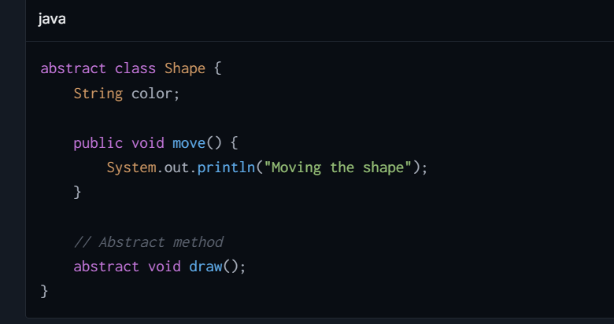

**2. Interfaces**

**Purpose:**

* Interfaces in Java are intended to define a contract for what a class can do, without dictating how it should do it. Interfaces are purely abstract, with the ability to specify method declarations but no implementations.

**Benefits:**

* **Decoupling:** Interfaces help in decoupling the code from its implementation. Since only method signatures are provided, any class implementing an interface can provide its own implementation without affecting the consuming code.
* **Multiple Inheritance:** Unlike classes, interfaces support a form of multiple inheritance. A class can implement multiple interfaces, thereby inheriting the method declarations from multiple sources.

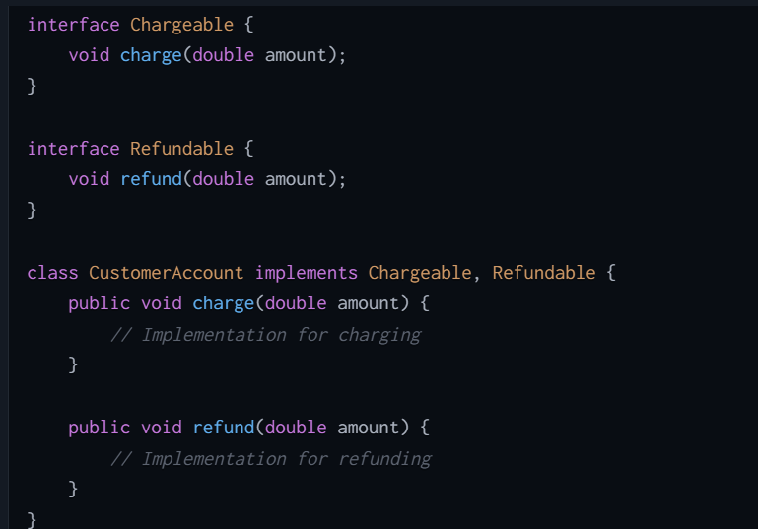

## **Can Create instances of an abstract class?**

No, we cannot create instances of an abstract class directly in Java. An abstract class is a class that is declared with the **abstract** keyword and is intended to be a superclass from which other classes can inherit. The purpose of an abstract class is to provide a common definition of a base class that multiple derived classes can share and extend.

## **Can Abstract class create Constructor and If it is then explain?**

Yes, an abstract class can have a constructor, although it seems contradictory because you cannot instantiate an abstract class directly. The purpose of the constructor in an abstract class is to initialize fields of the abstract class or perform any setup steps that are required for the abstract class. The constructor of the abstract class is called when an instance of a derived class is created.

**Yes, abstract classes in Java can have constructors, even though abstract classes cannot be instantiated directly**.

**To Initialize State**: Even though abstract classes cannot be instantiated, they can have member variables that need initialization. Constructors in abstract classes allow you to execute logic during the instantiation of a subclass, ensuring that all member variables of the abstract class are properly set before the subclass's constructor is executed.

## **How Constructors in Abstract Classes Work ?**

When a concrete class that extends an abstract class is instantiated, the constructor chain is invoked such that the abstract class’s constructor runs first, then the derived class’s constructor runs next. This ensures that the setup required by the abstract base class is completed before the derived class adds its own specifics.

E.G.

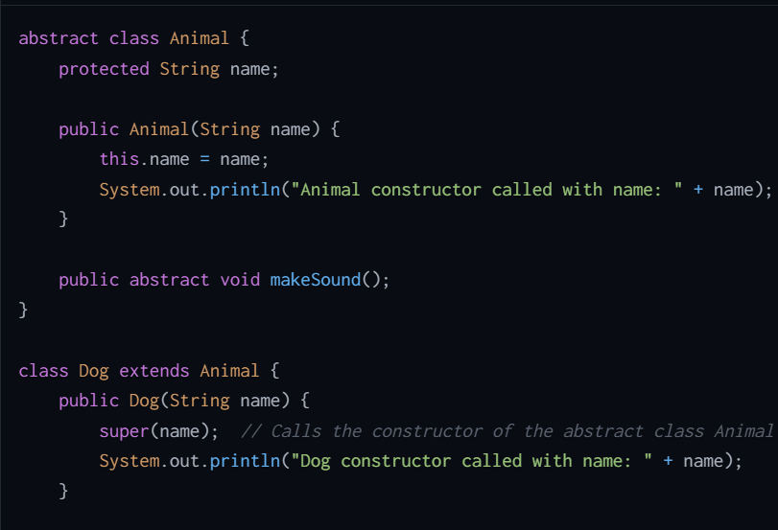

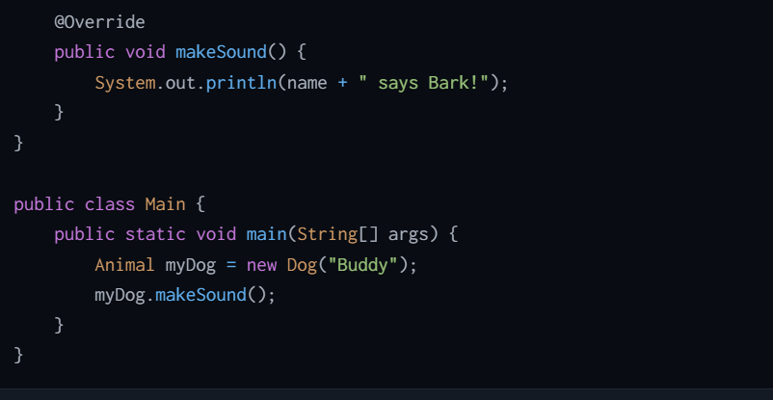

## **How to create an object of a class with a private constructor?**

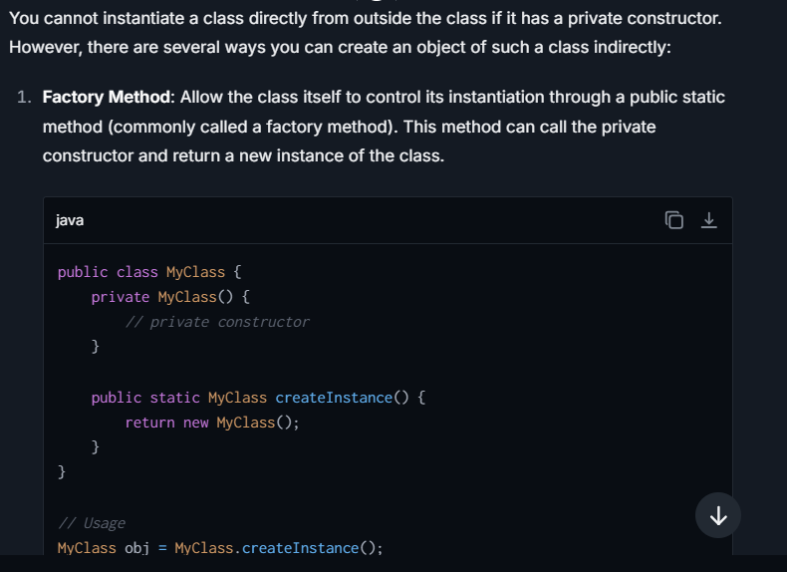

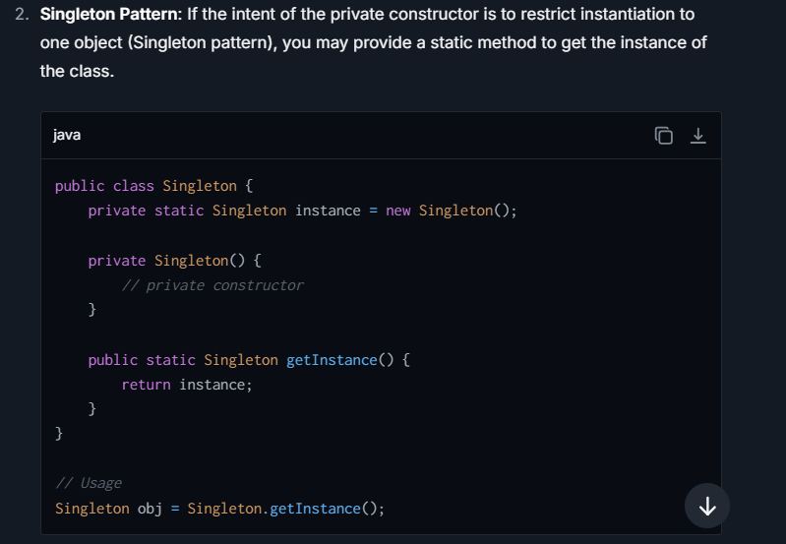

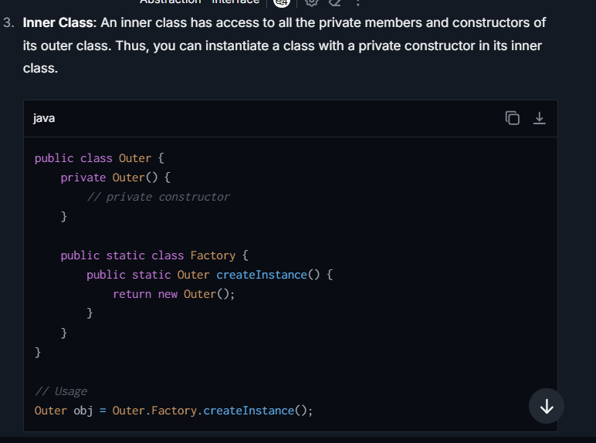

## **What is Static Keyword? Explain with an example**

The **static** keyword is used to indicate that a particular member (variable or method) belongs to the class, rather than instances of the class. This means that the static member is shared among all instances of the class, and it can be accessed directly using the class name, without needing to instantiate the class.

**Features of static Members:**

1. **Static Variable**: A variable that's declared as static is typically called a class variable. It is shared among all instances of the class.
2. **Static Method**: A method declared as static belongs to the class rather than any object of the class and cannot access instance variables or methods directly.
3. **Static Block**: Used for static initializations of a class. This code inside static block is executed only once: the first time the class is loaded into memory

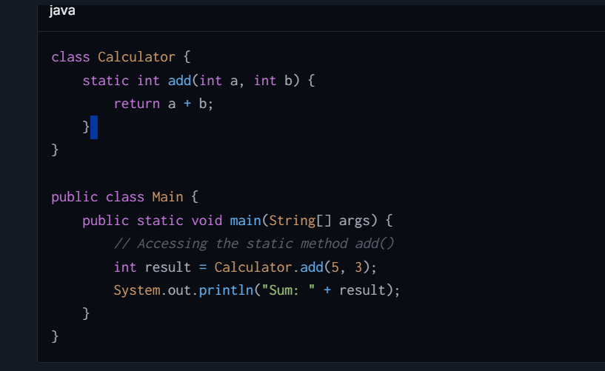

## **What is static methods and how we can override static method ?**

a static method belongs to the class rather than instances of the class. This means the method can be invoked directly on the class itself, without creating an instance of the class. Static methods can access static data members and can change their values. They are declared using the **static** keyword.

**Characteristics of static methods:**

* They can only call other static methods directly (i.e., without creating an instance of the class).
* They can only access static data directly.
* They cannot access instance methods and instance variables directly.
* They don't have access to **this** keyword since **this** refers to the current object, and static methods are called on the class, not an object.

## Can We Override Static Methods?

In Java, static methods **cannot** be overridden in the way that instance methods can be, because method overriding is based on dynamic binding at runtime and static methods are bound statically at compile time.

However, static methods can be re-declared in a subclass, which is sometimes confused with overriding but is quite different. When you re-declare a static method in a subclass, you simply create another static method with the same signature that is not associated with the static method in the superclass.

**Why Static Methods Are Not Overriden?**

* **Static Binding:** Static methods are bound at compile time using type information and not at runtime. This binding is called static binding. Since overriding is a runtime concept (achievable through dynamic binding), static methods cannot participate in this behavior.
* **No Polymorphism:** Overriding is a cornerstone of implementing polymorphism, and static methods cannot be polymorphic. The method invoked is determined by the type of the reference, not the type of the object.

## **Method Hiding**

Method hiding occurs when a subclass defines a static method with the same signature as a static method in the superclass. In this case, the method in the superclass is "hidden" by the one in the subclass. This phenomenon is related to the way Java handles static method calls. Static methods belong to the class, not instances of the class, and are not part of the polymorphism.

## **Arraylist in the final keyword and How to modify that arraylist, How can I modify ?**

when you declare an **ArrayList** variable with the **final** keyword, it means that you cannot reassign this variable to reference a different **ArrayList** object. However, the **final** keyword does not prevent you from modifying the contents of the **ArrayList**, such as adding or removing items

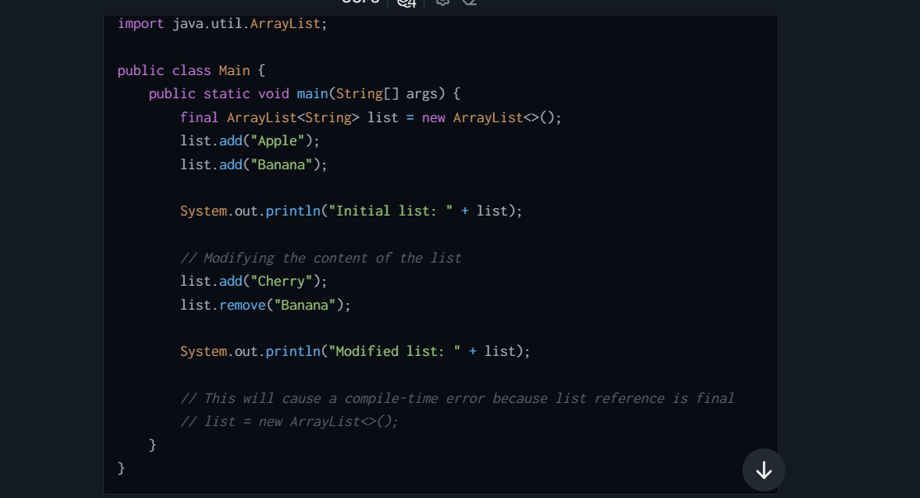

**Operations you can perform on a final ArrayList:**

1. **Add Elements**: You can add elements to the **ArrayList** using methods like **add()**.
2. **Remove Elements**: You can remove elements by specifying either the element itself with **remove(Object)** or an index with **remove(int index)**.
3. **Update Elements**: You can update or replace elements by setting a new value at a specific index using **set(int index, E element)**.
4. **Clear List**: You can clear all elements from the list using **clear()**.

**What you cannot do:**

* You cannot assign the **final** **ArrayList** reference to a different **ArrayList** object. Once initialized, the reference must point to the original **ArrayList** object for as long as that reference exists.

## **How do you compare two be objects?**

**1. Using == Operator**

The **==** operator compares the references of two objects, determining whether they refer to the exact same object in memory. It does not compare the actual content or state of the objects.

**2. Using equals() Method**

The **equals()** method, which is available in every class (since it's defined in **Object** class), should be overridden to perform equality comparison based on the content or state of the objects (i.e., their data fields). By default, the **equals()** method behaves like the **==** operator unless overridden.

**3. Using Comparable Interface**

If you need to compare objects with a natural ordering (e.g., sorting), implement the **Comparable** interface and define the **compareTo()** method. This method should return a negative integer, zero, or a positive integer if this object is less than, equal to, or greater than the specified object.

**4. Using Comparator Interface**

If you want to provide full control over the comparison logic external to the objects themselves, or if you need multiple different ways to compare the same set of objects, implement a **Comparator**.

## **What is the Diamond Problem? How it resolves**

The **Diamond Problem** is a common ambiguity issue in **multiple inheritance**, where a derived class (child class) tries to inherit from two or more parent classes that originate from a common ancestor class. This situation creates confusion because the derived class is unsure about which version of a method or property from the parent classes it should inherit.  
Java does not support multiple inheritance of classes (it prevents the diamond problem by not allowing multiple class inheritance). Instead, it supports multiple inheritance of interfaces using the concept of default methods in interfaces introduced from Java 8 onwards.

**Solution Using Interfaces in Java:  
Before Java 8,** Interfaces in Java do support multiple inheritance. Interfaces could only contain abstract methods, so there was no ambiguity; any class implementing multiple interfaces would implement the abstract methods itself.  
**Starting with Java 8**, interfaces can also have default methods (methods with a body). However, with the introduction of default methods in Java 8, ambiguity can occur if a class inherits multiple interfaces with conflicting default methods.

When a class implements two interfaces that have default methods of the same signature, Java mandates overriding that method in the class. This way, Java forces the resolution of any ambiguity  
  
**Case 1: Abstract Methods in Interfaces (No Problem)  
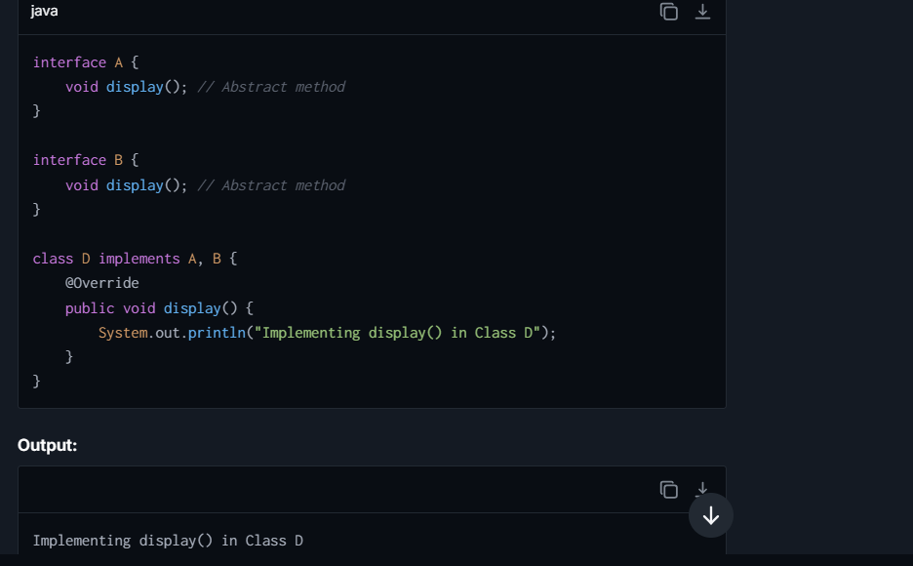  
  
Case 2: Default Methods in Interfaces (Ambiguity)**

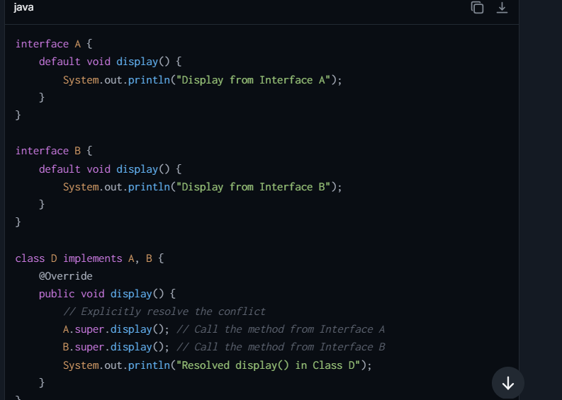  
  
**Case 3: One Interface Has Default Method, Another Abstract Method  
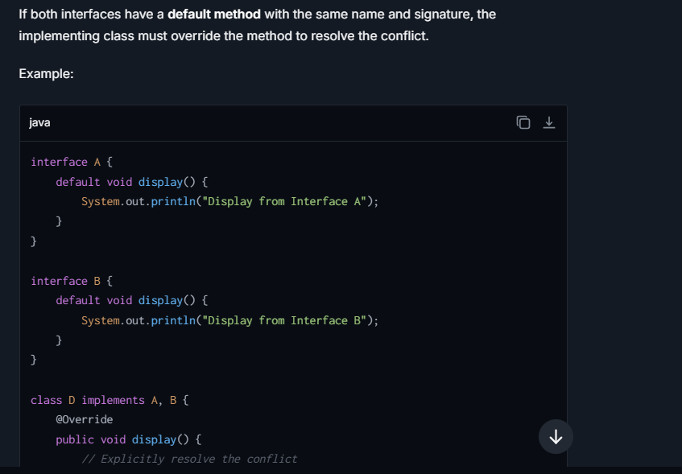**

## Difference between Abstract class and interface

|  |  |
| --- | --- |
| **Abstract class** | **Interface** |
| 1) Abstract class can **have abstract and non-abstract** methods. | Interface can have **only abstract** methods. Since Java 8, it can have **default and static methods** also. |
| 2) Abstract class **doesn't support multiple inheritance**. | Interface **supports multiple inheritance**. |
| 3) Abstract class **can have final, non-final, static and non-static variables**. | Interface has **only static and final variables**. |
| 4) Abstract class **can provide the implementation of interface**. | Interface **can't provide the implementation of abstract class**. |
| 5) The **abstract keyword** is used to declare abstract class. | The **interface keyword** is used to declare interface. |
| 6) An **abstract class** can extend another Java class and implement multiple Java interfaces. | An **interface** can extend another Java interface only. |
| 7) An **abstract class** can be extended using keyword "extends". | An **interface** can be implemented using keyword "implements". |
| 8) A Java **abstract class** can have class members like private, protected, etc. | Members of a Java interface are public by default. |

## Difference between **ArrayList vs Linkedlist**

| **Feature** | **Array** | **LinkedList** |
| --- | --- | --- |
| Structure | Fixed size, contiguous memory allocation. | Dynamic size, consists of nodes where each node contains data and a reference to the next node. |
| Size Modification | Cannot be resized once initiated. | Can grow or shrink dynamically as elements are added or removed. |
| Memory Usage | Efficient memory usage as elements are stored in continuous memory blocks. | Higher memory usage due to storage of additional references for each element (next, and possibly previous). |
| Element Access | Direct access via index, O(1) time complexity. | Sequential access required, O(n) time complexity for accessing an element by index. |
| Insertions and Deletions | Slow, especially at the start or middle, O(n) due to shifting elements. | Fast at the start and potentially at the end, O(1). Insertions/deletions in the middle require traversal, making it O(n). |
| Use Cases | Suitable for applications where frequent access to elements by index is needed. | Suitable for applications where frequent insertion and deletion of elements are required. |
| Element Type | Can hold any data type, primitives or objects. Length must be defined at creation. | Typically used for storing objects. Does not support primitive data types directly (requires wrappers). |
| Search Efficiency | Linear search is O(n); if sorted, binary search can be applied in O(log n). | Always O(n) as elements are not contiguous in memory. |
| Implementation Overhead | Minimal implementation overhead. | Additional overhead due to handling of node references and dynamic size. |

## **Difference between Array and List in Java**

| **Feature** | **Array** | **List** |
| --- | --- | --- |
| Size | Fixed. The size is defined at the time of creation and cannot be changed. | Dynamic. Lists can grow or shrink as elements are added or removed. |
| Type Safety | Can hold primitives or objects. The type is defined when the array is declared. | Generic. Can hold any type of objects but not primitives directly (use wrapper classes). |
| Dimension | Can be multi-dimensional (e.g., 2D arrays). | Typically one-dimensional, though lists of lists can simulate multi-dimensionality. |
| Performance | Very efficient in terms of performance since arrays are a contiguous block of memory. | Less efficient compared to arrays due to additional layer of abstraction, more memory overhead. |
| Flexibility | Less flexible as it does not automatically adjust size and has fixed type. | More flexible with regard to size and operations like insertion, deletion, and resizing. |
| Method and Operations | Limited methods. Manipulations require manual handling or java.util.Arrays helper class. | Rich set of methods provided by implementations like ArrayList or LinkedList (add, remove, indexOf, contains, etc.). |
| Example Use | Effective for storing and handling fixed set of strongly typed items. Suitable for performance-sensitive scenarios. | Ideal for cases where the number of elements varies, or frequent insertion and deletion operations are needed |

## **Difference Between Covariance and Contravariance ?**

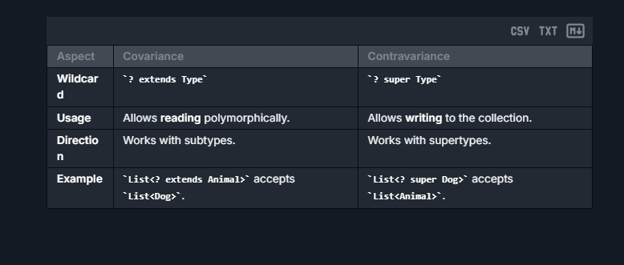

## **Difference between Compile time and run time**



## Difference between Set and List in Java



## Difference between Static Binding and dynamic binding?



# **SOLID & Design Pattern**

## **Relation b/w SOLID and Design Pattern**

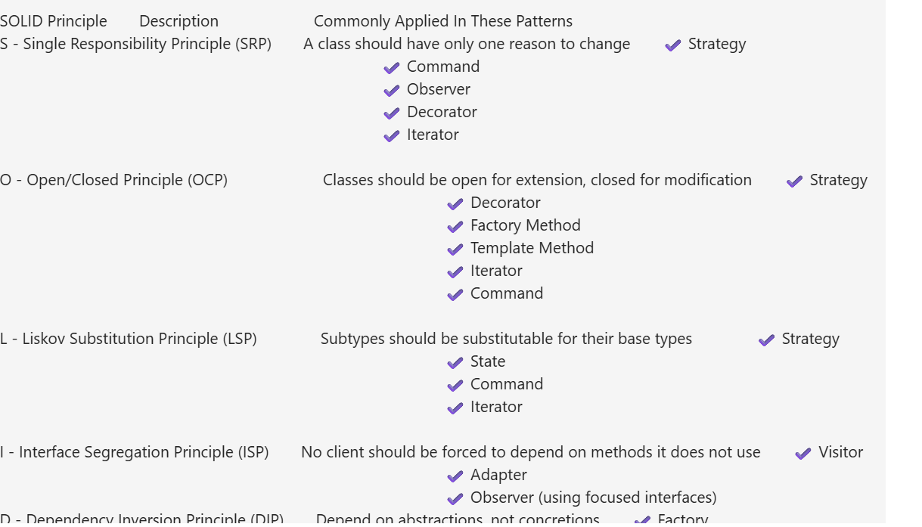

## **Explain the SOLID Principle**

1. **Single Responsibility Principle (SRP)**:
   * **Explanation**: A class should have one, and only one, reason to change, meaning it should have only one job.
   * **Example**: Consider a class named **ReportGenerator** that handles both data fetching from the database and rendering it as a PDF. This class has two reasons to change: changes in data fetching logic and changes in PDF rendering. According to SRP, these should be separate classes, one handling database operations (**DataFetcher**) and another handling the PDF rendering (**ReportRenderer**).
2. **Open/Closed Principle (OCP)**:
   * **Explanation**: It states that **the module should be open for extension but closed for modification.** The extension allows us to implement new functionality to the module
   * **Example**: Suppose you have a **Shape** class, and you need to calculate the area of various shapes. Instead of modifying the **Shape** class each time you add a new shape, create an interface **Shape** with a method **calculateArea()**. New shapes implementations like **Circle**, **Square** can implement this **Shape** interface without modifying the existing class.
3. **Liskov Substitution Principle (LSP)**:
   * **Explanation**: It applies to inheritance in such a way that the **derived classes must be completely substitutable for their base classes**. In other words, if class A is a subtype of class B, then we should be able to replace B with A without interrupting the behavior of the program.
   * It extends the open-close principle and also focuses on the behavior of a superclass and its subtypes. We should design the classes to preserve the property unless we have a strong reason to do otherwise.
   * **Example**: If you have a class **Bird** with a method **fly()**, and subclasses like **Sparrow** and **Ostrich**, although an **Ostrich** is technically a bird, it can’t fly. Thus, class **Ostrich** replacing **Bird** might lead to incorrect behaviors in the system where **fly()** method doesn't make sense for **Ostrich**.
4. **Interface Segregation Principle (ISP)**:
   * **Explanation**: It states that the larger interfaces split into smaller ones. Because the implementation classes use only the methods that are required. We should not force the client to use the methods that they do not want to use. The goal of the ISP is similar to the single responsibility principle..

**Example**: If you develop an interface **IMultifunctionDevice** with methods **print()**, **scan()**, and **fax()**, a device that only supports printing still needs to implement all methods. To adhere to ISP, split **IMultifunctionDevice** into smaller, distinct interfaces like **IPrinter**, **IScanner**, and **IFax**. Each device implements only the interfaces that apply to its functionalities

1. **Dependency Inversion Principle (DIP)**:
   * **Explanation:** It states that we must use abstraction (abstract classes and interfaces) instead of concrete implementations. High-level modules should not depend on the low-level module but both should depend on the abstraction. Because the abstraction does not depend on detail but the detail depends on abstraction
   * **Example**: In a notification system, if you directly instantiate an **EmailSender** within your **NotificationService** class, this creates a high dependency. Instead, inject an **INotificationSender** interface into **NotificationService**, and let **EmailSender** implement **INotificationSender**. This way, you can switch the notification service from email to, say, SMS by simply introducing a new implementation of **INotificationSender**.  
       
     **Case Studies for All Principles :-**
   * **Case Study: E-Commerce Application**
   * **Single Responsibility Principle**: Separate **Order** logic into classes like **OrderProcessor** (processing orders), **PaymentProcessor** (handling payments), and **OrderReportGenerator** (generating reports).
   * **Open/Closed Principle**: Adding new payment methods (e.g., Credit Card, PayPal) without modifying core order logic.
   * **Liskov Substitution Principle**: Use a **Product** superclass for substituting different products like electronics, books, and clothing.
   * **Interface Segregation Principle**: Separate interfaces for **PaymentProcessor**, **RefundProcessor**, and **LoyaltyPointsManager** to avoid forcing unrelated implementations.
   * **Dependency Inversion Principle**: Use **PaymentServiceInterface** as an abstraction to decouple **OrderManager** from specific payment implementations.

## **Explain the KISS Principle**

It suggests simplicity should be a primary goal in design and development, advocating for straightforward and uncomplicated solutions over unnecessarily complex ones. This principle is widely applied across various fields, including engineering, software development, user interface design, and project management, to name a few.  
The core idea is to keep things as simple as possible while still achieving the desired functionality or outcome. This principle suggests that simpler solutions are typically easier to understand, implement, maintain, and use.

The KISS principle has several implications:

1. **Simplicity**: Prioritize simplicity in design and development. Avoid unnecessary complexity, abstraction, or over-engineering.
2. **Clarity**: Simple designs are usually easier to understand and maintain. They reduce ambiguity and make it easier for others to comprehend the system or product.
3. **Efficiency**: Simpler solutions often require fewer resources (such as time, effort, and code) to implement and maintain. They can lead to faster development cycles and lower costs.
4. **Usability**: Simple designs tend to result in better user experiences. Products or interfaces that are intuitive and easy to use are more likely to be adopted and appreciated by users.

**Variants of KISS in Software Development**

Here are some common variants of KISS principle:

* **Keep It Short and Simple**: This variant maintains the essence of simplicity but emphasizes brevity as well. It's particularly relevant in communication, writing, and presentations, where concise messaging is valued.
* **Keep It Simple and Straightforward**: This variant highlights the importance of straightforwardness along with simplicity. It suggests that solutions should not only be simple but also direct and easy to understand.
* **Keep It Super Simple**: This version emphasizes an extreme level of simplicity, advocating for solutions that are as basic and uncomplicated as possible. It's often used to underscore the need for minimalism and avoidance of unnecessary complexity.
* **Keep It Silly Simple:**This playful variant retains the acronym "KISS" while injecting a sense of humour. It serves as a reminder not to take simplicity too seriously and to approach problems with a light-hearted attitude.

**Benefits of KISS principle**

The KISS (Keep It Simple, Stupid) principle offers numerous benefits across various domains:-

1. **Ease of Understanding**: Simple solutions are easier to understand for both developers and end-users. Clear and straightforward designs reduce cognitive load and make it easier to grasp the underlying concepts or functionalities.
2. **Reduced Errors**: Simplifying solutions can help minimize the risk of errors or bugs. Complex systems are more prone to mistakes due to their intricate nature, whereas simpler designs are less likely to contain hidden flaws.
3. **Improved Maintenance**: Simple systems are easier to maintain over time. When modifications or updates are required, developers can navigate and modify simple codebases more efficiently, reducing maintenance costs and efforts.
4. **Faster Development**: Keeping things simple often leads to faster development cycles. Developers can focus on implementing essential features without getting bogged down by unnecessary complexity, resulting in quicker time-to-market for products and solutions.

**Steps to Apply KISS Principle**

Applying the KISS (Keep It Simple, Stupid) principle involves intentionally simplifying solutions, designs, processes, and decision-making to achieve greater efficiency, clarity, and effectiveness. Here are some practical steps to apply the KISS principle:

**Identify Core Objectives**

* Clearly define the problem or objective you're addressing.
* Identify the essential goals and requirements.

**Focus on Essentials**

* Prioritize essential features or components necessary to achieve objectives.
* Avoid unnecessary embellishments or functionalities.

**Simplify Design and Workflow**

* Streamline processes and workflows to minimize complexity.
* Eliminate redundant steps or unnecessary complications.

**Prioritize Clarity and Understandability**

* Ensure that solutions are clear and easy to understand for all stakeholders.
* Use simple and straightforward language in documentation and communication.

**Iterate and Refine**

* Continuously review and refine solutions to simplify further.
* Seek feedback and iterate based on insights gained.

**Examples or Case Studies of KISS principle**

Here are a few examples and case studies that demonstrate the application of the KISS (Keep It Simple, Stupid) principle across various domains:

**Google Search Engine:**

* Google's search engine interface exemplifies simplicity. The homepage consists of a single search bar and minimal text, making it easy for users to understand and use.
* Despite the underlying complexity of the search algorithms, Google's focus on simplicity has made it the most widely used search engine globally.

**Apple iPhone:**

* Apple's iPhone is known for its intuitive and user-friendly design, adhering to the KISS principle. The interface features straightforward navigation, minimalistic icons, and intuitive gestures.
* Apple prioritizes simplicity in its hardware and software design, resulting in a seamless and enjoyable user experience for millions of users worldwide.

## **Explain the YAGNI Principle?**

The core idea of YAGNI is this:

**Avoid writing code or creating features 'just in case' they be needed in the future, because you likely aren't going to need it.  
  
Benefits of YAGNI**

The benefits of YAGNI (You Aren't Gonna Need It) in software development are numerous and can have a significant impact on the development process, the quality of the final product, and the overall success of the project. Here are some of the key benefits:

* **Faster Development**: By focusing only on what is needed at the moment, developers can avoid spending time on features that may never be used. This can lead to faster development cycles and more efficient use of resources.
* **Simplicity**: Unnecessary features can add complexity to the codebase, making it harder to maintain and understand. YAGNI helps keep the codebase simple and focused, making it easier for developers to work with.
* **Flexibility**: By avoiding unnecessary features, developers can keep the codebase flexible and adaptable to change. This can be especially important in fast-paced environments where requirements may change frequently.
* **Reduced Risk**: Unnecessary features can introduce bugs and other issues into the codebase. By avoiding these features, developers can reduce the risk of introducing bugs and other issues into the codebase.

**How do I use YAGNI in my code?**

To use YAGNI as a developer, it's like having a practical guide to keep your work focused and efficient.

YAGNI Principal for Developers

**1. Get the Necessary Requirements**

All the things your project needs and sort them into "must-haves" and "can wait." This helps you know exactly what to work on. Whether you write it down on paper or type it out on a screen, having a list keeps you organized.

**2. Discuss with Your Team**

After that, it's time to talk with your team. Share your plans and goals with them. This makes sure everyone is on the same page and understands what needs to be done. It's like being a team captain and making sure everyone is playing the same game.

**3. Analyze a Simple Plan for the Solution**

Now, when it comes to planning the actual work, keep it simple. Break down your big goals into smaller tasks. This helps you avoid getting overwhelmed and ensures you're focusing on what really matters. Think of it like building a step-by-step roadmap for your project.

**4. Refuse If It Doesn't Fit for the Solution**

Sometimes, your team might come up with new ideas or want to add extra things. While these ideas might be cool, you've got to be ready to say "no" unless it's a tiny improvement. Saying "no" can be tough, but it keeps you from getting off track and missing deadlines.

**5. Have a Record of Your Progress**

Keep a record of what you've done. It's like keeping score in a game. This helps you see how far you've come and if you're heading in the right direction. Tools that help you manage this process are like scoreboards for developers, helping them stay on track and deliver what the customers really need.

**Example 1: Developing a User Profile**

**Scenario:**

You're tasked with developing a simple **User Profile** for a web application. The current requirements state:

1. User Profile should include:
   * Username
   * Email
2. Users should be able to update their profile.

**Developer's Thought Process (Violating YAGNI)**: The developer thinks, "What if, in the future, we want to add additional features like user's address, phone number, or profile picture? Let me add fields and logic for these now to 'prepare for the future.'"

**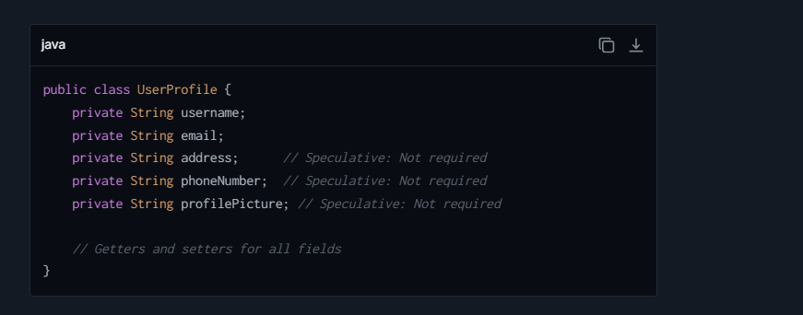  
Why This Violates YAGNI**:

* The system doesn’t yet require "address," "phoneNumber," or "profilePicture."
* Speculative features add complexity to the class (e.g., extra getters, setters, and testing).
* A higher maintenance burden: If requirements change for these fields, the extra code might need to be refactored or deleted.

**Applying YAGNI (Correct Approach)**: Focus on **what is actually needed** right now. Only implement **username** and **email**.

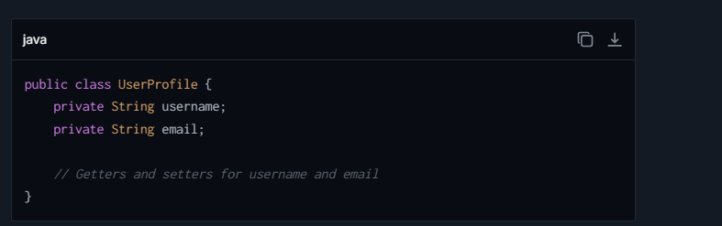

**Benefits of YAGNI**:

* Simplifies initial code.
* Reduces maintenance and testing burden.
* When a new feature (e.g., address or profilePicture) is required, you can implement it **based on actual requirements.**

**Example 2: Payment Processing System**

**Scenario:**

You are building a payment processing system for an e-commerce platform. The requirement is to support **credit card payments only**.

**Developer's Thought Process (Violating YAGNI)**: The developer assumes, "What if we later support PayPal, Google Pay, or Bitcoin? Let me design the system upfront to handle all these payment options."

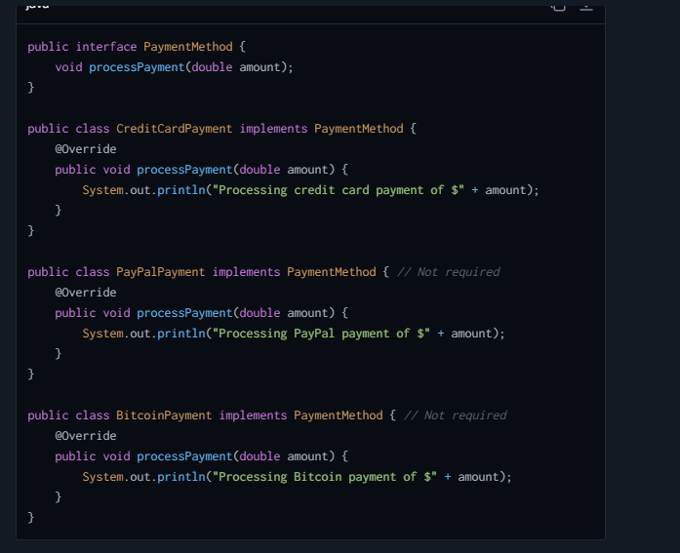  
**Why This Violates YAGNI**:

* You don’t need PayPal or Bitcoin support **right now**.
* It increases complexity by adding new classes and interfaces, which need to be tested and maintained.

**Applying YAGNI (Correct Approach)**: Implement only **credit card payment** logic. When a new payment method is requested, **refactor** or evolve the system.

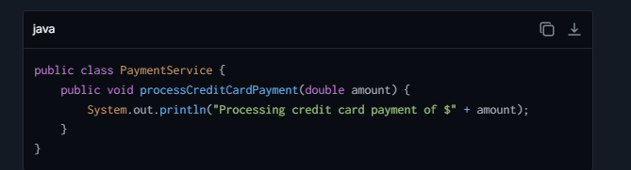

**Benefits of YAGNI**:

* Focuses on delivering **working features** that meet current business requirements.
* Adds other payment methods (e.g., PayPal) **when requirements emerge**, potentially with input from stakeholders about how to implement them.

**Example 3: Unused API Endpoints**

## **How to achieve a singleton design pattern?**

It ensures that a class has only one instance, and provides a global point of access to that instance. Implementing the Singleton pattern involves several steps, and it can vary slightly depending on the programming language in use.

**Step 1: Make the Constructor Private**

It Prevents external construction of instances is crucial. Making the constructor private ensures that no external code can instantiate the class directly.

**Step 2: Create a Private Static Instance of the Class**

Declare a static private variable inside the class. This variable will hold the single instance of the class. It's static because it needs to be shared across all instances and accessible through a static method.

**Step 3: Provide a Public Static Method for Access**

This method (commonly named **getInstance()** or similar) is used to access the instance of the class. Inside this method, you check if the instance already exists:

* If it does, return it.
* If it doesn’t, create it.

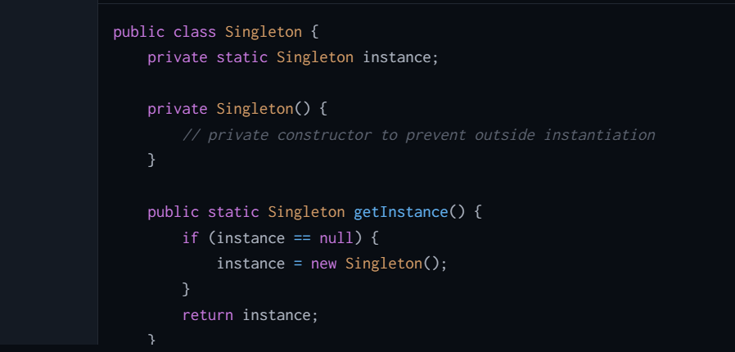

## **How Can we make singleton design pattern thread safe?**

Making a Singleton design pattern thread-safe ensures that only one instance of the singleton class is created even in multithreaded environments. Here are several methods to achieve a thread-safe Singleton in Java:

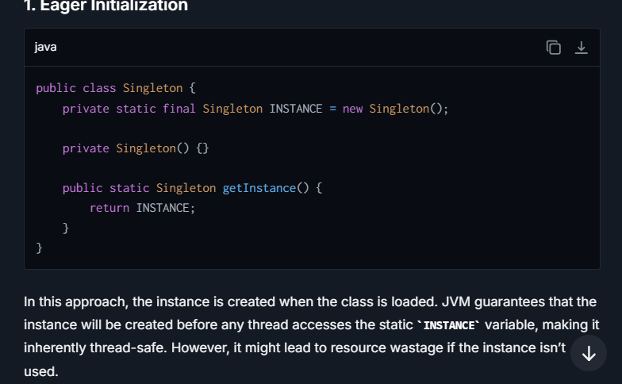

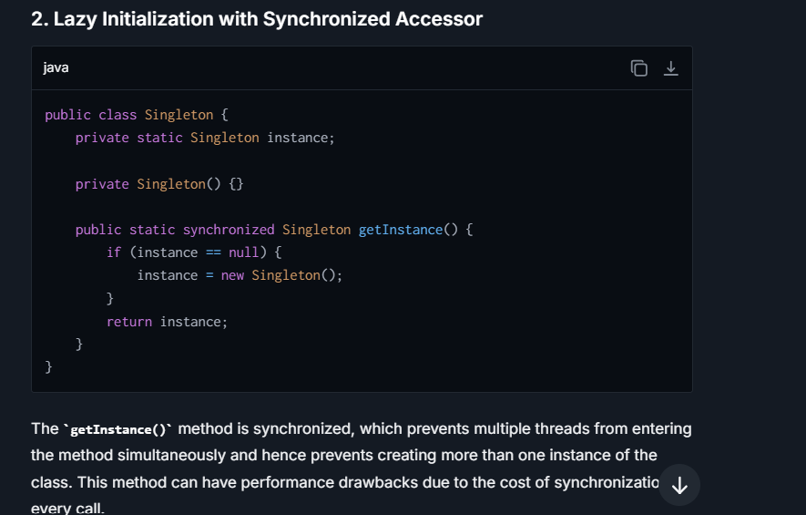

## **How do you implement the Open Closed Principle?**

It states that software entities (such as classes, modules, functions, etc.) should be open for extension, but closed for modification. This means that a class should allow its behavior to be extended without modifying its source code.

Here’s how you can implement the Open/Closed Principle:

**1. Use Inheritance:**

Inheritance is a straightforward way to achieve OCP whereby new functionality can be achieved by creating derived classes that extend the base class.

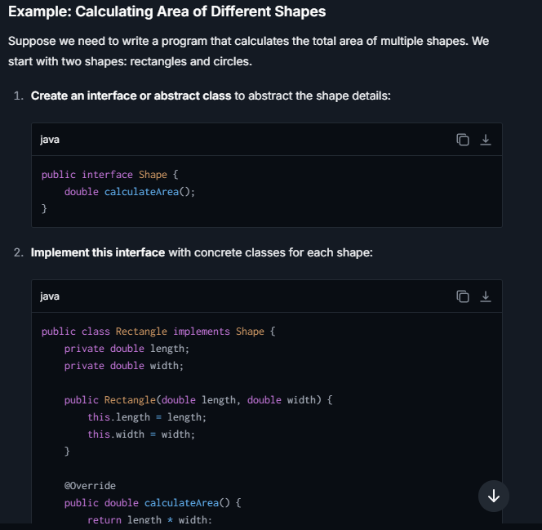  
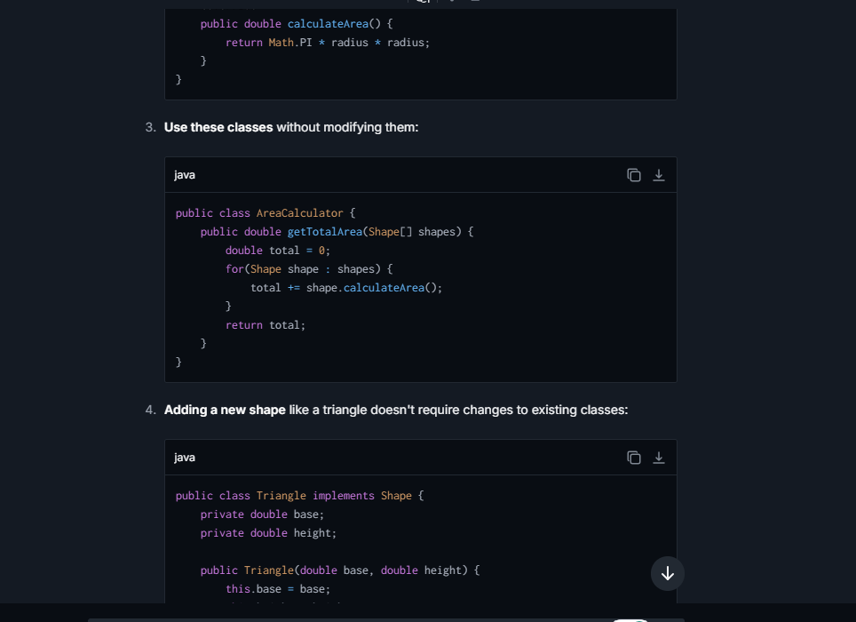

**2. Use Interfaces or Abstract Classes:**

You can define interfaces or abstract classes which dictate the structure that the extending classes must follow without dictating the specifics of the internal implementation.

**3. Use Composition:**

Instead of using inheritance, you can use composition to achieve flexibility by designing components that can be composed together in different ways.

**Example**: You might have a **Printer** class and instead of extending this to add functionality, you could compose it with different **IPrintStrategy** instances.

## **Implement the Open Closed Principle using Enums ?**

The use of enums to implement the Singleton pattern takes advantage of several key features of enums in Java:

1. **Thread Safety**: Enums provide inherent thread-safety during instance construction.
2. **Serialization**: Java guarantees any enum value to be a singleton by default, and you get serialization machinery for free. You cannot create further instances through serialization.
3. **Prevention of Reflection Attacks**: Enums have mechanisms that prevent reflection from being used to destroy the Singleton property.

## **Tell me about Interface Segregation in detail?**

It emphasizes that no class should be forced to implement interfaces they do not use. It advocates for creating specific interfaces instead of one general-purpose interface. By following ISP, each interface should serve a specific subset of client-specific functionality, essentially decoupling the system components.

**E**.**G**. :- **Problem with Fat Interfaces:**

In software engineering, an interface is a set of publicly exposed methods that a class implements. A common issue that occurs in object-oriented design is the creation of "fat" interfaces. A fat interface is an interface with too many responsibilities, i.e., methods which not every class (implementing this interface) needs. When a class is forced to implement such an interface, it ends up implementing methods that it doesn't need or use. This is inefficient and can lead to code that is hard to understand and maintain.

**ISP Solution:**

Interface Segregation Principle suggests segregating, i.e., breaking down, a broad interface into smaller, more specific ones so that they better cater to the specific needs of their clients. Classes can then implement one or more of these smaller interfaces according to their needs.

## **Explain Design Principles?**

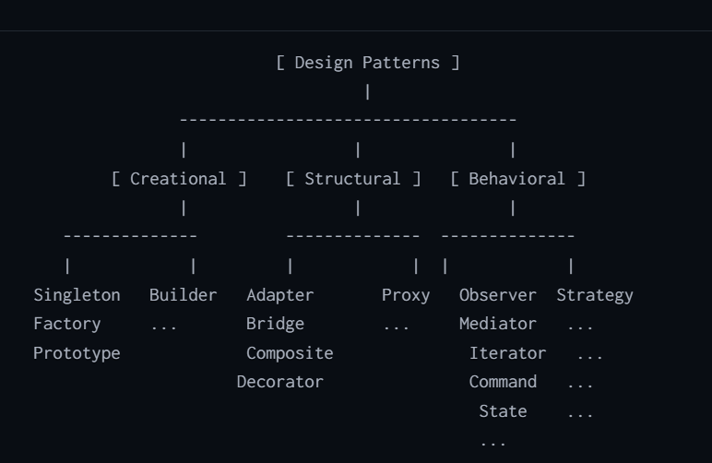

**1. Creational Design Patterns:**

Creational design patterns deal with object creation mechanisms, trying to create objects in a manner suitable to the situation. The basic form of object creation could result in design problems or added complexity to the design. Creational design patterns solve this problem by somehow controlling this object creation.

**Key Aspects:**

* These patterns abstract the instantiation process.
* They help make a system independent of how its objects are created, composed, and represented.
* They provide more flexibility in deciding which objects need to be created for a given use case**.**

**2. Structural Design Patterns:**

Structural design patterns are concerned with how classes and objects are composed to form larger structures. Structural patterns ease the design by identifying a simple way to realize relationships among entities.

**Key Aspects:**

* They help ensure that if one part of a system changes, the entire system doesn't need to do the same.
* They help in organizing different classes and objects to form larger structures while keeping these structures efficient and manageable.
* They focus on simplifying the structure by identifying the relationships

**3. Behavioral Design Patterns:**

Behavioral design patterns are concerned with algorithms and the assignment of responsibilities between objects. What makes them different is not just what they do but how they realize it. Behavioral patterns characterize complex control flow that's difficult to follow at run-time.

**Key Aspects:**

* They are concerned with the interaction and responsibility of objects.
* They help make interactions easy and flexible between different objects.
* They focus on how objects distribute work among themselves.

## **Why do we need Design Principles?**

Design principles are crucial in software development for several reasons, as they guide developers to build software that is robust, maintainable, scalable, and efficient. Here are some key reasons why we need design principles:

1. **Maintainability**: It encourage practices that make the software easier to understand and modify. By adhering to principles like the Single Responsibility Principle, changes in one part of the system have minimal impact on other parts, thereby reducing the risk of introducing bugs when modifications are made.
2. **Extensibility**: Good design promotes the ease of adding new features or functionalities without having to overhaul the existing system. Principles like the Open/Closed Principle ensure that extending a module's behavior doesn't require altering the module itself, which means new features can be added with minimal risk to the existing system's functionality.
3. **Scalability**: Design principles help in structuring the software so that it can grow smoothly. This is particularly important in handling increasing loads or when branching out the software for new requirements. Modular design, promoted by principles such as Interface Segregation, allows different parts of the system to scale independently.
4. **Reusability**: By adhering to principles like Dependency Inversion and Liskov Substitution, systems are built with components that are more reusable. These components are less coupled to the specifics of one application and can be used in various contexts, reducing code duplication and the effort needed to develop similar software in the future.
5. **Testability**: Code that follows design principles is generally easier to test. Decoupling of components (an aspect of many design principles) allows for easier unit testing since each component can be tested independently of others. This promotes more reliable code and quicker testing cycles.
6. **Reduced Complexity**: Complex code is difficult to manage, test, and debug. Design principles guide developers toward creating simpler, cleaner code by encouraging the segregation of concerns and reduction of dependencies.
7. **Improve Collaboration**: In team environments, consistency in coding standards and architecture makes it easier for multiple developers to collaborate effectively. Design principles provide a common language and understood "best practices" that help align team members on how to approach design problems.
8. **Future-proofing**: By building systems that are flexible and adaptable to changes, design principles help future-proof software. This adaptability means the software can handle not only current requirements but also adapt as those requirements evolve or expand.

## **Some Popular Design pattern?**

**1. Singleton (Creational)**

The Singleton pattern ensures that a class has only one instance and provides a global point of access to it. This is particularly useful when you have a global state in your application or when logging, database operations, or file operations are involved.

**Example Usage**: Implementing a logging class that writes logs to a file. Since you want to centralize the logging interface and avoid opening and closing the file multiple times, using a Singleton to manage a single log file writer instance makes sense.

**2. Factory Method (Creational)**

The Factory Method pattern defines an interface for creating an object but lets subclasses decide which class to instantiate. This pattern lets a class defer instantiation to subclasses.

**Example Usage**: Consider a UI library where your application needs to create buttons that look native on Windows, macOS, or Linux. You can define an interface, **Button**, with a method **draw()**, and concrete classes **WindowsButton**, **MacOSButton**, and **LinuxButton**. A **ButtonFactory** decides which button to instantiate based on the operating system.

**3. Adapter (Structural)**

The Adapter pattern allows objects with incompatible interfaces to work together. It acts as a bridge between two incompatible interfaces.

**Example Usage**: Suppose you have a new system that uses modern JSON-based services, but you need to integrate it with legacy systems that use XML data formats. An adapter can convert JSON to XML (and vice versa), allowing the systems to communicate transparently

## Difference between Liskov and dependency principle ?



# String

## **What is String Pool, How It Works and Characteristics. explain?**

It is also known as the Intern Pool  is a special storage area in the Java heap memory where Java runtime stores String literals. The String Pool helps in optimizing the memory usage and improving performance by reusing immutable String objects.

**Here's how the String pool works:**

1. **Storage of String Literals**: When you create a String literal in Java, the JVM checks the String pool first. If the literal already exists in the string pool, the reference to the pooled instance is returned instead of creating a new object. If it doesn't exist, a new String object is created and placed in the pool.
2. **Interning Strings**: Java provides a method **String.intern()**, which is used to put the String object into the pool or return the reference if one already exists in the pool. This means you can manually intern Strings that are not created as literals and gain memory efficiency by using the same memory space for Strings that are equal in content.

**Characteristics of the String Pool:**

1. **Immutability**: Since Strings are immutable in Java, once a String is created, it cannot be changed. This property allows Strings to be safely reused by multiple parts of a program without worries that their values will be altered.
2. **Efficiency**: By storing only one copy of each literal String, the JVM reduces the amount of memory required for String storage.

## **What is immutability in strings? Explain**

Immutability in strings means that once a string object is created, its value cannot be changed. Any attempts to modify an existing string will result in the creation of a new string object with the updated value. This ensures data consistency, thread safety, and performance optimization since immutable objects can be easily shared and reused without synchronization.

## **How to implement Custom immutable class?**

**1. Mark the Class as Final**

The class itself should be declared as **final** to prevent subclassing, which can potentially alter its behavior and state.

**2. Mark All Fields as Private**

This access specifier prevents direct access to the fields from outside the class.

**3. No Setter Methods**

Avoid providing methods that modify fields; only getters are allowed.

**4. Make All Fields Final**

This ensures that fields can be assigned only once.

**5. Ensure exclusive access to any Mutable Objects**

If your immutable object has fields reference other mutable objects, you must ensure that these other objects cannot be changed:

* Do not provide methods that modify the mutable objects.
* Do not share references to the mutable objects. Return a new copy of the object or a clone whenever needed.

**6. Initialize All Fields via Constructor**

The class should have a constructor that initializes all the fields of the class. Since fields are **final**, they can only be assigned once, typically inside the constructor

**Real-Life Examples of Immutable Classes in Java**

1. **Wrapper Classes (Integer, Double, etc.):**
   * These are immutable versions of primitive types.
2. **LocalDate, LocalTime, LocalDateTime (java.time API):**
   * Used for date and time operations. They are immutable and thread-safe.

## **Why they made strings immutable?**

Strings were made immutable for several reasons:

1. Security: String objects are commonly used for storing sensitive data like usernames, passwords, and other credentials. Immutability ensures that these values cannot be changed maliciously, thereby improving application security.
2. Efficiency: Immutable objects can be safely stored in a cache and reused multiple times, reducing memory overhead and speeding up repeated string operations.
3. Thread-Safety: Immutable objects are inherently thread-safe because their state cannot be changed after creation. This eliminates the need for synchronization and improves performance in concurrent environments.
4. Support for Hashing: Strings are frequently used as keys in hash tables. Since the value of an immutable string cannot change, its hash code remains constant, ensuring efficient retrieval from hash-based collections.

## **What is Exit() method?**

The exit() method in Java is a static method from the System class that terminates the currently running Java Virtual Machine (JVM). The method is commonly used to abruptly terminate a Java application. It requires an argument of type int, which serves as a status code to signal to the operating system or the calling process about the nature of the program's termination.

## **What can be the breakpoint ?**

A breakpoint in the context of immutability can occur if the immutability contract is broken.   
**For example,** if an immutable class exposes references to its mutable members or if subclasses are allowed to override behavior in a way that enables modification of internal state. This could lead to unexpected behavior, data corruption, or security vulnerabilities. To mitigate this, it's crucial to design immutable classes carefully and rigorously enforce their constraints.

A breakpoint is a debugging tool that allows a developer to pause the execution of a program at a specific line or condition. This enables the inspection of variables and program state to analyze and debug issues. When a breakpoint is reached, the program execution halts, and the developer can step through the code line by line to identify problems.

## **What is String, String builder and String buffer?**

**String :-**

* **Definition**: The **String** class represents immutable character sequences. Once a **String** object is created, its value cannot be changed.
* **Memory**: Strings are stored in the **String Pool** (within heap memory) for efficiency, allowing for reuse of identical values.
* **Immutability**: When a **String** is modified (e.g., concatenation), a new **String** object is created instead of modifying the original object.
* **Thread Safety**: Immutable strings are **thread-safe** because their state cannot be changed, making them inherently safe for concurrent access.

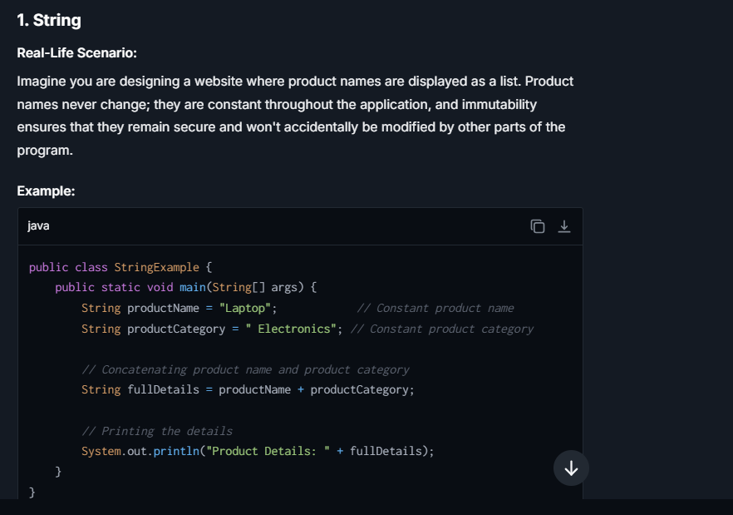

**StringBuilder:-**

* **Definition**: The **StringBuilder** class represents mutable sequences of characters. It allows modifications, such as appending, inserting, or replacing characters, without creating new objects for every change.
* **Memory**: Objects are stored in the heap, **not the String Pool**. The same object’s internal buffer is modified directly.
* **Mutability**: You can modify the object itself without creating new instances, making it suited for efficient string manipulation.
* **Thread Safety**: **StringBuilder** is **not thread-safe**, meaning it should only be used in single-threaded contexts.

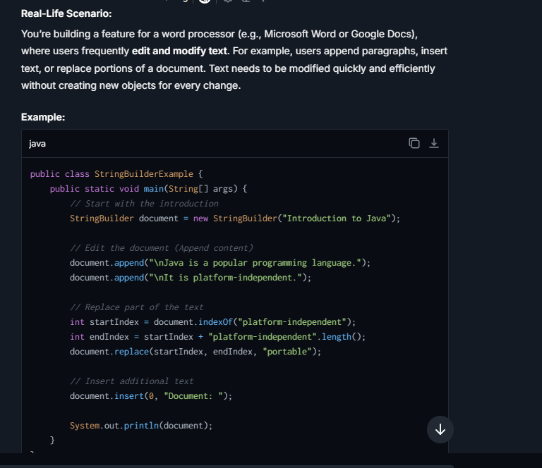

**StringBuffer**

* **Definition**: The **StringBuffer** class is similar to **StringBuilder**, with the main difference being **thread safety**. **StringBuffer** provides synchronized methods to make it safe for use in multi-threaded environments.
* **Memory**: Like **StringBuilder**, objects are stored in the heap. The content can be modified directly without creating new objects.
* **Mutability**: You can modify the object itself, similarly to **StringBuilder**.
* **Thread Safety**: **StringBuffer** methods are synchronized, making it safe for concurrent threads but slightly slower than **StringBuilder**.

**Real-Life Sceanrio :-Imagine you're building a web server where multiple users concurrently submit large logs or messages for processing. For example, each user generates a log for their activity, and all logs need to be maintained safely in a shared log file. Thread safety is important because multiple threads (from different users) interact with the same object simultaneously.**

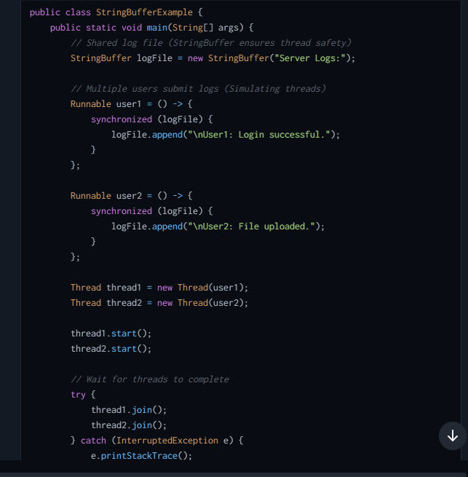

## **Difference between Deep copy and shallow copy explain ?**

| **Feature** | **Shallow Copy** | **Deep Copy** |
| --- | --- | --- |
| Definition | Creates a new object which stores the references of the objects found in the original. | Creates a new object and recursively copies all objects it references, not just the top-level references. |
| Memory Allocation | Less memory usage since only references are duplicated. | More memory usage as copies of all nested objects are created. |
| Changes to Copied Objects | Changes to the objects inside the original will be reflected in the shallow copy as they share references. | Changes to the objects inside the original will not affect the deep copy as they are entirely separate. |
| Copying Process | Simple and fast because it only copies object references, not the actual objects. | Time-consuming and complex due to the necessity of copying every element and their nested objects. |
| Suitable For | Suitable when working with immutable objects or when there's no concern about the independence of objects. | Suitable for cases where full independence of copies from the original objects is crucial. |
| Implementation | Usually can be achieved by simple member-wise copying. | Often requires custom methods or functions to ensure all objects are cloned completely, including objects referenced by the initial object. |
| Common Usage Examples | Copying references of strings or database connections in a new object where the actual data isn't modified. | Cloning a complex data structure like a linked list or a tree where modifications to clone should not affect the original. |
| Impact of Modifications | Modifications to objects contained in the shallow copy will reflect in all copies since they reference the same objects. | Modifications in the deep copy do not affect the original object or any other copies. |

# **Spring Boot**

## **What is Spring boot ?**

Spring Boot is a project built on top of the Spring framework. It simplifies the setup and development of Spring applications through convention over configuration. It provides a set of starter dependencies that you can add to your project's build file which in turn provides the necessary dependencies and auto-configuration required to get started quickly. Spring Boot is designed to get you up and running as quickly as possible, with minimal upfront configuration. It also provides production-ready features such as metrics, health checks, and externalized configuration. Essentially, Spring Boot makes it easy to create stand-alone, production-grade Spring-based applications that you can "just run"

* **Auto-configuration**: It automatically configures your application based on the dependencies you have added. For instance, if you have **spring-boot-starter-web** in your classpath, it configures Tomcat and Spring MVC.
* **Standalone**: It allows applications to be run independently without relying on an external web server.
* **Opinionated Defaults**: It provides a range of 'starter' dependencies that bundle common dependencies together (like **spring-boot-starter-data-jpa** for JPA-related dependencies) and provide sensible default configurations.
* **Production-ready**: It provides features like health-check, metrics, externalized configuration that are essential for deploying applications to production.

## **What is the advantage of Spring Boot over Spring?**

 Spring Boot is a highly popular framework that simplifies the development, configuration, and deployment of Spring applications. It offers several advantages that make it attractive for developers working on enterprise applications as well as smaller projects. Here are some of the key benefits of using Spring Boot:

**1. Auto-Configuration**

Spring Boot automatically configures your application based on the libraries you have in your classpath. This means you spend less time managing configurations and more time focusing on building your app. For instance, if Spring Boot detects Spring Web MVC on the classpath, it automatically sets up web applications.

**2. Standalone**

Spring Boot applications are standalone and do not require deployment to an external web server or an application server. This is because they include an embedded server (such as Tomcat, Jetty, or Undertow) out of the box. This makes it easy to develop and test your applications.

**3. Production-Ready**

Spring Boot comes with features to help you monitor and manage your application when you put it into production. Metrics, health checks, and externalized configuration are just a few of the out-of-the-box features you can use to get your application production-ready.

**4. Opinionated Defaults**

Spring Boot offers "opinionated defaults" which means that it guesses the configurations you are likely to want and pre-implements them for you. This greatly speeds up the development process since you only need to specify the deviations from these defaults. This feature is perfect for developers new to Spring and those who want to develop a proof-of-concept quickly.

**5. Dependency Management**

Spring Boot simplifies dependency management by providing a set of managed dependencies (known as starters) that represent common usage or common capabilities. These starters ensure that you have all the dependencies you need for a specific feature and that they are version-compatible with one another.

**6. Community and Documentation**

Spring Boot benefits from the strong community and comprehensive documentation provided by the developers and numerous contributors globally. This makes learning and troubleshooting much easier compared to less popular frameworks.

**7. Microservices Ready**

Spring Boot fits very well into the microservices architecture due to its ability to develop standalone applications that can run independently or as services. Furthermore, it integrates seamlessly with Spring Cloud for building some of the common patterns in microservice architectures like configuration management, service discovery, and circuit breakers.

## **Advantage and disadvange of Spring boot with example ?**

Spring Boot is a popular extension of the Spring framework that simplifies the development and deployment of Spring-based applications. It offers several out-of-the-box features that reduce boilerplate code and configuration complexities. Below, I encapsulate the advantages and disadvantages of Spring Boot in a tabular format, along with examples to provide clearer insights.

| **Advantage** | **Example** | **Disadvantage** | **Example** |
| --- | --- | --- | --- |
| **Auto-configuration** | Spring Boot can automatically configure your application based on the jars you have in your classpath. For instance, if H2 database is in the classpath, Spring Boot auto-configures an in-memory database. | **Opinionated Setup** | You might have less control over third-party configurations, as Spring Boot provides an opinionated 'starter' setup that may include more dependencies than necessary. |
| **Standalone** | Spring Boot applications can run independently using an embedded server, without needing to deploy to an external server. | **Memory Consumption** | Embedded servers and default configurations might result in higher memory usage compared to tailored traditional deployments. |
| **Rapid Development** | Spring Boot has a range of ready-to-use Spring “Starters” that simplify dependency management. This also enables rapid prototyping and development. | **Learning Curve** | For developers new to Spring or Spring Boot, the vast range of features, configuration properties, and conventions can be overwhelming. |
| **Production-ready features** | Includes built-in endpoints for monitoring & management (Spring Boot Actuator), which helps in maintaining and monitoring application health in production. | **Less flexibility in certain configurations** | Some auto-configurations might not be suitable for all projects, and customizing those further than what Spring Boot allows can be cumbersome. |
| **Supports a wide range of development tools** | Spring Boot supports embedded servers like Tomcat, Jetty, and can work seamlessly with databases, messaging, etc., through convenient starter kits. | **Dependency Overhead** | With multiple starters and auto-configurations, applications might end up with redundant dependencies leading to bloated deployments. |
| **Simplified Deployment** | Deployable jars ('fat jars' or 'uber jars'), including all necessary dependencies, simplify deployment and versioning processes. | **Potential for not fully understanding auto-configured components** | Beginners might rely on auto-configurations without understanding the underlying mechanics, which can hinder problem-solving in non-trivial application issues. |
| **Extensive Community and Documentation** | Spring Boot benefits from the large Spring community, extensive documentation, blogs, and guides that aid in problem-solving. | **Rapid Pace of Change** | Staying up-to-date with frequent releases and changes may require ongoing learning and adaptations in your projects. |

## **What are the key components of spring Boot?**

Spring Boot is a powerful extension of the Spring framework that simplifies the development of stand-alone, production-grade Spring applications. It favors convention over configuration, reducing the need for explicit setup and boilerplate code.

**1. Auto-Configuration**

Spring Boot automatically configures your application based on the libraries you have added to the project. For example, if you have H2 database and Spring Data JPA libraries in your classpath, Spring Boot automatically sets up an in-memory database, an EntityManager, and other necessary configurations without requiring manual setup.

**2. Starter Dependencies**

These are special sets of dependency descriptors you can include in your application's build configuration to bootstrap dependencies needed for a specific feature. For instance, adding **spring-boot-starter-web** to your project will bring in all the dependencies required for building web applications such as Tomcat and Spring Web MVC.

**3. Spring Boot CLI**

This is a command-line tool that you can use to quickly prototype with Spring. It allows you to run Groovy scripts, which simplifies the bootstrapping process and reduces the need for large amounts of boilerplate code written in your development projects.

**4. Spring Boot Actuator**

This tool provides built-in production-grade features to help you monitor and manage your application. It provides numerous endpoints for accessing health, metrics, info, and other administrative details. It’s invaluable for gaining insights into applications running in production environments.

**5. Embedded Servers**

Spring Boot comes with embedded server support (Tomcat, Jetty, and Undertow), meaning you do not need to deploy your application to an external server. This simplifies deployment and development practices since the same setup can be used in both development and production. The server is automatically started when you run your Spring Boot application.

**6. Properties and Configuration Management**

Spring Boot simplifies configuration with properties files, YAML files, environment variables, and command-line arguments. It has a very layered approach to configuration, allowing property values to be overridden in different environments, which is crucial for managing production, development, and testing settings.

**7. Logging and Tracing**

Spring Boot sets up default configurations for logging with common libraries like Logback or Log4J2, making it easy to keep track of what's happening in your application. Configuration can be easily overridden via application properties or YAML files.

**8. Profiles**

These allow different parts of your configuration to be switched under certain conditions, making it easy to migrate between environments (like dev, test, and prod) without changing anything in the codebase. You can define certain beans or configurations to only be active under specific profiles.

## **How Run() Method execute?**

**SpringApplication.run()** is the entry point for starting a Spring Boot application from the main method. Here’s a concise step-by-step explanation of how this method executes:

**1. Create SpringApplication Instance**

* Initializes a new **SpringApplication** instance using the annotated **@SpringBootApplication** class, typically your main application class.

**2. Determine ApplicationContext Type**

* Determines which type of **ApplicationContext** to create based on the classpath and the environment (e.g., **AnnotationConfigApplicationContext** for non-web applications or **AnnotationConfigServletWebServerApplicationContext** for web applications).

**3. Prepare Environment**

* Prepares the **Environment** by loading configurations from various external properties sources (like **application.properties**, environment variables) and profiles.

**4. Create ApplicationContext**

* Creates and configures the **ApplicationContext** with the prepared environment.

**5. Load Bean Definitions**

* Registers bean definitions including components detected through classpath scanning, configurations from annotated classes, and beans from externalized configurations.

**6. Refresh ApplicationContext**

* Refreshes the **ApplicationContext**, which triggers the bean initialization processes including dependency injection, bean lifecycle callbacks, and auto-configuration classes.

**7. Run CommandLineRunners and ApplicationRunners**

* Executes **CommandLineRunner** and **ApplicationRunner** beans that allow running additional code before the application is fully up and ready to service requests.

**8. Trigger Application Events**

* Triggers application events such as "application started" and "application ready" which other components in the application can listen to perform actions at these stages.

**9. Return ApplicationContext**

* Finally, returns the initialized **ApplicationContext**.

## **What is Spring starter/Run dependencies?**

"Spring Starter" and "Run Dependencies" are key concepts that facilitate the set-up and management of a project.

**Spring Starter:**

Spring Starters are a set of convenient dependency descriptors that you can include in your application. Each starter contains a group of auto-configurable dependencies that work together to fulfill a specific development need. These starters are part of Spring Boot, which is designed to simplify bootstrapping and developing new Spring applications.

Starters cover a broad range of development functionalities, including:

* Web Services
* Data Access (with various database technologies)
* Messaging (JMS, AMQP)
* Logging
* Testing

Each starter is named with a **spring-boot-starter-\*** pattern, where **\*** is a particular type of application or technology stack. For example:

* **spring-boot-starter-web**: Starter for building web applications using Spring MVC. Includes RESTful application support using Tomcat as the default embedded container.
* **spring-boot-starter-data-jpa**: Starter for using Spring Data JPA with Hibernate.
* **spring-boot-starter-test**: Starter for testing Spring Boot applications with libraries including JUnit, Hamcrest, and Mockito.

By using Spring Starters, developers can avoid the tedious and error-prone process of setting up dependency configurations and more reliably manage project dependencies.

**Run Dependencies:**

"Run Dependencies" generally refers to the dependencies that are necessary for the running of a Spring Boot application as configured through the starters. They make sure that all required libraries and frameworks are included and properly configured to work together when the application runs. Dependencies included might encompass:

* Core Spring libraries for Inversion of Control and Dependency Injection.
* Embedded servers like Tomcat or Jetty if you're building a web application.
* Database connectors if interacting with a database.
* Specific API clients if interacting with external services.

For instance, including **spring-boot-starter-web** in your project brings in dependencies like Spring's web MVC framework, an embedded Tomcat server, and other necessary libraries to get a web service up and running quickly.

These dependencies are managed in the Maven **pom.xml** or Gradle **build.gradle** files. When you build your project, Maven or Gradle resolves these dependencies, along with their transitive dependencies, and includes them in the application's package or classpath for execution.

## **What are Spring starter dependencies?**

In the context of Spring Boot, "starter dependencies" are a set of convenient dependency descriptors that you can include in your project to quickly enable specific functionality. These starters contain a collection of pre-configured and auto-configured dependencies that work together to provide a specific feature or capability, reducing the amount of setup and boilerplate code you need to write.

**Purpose of Starter Dependencies :-**

The primary goal of starter dependencies is to enhance developer productivity by providing a quick way to add necessary dependencies without worrying about version compatibility and reducing boilerplate configuration. Each starter is designed to give you everything you need for a specific type of application or technology stack. They manage transitive dependencies for you, ensuring that all necessary dependencies are included and are compatible.

**1. spring-boot-starter**

This is the core starter, including auto-configuration support, logging, and YAML. It's the base of all other starters.

**2. spring-boot-starter-web**

* Purpose: Building web applications using Spring MVC. It includes full-stack autoconfiguration for building web applications and RESTful services.
* Comes with embedded Tomcat for serving web content, and includes Jackson for JSON serialization/deserialization, among other things.

**3. spring-boot-starter-Data-JPA**

* Purpose: Provides key dependencies for working with databases using Spring Data JPA.
* Includes JPA vendor adapter, Hibernate by default as the implementation provider, and Spring Data JPA itself.

**4. spring-boot-starter-security**

* Purpose: Adds dependencies for using Spring Security.
* Helps in securing applications via authentication and authorization capabilities.

**5. spring-boot-starter-test**

Brings in commonly used testing libraries including JUnit, Spring Test & Spring Boot Test, AssertJ, Hamcrest, Mockito, and JSONassert. It’s essential for facilitating the testing of Spring components with JUnit or other testing frameworks.

**6. spring-boot-starter-actuator**

Provides production-ready features to help monitor and manage your application. It exposes operational information about the running application – health, metrics, info, dump, etc., via HTTP endpoints or JMX.

**7. spring-boot-starter-mail**

Provides support for sending emails and includes the JavaMail sender.

**8. spring-boot-starter-thymeleaf**

Includes integration with Thymeleaf, a popular server-side Java template engine for web applications.

## **What is dependency Injection and IOC Container ?**

Dependency Injection is used to implement IoC (Inversion of Control), allowing a program design to follow the Dependency Inversion Principle. The primary purpose of DI is to reduce hard-coded dependencies among your classes by injecting these dependencies at runtime instead of during design time technically. This leads to more modular, testable, and maintainable code.

**How it works:** In DI, objects do not create their dependencies themselves. Instead, they are constructed by an external entity (container or factory), and those dependencies are "injected" into them, typically through the constructor, a setter method, or directly into a field.

**Types of Dependency Injection:**

1. **Constructor Injection**: Dependencies are provided through the class constructor.
2. **Setter Injection**: The client exposes a setter method that the injector uses to inject the dependency.
3. **Field Injection**: The injector directly sets the dependencies into annotated fields of the class.

**IoC (Inversion of Control) Container**

An IoC container is a framework used to manage the dependencies between objects in your application. It is responsible for instantiating objects, managing their life cycles, and injecting dependencies as defined by the DI pattern.

**Roles of an IoC Container:**

1. **Object Creation**: The container dynamically constructs service objects that form the backbone of your application.
2. **Dependency Management**: It manages the dependencies among classes by way of dependency injection, either constructor injection, method injection, or field injection.
3. **Lifecycle Management**: Many IoC containers manage the complete lifecycle of objects from creation to destruction.
4. **Configuration**: An IoC container often includes ways to configure the application from external sources and programmatically.

**Examples of IoC Containers in Java:**

* **Spring Framework**: Uses DI and manages beans primarily via an **ApplicationContext** object.
* **Google Guice**: Provides support for dependency injection using annotations.

## **What are the types of Dependency Injection ?**

## 

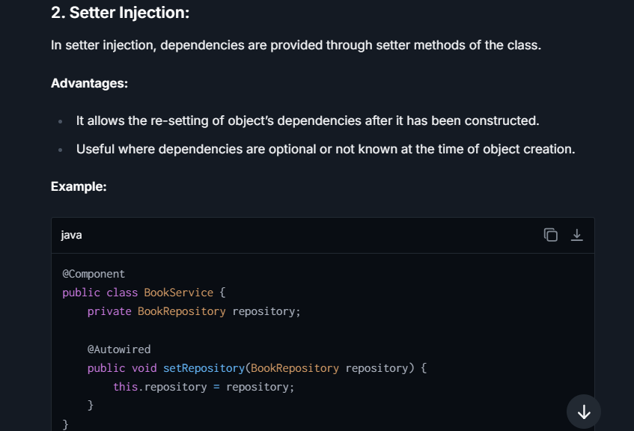  
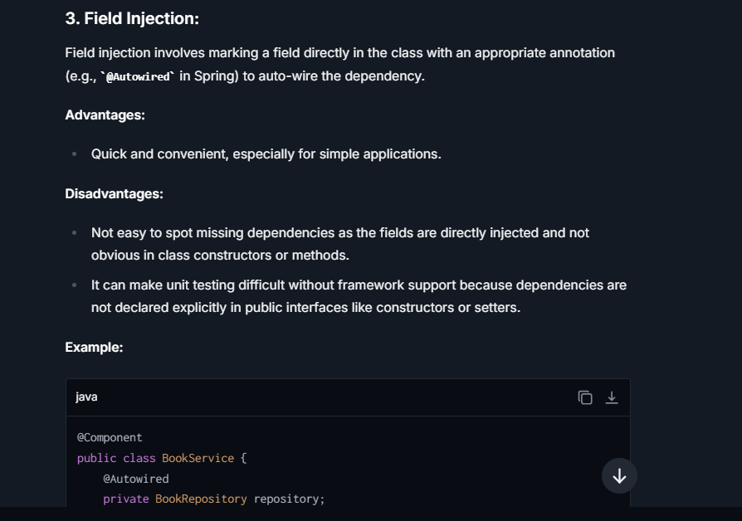

**Lesser Used Types of Injection**

**4. Interface Injection:** This type of injection involves defining an injector interface that client classes implement to allow a framework to inject the dependency through a setter method defined in the interface.

**5. Method Injection:** Sometimes used in scenarios where a given dependency is needed only for the duration of a method call, not for the life of the object. A method directly taking the dependency as a parameter is an example of this approach.

## **Advantage/disadvantage of all types of Injection and Uses?**

 Choosing the right type of injection depends significantly on the use case, and understanding their advantages and disadvantages can be crucial for designing robust Spring applications.

**1. Constructor Injection**

**Advantages:**

* **Immutability**: Constructor injection allows the injected dependencies to be final. This means they can't be changed once set, leading to safer, thread-safe components that are easier to reason about.
* **Ease of Determining Dependencies**: All mandatory dependencies of the bean are explicitly required in the constructor, making it easy to understand what dependencies are necessary for the bean to function.
* **Error Detection**: If dependencies aren't properly provided, the object won’t be constructed, which helps catch configuration errors early in the application lifecycle.

**Disadvantages:**

* **Verbosity with Many Dependencies**: The constructor could get very crowded if there are many dependencies, leading to unwieldy code.
* **Circular Dependencies**: Constructor injection can lead to circular dependencies that are hard to detect and resolve. Although the framework helps manage these, it can complicate the configuration.

**When to Use**: You should use constructor injection for mandatory dependencies and when aiming for immutability in your components, or when working with components that require all of their dependencies at instantiation time.

**2. Setter Injection**

**Advantages:**

* **Flexibility**: Not all properties have to be set via setters; you can pick what dependencies or properties to inject. This allows for optional dependencies.
* **Less Crowded**: If a class has many dependencies, setting them through setters rather than a lengthy constructor can make the code cleaner and more readable.

**Disadvantages:**

* **Incomplete Object State**: Using setter injection can lead to the situation where the object is constructed but not fully initialized with its dependencies, leading to potential errors.
* **Mutability**: Since dependencies can be changed after the object has been constructed, it might lead to concurrency issues unless managed carefully.

**When to Use**: Setter injection is suitable for optional dependencies and where dependencies might need to be reconfigured or reassigned. It’s also useful when you have too many dependencies causing the constructor approach to be impractical.

**3. Field Injection**

**Advantages:**

* **Ease of Use**: It’s straightforward to use as it doesn’t require additional constructors or methods. It leads to cleaner and less boilerplate code in simple scenarios.
* **Ideal for Tests**: Easily injecting mock dependencies in tests without having to create constructors or use setters.

**Disadvantages:**

* **Hidden Dependencies**: Field injection doesn’t enforce dependency declaration like constructor injection, making it harder to understand what dependencies are necessary at a glance.
* **Immutability and Access**: Injected fields typically aren't final, which can lead to mutability issues. Also, they can’t be private if you intend to replace them in unit tests without using Reflection.

**When to Use**: Field injection is particularly useful for injection in components managed by frameworks (like Spring MVC controllers), where the framework entirely controls the lifecycle. Also convenient in testing scenarios where dependencies need to be inserted directly.

**Conclusion:**

* **Constructor Injection** is the most recommended method for most use cases by the Spring team because it encourages immutable objects and clear declaration of dependencies.
* **Setter Injection** is helpful when dealing with optional dependencies or when the number of dependencies is too large, causing the constructor signature to be unmanageable.
* **Field Injection** should be used cautiously and is mostly suitable in specific framework-managed scenarios like Spring MVC where controllers are entirely lifecycle-managed by Spring.

## **What are the types of Stereotype annotation?**

Here are the primary stereotype annotations provided by Spring:

1. **@Component**: This is the generic stereotype for any Spring-managed component. Classes that are annotated with **@Component** are considered as candidates for auto-detection when using annotation-based configuration and classpath scanning.
2. **@Repository**: This annotation is a specialization of **@Component** and is used on classes that define the mechanism for storage, retrieval, search, update, and delete operation on objects. **@Repository** annotation also allows the Spring Framework to translate technology-specific exceptions into Spring’s DataAccessException when exception translation is enabled.
3. **@Service**: Another specialization of **@Component**, **@Service** is used on classes that hold business logic. It typically involves some operations, calls to external APIs, or database transactions.
4. **@Controller**: This annotation is used on classes that act as controllers in Spring MVC or Spring WebFlux. **@Controller** indicates that a particular class serves the role of a controller and is a specialization of **@Component**. It is capable of handling processing requests and returning responses.
5. **@RestController**: A specialized version of **@Controller** that simplifies creation of RESTful services. It combines **@Controller** and **@ResponseBody**, meaning that returned object from a **@RestController** method will automatically be serialized into JSON or XML and written into the HttpResponse object.
6. **@Configuration**: Although not traditionally listed with stereotypes, **@Configuration** is similar in that it indicates a component is used by Spring. It is used on classes that define beans directly through **@Bean** annotations. This signals to Spring that the class can be used by the Java Config dependency injection mechanism.

## **What are the Ways of Autowiring ?**

autowiring is a feature that allows you to inject dependencies automatically into your Spring beans. This feature minimizes the need to specify beans as properties or constructors in your Spring configuration file.   
The main types of autowiring supported by Spring are:

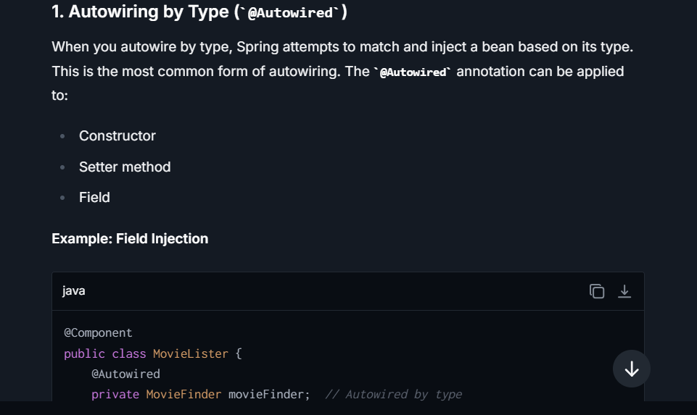

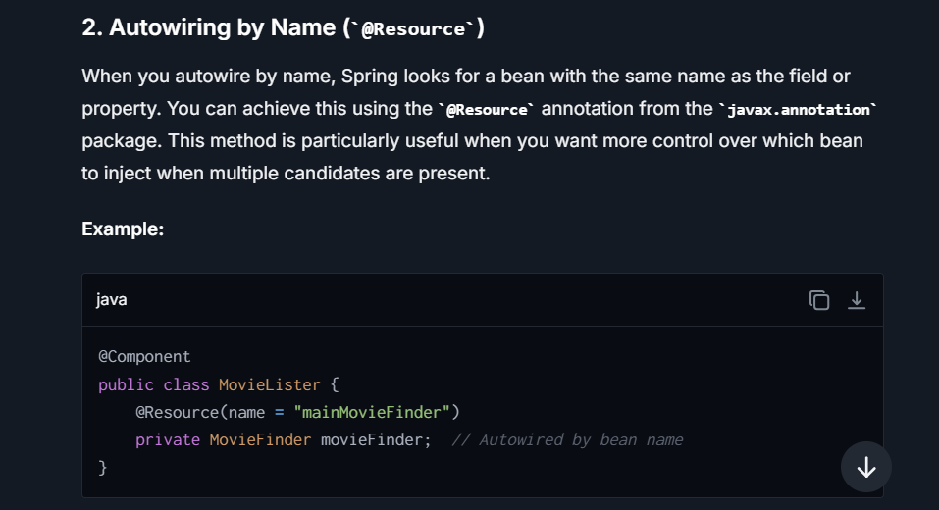

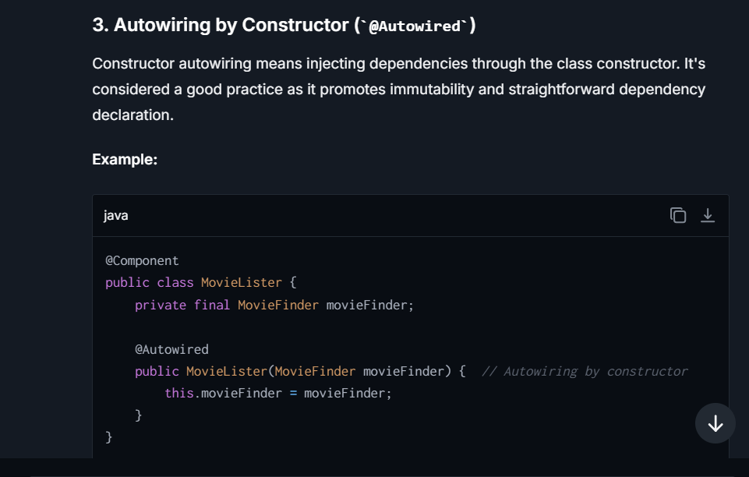

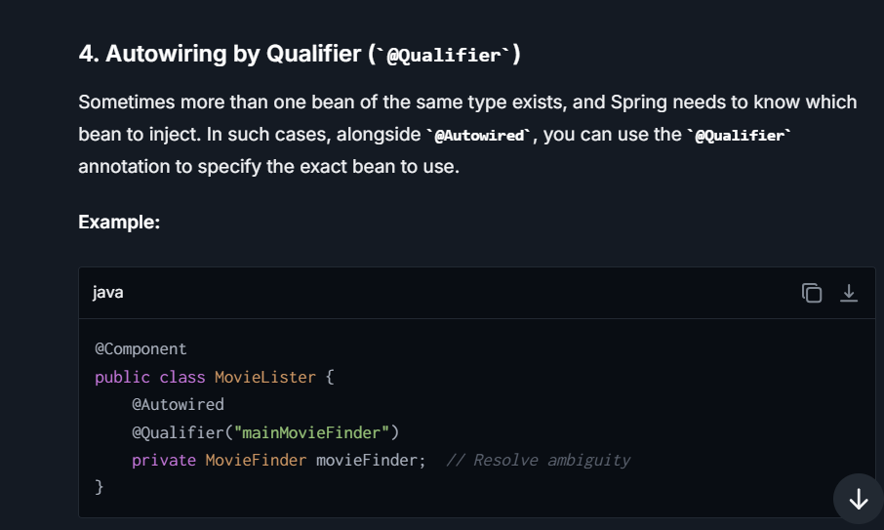

## **What is problem with @AutoWired annotation?**

The **@Autowired** annotation in Spring is used extensively for dependency injection, marking a dependency that Spring should inject. While it is a powerful and easy-to-use feature, there are a few potential downsides or challenges associated with its use:

1. **Overuse of Field Injection:**
   * **Hidden Dependencies:** Field injection (injecting directly into class fields) using **@Autowired** can lead to hidden dependencies, making it difficult to see what dependencies are actually necessary in the class constructor.
   * **Testing Challenges:** It can make unit testing harder because you cannot easily construct an instance without reflections or Spring, as the dependencies are directly injected into fields without setters or constructors.
2. **Null Safety:**
   * By default, **@Autowired** dependencies are required, and attempting to inject a **null** instance will result in an exception. However, you can make an autowired dependency optional by setting **@Autowired(required=false)**, but this can lead to objects not being properly initialized in some cases, potentially causing **NullPointerExceptions** at runtime.
3. **Tight Coupling with Spring:**
   * Using **@Autowired** ties your code to the Spring Framework directly, which can hinder the ability to use the class outside of a Spring container. This can be problematic when you need to migrate your code to a different framework or in environments where Spring is not a dependency.
4. **Difficulty in Debugging and Flow Tracking:**
   * When using **@Autowired**, especially with field or setter injections, it becomes difficult to trace the instantiation and configuration of components, which can complicate debugging and understanding the flow of an application.
5. **Ambiguities in Bean Resolution:**
   * If Spring finds multiple beans that match a dependency, it will throw an error unless disambiguated manually. This requires additional configuration such as using **@Qualifier** annotation to specify which bean should be injected.
6. **Influence on Container Performance:**
   * Relying heavily on runtime dependency resolution and injection can potentially have a slight performance impact, especially when the application context contains numerous beans.

## **What are the Autowiring modes ?**

In Spring framework, autowiring is a mechanism that allows Spring to resolve dependencies for your beans automatically. This is done based on predefined autowiring modes. When you use autowiring, Spring can automatically inject the dependencies either by type, name, constructor, or qualifiers. Below are the major autowiring modes available in Spring:

1. **No Autowiring (default)**:
   * **Mode:** **no**
   * Spring does not apply any autowiring. Dependencies should be explicitly injected through constructor arguments or properties setters in your bean configuration file.
2. **By Type**:
   * **Mode:** **byType**
   * Spring autowires the property if exactly one bean of the property type exists in the container. If more than one exists, a fatal exception is thrown, indicating that more than one bean is available for autowiring.
3. **By Name**:
   * **Mode:** **byName**
   * Spring autowires a property when its name matches the bean name in the configuration. The property name must exactly match the bean name. This is more straightforward but can be limited by naming conventions and refactoring.
4. **Constructor**:
   * **Mode:** **constructor**
   * Similar to byType, but this method applies to constructor arguments. If there's a constructor defined in your bean class, Spring tries to autowire the constructor arguments by matching with the beans defined by type in the configuration.
5. **Autodetect**:
   * **Mode:** **autodetect**
   * Spring first tries to autowire by constructor; if it does not succeed, it will try to autowire by type. This mode has been deprecated and is not recommended for use.
6. **Qualifier (not a mode but often used with autowiring)**:
   * When autowiring byType or constructor leads to multiple candidates, it becomes necessary to guide Spring on which bean to choose. You can specify the **@Qualifier** annotation alongside **@Autowired** to indicate exactly which bean should be autowired.

## **What is Autoconfiguration in Spring Boot ?**

The goal of autoconfiguration is to enable Spring Boot to intelligently configure application components as much as possible, based on the jar dependencies that you have added in the classpath and various environment settings.

**How Autoconfiguration Works:**

Spring Boot autoconfiguration attempts to automatically configure your Spring application based on the jar dependencies that you have added. For example, if you have added **spring-boot-starter-web**, it assumes you are developing a web application and sets up Spring MVC, Tomcat, and other related configurations automatically.

This is implemented primarily by the **@EnableAutoConfiguration** annotation, which is itself annotated with **@SpringBootApplication**. When you use the **@SpringBootApplication** annotation, it includes **@EnableAutoConfiguration** among other features like **@ComponentScan** and **@Configuration**.

## **@Configuration and @AutoConfiguration - what does it actually do in the spring boot app?**

**@Configuration**

It is used in Spring to indicate that a class declares one or more **@Bean** methods and may be processed by the Spring container to generate bean definitions and service requests for those beans at runtime. This is a core feature of Spring's Java-based configuration mechanism.

Here’s what happens with **@Configuration**:

* **Bean Definition**: Classes marked with **@Configuration** provide methods with **@Bean** annotations that create and return object instances. Spring treats these method return values as beans and manages them in the Spring container.
* **Full Support for Dependency Injection**: Beans created in a **@Configuration** class can depend on other beans via constructor injection or using the **@Autowired** annotation.
* **Advanced Features**: **@Configuration** classes support other features such as **@Import** (to import other configuration classes), **@Profile** (to conditionally load beans for specific profiles), and inter-bean method calls.

**@EnableAutoConfiguration**

**It**  is a key annotation in Spring Boot, which enables Spring Boot’s powerful auto-configuration feature. This annotation tells Spring Boot to automatically configure your application based on the dependencies that you have added in the project.

For example, if you add a **spring-boot-starter-web** dependency, Spring Boot auto-configures beans necessary to develop a web application, like DispatcherServlet, ResourceHandlers, and MessageResolvers among others. This is done without needing to explicitly write any boilerplate code or configuration setups.

Here’s what happens with **@EnableAutoConfiguration**:

* **Conditional Configuration**: It relies on Spring Boot’s **@Conditional** annotations that determine what configuration should apply based on certain conditions, such as class presence in the Classpath, existing beans, property settings, etc.
* **Automatic Bean Creation**: It automatically creates and registers beans based on the libraries present on the classpath or other criteria.
* **Configuration Avoidance**: It reduces the need for specified configurations that are typically boilerplate and repetitive.

## **How you exclude Auto-Configuration for the spring boot application?**

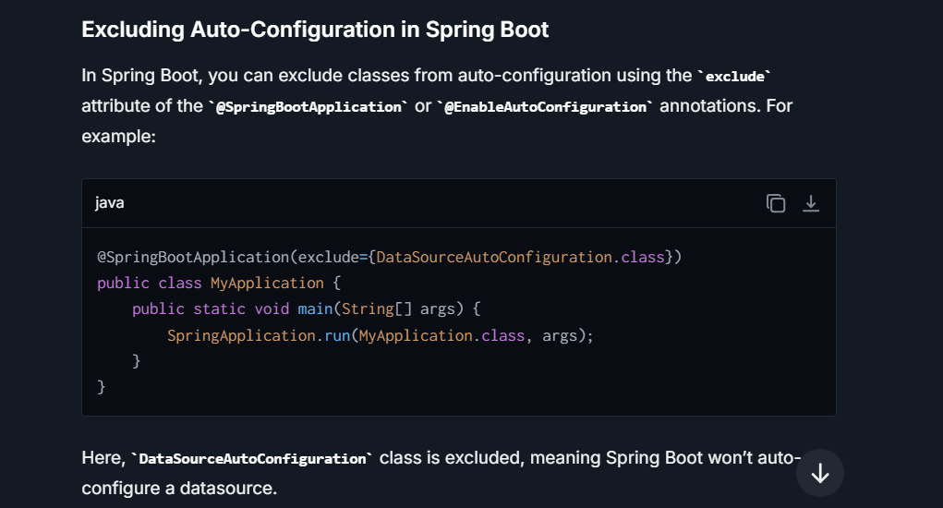

## **What is scope of Spring bean? how can you change it??**

The default scope of a Spring Bean is "singleton". This means once a singleton bean is instantiated, Spring IoC container will use the same bean instance every time that bean is requested in the application.

**Changing the Scope of a Spring Bean:**

You can change the scope of a bean by using the **@Scope** annotation.

**Beans** can be defined with different scopes that determine how the instances of these beans are created, reused, and managed within the application context. The scope of a bean directly influences its lifecycle and how it is shared among objects that depend on it. Below are the most commonly used scopes:-

**1. Singleton (Default Scope)**

The singleton scope is the default scope in Spring. A bean defined as a singleton will have exactly one instance in the Spring container. No matter how many times it is requested, the same object instance is returned. This is particularly useful for stateless beans where the same configuration can be shared across multiple clients.

**2. Prototype**

A prototype-scoped bean will result in the creation of a new bean instance every time it is requested. This is useful for all beans that are meant to have state specific to a particular process or user session.

**3. Request**

This is a web-aware scope and is only valid in the context of a web-aware Spring ApplicationContext. A request-scoped bean is created once per HTTP request; each HTTP request has its own instance of a bean created off the container. This is useful when you intend to maintain bean state during an HTTP request.

**4. Session**

Similar to request scope, session scope is also specific to web applications. A bean defined as session-scoped will be created once per HTTP session. As long as the HTTP session is alive, the same bean instance will be returned to the application. This is useful for user session-specific data.

**5. Application**

The application scope creates a bean instance for the lifecycle of a ServletContext. This is similar to the singleton scope, but instead of being bound to the Spring application context (global across all servlet-based contexts), the bean is scoped to a ServletContext. Only one instance of the bean is created and shared across all servlet-based contexts.

**6. WebSocket**

A websocket-scoped bean is defined for the lifecycle of a WebSocket. This is useful specifically in web applications making use of WebSocket connections.

It's important to choose the appropriate bean scope based on the usage requirements, as each scope has its specific purpose and affects how your application consumes resources and manages data consistency.

## **What are spring Scopes, when I have single and prototype, how u make sure protype is used?**

**Spring**, **Bean Scopes** define the **lifecycle** and **visibility** of a bean (an object managed by the Spring IoC container). A *scope* controls how and when a bean is instantiated and how many instances of the bean are created or shared.

By default, Spring provides **five bean scopes**, with the **singleton** and **prototype** scopes being the most commonly used.

**Types of Spring Scopes**

| **Scope** | **Description** |
| --- | --- |
| **singleton** | (Default) Only **one instance** of the bean is created in the Spring IoC container, shared across the entire application context. |
| **prototype** | A new bean instance is created every time the bean is requested (not shared). |
| **request** | Scoped to the **lifecycle of an HTTP request** (web applications only). A new bean instance is created for each HTTP request. |
| **session** | Scoped to the **HTTP session lifecycle**. A new instance is created and shared within the same session scope. |
| **application** | Scoped to the **ServletContext lifecycle**. Shared across all servlets in the same **ServletContext**. |
| **websocket** | Scoped to the **lifecycle of a WebSocket session** (web applications only). Shared across the same WebSocket session. |

**How to Make Sure Prototype Scope is Used Correctly?**

When using prototype scope in combination with other singleton beans, you must ensure that a **new instance** of the prototype bean is used for **each request**, even when the singleton bean holds a reference to it. Since the singleton scope maintains a single shared instance, directly injecting a prototype bean into a singleton bean will result in the **prototype bean being initialized only once** (during singleton creation).

**1. Using ApplicationContext.getBean()**

You can programmatically retrieve the prototype bean from the Spring container using the **ApplicationContext** whenever it is needed.

**2. Using ObjectProvider**

**ObjectProvider** is a lightweight wrapper introduced in Spring Framework 4.3 for obtaining beans lazily without directly depending on **ApplicationContext**.

**3. Using @Lookup Annotation**

The **@Lookup** annotation tells Spring to override the method that returns the prototype bean, ensuring the method always provides a new instance

**4. Using ScopedProxy (for Dependency Injection in Web Applications)**

In cases where a prototype bean is injected into a singleton bean and used in a multi-threaded environment, you can use a **scoped proxy** to ensure thread safety. Spring creates a proxy for the prototype bean and delegates calls to the actual prototype instance.

**When Should You Use Prototype Scope?**

1. **Stateful Beans**:
   * When you need a unique instance of your bean for processing individual client requests or user operations.
   * Example: A **TaskProcessor** class that processes independent tasks and must not share state across thread executions.
2. **Memory-Efficient Use of Resources**:
   * To avoid keeping redundant objects in memory for the entire application lifecycle. For example, objects requiring heavy initialization but with a short lifespan.

**When Should You Use Singleton Scope?**

1. **Stateless Beans**:
   * When a single shared instance is sufficient for the application.
   * Example: Utility classes, database connection pools, or configuration handlers.
2. **Global Resources**:
   * Components such as service layers and DAOs, which don’t store user-specific states and are safe to share between multiple threads.

## **What is Flow of hit Api from postman🡨🡪 response?**

When you interact with an API developed using Spring MVC via a tool like Postman, several components within the Spring framework and the underlying server work together to process the request and generate a response.   
**Here’s a detailed step-by-step overview of the flow:**

**1. Sending the Request from Postman**

You start by sending a request from Postman. This can be any HTTP request such as GET, POST, PUT, DELETE, etc. The request will include various elements like headers, URL paths, query parameters, and possibly a body (for POST and PUT requests).

**2. Receiving the Request by the Server**

The server that hosts the Spring MVC application (e.g., Tomcat, Jetty, or Undertow) receives the request.

**3. Dispatching Request to the DispatcherServlet**

The initial handling of the request on the Spring side is done by the **DispatcherServlet**. This is a front controller in the Spring MVC framework that ensures that incoming requests are dispatched to the correct handlers.

**4. Filter Chain**

Before reaching the **DispatcherServlet**, the request must pass through a series of filter chains defined in the context:

* **Security Filters**: If Spring Security is integrated, this can include authentication and authorization checks.
* **Logging and Auditing Filters**: Filters to log request data or perform audit checks.
* **CORS Filters**: Handle Cross-Origin Resource Sharing if configured.
* Custom Filters (**@Filter**): You may have custom filters set up for tasks like request modification, additional security checks, etc.

Filters can modify the incoming request or the response objects and decide whether or not to pass the request further down the chain.

**5. Handler Mapping**

The **DispatcherServlet** consults one or more **HandlerMapping** components to determine which controller should process the request based on the URL path and other request attributes.

**6. Handler Interception**

Before the chosen handler method is invoked, the request might be intercepted by one or more configured **HandlerInterceptor** implementations:

* **Pre-processing (preHandle method)**: This might involve tasks like logging, security checks, or preprocessing tasks. This method must return **true** to continue the request execution, or **false** if the flow should be interrupted.
* If **preHandle** returns **false**, the post-processing (**postHandle**) and after completion (**afterCompletion**) methods will typically not be executed.

**7. Controller Handling**

Once the appropriate controller is identified, the **DispatcherServlet** routes the request to it. Controllers in Spring MVC are annotated with **@Controller** and typically have methods annotated with **@RequestMapping** or one of its shorthand variants (**@GetMapping**, **@PostMapping**, etc.) which define specific handling functions for different endpoints.

**8. Business Logic Execution**

The controller calls the necessary services or components needed to process the request. This usually involves business logic which may interact with a database or other services. This part of the process is where the application-specific operations occur, such as querying a database, processing data, etc.

**9. Model Preparation**

Once the business logic is executed, the result is typically placed in a model, a data structure used to pass data between the controller and the view (if the app uses server-side rendering) or back to the **DispatcherServlet** which then constructs the response body.

**10. View Resolution**

For API services, rather than resolving a view for rendering HTML (which is typical in web applications), data is usually returned in JSON or XML format. In Spring MVC, this is often handled automatically by **HttpMessageConverters**. Depending on the content negotiation configuration and request headers (like **Accept: application/json**), Spring converts the response data to the requested format.

**11. Returning the Response**

The formatted data is sent back to the **DispatcherServlet**, which compiles the final response (including correct HTTP headers, status code, and body) and sends it back to the client (Postman, in this scenario).

**12. Response Received by Postman**

Finally, Postman receives the HTTP response generated by the server. You can view the status code, headers, and any response data provided by the server in the Postman interface.

## **How to enable debugging log in the spring boot application?**

It can be done in several ways, depending on the logging framework in use (e.g., Logback, Log4J2) and your specific needs. Spring Boot uses SLF4J with Logback by default.

**1. Application Properties or YAML**

One of the simplest ways to enable debug logging is via the application's configuration files (**application.properties** or **application.yml**).

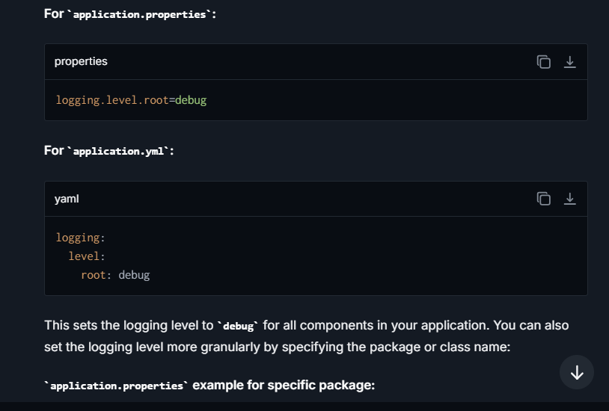

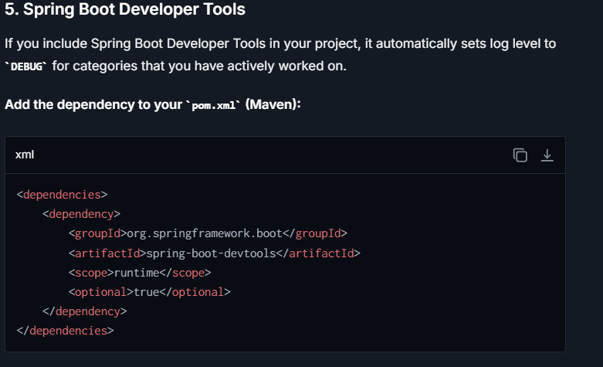  
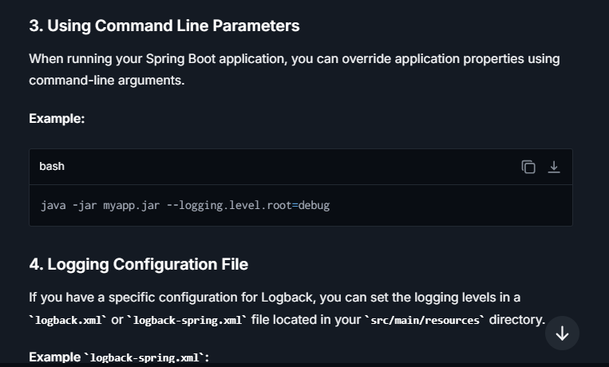

## **What is Spring Actuator ? Explain in detail.**

It provides a series of production-ready features that aid in monitoring and managing a Spring Boot application. Features range from monitoring the app’s health and metrics to understanding traffic or the state of your database. The Actuator is primarily designed to help you monitor your applications in production, providing crucial insights and metrics.

**Key Features of Spring Boot Actuator:**

**1. Health Checks:** Actuator provides a health indicator feature which can be accessed via HTTP endpoint **/actuator/health**. This endpoint shows application health information (like database, message broker connection, disk space) which is useful for system monitoring and uptime checks.

**2. Metrics:** Actuator exposes a range of metric data such as JVM memory usage, HTTP requests statistics, datasource metrics, cache statistics, and more through the **/actuator/metrics** endpoint. You can dive into each metric to see more detailed statistics which are useful for diagnosing performance issues.

**3. Application Info:** Endpoints like **/actuator/info** can be configured to display general information about your application, which might include build version, project name, or other custom information like relevant contact details.

**4. Auditing:** Actuator can support auditing, traceability, and understanding the traffic received by the application via HTTP trace and audit events, showing each request-response session details.

**5. Thread Dump:** Through the **/actuator/threaddump** endpoint, the actuator produces a complete thread dump, which helps in diagnosing deadlock or performance issues by showing which threads are running, are in deadlock, or waiting on resource.

**6. Logging Configuration:** Spring Boot Actuator allows downloading and dynamically changing logging levels of your application at runtime without restarting your app, accessible via **/actuator/loggers** endpoint.

**7. Dynamic Configuration:** Certain aspects of the application configurations, such as feature flags or caching parameters, can be updated on the fly using the actuator’s environment and config properties endpoints.

**8. Custom Endpoints:** In addition to predefined endpoints, Actuator allows developers to create custom endpoints as per their business needs. This can be useful for exposing application-specific metrics or operations.

**Security with Actuator:**

Given the sensitive nature of the data exposed by some of these endpoints, securing them is crucial. Actuator endpoints are secure by default - most of them are only available via JMX by default, and require explicit HTTP exposure. You can also integrate Spring Security to add further restrictions, like IP whitelisting, HTTPS, or basic authentication.

**Setting Up Actuator:**

Including Actuator in a Spring Boot project is simple. Add the following dependency to your **pom.xml** or **build.gradle**:

## **What is the benefit of using spring other than java EE apps? Explain**

Spring Framework offers several advantages over traditional Java EE applications, and these benefits are not just technical but also pertain to the overall developer experience, project management, and application performance. Here Some Benefits :-

**->Simplified Development with Inversion of Control (IoC) and Dependency Injection (DI):**

* + Spring promotes loose coupling through DI and IoC. The framework manages the lifecycle and configuration of application objects, which reduces the dependency-related boilerplate code and eases unit testing. In contrast, Java EE also supports DI (e.g., via CDI - Contexts and Dependency Injection), but Spring’s DI is more versatile and easier to configure, especially with annotations and Java-based configuration.

-> **Comprehensive Data Access Integration:**

* While Java EE provides JPA for ORM, Spring Data JPA integrates with the JPA and simplifies data access layers even further by reducing boilerplate code, providing repository support with handy, ready-to-use interfaces, and easily integrable custom query methods. Spring also supports extensive integrations with other data management systems like JDBC, JMS, and JTA out-of-the-box, which can sometimes be more cumbersome in Java EE

-> **Flexible Transaction Management:**

* Spring offers a consistent transaction management interface that can scale down to a local transaction (using a single database, for example) and scale up to global transactions (JTA). This is achieved using Spring’s abstraction over different transaction management APIs, providing a simpler and consistent programming model compared to Java EE

**-> Better Testability:**

Due to DI and IoC, Spring applications are easier to unit test compared to traditional Java EE applications. Spring also provides first-class support for integration testing with baked-in support for test configurations and caching.

**Microservices Ready:**

Spring Boot makes Spring-based applications ready for the microservices architecture with minimal configurations. It provides a vast array of features to support building and deploying microservices, including Spring Cloud for handling distributed system-related challenges

## **Benefits of using application.yaml over application.properties? Explain**

* **Organization**: YAML files use a clear, hierarchical structure which can be easier to understand and manage, especially for large configurations with nested properties.
* **Readability**: YAML generally requires less syntax than **.properties** and supports comments which make it more readable.
* **Support for Complex Structures**: YAML naturally supports lists and complex hierarchical configurations, which can be cumbersome in **.properties** files.

## **What is Spring Profiles and benefits in spring boot ?**

**Profiles** are a powerful feature used to segment parts of the application configuration and make it available only in certain environments. This capability is essential in modern application development, which often involves multiple environments for development, testing, staging, and production.

**Uses of Profiles:**

**1. Environment-Specific Configuration:** The primary use of profiles is to manage environment-specific configurations. You can define different application properties or even different bean definitions that should only be activated under specific profiles. For example, you might use an in-memory database like H2 for development (**dev** profile) and a production-grade database like PostgreSQL for production (**prod** profile).

**2. Controlled Deployment:** Profiles can control which components are included in the application at runtime. This helps in streamlining deployments and reducing the surface area of the application during specific stages. For instance, certain background tasks or scheduled jobs might be disabled in a development environment to conserve resources.

**3. Simplifying Test configurations:** During testing, certain configurations can be enabled to facilitate testing scenarios, like profile-specific data setups or mocking external services. Profiles can help avoid polluting the production configuration with test-specific settings.

**4. Feature Flags:** Profiles can act as feature flags, enabling or disabling features in certain environments without changing the codebase. This enables safer rollouts and faster reverts if issues are detected.

**Benefits of Using Profiles:**

**1. Flexibility**: Easily change the application's behavior without changing the code, just by activating different profiles.

**2. Simplicity**: Keep all configurations for different environments in one codebase without any branches or complex conditional logic.

**3. Improved Security**: Avoid pushing sensitive production credentials into version control by isolating them in profile-specific configurations that aren't shared.

**4. Enhanced Testing**: Quickly test how components behave under different configurations or in different environments by switching profiles.

## **What are the Spring Callbacks?**

In the Spring Framework, callbacks are methods that are called at specific points within the lifecycle of a bean, allowing custom logic to be executed during these moments. These callbacks can be used to perform certain actions when beans are created, initialized, or destroyed, offering a hook into the Spring lifecycle management process.

Here are the primary types of Spring callbacks:

**1. InitializingBean and DisposableBean:**

Spring provides two lifecycle interfaces for beans: **InitializingBean** and **DisposableBean**.

* **InitializingBean**: Beans that need to perform some initialization after all their necessary properties have been set by the Spring container can implement this interface. The container calls the **afterPropertiesSet()** method once all the bean's properties have been set.

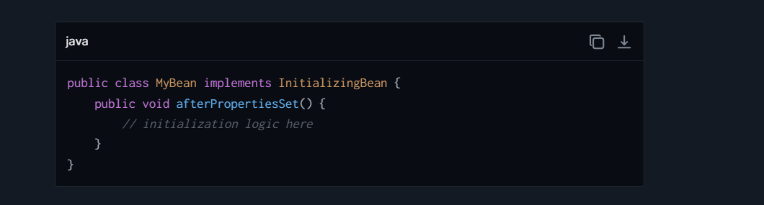

* **DisposableBean**: If a bean needs to release resources upon shutdown of the container, it can implement this interface. The **destroy()** method is called by the Spring container during the destruction phase of the bean's lifecycle.

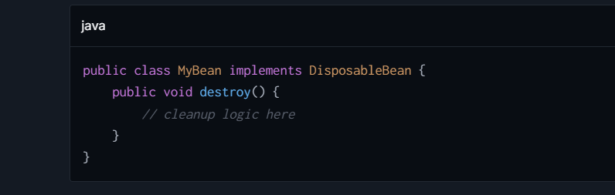

**2. Bean Post Processors**

Bean Post Processors allow additional processing before and after the bean initialization callback. You can modify new bean instances before and after their initialization (post-construction and pre-destruction).

* **BeanPostProcessor**: This interface consists of two callback methods:
  + **postProcessBeforeInitialization(Object bean, String beanName)**: called before a bean's initialization methods (like **InitializingBean.afterPropertiesSet** or custom init-method).
  + **postProcessAfterInitialization(Object bean, String beanName)**: called after a bean's initialization methods.

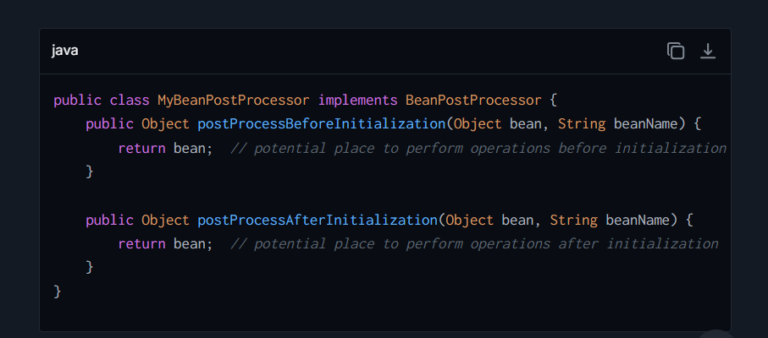

**3. Custom init-method and destroy-method**

The XML configuration or **@Bean** annotations in Java Configuration allows specifying custom 'init-method' and 'destroy-method'. The specified methods are called on bean instantiation and destruction respectively.

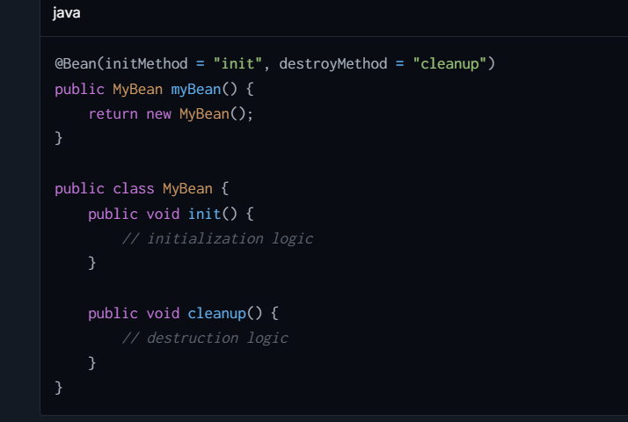

**4. @PostConstruct and @PreDestroy Annotations**

These annotations from the Java EE package **javax.annotation** can be used for more annotation-driven configuration:

* **@PostConstruct**: This annotation is used on a method that needs to be executed after dependency injection is complete to perform any initialization.

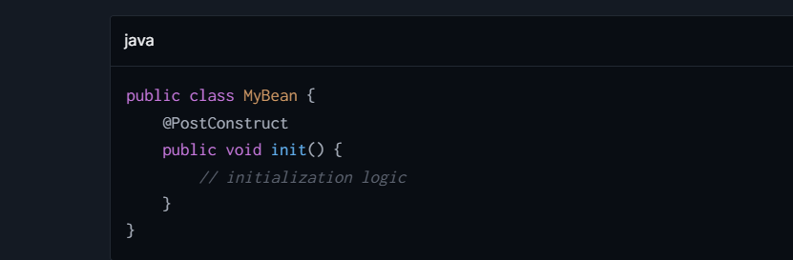

* **@PreDestroy**: This annotation is used on methods that are mapped to perform cleanup or shutdown operations just before the bean is destroyed by the container.

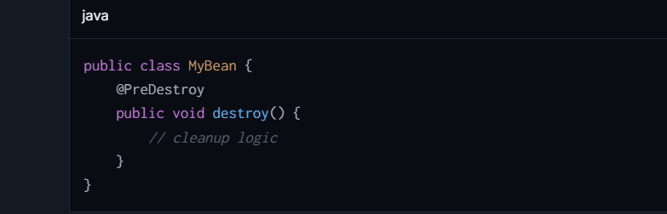

## **What is Spring Bean Life Cycle?**

 the lifecycle of a Spring bean refers to the series of phases that a bean undergoes from the moment it is instantiated until it is destroyed. Understanding the bean lifecycle is crucial for leveraging advanced features of the Spring Framework, such as custom lifecycle callbacks, bean post-processors, and more. Here is a theoretical overview:

**1. Instantiation**

The process starts with the instantiation of a bean. At this point, Spring reads the bean definitions provided either via XML configuration files, annotations, or Java config classes, and creates a bean instance.

**2. Populate Properties**

Once the bean is instantiated, Spring injects the bean's properties. This can involve simple direct values or references to other beans managed by the Spring container. This phase relies heavily on Spring's Dependency Injection (DI) capabilities.

**3. Awareness Interfaces**

If the bean implements any of Spring’s awareness interfaces like **BeanNameAware**, **BeanClassLoaderAware**, **BeanFactoryAware**, etc., the corresponding methods are called. Through these, the bean can access the Spring framework’s functionality and get information about its environment.

**4. Bean Post Processors (Before Initialization)**

Before the bean is fully initialized, the **postProcessBeforeInitialization** methods of any bean post-processors are called. This allows for customization of the bean before it is ready to use, such as wrapping it with a proxy.

**5. Initialization**

If the bean implements **InitializingBean**, the **afterPropertiesSet** method is executed. Alternatively, if a custom **init-method** is specified, it is called. This phase is used for performing any initialization logic needed by the bean.

**6. Bean Post Processors (After Initialization)**

After the bean initialization, the **postProcessAfterInitialization** methods of any bean post-processors are called. Similar to the pre-initialization phase, this allows further modification of the bean instance.

**7. Ready for Use**

At this point, the bean is fully initialized and ready to be used by the application. It can now be retrieved and managed by the Spring container, and its methods can be invoked.

**8. Destruction**

On the shutdown of the Spring container, if the bean implements **DisposableBean**, the **destroy** method is executed. Similarly, if the bean's definition contains a **destroy-method**, it is called. This phase is used to release resources the bean may be holding, or perform any other cleanup necessary before the bean is destroyed.

**9. Bean Post Processors (Before Destruction)**

The **postProcessBeforeDestruction** methods are executed if any destruction-aware post-processors are defined. This step is executed before the actual destruction methods (**destroy** or **destroy-method**) and allows custom pre-destruction behavior.

## **What is HTTP Status Code?**

HTTP status codes are standardized responses that servers use to tell a client about the result of its request.

* **200 OK:** The request has succeeded. The meaning of the success depends on the HTTP method: GET: The resource has been fetched and transmitted in the message body.
* **201 Created:** This means that the request has succeeded and resulted in one or more new resources being created.
* **204 No Content:** The server successfully processed the request, but is not returning any content.
* **301 Moved Permanently:** This response code means that the URI of the requested resource has been changed permanently. The new URI is given in the response.
* **302 Found:** This status code indicates that the resource requested has been temporarily moved to the URL given by the Location header. A browser redirects to this page but search engines don't update their links to the resource (in 'SEO-speak', it is said that the 'link-juice' is not sent to the new URL).
* **304 Not Modified:** Indicates that the resource has not been modified since the version specified by the request headers If-Modified-Since or If-None-Match. This is used for caching purposes.
* **400 Bad Request:** The server cannot or will not process the request due to an apparent client error (e.g., malformed request syntax, invalid request message framing, or deceptive request routing).
* **401 Unauthorized:** Although the HTTP standard specifies "unauthorized", semantically this response means "unauthenticated". That is, the client must authenticate itself to get the requested response.
* **403 Forbidden:** The request was a valid request, but the server is refusing to respond to it. Unlike 401, the client's identity is known to the server.
* **404 Not Found:** The server cannot find the requested resource. In the browser, this means the URL is not recognized. In an API, this can also mean that the endpoint is valid but the resource itself does not exist.
* **500 Internal Server Error:** The server encountered an unexpected condition that prevented it from fulfilling the request.
* **502 Bad Gateway:** The server, while acting as a gateway or proxy, received an invalid response from an inbound server it accessed while attempting to fulfill the request.
* **503 Service Unavailable:** The server is not ready to handle the request. Common causes are a server that is down for maintenance or that is overloaded.

## **What would HttpStatus be for POST endpoint for success?**

For POST requests, which typically create a new resource, the common HTTP status codes to indicate success are:

1. **201 Created**: This is the most appropriate and widely used HTTP status code for a successful POST request where a new resource has been created on the server. It indicates that the request has succeeded and led to the creation of a new resource. It's a signal to the client that the request met with success, and a new entity was established.
   * **Example**: When a new user account is created as a result of a POST request, the server should ideally respond with the status code **201 Created**.
2. **200 OK**: This status code can be used if the POST request has led to the successful manipulation or handling of a resource but hasn't necessarily resulted in the creation of a new resource. It simply means the request succeeded.
   * **Example**: If a POST request is made to send an email and the action is performed successfully without the creation of a new resource on the server, the server might appropriately respond with **200 OK**.
3. **202 Accepted**: This status code can be used if the server

## **What are the frameworks for develop java enterprise application ?**

Java enterprise applications require robust frameworks that can handle complex business logic, database operations, high scalability, and security demands. Here are some popular frameworks that are well-suited for developing Java enterprise applications:

**1. Spring Framework (and Spring Boot)**

Spring remains the most popular framework for developing enterprise applications in the Java ecosystem. It provides comprehensive infrastructure support for developing Java apps, offering features such as Dependency Injection, Aspect-Oriented Programming, transaction management, and more. Spring Boot, a part of the Spring ecosystem, simplifies the creation of stand-alone, production-grade Spring-based applications.

**2. Jakarta EE (formerly Java EE)**

Jakarta EE is the evolution of the old Java EE (Java Platform, Enterprise Edition) and provides APIs for creating scalable, multi-tiered, reliable, and secure network applications. It includes various specifications like JPA (Java Persistence API), JMS (Java Messaging Service), JSF (JavaServer Faces), and EJB (Enterprise JavaBeans).

**3. Quarkus**

Quarkus is a Kubernetes-native Java framework tailored for GraalVM and HotSpot, designed for high-performance and efficiency in cloud environments. It's known as a "Supersonic Subatomic Java" framework, offering first-class support for reactive programming and ensuring that applications use only the resources they need.

**4. Micronaut**

Designed for building modular, easily testable microservice applications, Micronaut is another modern framework optimized for minimal memory footprint and fast startup time. It supports application context and Dependency Injection container, aspect-oriented programming, and management endpoints for health, metrics, and more.

**5. Vert.x**

Eclipse Vert.x is a tool-kit for building reactive applications on the JVM. While not a framework in the traditional sense, it allows building robust, scalable, and concurrent systems typically required by modern enterprise applications. It supports traditional imperative programming as well as reactive, event-driven programming.

**6. Apache Camel**

Apache Camel is an integration framework that empowers you to quickly and easily integrate various systems consuming or producing data. It implements many Enterprise Integration Patterns (EIPs) and connects to a plethora of systems and APIs. Although not a full-stack framework, it's extremely useful for enterprise application integration needs.

**7. Play Framework**

For applications that require a high-velocity development web component, Play Framework provides developers with a clean and streamlined platform. It supports Scala and Java and is reactive in nature, built on top of Akka providing support for WebSockets and Actor-based concurrency.

**8. Hibernate**

While primarily known as an ORM (Object-Relational Mapping) tool, Hibernate has become integral to many Java EE applications, handling database interactions efficiently. It abstracts away the complexity of database interactions, allowing for more robust and cleaner database operations, often fulfilling the role of JPA provider.

**9. Spring Batch & Spring Integration**

Specialized libraries under the broader Spring ecosystem, these are designed for handling batch processing and integration scenarios, both typically needed in larger enterprise environments for transaction management and data-pipeline processing.

**Selection Consideration**

## **What are the safe and Idempotent method ?**

In the context of HTTP methods (used by APIs and web services), the concepts of "safe" and "idempotent" methods are important features that describe how requests impact the state of the server and the expectations of repeated requests.

**Safe Methods:**

A safe HTTP method is one that can be called without causing any side effects on the server – meaning it does not result in a change in server state. Essentially, safe methods are intended only for retrieving data and should not result in changes or side effects. This allows them to be used freely without concerns about unintended consequences on the server.

**Examples:**

* **GET**: Used to retrieve data. A GET request is expected to only fetch data without changing any data on the server.
* **HEAD**: Similar to GET, but it retrieves only the status line and header section of the response. It's used for obtaining meta-information written in response headers, without transferring the body.
* **OPTIONS**: This method is used to describe the communication options for the target resource, giving the client information about what other methods are supported.

**Idempotent Methods:**

An idempotent HTTP method is one where multiple identical requests will have the same effect on the server's state as a single request, regardless of the number of times it is repeated. This means that after the method executes once, any further executions of the same method (with the same parameters) do not affect the result.

**Examples:**

* **GET**: Apart from being safe, GET is also idempotent since making the same GET request multiple times will not change the state beyond the first request.
* **HEAD** and **OPTIONS**: Being safe, these are naturally also idempotent.
* **PUT**: This method is used to update a resource in its entirety. If a PUT request is made to update a resource with a particular state, making the same PUT request again with the identical data should leave the resource in the same state. Thus, PUT is idempotent.
* **DELETE**: Used to delete a resource. The first DELETE request changes the state by deleting the resource, but subsequent identical DELETE requests should not have any effect (as the resource is already deleted), making it idempotent.

**Non-Idempotent Method:**

* **POST**: Generally used to create new resources. Since repeating POST requests will typically continue to create new resources or trigger new actions, it is not idempotent.

## **What is Event driven approach in spring boot?**

In Spring Boot, the event-driven approach is facilitated primarily through the Spring Framework's event handling and asynchronous execution capabilities. This model allows your application to handle tasks and react to events in a decoupled, scalable, and flexible manner.  
 **How Events are Used in Spring Boot:**

**1. Built-in Events:** Spring Boot and the underlying Spring Framework automatically publish various types of system and framework events. Examples include:

* **ContextRefreshedEvent**: Published when the ApplicationContext is initialized or refreshed.
* **ContextClosedEvent**: Published when the ApplicationContext is closed.
* **ServletRequestHandledEvent**: In web applications, published after a request is handled.

**2. Custom Events:** Developers can create their own application-specific events, extending the **ApplicationEvent** class, and publish them using the **ApplicationEventPublisher**

## **Define ORM**

ORM stands for Object-Relational Mapping, which is a technique used in programming to facilitate the conversion of data between incompatible systems. In simpler terms, ORM is a method of accessing a relational database using an object-oriented programming language. It provides a bridge between the object-oriented domain model (classes) and the relational database model (tables), allowing a developer to write code against a conceptual object model rather than dealing directly with SQL queries and database schemas.

**Key Concepts of ORM:**

* **Object-Relational Impedance Mismatch**: Traditional relational databases and object-oriented languages handle data and relationships differently. ORM aims to bridge these differences by providing techniques to map data between objects (classes) and relational database tables seamlessly.
* **Persistence Layer**: ORM acts as a persistence layer, managing the storage of objects' state in a database and retrieving them as needed. This abstraction allows the developer to focus more on the business logic rather than database interactions.
* **Data Querying**: ORM frameworks usually provide data querying capabilities that allow fetching objects using methods that resemble object-oriented behavior rather than direct SQL queries.

## **Difference between Spring vs Spring Boot in table form**

| **Feature** | **Spring** | **Spring Boot** |
| --- | --- | --- |
| **Core Concept** | Spring is a framework used for developing enterprise applications with extensive infrastructure support such as Dependency Injection, Aspect-Oriented Programming, transaction management, etc. | Spring Boot is built on top of Spring and simplifies the configuration and deployment of Spring applications. It focuses on convention over configuration to reduce developer effort. |
| **Configuration** | Requires detailed setup and configuration (XML or annotation-based). Developers need to spend more time on configuration aspects. | Minimal configuration needed. Spring Boot uses auto-configuration and starters to simplify the use of the Spring framework. |
| **Project Setup** | Typically involves manually setting up and configuring each aspect of the Spring framework (data, MVC, security, etc.). | Provides a suite of tools for quick setup, including the Spring Initializr web tool for easy bootstrapping of a project. |
| **Embedded Servers** | Does not include embedded servers; requires manual setup to deploy to web servers like Tomcat, Jetty, or others. | Comes with embedded servers (like Tomcat, Jetty) for ease of development and testing. Allows running standalone applications using **java -jar**. |
| **Microservices Ready** | Can be used to build microservices but requires manual configurations and setup for things like service registries, configuration servers, etc. | Provides native support for microservices patterns with easy integration of Spring Cloud for handling service discovery, configuration, and resilience. |
| **Dependency Management** | Manages dependencies explicitly; developers must define all required frameworks and libraries. | Uses starters to manage dependencies - a collection of dependency descriptors that can be included in the application to enable specific features. |
| **Standalone Usage** | Primarily designed for integration into larger systems or server environments. | Designed to develop standalone, production-grade applications quickly and easily. |
| **Time to Production** | Takes more time from concept to production due to configuration and integration complexities. | Faster development to production time due to the convention over configuration approach and automated setup. |
| **Community and Support** | Well-established community, extensively documented with a large number of users. | Inherits Spring’s solidity and community, while increasingly becoming the default for new Spring applications due to its ease of use. |
| **Use Case Examples** | Appropriate for large-scale enterprise applications where fine-grained configuration control is needed. | Ideal for microservices, cloud-based applications, and for developers looking for a quick entry into Spring applications. |

## Difference between Authentication and Authorisation

| **Aspect** | **Authentication** | **Authorization** |
| --- | --- | --- |
| **Definition** | Process of verifying the identity of a user or system. It confirms who the user is. | Process of verifying what access rights a user or system has after their identity is confirmed. It determines what users can and cannot do. |
| **Question Answered** | "Who are you?" | "What are you allowed to do?" |
| **Techniques (Spring Security)** | Use of credentials like usernames, passwords, tokens (e.g., JWT), biometrics, etc. | Roles, permissions, and policies that control what resources and operations a user can access based on their roles. |
| **Example (Spring Security)** | User provides a username and password to login. After verification, they are granted a token (e.g., JWT). | Checking if the user token includes admin rights to allow modification of sensitive data in the database. |
| **Usage in Microservices** | Each microservice might require a separate authentication check, commonly at the API gateway or by using a centralized Identity Provider (IdP) like Keycloak. | Each microservice handles authorization checks independently, often based on the authenticated credentials (roles/permissions embedded in token). |
| **Tools and Implementations** | Spring Security, OAuth 2.0, OpenID Connect, JSON Web Tokens (JWT) | Spring Security annotations like **@PreAuthorize**, **@Secured**, externalized policy management systems (e.g., OPA - Open Policy Agent) |
| **Key Objective** | Ensure users are who they claim to be by securely managing identities and credentials. | Ensure that each user has appropriate access levels and permissions for specific resources and services. |

## Difference between **Annotation vs Reflection ?**

| **Feature** | **Annotation** | **Reflection** |
| --- | --- | --- |
| Definition | Metadata that provides data about a program but is not part of the program itself. | Ability to inspect and modify the runtime behavior of applications. |
| Usage | To provide information to the compiler or to be used by various tools during runtime | To inspect classes, interfaces, fields, and methods at runtime without knowing the names of the classes, methods, etc. |
| Examples | @Override, @Deprecated, @SuppressWarnings | java.lang.Class, java.lang.reflect.Method |
| When Applied | At compile time and runtime, depending on the retention policy | At runtime only |
| Key Java Package | java.lang.annotation | java.lang.reflect |
| Primary Purpose | Used for injecting additional information into code | Used for dynamic operations, e.g., creating objects, invoking methods, and setting field values dynamically |
| Execution Aspect | Compiler reads annotations to enforce certain checks or enhance code functionality | Enables dynamic behavior of applications via direct manipulation of code and logic structures |
| Dependence | Annotations are static and defined before runtime | Reflection operates dynamically during runtime |

## **Difference between Application Context and Bean Factory ?**

| **Feature** | **Application Context** | **Bean Factory** |
| --- | --- | --- |
| **Overview** | Higher-level interface that extends the BeanFactory interface. It provides additional features beyond basic bean factory capabilities. | Lower-level interface for managing beans. It is primarily focused on creating and managing beans and is less feature-rich compared to ApplicationContext. |
| **Functionality** | Contains all functionality of BeanFactory and adds more enterprise-specific functionality like event propagation, declarative mechanisms to create a bean, and various facilities to look up. | Primarily focused on bean instantiation and configuration. It is a simpler and lighter-weight container and provides core features needed for bean management. |
| **Bean Post Processing** | Supports registering BeanPostProcessors which allows for custom processing before and after bean initialization. | BeanFactory also supports BeanPostProcessors but using them is not as integrated or straightforward as in ApplicationContext. |
| **Resource Management** | Provides a more generic way to access resources such as URLs and files. | Basic resource access, more limited compared to ApplicationContext. |
| **Message Resource Handling** | Supports internationalization for messages. | Does not support internationalization. |
| **Event Propagation** | Provides built-in support for event publication and handling. | Does not support event handling mechanisms. |
| **AOP Integration** | Provides support for Aspect-Oriented Programming including managing aspects and AOP-enabled beans. | Requires manual setup for AOP support, it's not inherently integrated. |
| **Web-Specific Contexts** | Includes capabilities for web-based applications, allowing for contexts such as ServletContext. | No web-specific features or support directly available. |

## **Diference between Autowiring vs Dependency Injection**

| **Feature** | **Autowiring** | **Dependency Injection** |
| --- | --- | --- |
| **Definition** | Autowiring is a Spring framework mechanism that automatically injects dependencies into Spring beans. | Dependency Injection (DI) is a design pattern used to implement IoC, allowing a program design to follow the Dependency Inversion Principle. |
| **Mechanism** | In Spring, autowiring automatically resolves and injects bean dependencies by matching data types or qualifiers/identifiers. | DI can be implemented manually or using frameworks like Spring. It involves supplying objects (dependencies) to a class, rather than the class creating them internally. |
| **How It Operates** | Spring's autowiring can be done by types, names, constructors, etc., based on the configuration. It is more specific to how Spring configures objects with less manual setup. | DI can be implemented through constructors, setters, or interfaces. This is a broader concept applicable beyond Spring to any DI framework or even manual DI setups. |
| **Flexibility** | Autowiring is relatively less flexible as it relies on Spring's configuration to manage injections. It dictates how dependencies should be injected based on its own resolution logic. | DI is highly flexible in terms of how dependencies are provided to the dependent objects. This can be controlled entirely by the developer or through the configuration when using frameworks. |
| **Usage** | Used within the Spring framework to simplify dependency management by reducing boilerplate code. | Used in both Spring-driven applications and other programming environments to decouple class dependencies and to increase code modularity and testability. |
| **Configuration** | Typically configured using annotations like **@Autowired** or through XML/Java Config auto-scan and automatic wiring settings. | Configured manually or via IoC containers like Spring, Google Guice, etc. It uses annotations like **@Inject** or **@Autowired**, XML files, or programmatically. |
| **Scope** | Mostly limited to the Spring or similar frameworks supporting autowiring. Not a pattern by itself, but a feature of the framework. | Generic design pattern applicable in numerous programming environments and frameworks. It is a fundamental software design principle. |
| **Control** | Often criticized for hiding the control of dependencies too much (less transparent), which can lead to issues like unsatisfied dependencies that are harder to debug. | Provides explicit control over the dependencies, making it clearer where and how dep |

## **Difference between API gatway and Reverse proxy ?**

| **Feature** | **API Gateway** | **Reverse Proxy** |
| --- | --- | --- |
| **Definition** | An API Gateway acts as a central management layer to route, secure, transform, and manage API calls between clients and backend microservices. | A reverse proxy forwards client requests to one or more servers and returns the response from the server to the client. It focuses only on routing and load balancing. |
| **Primary Purpose** | Designed to handle complex scenarios such as API routing, rate limiting, authentication/authorization, caching, and monitoring specifically for API-driven architectures like microservices. | Primarily used to distribute requests among backend servers, load balancing, and masking the actual location of servers from clients. |
| **Routing** | Provides advanced routing capabilities for APIs, including request transformation, versioning, and dynamic path manipulation. | Mainly performs simple routing, forwarding client requests to backend servers based on load balancing or static configuration. |
| **Functionality Scope** | Broad range of features, including service discovery, API rate limiting, request validation, analytics, circuit breakers, and logging for APIs. | Limited functionality focusing on forwarding requests, implementing SSL termination, and simple configurations. |
| **Use Case** | Specifically suited for handling APIs in microservice architectures, especially when APIs need to be secured, monitored, and optimized. | Used to improve performance by distributing requests across servers or masking the backend server's identity in both API-based or non-API applications. |
| **Authentication and Security** | Provides built-in support for authentication, token validation, OAuth2, API key validation, and other security mechanisms for APIs. | Does not inherently provide authentication; security mechanisms must be added separately, typically handled by the backend servers. |
| **Request Transformation** | Can modify the request and response payload (e.g., adding headers, modifying JSON structures) before it reaches the backend or the client. | Does not modify requests or responses. Simply forwards them to and from backend servers. |
| **Rate Limiting/Throttling** | Supports advanced rate-limiting and throttling features to control the volume of incoming API calls at various levels (global, per client, or per endpoint). | Does not provide rate-limiting or throttling capabilities inherently. |
| **Microservices Management** | Facilitates better orchestration of multiple microservices by exposing them as a unified API endpoint and centralizing cross-cutting concerns like logging and monitoring. | Has no inherent understanding of microservices; simply routes requests to backend servers. |
| **Examples of Tools** | Tools/solutions like AWS API Gateway, Azure API Management, Kong, Apigee, and NGINX API Gateway. | Tools/solutions like NGINX, HAProxy, Apache HTTP Server acting as reverse proxies. |
| **Caching** | Offers API-level caching for responses to reduce backend load (e.g., caching popular API responses). | Can cache responses, but usually focuses on static content caching rather than API-level optimizations. |
| **Protocol Support** | Typically works with HTTP/HTTPS protocols, focusing on REST, SOAP, or GraphQL APIs. | Works with multiple protocols like HTTP, HTTPS, FTP, and more, not limited to APIs. |
| **Scalability** | Built-in features to scale and manage multiple APIs, load balancing, and service discovery for microservices. | Manages scalability and fault tolerance by distributing traffic across servers (e.g., round-robin). |
| **Monitoring and Analytics** | Provides detailed insights into API usage, request patterns, and performance analytics. | Does not inherently provide detailed analytics; logging and monitoring need to be configured externally. |

## **Difference between Dependency Injection vs IOC Container ?**

| **Feature** | **Dependency Injection (DI)** | **IOC Container** |
| --- | --- | --- |
| **Definition** | DI is a design pattern used to implement Inversion of Control, focusing on the delivery of dependencies to an object. | An IOC Container is a framework that manages the creation and injection of dependencies automatically. |
| **Purpose** | The primary purpose of DI is to reduce the coupling between software components and increase modularity, making the system easier to manage and test. | The main purpose of an IOC container is to instantiate objects, wire them together, manage their complete lifecycle, and provide configuration management. |
| **Implementation** | Implemented by passing dependencies into an object’s constructor, or by setting the object’s dependencies through setters or properties. | Provides mechanisms to configure an application’s components in a flexible manner (either via XML, annotations, or code) and automatically resolves and injects dependencies as needed. |
| **Control** | Dependency Injection gives the control of managing dependencies to the external system or framework, rather than the components themselves creating or searching for their dependencies. | An IOC container takes over the responsibility of managing object creation and wiring, acting as a sort of factory for generating objects based on a configuration file or annotations. |
| **Mechanism** | Works by users explicitly using constructors, methods, or properties to inject dependencies. | Works by reading configuration metadata (XML, annotations, or code configuration) and automatically orchestrating the provisioning and injection of dependencies. |
| **Usage** | Used directly within the components to allow external injection of dependencies. | Used as a tool or infrastructure that reads and interprets defined configurations to manage the application components. |
| **Example Tools/Frameworks** | DI patterns can be accomplished manually or can be facilitated by frameworks like Spring, Google Guice, .NET Core, etc. | Examples include Spring Framework, .NET Core built-in IOC container, Autofac, Unity Container, etc. |
| **Flexibility** | Allows flexibility in terms of how dependencies are provided to an object, either through constructor injection, setter injection, or method injection. | Provides higher-level flexibility and control for managing object lifecycles, configurations, and advanced wiring scenarios that go beyond simple dependency provision. |
| **Scope** | Generally limited to the injection and management of dependencies. | Encompasses a broader scope including object creation, lifecycle management, configuration, and dependency resolution. |

## Differences between Hibernate Session and EntityManager ?

| **eature** | **EntityManager** | **Hibernate Session** |
| --- | --- | --- |
| **Standard** | Part of JPA (Java Persistence API), which is a standardized Java API for object-relational mapping. | Specific to Hibernate, which is a popular implementation of JPA but also provides additional features beyond the JPA specification. |
| **Context Management** | Manages the persistence context (session cache) according to JPA specifications. It tracks entity instances, their lifecycle, and handles database synchronization. | Also manages a persistence context, handles database and session-level caching. It's similar to **EntityManager** but with additional capabilities native to Hibernate. |
| **Operations** | Provides standardized operations like **persist**, **merge**, **remove**, **find**, and supports JPQL (Java Persistence Query Language), Criteria API, and Native SQL. | Supports operations specific to Hibernate such as **save**, **update**, **delete**, **saveOrUpdate**, **merge**, etc., along with HQL (Hibernate Query Language), native SQL, and Criteria API. |
| **Transaction Management** | Typically participates in transactions managed by JPA, either through resource-local or JTA (Java Transaction API) transactions. | Transactions can be managed through Hibernate’s API either programmatically (via **Transaction** API) or using JTA in a similar manner to JPA. |
| **State Detachment** | Provides an explicit **detach** method to remove entities from the persistence context. | Uses **evict** or **clear** methods to detach entities or clear the session. |
| **Cascading Operations** | Supports cascading operations defined by JPA standards, which can be configured via annotations or **xml** mappings. | Hibernate supports cascading but also provides additional cascade types and flexibility beyond the standard JPA specifications. |
| **Session/Context Flushing** | **EntityManager** flushes the persistence context to synchronize the in-memory state with the database via the **flush** method. | Similar, the **Session** flush method ensures the session state is synchronized with the database, with additional control over flushing modes (**MANUAL**, **AUTO**, **COMMIT**, **ALWAYS**). |
| **Criteria API** | Uses JPA’s Criteria API which is more abstract and strongly typed but can be considered verbose. | Hibernate provides a Criteria API as well, which is being deprecated in favor of the JPA Criteria API, but also offers a more lenient type-checking system. |
| **Entity Graphs Usage** | Supports JPA Entity Graphs to customize fetch operations and limits what entity attributes are loaded in certain operations. | Allows fetching strategies using both JPA Entity Graphs and Hibernate-specific features like Fetch Profiles. |

## **Difference between @RequestMapping and @GetMapping ?**

| **Feature** | **@RequestMapping** | **@GetMapping** |
| --- | --- | --- |
| **Core Purpose** | General-purpose request handling with options to customize the mapping to handle various types of requests (GET, POST, etc.). | Specialization of @RequestMapping for handling only GET requests. |
| **HTTP Methods** | Can be configured to handle different HTTP methods by setting the method attribute (e.g., method=RequestMethod.GET). | Specifically designed to handle only HTTP GET requests. |
| **Verbosity** | More verbose, requires specification of method attribute if not handling all types of HTTP methods. | Less verbose and more declarative for GET method handling. |
| **Typical Use Case** | Used when a handler method should support multiple request methods, or when specification of additional attributes (like headers, params) is necessary. | Used when the handler method is intended exclusively for HTTP GET operations, making it clearer and more concise. |
| **Parameters and Headers** | Supports specifying parameters, headers, consumes, produces more flexibly. | Inherits all capabilities of @RequestMapping but doesn't need to specify the method, as it's preset for GET. |

## **Difference between @RestController and @RequestMapping?**

| **Feature** | **@RestController** | **@RequestMapping** |
| --- | --- | --- |
| **Core Purpose** | A class-level annotation that is a convenience annotation combining @Controller and @ResponseBody which indicates that the class handles web requests and response bodies are serialized into JSON or XML. | A method-level (or optionally type-level) annotation used for mapping web requests to specific handler classes/methods. |
| **Return Value** | The return type is directly written to the HTTP response body. | Controls where the request is mapped, but does not imply response serialization by itself. |
| **Typical Use Case** | Used for making RESTful controllers with automatic serialization of return types. | Used to map HTTP requests to different URL patterns and HTTP methods to handler methods. |
| **Dependency** | It is a standalone declaration that implicitly declares controller semantics. | Often used in combination with @Controller at the class level, and can be combined with @ResponseBody for serialization. |
| **ResponseBody** | No need to use @ResponseBody on each method, as it's implied by @RestController. | @ResponseBody needs to be added explicitly to each handler method if response serialization is desired. |

## **Difference between Persistent State vs Detached State ?**

| **Feature** | **Persistent State** | **Detached State** |
| --- | --- | --- |
| **Definition** | An entity is in the persistent state when it is associated with a persistence context, meaning the entity is managed by Hibernate or JPA session, and any changes to the entity will be automatically persisted to the database upon transaction commit. | An entity is in the detached state when it is no longer associated with a persistence context. This typically happens when the session that was managing it is closed. Changes to the entity will not be automatically persisted to the database. |
| **Synchronization with DB** | Synchronized with the database automatically, often at the end of the transaction or when the session is flushed. | Not synchronized with the database automatically. Manual reattachment or merging is required to persist changes back to the database. |
| **Lifecycle** | Typically becomes persistent when fetched from the database or saved (persist, merge, save, or saveOrUpdate operations in Hibernate). | Becomes detached when the session is closed or the entity is explicitly evicted from the session. |
| **Transactions** | Changes are tracked within the context of a transaction. On commit, changes are flushed to the database. | Any changes after detaching are not tracked by the persistence context, and hence, not reflected in the database unless explicitly reattached and updated. |
| **Use Case** | Useful for operations within a single transaction or request, managing data consistency efficiently. | Useful for long-running operations or when an object's state needs to be manipulated independently of the database, then later re-persisted in a new transaction. |
| **Memory Management** | Can lead to higher memory consumption if the session grows too large since entities are managed and tracked. | Reduces memory consumption as entities are not managed by any session, reducing the overhead on the persistence context. |
| **Examples of Operations** | **session.save(entity)**, **session.persist(entity)**, **entity = session.get(Entity.class, id)** | **session.evict(entity)**, **session.close()**, after session or entity manager is closed, entities become detache |

## **Difference between Spring vs Spring Boot in table form**

| **Feature** | **Spring** | **Spring Boot** |
| --- | --- | --- |
| **Core Concept** | Spring is a comprehensive framework used for developing enterprise applications with extensive infrastructure support such as Dependency Injection, Aspect-Oriented Programming, transaction management, etc. | Spring Boot is built on top of Spring and simplifies the configuration and deployment of Spring applications. It focuses on convention over configuration to reduce developer effort. |
| **Configuration** | Requires detailed setup and configuration (XML or annotation-based). Developers need to spend more time on configuration aspects. | Minimal configuration needed. Spring Boot uses auto-configuration and starters to simplify the use of the Spring framework. |
| **Project Setup** | Typically involves manually setting up and configuring each aspect of the Spring framework (data, MVC, security, etc.). | Provides a suite of tools for quick setup, including the Spring Initializr web tool for easy bootstrapping of a project. |
| **Embedded Servers** | Does not include embedded servers; requires manual setup to deploy to web servers like Tomcat, Jetty, or others. | Comes with embedded servers (like Tomcat, Jetty) for ease of development and testing. Allows running standalone applications using **java -jar**. |
| **Microservices Ready** | Can be used to build microservices but requires manual configurations and setup for things like service registries, configuration servers, etc. | Provides native support for microservices patterns with easy integration of Spring Cloud for handling service discovery, configuration, and resilience. |
| **Dependency Management** | Manages dependencies explicitly; developers must define all required frameworks and libraries. | Uses starters to manage dependencies - a collection of dependency descriptors that can be included in the application to enable specific features. |
| **Standalone Usage** | Primarily designed for integration into larger systems or server environments. | Designed to develop standalone, production-grade applications quickly and easily. |
| **Time to Production** | Takes more time from concept to production due to configuration and integration complexities. | Faster development to production time due to the convention over configuration approach and automated setup. |
| **Community and Support** | Well-established community, extensively documented with a large number of users. | Inherits Spring’s solidity and community, while increasingly becoming the default for new Spring applications due to its ease of use. |
| **Use Case Examples** | Appropriate for large-scale enterprise applications where fine-grained configuration control is needed. | Ideal for microservices, cloud-based applications, and for developers looking for a quick entry into Spring applications. |

## **Difference between Singleton vs Prototype?**

| **Feature** | **Singleton** | **Prototype** |
| --- | --- | --- |
| **Definition** | In a Singleton scope, the container creates a single instance of a bean per Spring IoC container and it is cached for all future requests for that bean. | In Prototype scope, the container creates a new instance every time a bean is requested. |
| **Instance Management** | Only one instance is created no matter how many times it is requested. This instance is stored in the Spring Container and shared among the beans requesting it. | A new instance is created each time a bean is requested from the Spring container. |
| **Memory Consumption** | Lower memory footprint since only one instance is created. | Higher memory consumption as more instances are created. |
| **Use Case** | Useful for stateless beans where shared state is not modified, ensuring consistent behavior across all uses of the bean. | Suitable for stateful beans where each consumer might change the state of the bean without affecting others. |
| **Configuration in Spring** | By default, all Spring beans are Singleton scope if not explicitly specified otherwise. | Must be explicitly configured in the Spring bean definition by setting the scope to **prototype**. |
| **Thread Safety** | Needs special consideration in multi-threaded environments since the single instance is used by all threads. State should not be stored in instance variables. | Safer in multi-threaded environments as each thread will use a separate bean instance. |
| **Lifecycle Management** | Managed by Spring IoC container extensively, including the full lifecycle from creation to destruction. | Spring manages the instantiation, but management of the complete lifecycle (like destruction) is left to the coder since the Spring cannot know when the prototype-scoped bean is no longer in use. |

## **Advantage and disadvange of Spring boot with example ?**

**Advantages of Spring Boot:**

**1. Rapid Development:** Spring Boot’s opinionated setup means that you can get up and running with minimal configuration. Autoconfiguration attempts to automatically configure your Spring application based on the included jar dependencies, provided no manual configuration is given for those.

**Example**: When you add **spring-boot-starter-web**, Spring Boot automatically sets up a Tomcat and Spring MVC with sensible defaults.

**2. Standalone Application:** Spring Boot makes it easy to create standalone applications that can be started using **java -jar**. This aligns well with microservices architectures where deploying single, self-contained units is preferred.

**3. Integrated Server:** Embedded server integration (Tomcat, Jetty, Undertow) simplifies web application deployment without needing separate WAR files and an external web server.

**4. Extensive Starter Templates:** Spring Boot provides a range of ‘Starter’ POMs that aggregate typical dependencies together (e.g., **spring-boot-starter-web**, **spring-boot-starter-data-jpa**) which reduces the burden of dependency management.

**5. Production-ready Features:** With integrated features such as Spring Boot Actuator, applications are production-ready with features for monitoring and managing applications (health checks, metrics).

**6. Wide Community and Spring Ecosystem Integration:** Being part of the Spring ecosystem, Spring Boot is compatible with a broad range of data access, messaging, and database technologies, plus it has a strong community and support.

**Disadvantages of Spring Boot:**

**1. Overriding Defaults:** While the convention over configuration provided by Spring Boot simplifies many tasks, it can sometimes be complex to override these defaults if your application needs deviate from these conventions.

**Example**: Customizing the default embedded server configurations (like server port, SSL, data sources) demands understanding Spring Boot’s properties and often detailed bean overriding.

**2. Memory Consumption:** Spring Boot applications can be heavyweight due to their embedded servers and auto-configuration features, leading to significant resource (RAM, CPU) utilization, especially problematic for microservices architecture where multiple instances might be running.

**3. Limited Control and Understanding:** Because much of the configuration is auto-handled, new developers might find it challenging to understand what's happening “under the hood”. This can make debugging and tuning performance issues tricky.

**4. Risk of Unused Dependencies:** The ease of adding starters can lead to including unnecessary dependencies, which could increase the build size, startup time, and potential security risks with unused or outdated libraries.

**5. Slower Startup Time:** Due to its opinionated setup and auto-configuration, Spring Boot apps might experience slower startup times compared to lightweight, non-Spring frameworks, particularly noticeable in large applications with many dependencies.

# **Spring Data JPA?**

## **What is Data JPA?**

 It is a Java specification for accessing, persisting, and managing data between Java objects or classes and a relational database. The primary goal of JPA is to simplify the development process involved in interacting with databases from within Java applications. JPA serves as a bridge between object-oriented domain models and relational database systems.

JPA provides a set of APIs and annotations that describe how relational data should map to objects and vice-versa. For instance, annotations like **@Entity**, **@Table**, **@Column**, **@Id** are used to mark a class as a JPA entity and map it to a corresponding database table and columns. Developers can focus more on their application logic rather than worrying about the underlying database interactions.

Moreover, JPA supports features like caching, which helps in improving the performance of applications by reducing the number of read operations from the database, and versioning, which is useful for handling concurrency in transaction processing. These included features make JPA a robust choice for handling persistence in enterprise-level Java applications.

## **What are jpa implementation and which one you worked with? Explain?**

It is a specification for object-relational mapping in Java, and although it provides a standard for ORM, it does not implement the functionality itself. To use JPA, developers need to incorporate an actual implementation of this specification, which provides the underlying ORM functionality. Some of the most popular implementations of JPA include Hibernate, EclipseLink, and Apache OpenJPA. Each implementation adheres to the JPA specifications but may also offer additional features or optimizations.

1. **Hibernate**: Perhaps the most widely used JPA implementation, Hibernate not only adheres to the JPA specifications but also extends them with additional features. It is known for its robustness, scalability, and extensive community support. Hibernate offers features like dirty checking, an advanced caching mechanism, and natural id support, which are not covered by JPA specifications. These additional features make Hibernate a preferred choice for many complex enterprise applications that require fine-grained optimization control.
2. **EclipseLink**: Developed by the Eclipse Foundation, EclipseLink is the reference implementation of the JPA specification. It originated from the TopLink product from Oracle. EclipseLink provides additional features beyond JPA such as multiple levels of caching and support for XML as a persistence data source. EclipseLink is particularly known for its performance tuning capabilities and its robust support for XML and JSON binding.

**In the projects** that I have worked on, I primarily used **Hibernate** as the JPA implementation. My choice of Hibernate was driven by its wide acceptance, strong community support, and extensive features beyond standard JPA. During my use of Hibernate, I particularly appreciated its advanced caching capabilities which helped significantly in improving the performance of our data-heavy applications. Hibernate's session factory, transaction management, and dirty checking also simplified our CRUD operations and reduced the overhead of managing database states and connections

## **List down annotations specific to jpa? Explain?**

Some of the annotations specific to JPA include:

1. @Entity: This annotation specifies that the class is an entity and is mapped to a database table.
2. @Table: This annotation specifies the table in the database with which the entity is mapped.
3. @Id: This annotation specifies the primary key of the entity.
4. @GeneratedValue: This annotation is used to specify the primary key generation strategy.
5. @Column: This annotation is used to specify the mapped column for a persistent property or field.
6. @ManyToOne: This annotation defines a single-valued association to another entity class that has many-to-one multiplicity.
7. @OneToMany: This annotation defines a single-valued association to another entity class that has one-to-many multiplicity.
8. @JoinColumn: This annotation is used in association mappings. It indicates the column for joining an entity association or element collection.
9. @Transient: This annotation specifies that a property or field is not persistent. It is used to annotate properties of an entity class that do not correspond to a column in the database.
10. @Temporal: This annotation is used with java.util.Date and java.util.Calendar classes. It converts the date and time values from Java object to compatible database type and vice versa.

## **What are the Hibernate States (Transient,Persistent,Detached)?**

Hibernate is a popular ORM tool in the Java ecosystem to manages the state of entities. Hibernate has three main states:

1. **Transient State:**

**Description**: When an entity is created using the new keyword but is not yet associated with the persistence context or the database, it is in the transient state. The entity is neither persisted (saved in the database) nor managed by the persistence context.**Characteristics**: The entity doesn't have a primary key (identifier) assigned from the database. Changes made to the entity will not be persisted unless it transitions to the persistent state. The entity exists only in Java memory (heap) and will be garbage-collected if not referenced.

1. **Persistent State:**

**Description**: An entity becomes persistent when it is associated with the persistence context (or Hibernate Session). It has a representation in both Java memory (as a managed entity) and the database. Hibernate automatically tracks and synchronizes changes in the persistent entity with the database (via dirty checking).**Characteristics**:Managed by the persistence context.Auto-synchronized with the database when the transaction is committed or flushed.Exists in the persistence context; won't be garbage-collected as long as the persistence context is active.Hibernate assigns a primary key (if absent) when the object transitions to the persistent state.

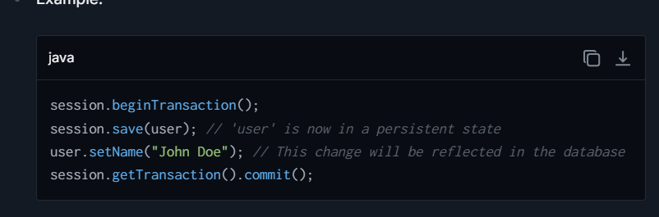

**3. Detached State:**

An entity becomes detached when its associated session is closed or the entity has been evicted from the session. Detached objects have a representation in the database but are currently not tied to any active Hibernate session.

* To persist any changes made to a detached instance, it needs to be reattached to a valid Hibernate session. This can be achieved using methods like **update()**, **merge()**, or **saveOrUpdate()**.

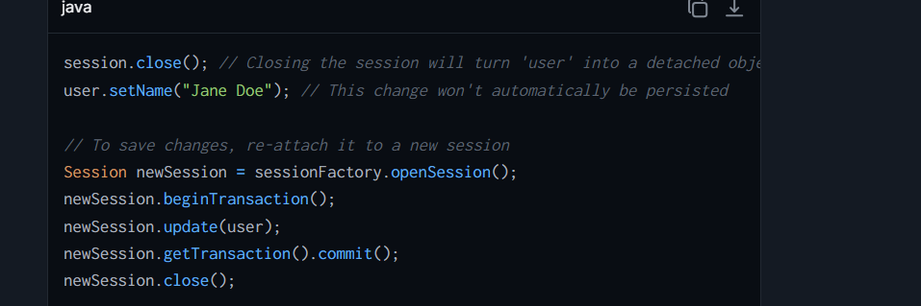

**4. Removed State:**

* **Description**:
  + A removed entity is scheduled for deletion from the database but still exists in memory as a managed object.
  + It becomes permanently deleted from the database when the transaction is committed.
* **Characteristics**:
  + Managed by the Hibernate Session, but flagged for deletion.
  + Once deleted, it transitions to a transient state.

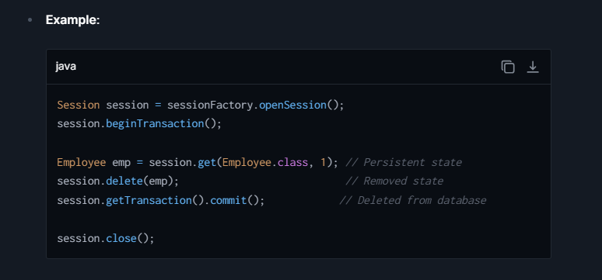

## **How does Hibernate Manage Caching ? Explain.**

Hibernate caching is a powerful mechanism to enhance the performance of a Hibernate-based application by reducing the number of database access requests. Hibernate supports two levels of caching: first-level cache and second-level cache. Here’s a detailed explanation of each:

**1. First-Level Cache**

The first-level cache is associated with the Hibernate **Session** object and is enabled by default. It works on a per-session basis and ensures that each session object retrieves the same data when accessed multiple times within the same session. This cache mainly reduces the number of SQL queries made within a session, not across sessions.

**How it works:**

* When a **Session** retrieves an entity, Hibernate first checks the first-level cache. If the entity is in the cache, it returns the cached entity instead of making a database call.
* If the entity is not in the cache, Hibernate retrieves it from the database and stores it in the first-level cache before returning it.
* Modifications made to entities are first stored in the cache and then synchronized with the database when the session is flushed or closed.

**2. Second-Level Cache**

Unlike the first-level cache, the second-level cache is associated with the **SessionFactory** and not bound to a single session. It's shared across different sessions and can significantly improve performance by caching entities or collections of entities across sessions. The second-level cache is not enabled by default in Hibernate and requires explicit configuration.

**How it works:**

* When an entity is fetched, Hibernate first checks the second-level cache. If the entity exists there, it is retrieved and used to populate the session cache.
* If not found in the second-level cache, Hibernate fetches the entity from the database, stores it in both the second-level and the session caches, and then the entity is returned.
* Hibernate uses third-party cache providers like EHCache, Infinispan, or Hazelcast to implement the second-level cache.

**Configuration and Usage:**

To use the second-level cache, developers must:

* Include the necessary caching provider in the project dependencies.
* Configure the second-level cache provider in the Hibernate configuration.
* Mark entities or collections as cacheable using annotations or XML mapping files.

1. **Query Cache**

Hibernate also supports a query cache that caches the results of query instances. This cache should be used together with the second-level cache because it doesn’t cache the state of the actual entities but rather the identifiers (primary keys) of the entities returned by the query. Each time a cached query is invoked, the cached identifiers are used to look up the actual entity instances from the second-level cache.

**How to enable:**

* Enable the query cache in the Hibernate configuration.
* Configure individual queries to use the cache.

**Benefits of Hibernate Caching:**

* **Reduced Database Load**: By serving repeated data requests from the cache rather than the database, it reduces the number of database hits.
* **Improved Performance**: Accessing data from memory is faster than accessing data from a disk-based database.
* **Scalability**: Reducing database load indirectly supports a higher number of transactions and users.

## **What are the Custom Queries in Spring data JPA?**

Spring Data JPA is an extension of JPA that simplifies data access operations by providing a more intuitive way to work with the data layer in a Spring application. It leverages repository interfaces to reduce boilerplate code and provides a range of functionality like querying capabilities, pagination, and sorting.   
Here are some common questions about **custom queries in Spring Data JPA**:

**How to Define Custom Queries:**

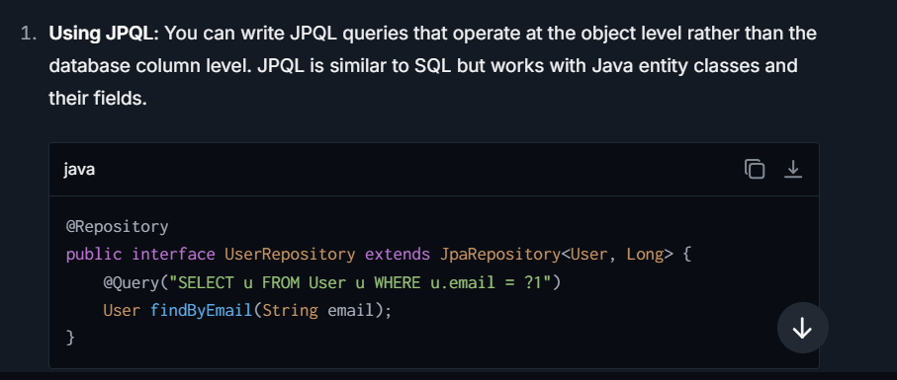

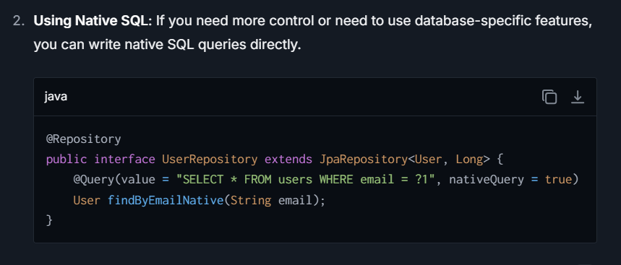

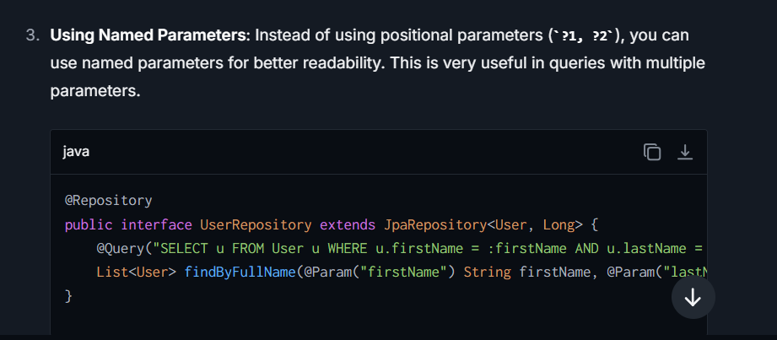

## **What is N+1 Problem, How does it occur and what is the Solutions (JOIN FETCH, Entity Graphs, Batch Size) ?**

## **Criteria API in hibernate?**

It is a programmatic, object-oriented way to create and execute queries for retrieving entities from the database. Unlike **HQL (Hibernate Query Language)**, which is string-based and resembles SQL, Criteria API allows you to construct queries dynamically at runtime in a type-safe manner using Java code.

This approach is particularly useful when:

* You need to build queries dynamically (e.g., based on user inputs in search forms).
* You want to avoid embedding query strings directly into your code.
* You need a programmatic way to handle predicates, ordering, projections, aggregations, etc.

**Key Features of Criteria API**

* **Type-Safe**: Criteria API works directly with entity classes and uses Java types, reducing errors caused by invalid queries (e.g., misspelled class names or column names).
* **Dynamic**: Queries can be constructed dynamically based on runtime conditions (ideal for complex search scenarios).
* **Object-Oriented**: The API uses a method chaining model to build queries programmatically, making it intuitive to work with.
* **Supports Joins**: You can explicitly define joins between entities.

**When to Use Criteria API**

The Criteria API is ideal when:

1. You need **dynamic query generation** or **conditional querying** (e.g., search forms).
2. Queries involve **complex filtering or aggregation**.
3. **Type safety** is a priority.

# **Spring Batch ?**

## **What is Spring Batch?**

Spring Batch is a lightweight, comprehensive framework designed to facilitate the development of robust batch processing applications in Java. It is part of the wider Spring ecosystem and built upon the POJO-based development approach of the Spring Framework. Spring Batch provides reusable functions that are essential in processing large volumes of records, including logging/tracing, transaction management, job processing statistics, job restart, skip, and resource management.

Spring Batch is designed to handle the robust execution of the batch jobs that can be used for daily tasks (like reading and writing to files), and complex batch processing that requires high reliability and performance measures (such as processing high volumes of information from database to database).

**Key Components of Spring Batch:**

1. **Job**: In Spring Batch, a job is the entire batch process that needs to be performed. A job can have multiple steps.
2. **Step**: A step is a single task that forms part of the job. Each step typically involves reading data, processing it, and writing it to a target source.
3. **ItemReader**: Responsible for reading input data from various data sources (files, databases, etc.).
4. **ItemProcessor**: Processes the input data. It is an optional part and is useful for tasks like business rules processing, translations etc.
5. **ItemWriter**: Writes the processed data to the specified destination (file, database, etc.).
6. **JobRepository**: Stores all jobs and metadata around executions (start, end, states, etc.).
7. **JobLauncher**: Responsible for launching jobs with different parameters.

**Advantages of Spring Batch:**

* **Reusability**: Promotes the reuse of code and business logic.
* **Customization**: Diverse and adaptable ways to handle data and customize how jobs are executed.
* **Scalability**: Designed to process high volumes of records in an efficient manner.
* **Robustness**: Provides functionalities like transaction management, chunk-based processing, error handling, and logging.
* **Integration**: Easily integrates with other Spring projects as well as J2EE environments.

## **How would you define Batch processing?**

Batch processing refers to the processing of a series of jobs without user interaction, often automated as part of system workflows. It is applied in situations where a large amount of data needs to be processed periodically. Batch processing is an efficient way of handling automated tasks as it allows for the collection of data over a period, and the processing of it all at once. This method can reduce system load and help optimize resource usage.

**Characteristics of Batch Processing:**

* **Volume**: Batch processes handle large volumes of data.
* **Automatic**: Usually run automatically at scheduled times or when specified conditions are met.
* **Efficiency**: Processes data with minimal or no intervention which reduces operational costs.

**Example:**

Consider a retail company that needs to process transactions recorded throughout the day and update the inventory at night. Spring Batch can be used to define a job where one step involves reading the transaction files (ItemReader), another step processes these transactions to evaluate impacts on inventory (ItemProcessor), and another step updates the inventory system (ItemWriter).

# **Microservices**

## **What challenges Monolithic to Microservices ?**

1. **Understanding and Analyzing the Current Monolithic Application:**
   * **Challenge:** Before splitting a monolith into microservices, it's critical to understand the existing application architecture deeply. Identifying the boundaries of functionalities that can be split into services can be difficult, especially if the codebase is large and lacks proper documentation.
   * **Solution:** Conduct domain-driven design (DDD) or analyze business processes to understand key functional domains and boundaries.
2. **Defining Service Boundaries:**
   * **Challenge:** Deciding how to break the monolith into smaller services. Misidentifying service boundaries can lead to tightly coupled services, defeating the purpose of microservices.
   * **Example Issue:** If a single backend process is shared by many parts of the application, deciding whether to split it into different services or merge it into one may cause confusion.
   * **Solution:** Use principles like domain-driven design, aggregate related functionality into services, and identify natural boundaries like different business domains or use cases.
3. **Data Management and Database Decoupling:**
   * **Challenge:** Monolithic applications often use a single, centralized database. When transitioning to microservices, each service should ideally manage its own database (decentralized data).
   * Issues include:
     + Migrating data for specific services.
     + Handling data consistency across services.
   * **Example Issue:** A shared **users** table in a monolith needs to be split and managed while ensuring consistency for services like **Billing** and **Order Management**.
   * **Solution:**
     + Use techniques like **Database per Service** or **Shared Database per Service** during the transition.
     + Implement eventually consistent patterns (e.g., Saga or event-driven architecture) to manage cross-service transactions.
4. **Handling Inter-Service Communication:**
   * **Challenge:** Breaking a monolithic application into independent services introduces new communication challenges. Unlike the monolith where all components interact directly via function calls, microservices need to communicate over the network.
   * Issues include:
     + Increased latency.
     + Fault tolerance when one service is down.
     + Choosing between synchronous (REST/HTTP) or asynchronous (Message queues, Kafka) communication.
   * **Solution:**
     + Use **REST APIs** or **gRPC** for synchronous requests.
     + Use asynchronous solutions like **RabbitMQ** or **Apache Kafka** for event-driven communications.
     + Implement **circuit breakers** (e.g., Hystrix, Resilience4j) to handle failures gracefully.
5. **Managing Distributed Transactions:**
   * **Challenge:** In a monolith, transactions involving multiple components are easy to manage via database transactions (ACID properties). In a microservices environment, distributed transactions are complex and not inherently supported.
   * **Solution:** Implement distributed transaction patterns like **Saga** (orchestration or choreography) or **event sourcing** to ensure data consistency across services.
6. **Authentication and Authorization:**
   * **Challenge:** In a monolithic application, authentication and authorization are often centralized. With microservices, this needs to be decentralized or managed via an API gateway.
   * Issues:
     + Ensuring secure communication between services.
     + Managing user sessions and tokens.
   * **Solution:** Use centralized identity providers like **OAuth2**, **JWT**, or tools like **Keycloak** for authentication and authorization. Implement API gateways to standardize security for incoming requests.
7. **Deployment and Infrastructure Changes:**
   * **Challenge:** Moving from a single deployable unit to multiple microservices introduces complexity in deployment. Each service should be deployed, scaled, and monitored independently.
   * **Solution:**
     + Use **CI/CD pipelines** for automating the build and deployment process.
     + Use containerization tools like **Docker** and orchestration tools like **Kubernetes** to deploy and manage microservices efficiently.
8. **Testing the System:**
   * **Challenge:** Testing a monolith is typically simpler because everything resides in one codebase, whereas microservices introduce challenges like:
     + Unit testing each service independently.
     + Integration testing for inter-service communication.
     + End-to-end testing across multiple services.
   * **Solution:** Adopt microservices-specific testing strategies such as:
     + Implementing **contract testing** (e.g., with Pact) to ensure services communicate correctly.
     + Using tools like Postman, Selenium, or Cypress for end-to-end testing.
9. **Monitoring and Debugging:**
   * **Challenge:** In monoliths, logs and exceptions are centralized. Distributed systems introduce complexity when identifying issues because logs are scattered across services.
   * **Solution:** Implement centralized logging and monitoring tools like:
     + **ELK Stack (Elasticsearch, Logstash, Kibana)** for aggregating logs.
     + **Prometheus** and **Grafana** for service-specific metrics.
     + Use **distributed tracing** tools like **Jaeger** or **Zipkin** to trace requests across services.

## **Advantage and Disadvantage of Monolithic?**

**Advantages of Monolithic Applications:**

1. **Simplicity in Development**: Since the application is unified, it's often simpler to develop, test, deploy, and scale as a single entity. This can make the initial stages of development quicker and less complex.
2. **Standardized Development**: Monolithic applications typically use a single technology stack and a consistent development approach throughout the entire application, which can simplify management and reduce the need for diverse expertise.
3. **Easier Debugging and Testing**: With everything running as a single service, it can be easier to debug and test the application because there are no inter-service dependencies to consider, unlike in microservices.
4. **Simplified Deployment**: Deployment processes are straightforward — typically, you only need to manage and deploy one WAR or EAR file. This can make continuous integration and delivery processes less complex.
5. **Transactional Integrity**: Since all parts of the application use a single data source and shared data, ensuring transactional integrity is easier and more straightforward.

**Disadvantages of Monolithic Applications:**

1. **Scalability Issues**: Scaling a monolithic application can be challenging since every time the application needs to scale, the entire application must be scaled, not just the parts experiencing heavy demand.
2. **Limited Agility**: As the application grows, making changes can become increasingly slow and risky. A small change affects the whole system, which can impede quick modifications and adaptations.
3. **Technology Stack Limitation**: The entire application is often confined to a single technology stack. This limitation can prevent adopting new technologies that may be more efficient for certain functionalities.
4. **Reliability Risks**: In a monolithic architecture, if one feature of the application fails, it can jeopardize the entire system, leading to potential downtime and service disruption.
5. **Complicated Updates and Maintenance**: Over time, the codebase can become large and complex. This complexity makes the application difficult to understand and maintain, often referred to as "spaghetti code."

## **What is Micro-services?**

Microservices is a software architecture style that structures an application as a collection of loosely coupled services, which implement business capabilities. Each service is a small, independent process interacting with other services via well-defined APIs. Microservices are a departure from traditional monolithic applications where all components are interdependent and tightly coupled.

## **Why not Monolithic application?**

Monolithic applications are built as a single unit. While this can be simpler to develop, test, and deploy initially, it becomes cumbersome as the application grows. Scaling specific functions of the application, independent deployments, and isolating failures are difficult in a monolithic design. Microservices, on the other hand, are designed to be highly scalable, easily maintainable, and allow decentralized data management which often leads to improved resilience and productivity.

## **Explain the flow of Micro-services?**

**Flow of Microservices:**

1. **Client Request:** A request is made to an API Gateway.
2. **Routing:** The API Gateway routes the request to appropriate microservices.
3. **Service Execution:** Each microservice performs its designated functionality. It might interact with other services or a database.
4. **Response Aggregation:** Responses from services are aggregated.
5. **Response to Client:** The final response is sent back to the client.

## **What is Service discovery?**

In a microservices architecture, applications are typically divided into multiple smaller, interconnected services. Each of these services performs a specific function and needs to communicate with other services. However, managing the network locations (IP addresses and ports) of all these services can become complicated, especially as the number of services grows and changes over time.

**Service Discovery** is the process used in microservices architectures to automatically detect and keep track of the locations (such as IP addresses and ports) of all the services within the system. This allows services to communicate with each other without needing to know the exact location of the other services beforehand.

**Here’s how it typically works:**

1. **Registration**: Each service, when it starts up, registers itself with a service discovery tool(such as **Eureka, Kubernetes Services,Zookeeper, Consul**). The service includes details about itself such as its name, IP address, port, and sometimes other metadata.
2. **Discovery**: When one service needs to communicate with another, it asks the service discovery tool where the other service is. The tool responds back with the necessary details (IP address and port).
3. **Deregistration**: When a service shuts down, it notifies the service discovery tool to remove it from the list, so no other services try to communicate with it.

**Popular Service Discovery Tools:**

* **Eureka**: Developed by Netflix, it's often used in **Spring Cloud applications**. Has both server and client components.
* **Consul**: Developed by HashiCorp, provides service discovery along with health checking.
* **Zookeeper**: Developed by Apache, used frequently with Kafka and Hadoop, but also supports generic service discovery.
* **Kubernetes Services**: In Kubernetes environments, services are automatically discovered and DNS automatically updated.

## **What is Service/API Registry ?**

 A service registry is a key component in microservices architectures used for service discovery. It allows services to find and communicate with each other. Each service registers its location in the registry, which other services look up as needed to communicate.

The service registry is critical in a microservices environment because it helps manage the complexity of dynamic, distributed systems. When a microservice starts, it registers itself with the service registry, providing details about its API endpoints, location (such as a URL or IP address), and other necessary information. When a microservice needs to communicate with another service, it queries the registry to find the most current information about that service.

A service registry can be implemented using various tools and platforms, such as Netflix's Eureka, HashiCorp's Consul, or Apache Zookeeper, depending on the specific requirements and preferences of the development environment.

## **What is service mesh in microservices?**

In a microservices architecture, you typically have many small, independent services that communicate with each other over a network. Handling and controlling this communication efficiently, securely, and in a scalable way can be challenging. That's where a service mesh comes in.

**Key Components of a Service Mesh:**

1. **Data Plane**: This consists of a collection of lightweight network proxies, often referred to as sidecars, which are deployed alongside application code but without the application's direct involvement. These proxies intercept and manage the network communication between microservices. They handle functions like service discovery, load balancing, encryption, authentication, authorization, and observability.
2. **Control Plane**: This component is responsible for managing and configuring the proxies in the data plane. It provides centralized control over the configuration and behavior of the network communication, including policies for security and routing decisions.

**How a Service Mesh Works:**

Imagine you have several microservices. Each microservice has a sidecar proxy deployed with it. When service A wants to communicate with service B:

1. Service A sends a request to its sidecar proxy.
2. The sidecar proxy might apply some configured rules like checking if Service A is authorized to talk to Service B.
3. It then uses service discovery to find Service B’s sidecar proxy and sends the request there.
4. Service B’s sidecar proxy might check the request again based on its own rules or policies and, if all checks out, passes it to Service B.

## **What is Eureka Server?**

**Eureka Server** is a tool developed by Netflix for service discovery in microservices architectures. Think of it as a phone directory for microservices. Just like you look up a phone number in a phone directory, microservices use Eureka to discover where other services in the system are located. Components Involved in Service discovery**.**

**how Eureka Server works in a typical setup:**

1. **Service Registration:** When a microservice instance starts, it registers itself with the Eureka server. The service provides metadata about itself such as its IP address, port, version, and other service-specific details.
2. **Service Discovery:** When a microservice needs to communicate with another service, it asks the Eureka server to discover the available instances of the service. The Eureka server then returns a list of available service instances with their metadata.
3. **Heartbeat:** Once registered, each microservice instance sends a heartbeat signal to the Eureka server at regular intervals to signify that it is still alive. If the Eureka server does not receive a heartbeat for a predefined period, it will unregister the instance, assuming it to be unavailable.
4. **Registry Fetch:** Microservice clients fetch the registry information from the server and cache it locally. This registry information is used to find other services. The local cache allows clients to minimize calls to the Eureka server.
5. **Self Preservation:** Eureka Server has a self-preservation mode, which is a protective feature designed to prevent the server from expiring too many instances when there's possibly an underlying network issue between the microservices and the Eureka server.

Eureka has two primary components: Eureka Server and Eureka Client. The server acts as the service registry, and the client is embedded in each microservice to handle interactions with the server for registration, deregistration, and discovery.

## **What is Feign Client?**

Feign client is used to make writing web service clients easier. Basically, it's a simplify way how you call other services (or APIs) over the internet from your application.

Imagine you're writing an application, and you need to get some data from a different application or service. Normally, you'd have to write a lot of code to manage the connection, handle possible errors, and format the data right. Feign takes care of a lot of that boilerplate code for you.

Here’s how Feign works:

1. **Easy to Use**: You define a Java interface and annotate it with details about the web service you want to call. These details include the URL path, request type (like GET or POST), and any parameters.
2. **Declarative Style**: Instead of writing the actual code to handle the HTTP requests and responses, you simply declare what you want to happen using annotations. Feign then generates the necessary code at runtime.
3. **Integration**: Feign works well with other tools like Ribbon (for load balancing) and Eureka (for service discovery) which are often used in microservices architectures.

By using Feign, you can focus more on what your client needs to do with the service, rather than getting bogged down in the mechanics of how to connect to it and handle the data. It makes your client code cleaner and easier to read and maintain.

## **How to call from 1 microservice to another microservice?**

In a microservices architecture, there are several ways to enable communication between services.

**1. REST Template**

**RestTemplate** is a synchronous client to perform HTTP requests, exposing a simple, template method API over underlying HTTP client libraries.

**2. Feign Client**

Feign is a declarative HTTP client which makes writing web service clients easier. It works well with Spring Cloud and allows you to write your HTTP client by annotations.

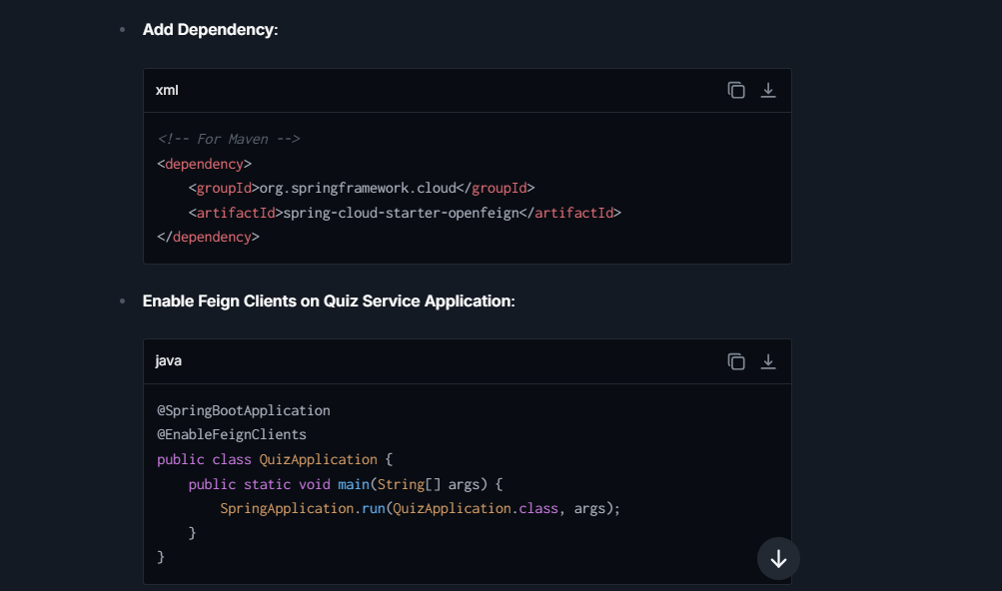

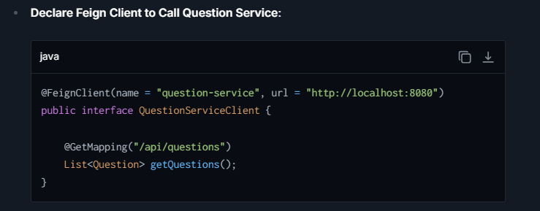

**3. WebClient**

**WebClient** is a non-blocking, reactive client for performing HTTP requests with Reactive Streams back pressure. It suits applications that require reactive stack.

## **What is API Gateway?**

**Spring-cloud-starter-gateway** add this dependency.

**spring.cloud.gateway.discovery.locator.enabled = true,** We are allowing the gateway to automatically discover and route to services registered in a service discovery mechanism like Eureka, Consul, or Zookeeper.

an API Gateway manages all requests coming into your system.

**Functions of an API Gateway:**

1. **Request Routing**: When a request comes in, the API Gateway acts like a receptionist. It determines where to send the request within your system of various microservices. For example, a request for customer data might be sent to the Customer Service, while a request to place an order goes to the Order Service.
2. **Aggregation**: Sometimes, to fulfill one request, the Gateway may need to call multiple microservices and combine their responses. For example, to show a user dashboard, it might need to fetch data from services handling user profiles, orders, and user statistics.
3. **Authentication and Authorization**: Before letting any request go to the backend services, the API Gateway checks if the request is from a valid user and if they have the right permissions. It's like checking if someone has the key and permission to enter your home.

**How It Works:**

* When a client sends a request to the gateway with a specific URI pattern, the gateway knows which microservice to forward the request to, based on the service discovery's data.
* A common URI pattern used by the gateway for these routes is: **/<serviceId>/\*\***. Here, **serviceId** corresponds to the service’s identifier in the service registry. For example, if there is a service with the serviceId "user-service" registered with Eureka, any request to the gateway at **/user-service/\*\*** will be automatically routed to the "user-service".

**Why Use an API Gateway?**

* **Simplicity**: Clients need to call a single, unified API instead of handling multiple different service APIs.
* **Security**: Provides a layer where security can be enforced, like SSL termination, authentication, and more.
* **Decoupling**: Allows backend services to change without every client needing to know about those changes because the Gateway can handle routing to the right service

## **What is Load balancer?**

A Load Balancer is a system that distributes incoming network traffic across a group of backend servers, also known as a server farm or server pool. This helps to ensure that no single server bears too much demand. By spreading the load, it increases the responsiveness and availability of applications, websites, or databases.

A load balancer acts like a traffic cop sitting in front of your servers, directing incoming network traffic to prevent any one server from getting too overwhelmed. This helps keep your application running smoothly by spreading out the workload evenly across multiple servers.

**Why Use a Load Balancer?**

1. **Avoid Overload**: Keeps any single server from becoming a bottleneck.
2. **Better Performance**: Helps improve user experience by reducing response time.
3. **Failover Support**: If one server fails, the load balancer redirects traffic to the remaining operational servers.

**Types of Load Balancing:**

* **Round Robin**: Distributes client requests sequentially to each server in a pool.
* **Least Connections**: A new request is sent to the server with the fewest current connections to clients.
* **IP Hash**: The client’s IP address is used to determine which server receives the request.

**Load Balancer in Spring Boot**

In Spring Boot, load balancing can be managed with the help of Spring Cloud, which integrates tools like Netflix Ribbon or Spring Cloud LoadBalancer.

**1. Spring Cloud Netflix Ribbon:**Ribbon is a client-side load balancer that gives you a lot of control over the behavior of HTTP and TCP clients. Here's how to use it:

* Include the Ribbon dependency in your pom.xml or build.gradle.
* Configure the list of servers in the application properties.
* Use @LoadBalanced annotation to indicate that a RestTemplate bean should use Ribbon.

**2. Spring Cloud LoadBalancer:** Spring Cloud LoadBalancer is a more modern client-side load balancer that allows replacing Ribbon. It's reactive-aware and works more smoothly with Spring WebFlux.

To use Spring Cloud LoadBalancer:

* Add the Spring Cloud LoadBalancer dependency.
* Create a configuration that creates a **ServiceInstanceListSupplier** for the services you want to load balance.
* Inject a **WebClient.Builder** bean with **@LoadBalanced** and build WebClient instances as needed.

**Example Or Scenario**

Suppose you have a microservice called **OrderService** that handles user orders, and this service needs to get product details from another microservice called **ProductService**. Now, let's say you have multiple running instances of **ProductService** to handle high volumes of requests efficiently and to provide redundancy in case one of the instances fails.

**Load Balancing Process**

1. **Distribution**:
   * **OrderService** needs to fetch product details and it sends a request.
   * Instead of sending all requests to a single instance of **ProductService**, which could overload that instance, **OrderService** uses a load balancer to divide the traffic fairly among all available instances of **ProductService**.
2. **Routing Mechanisms**:
   * The load balancer employs various algorithms to decide which instance of **ProductService** to forward the request to. Common methods include:
     + **Round Robin**: Cycles through a list of servers and distributes each request sequentially.
     + **Least Connections**: Chooses the server that has the fewest current connections.
     + **Hashing**: Uses a consistent hashing mechanism, for example using certain aspects of the request (like session ID) to always route specific types of requests to the same server.

## **What is a Circuit-breaking?**

A circuit breaker is a design pattern used in distributed systems to prevent system failure when part of the system becomes unstable. When the number of failures crosses a certain threshold, the circuit breaker trips, and for a set period, all attempts to invoke the service will fail immediately. This gives the problematic service time to recover. After a cool-down period, the circuit tries to reset by letting a few requests go through to check if the backend service is back to normal.

**Example Scenario**: Imagine you are running an e-commerce platform with microservices architecture, including services such as OrderService, PaymentService, and InventoryService. Let's say the InventoryService, which is responsible for checking item availability, starts responding slowly or fails due to a database issue.

**Without a circuit breaker**, the OrderService might continue to make calls to InventoryService, waiting for responses that won't come, thus tying up resources and potentially causing user requests to timeout or fail, affecting customer satisfaction.

**With a Circuit Breaker:**

**Step 1**: The OrderService makes a call to the InventoryService.

**Step 2**: Due to the issues in InventoryService, the response is delayed or failed repeatedly.

**Step 3**: After a certain number of failures, the circuit breaker trips, and further calls to InventoryService are blocked.

**Step 4:** Instead, the circuit breaker might trigger a fallback method within OrderService to handle the situation, perhaps by allowing purchases (assuming availability) and resolving discrepancies later.

**Step 5**: After a cooldown period, the circuit breaker attempts to close the circuit by allowing a few calls through to see if InventoryService has recovered.

**Implementing a Circuit Breaker in Microservices :-**

Itcan be achieved using various libraries and tools that support this pattern, such as Netflix Hystrix, Resilience4J, or Istio for Kubernetes environments.

**Example with Resilience4J:**

**Resilience4J** is a fault tolerance library designed for Java8 and functional programming. It provides an easy way to apply the circuit breaker mechanism.

1. Add Dependencies: Include Resilience4J in your project. For a Maven project, add the following dependency:

2. By implementing this pattern, you ensure that your microservices can handle failures gracefully, maintain stability, and continue serving users even when parts of the system are struggling.

## **What is a Circuit Design pattern?**

It helps to prevent a network or service failure from cascading to other parts of a system. It is quite similar in concept to an electrical circuit breaker that cuts off electricity flow in case of an overload, protecting the whole system from damage.

**How It Works:**

1. **Closed State**: In normal operation, the circuit breaker allows operations to proceed, monitoring for failures. If the failures exceed a certain threshold (like a certain percentage of requests failing in a given time frame), it trips the circuit breaker.
2. **Open State**: When the circuit breaker is tripped, it enters the Open state where it will prevent any operations from being performed, usually by throwing an exception or returning a fallback response. This gives the failing service time to recover.
3. **Half-Open State**: After a timeout period, the circuit breaker enters a half-open state where a limited number of test requests or operations are allowed to pass through. If these requests succeed, the circuit breaker resets back to the Closed state; if they fail, it goes back to the Open state.

**Practical Example:**

Imagine a microservice architecture where Service A calls Service B. If Service B becomes slow or fails frequently (due to network issues, heavy load, or internal errors), Service A's performance would also degrade if it had to wait for Service B to timeout/resume each time. By implementing a Circuit Breaker:

* When certain failure thresholds are reached, the Circuit Breaker trips.
* Service A can either immediately return a default response/fallback or error, instead of waiting for a timeout from Service B.
* This prevents resources in Service A from being consumed by waiting for a response from B, thus safeguarding A’s stability.

This pattern is particularly useful in maintaining business operation levels even when some parts of the system fail, enhancing the user experience by preventing system freezes or delays.

**Implementation:**

There are several libraries and frameworks that provide circuit breaker capabilities, especially in the context of web services and distributed systems:

* **Hystrix**: A Java library by Netflix that provides latency and fault tolerance control.
* **Polly**: A .NET resilience and transient-fault-handling library that includes circuit breakers.
* **Resilience4j**: A lightweight, easy-to-use fault tolerance library inspired by Hystrix, built for Java 8 and functional programming.
* **Spring Cloud Circuit Breaker**: Integrates circuit breaker functionality with other Spring Cloud projects.

## **Why Do People Run After Microservices??**

The shift towards microservices is largely driven by the demands for better scalability and autonomy in application development and deployment. Organizations needing to iterate rapidly, scale specific parts of their systems efficiently, and ensure resilience find microservices architecture advantageous.

## **What is caching 1st and 2nd level?**

**Caching - 1st and 2nd Level:**

1. **1st Level Cache:** Typically an in-memory cache that lives within the application instance (e.g., Hibernate‘s first-level cache in Java applications). This type of cache is tied to the lifecycle of a transaction or a session.
2. **2nd Level Cache:** Shared across multiple application instances, usually distributed among multiple servers. This kind of cache can outlive a transaction and significantly improve the application performance by reducing the load on the database.

## **What is HTTP Status Code?**

HTTP status codes are standardized responses that servers use to tell a client about the result of its request.

* **200 OK:** The request has succeeded. The meaning of the success depends on the HTTP method: GET: The resource has been fetched and transmitted in the message body.
* **201 Created:** This means that the request has succeeded and resulted in one or more new resources being created.
* **204 No Content:** The server successfully processed the request, but is not returning any content.
* **301 Moved Permanently:** This response code means that the URI of the requested resource has been changed permanently. The new URI is given in the response.
* **302 Found:** This status code indicates that the resource requested has been temporarily moved to the URL given by the Location header. A browser redirects to this page but search engines don't update their links to the resource (in 'SEO-speak', it is said that the 'link-juice' is not sent to the new URL).
* **304 Not Modified:** Indicates that the resource has not been modified since the version specified by the request headers If-Modified-Since or If-None-Match. This is used for caching purposes.
* **400 Bad Request:** The server cannot or will not process the request due to an apparent client error (e.g., malformed request syntax, invalid request message framing, or deceptive request routing).
* **401 Unauthorized:** Although the HTTP standard specifies "unauthorized", semantically this response means "unauthenticated". That is, the client must authenticate itself to get the requested response.
* **403 Forbidden:** The request was a valid request, but the server is refusing to respond to it. Unlike 401, the client's identity is known to the server.
* **404 Not Found:** The server cannot find the requested resource. In the browser, this means the URL is not recognized. In an API, this can also mean that the endpoint is valid but the resource itself does not exist.
* **500 Internal Server Error:** The server encountered an unexpected condition that prevented it from fulfilling the request.
* **502 Bad Gateway:** The server, while acting as a gateway or proxy, received an invalid response from an inbound server it accessed while attempting to fulfill the request.
* **503 Service Unavailable:** The server is not ready to handle the request. Common causes are a server that is down for maintenance or that is overloaded.

## **What is Saga Design Pattern? How Does the Saga Pattern Work?**

 The Saga pattern is a design pattern used to manage data consistency across microservices in distributed transaction scenarios. In a microservices architecture, applications are divided into multiple independent services, each owning its own data. Traditional transaction management mechanisms like two-phase commits can be problematic in these environments due to their constraints on performance and coupling. The Saga pattern addresses this issue by breaking up a long-running transaction into a series of smaller, local transactions, each handled by individual services.

The Saga pattern can be implemented in two primary ways:

**Choreography**

Each service involved in the Saga knows which service to call next and what to do after the previous service completes. These services communicate directly with each other using events. A service does its job, publishes an event, and the next service reacts to that event and proceeds. This continues until the entire business transaction is either completed or a failure is detected. In the event of a failure, compensating transactions (or actions) are triggered to revert the changes.

Example:

* **Service A** processes part of a transaction and publishes an "Action Completed" event.
* **Service B** hears that event, performs its part of the transaction, and publishes its event.
* If **Service B** cannot complete its action, it issues a "Compensating Action" event, to which **Service A** listens and reacts by undoing its previous action.

**Orchestration**

There is a central orchestrator (a coordinator or a saga manager) that tells the involved services what transaction to execute next based on the feedback it gets from them. The orchestrator is responsible for both the success scenario and the failure recovery scenario (compensating transactions).

Example:

* The **Orchestrator** instructs **Service A** to perform a transaction.
* Once **Service A** completes the transaction, it reports the success to the orchestrator.
* The **Orchestrator** then instructs **Service B** to perform the next step.
* If **Service B** reports a failure, the orchestrator instructs **Service A** to perform a compensating transaction.

## **Why we need SAGA Pattern?**

**1. Complex Distributed Transactions**

* Modern applications often span multiple microservices each owning its piece of data, leading to distributed transactions that need coordination without compromising independence and service encapsulation. Sagas provide a transaction management method that respects service boundaries.

**2. Decentralization**

* In a microservices architecture, decentralization is key. The Saga pattern supports this architectural need by allowing each service to manage its transactions while coordinating the overall business process loosely through messages or events.

**3. Failure Management**

* Handling failures effectively is essential in distributed systems. The ability of the Saga pattern to execute compensating transactions allows systems to recover gracefully from failures, maintaining data consistency without leaving the entire system in an inconsistent state.

**4. Flexibility and Maintainability**

* Sagas increase the flexibility of the application development and maintenance by allowing developers to change, add, or remove steps from the saga without redesigning the whole transaction system. Each microservice can evolve semi-independently.

## **What is Traditional and Distributed transaction?**

**Traditional Transaction:-** Traditional transactions, often termed as local transactions, are those that interact with a single database system or a single resource. These transactions are managed by a single, centralized database system**.**

**Characteristics:**

* **Atomicity:** The transaction is treated as a single unit, which means it either fully completes or doesn’t happen at all.
* **Consistency:** The transaction transforms the system from one valid state to another, maintaining data integrity.
* **Isolation:** Transactions do not affect each other; changes of a transaction are invisible to others until committed**.**
* **Durability:** Once a transaction is completed, the changes are permanent, even in the event of a system failure**.**

**Example:**

A simple example is a bank transaction conducted from a single bank account to another within the same bank database. When you transfer money, the transaction will ensure that the money is debited from one account and credited to another securely and atomically. If any part of the transaction fails, like a system crash after debiting but before crediting, the whole transaction rolls back to its initial state, ensuring no money is lost.

Traditional transactions are usually implemented:

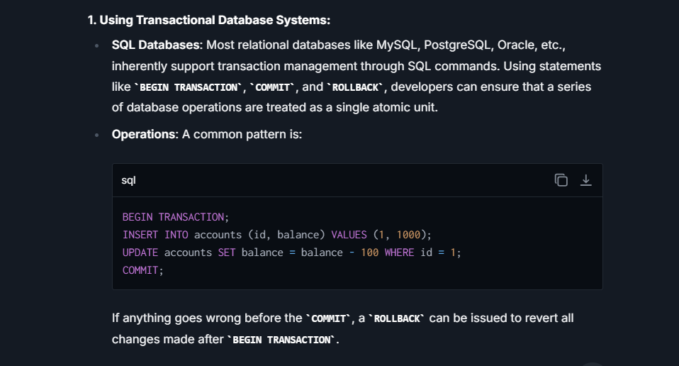

**Distributed Transactions**

Distributed transactions span across multiple databases or multiple microservices, possibly across different networks or even geographical locations. They are more complex because they need to coordinate multiple transaction segments, each possibly managed by different databases or services.

**Characteristics:**

* **Extended ACID Properties:** While they still need to adhere to Atomicity, Consistency, Isolation, and Durability, managing these across distributed systems is more challenging.
* **Coordination**: They require coordination between different systems involved in the transaction. This is often achieved using protocols like Two-Phase Commit (2PC).
* **Performance and Reliability Issues:** Distributed transactions are often slower and less reliable due to network latencies, differing system capabilities, or partial system failures.

**Example:**

Consider an online retail system where you place an order, make a payment, and update the inventory, each handled by different microservices or different databases (Order Service, Payment Service, Inventory Service). When you confirm an order, a distributed transaction ensures:

* Your payment is processed.
* The order details are recorded.
* The stock is updated accordingly.

If there's a failure at any point, all changes made in each service need to be undone to maintain data integrity, which complicates recovery mechanisms. **Managing these transactions** is more complex due to network delays, synchronization issues, and the handling of partial failures.

**1. Two-Phase Commit (2PC):**

* **Phase 1 (Prepare Phase)**: The transaction manager asks all the participating databases (or services) to prepare for the transaction. If all agree (i.e., they all vote 'Yes'), the system moves to the next phase. If any database votes 'No', the transaction is aborted.
* **Phase 2 (Commit/Rollback Phase)**: Depending on the votes, the transaction manager will either send a commit or rollback command to all participants.
* **Drawbacks**: 2PC can be slow and is susceptible to failures. If the coordinator fails after some nodes have prepared but before they commit, those nodes can be left in a locked state indefinitely.

**2. Three-Phase Commit (3PC):**

* An improvement over 2PC, adding an extra phase to avoid some of the locking issues and making the protocol non-blocking.
* **Can Commit Phase**: Coordinator asks nodes if they can commit. Nodes promise to commit and wait.
* **Pre-Commit Phase**: If all nodes agreed, the coordinator sends a pre-commit request. Nodes prepare to commit without locking resources.
* **Commit Phase**: Finally, if all nodes are prepared, the commit is finalized.
* **Drawbacks**: More complex and still has some failure scenarios that can cause problems.

**3. Saga Pattern:**

* Used in microservices architecture as an alternative to 2PC and 3PC. It involves breaking up the larger distributed transaction into smaller, local transactions. Each local transaction updates the database and sends a message/event to trigger the next part of the saga.
* If a step fails, compensating transactions (which are like a rollback but for distributed services) are executed to undo the part of the saga that had been processed.
* **Advantages**: It avoids long-held locks and is highly resilient to partial failures.

**4. Eventual Consistency and Outbox Patterns:**

* Instead of ensuring strong consistency (all nodes see the same data at the same time), eventual consistency models allow for temporary inconsistencies with the understanding that the system will eventually become consistent.
* **Outbox Pattern**: Changes within a service are recorded in an outbox table inside the same transaction. Separate processes or services then propagate these changes to other services asynchronously, leading to eventual consistency.

## **What are the design patterns of Microservices?**

Design patterns in microservices are established solutions to common problems that developers face when designing and implementing microservices architectures. These patterns help tackle challenges related to microservices' development and maintenance, such as service decomposition, data management, and message processing.

some of the key design patterns used in microservices:

**1. Decomposition Patterns**

* **Single Responsibility Principle (SRP)**: Each microservice should handle a single part of the application's functionality and manage its own data. This simplifies development, testing, and deployment.
* **Bounded Context**: This pattern comes from Domain-Driven Design (DDD) and involves defining clear boundaries for each microservice, which encapsulates a specific domain model or business capability.

**2. Database Patterns**

* **Database-per-Service**: Each microservice manages its own database, either different instances of the same database system or entirely different database systems, preventing database management from becoming a bottleneck.
* **Shared Database**: Less common, but used when tight integration between services is necessary, this pattern involves multiple services sharing the same database. Managing direct dependencies among services must be handled carefully.

**3. Integration Patterns**

* **API Gateway**: Acts as a single-entry point for all clients. The API Gateway routes requests to the appropriate microservice, handles authentication, and aggregates results from various services.
* **Service Mesh**: Implements a networking layer to manage service-to-service communications, capable of handling load balancing, monitoring, and security more transparently.

**4. Communication Patterns**

* **Synchronous Communication (Request/Response)**: Services communicate with each other using synchronous protocols like HTTP/REST or gRPC.
* **Asynchronous Communication (Event-Driven)**: Services communicate using events. This pattern decouples services by using message queues which help services interact through events without direct knowledge of each other.

**5. Observability Patterns**

* **Logging**: Consistent logging across all services which can be centralized using tools like ELK stack (Elasticsearch, Logstash, Kibana).
* **Monitoring**: Implementing monitoring tools like Prometheus and Grafana for visualizing and alerting based on the performance metrics collected from microservices.
* **Tracing**: Distributing tracing systems like Jaeger or Zipkin help track a request as it flows across various microservices, aiding in debugging and monitoring.

**6. Resilience Patterns**

* **Circuit Breaker**: Prevents a cascade of failures when a microservice is down.
* **Retry**: Automatically retrying a failed request again based on certain policies like delay and max attempts.
* **Fallback**: Provides a default response or a cached response when a service fails, ensuring the system remains functional.
* **Bulkhead**: Isolates elements within an application into pools so that if one fails, the others will continue to function.

**7. Security Patterns**

* **Authentication**: Ensuring that only valid users can access the services, often implemented at the API gateway level.
* **Authorization**: Ensuring users can only perform actions they are permitted to do, managed either at the gateway or individual services.
* **Confidentiality**: Encrypting data both at rest and in transit between services to prevent unauthorized data access.

## **Advantages/Disadvantages of Microservices:**

**Advantages of Microservices:**

1. **Scalability**: Since services are deployed independently, it is easier to scale out particular services that require more resources, without having to scale the entire application.
2. **Flexibility in Technology**: Microservices allow you to use multiple technology stacks across the different services, enabling the use of the right tool for the right job and facilitating innovation and experimentation.
3. **Resilience**: If one microservice fails, it doesn’t necessitate the failure of the entire system. This containment of faults is crucial in large-scale systems, enhancing overall reliability.
4. **Easier Maintenance and Updates**: Services are small and focused on specific functionalities, making them easier to understand, develop, and maintain. Teams can update services without impacting others, enabling faster iteration and deployment.
5. **Deployment Agility**: Microservices offer the ability to deploy independently which is a huge advantage for continuous integration and development strategies. Teams can push updates for specific services without affecting the entire application.
6. **Decentralized Data Management**: Each microservice can manage its own database and transactions, avoiding the database management and transaction complications that can occur in monolithic architectures.

**Disadvantages of Microservices**

**Complexity in Management**: While each service might be simpler, the system as a whole becomes more complex. Managing multiple services, inter-service communication, and distributed data can be challenging.

**Data Integrity**: With each service managing its own database, ensuring consistency and integrity across services can be difficult, particularly in transactions that span multiple services.

**Testing Challenges:** Integration testing can become more complicated because you must account for inter-service communication, network failures, and other distributed data challenges.

**Deployment Overhead:** While individual services can be deployed independently, managing dozens or hundreds of services and their dependencies requires robust automation tools and techniques.

**Performance Overhead**: Communication between services over a network introduces latency. Moreover, data might need to be aggregated from multiple services, which can lead to complex queries that span several services.

**Increased Resource Usage**: Each microservice might need separate resources, databases, or virtual machines, leading to potentially higher costs and resource usage compared to a monolithic approach.

**Security Concerns:** More inter-service communication over the network can increase security vulnerabilities. Implementing security protocols across various services can also add to the complexity.

# **Junit**

## **What is Mockito testing ?**

Mockito is a popular open-source Java-based mocking framework used for unit testing in Java applications. Mocking is a technique used in testing where objects that simulate the behavior of real objects are created. It is useful when the real objects are impractical to incorporate into a unit test.

Mockito helps create these mock objects and manage their behavior. The primary goal of Mockito is to allow developers to write clean, simple, and maintainable test code by providing a powerful and flexible way to produce mock implementations of dependencies within the system being tested.

Key features of Mockito include:

1. Verification of interactions: Mockito can verify that certain methods were called on the mock object with specific parameters.
2. Stubbing method calls: Developers can specify custom behavior when methods on a mock object are called, such as returning a specific value or throwing an exception.
3. Argument Matchers: Mockito provides ways to define flexible expectations on the parameters passed to methods by using argument matchers.
4. Spying: Mockito can also create spies on real objects, where one can stub only certain methods of the real objects while the rest of the methods will still exhibit their normal behavior.

## **Difference between @Mock and @Inject Mocks?**

| **Feature** | **@Mock** | **@InjectMocks** |
| --- | --- | --- |
| **Purpose** | Used to create a mock object. When you annotate a field with **@Mock**, Mockito initializes the field as a mock (or fake) implementation of the class. | Used to create an instance of a class and inject mocked fields into it automatically. Essentially, it auto-wires the mocks by type into the object under test. |
| **Usage** | Primarily used to create mock instances of dependencies that the object under test requires. | Used on the class that needs the dependencies. This annotation is applied to the field that is the class instance being tested, which might require mocks to be injected. |
| **How It Works** | When a field in a test class is annotated with **@Mock**, Mockito replaces it with a dynamically created mock instance. | Mockito populates the instance created with **@InjectMocks** with the mock objects created by **@Mock** based on type (and optionally name) compatibility. |
| **Test Scenario Example** | Assume you're testing a service that depends on a DAO. You'd annotate the DAO with **@Mock** to ensure that the real implementation is not used. | If you have a service class with multiple dependencies and you annotate this service's instance with **@InjectMocks**, Mockito will attempt to inject all the **@Mock** or **@Spy** annotated fields into this service instance. |
| **Initialization** | Mock objects must be initialized either implicitly by the Mockito runner or explicitly by calling **MockitoAnnotations.openMocks(this)** in a setup method. | Requires the mocks (created via **@Mock**) to be initialized before it can inject them into the declared object. Can lead to NullPointerExceptions if the mocks are not correctly initialized before **@InjectMocks** injection occurs. |

## **Mockito questions(limitation of mockito)**

## **How can we test static methods ?**

## **What is mocking ?**

## **why should we avoid writing static methods as a clean code practice ?**

## **How JUnit testing works?**

Here's how JUnit testing works:

1. **Writing Test Cases**: The developer writes test cases using JUnit annotations and asserts. Each test case is a method annotated with **@Test** within a class that typically represents the collection of tests for a single component of the system.
2. **Assertions**: Assertions are key to testing. They are used to check if the condition is true; if it's false, the test fails. JUnit provides a set of assertion methods such as **assertEquals()**, **assertTrue()**, **assertNotNull()**, etc., which allows verifying the expected results against the actual results.
3. **Annotations**:
   * **@Test**: Indicates that the method is a test method.
   * **@Before**: Method annotated with this will be executed before each test method. It is used for setting up test environments, e.g., creating objects.
   * **@After**: Method annotated with this will be executed after each test method. It's used for cleanup activities.
   * **@BeforeClass**/**@AfterClass**: These methods are executed once before and after all tests in the class, respectively.
   * **@Ignore**: Marks that the test method should not be executed.

# **SQL**

## **What are the types of Database management system ?**

Database Management Systems (DBMS) are crucial tools used for storing, retrieving, and managing data effectively. They enable secure, consistent, and integral interactions with the data. DBMSs come in various forms, each designed to fit specific requirements and use cases. Here’s an overview of the primary types of Database Management Systems:

1. **Relational Database Management System (RDBMS):**
   * Data is stored in structured formats using tables (relations) which consist of rows and columns.
   * Uses Structured Query Language (SQL) for querying and managing the database.
   * Examples: MySQL, PostgreSQL, Oracle Database, Microsoft SQL Server.
2. **Non-relational Database Management System (NoSQL DBMS):**
   * Designed to handle unstructured and semi-structured data with flexibility in data model structure.
   * Suited for big data applications and real-time web apps.
   * Data models include key-value stores, document databases, column-family stores, and graph databases.
   * Examples: MongoDB (Document), Redis (Key-Value), Cassandra (Columnar), Neo4j (Graph).
3. **Hierarchical Database Management System:**
   * Data is organized in a tree-like structure, using parent/child relationships where each record has a single root or parent.
   * Historically one of the earliest types of DBMS.
   * Example: IBM Information Management System (IMS).

## **Which query language we used to store the non-relational database ?**

For non-relational databases, commonly known as NoSQL databases, various query languages or interfaces are used depending on the type of the database. Unlike relational databases, which predominantly use SQL (Structured Query Language), NoSQL databases employ a range of query methods tailored to their specific data models. Here are some of the prominent NoSQL databases and the query methods or languages they use:

1. **MongoDB**:
   * **Query Language**: MongoDB uses a query language based on JSON-like documents. It doesn't use traditional SQL but instead employs a rich set of expressive operators for querying and manipulating document data directly. The syntax is JavaScript-like, making it intuitive for developers coming from a JavaScript background.
2. **Cassandra**:
   * **Query Language**: Cassandra Query Language (CQL) is used, which is reminiscent of SQL in its syntax. CQL provides a familiar structure for defining tables, inserting data, and querying data using SELECT statements, though it differs from SQL in how it handles scalability and indexing.
3. **Redis**:
   * **Query Interface**: Redis does not use a conventional query language. Instead, it operates through a series of commands that are executed to handle data structures like strings, hashes, lists, sets, and sorted sets.
4. **Neo4j**:
   * **Query Language**: Cypher. Neo4j uses this declarative graph query language that allows for expressive and efficient querying and updating of the graph store. Cypher's syntax provides a visual and logical way to match patterns and extract data from the graph.

## **What is SQL? Explain.**

SQL is responsible for maintaining the relational data and the data structures present in the database. Some of the common usages are given below:

* To execute queries against a database
* To retrieve data from a database
* To inserts records in a database
* To updates records in a database
* To delete records from a database
* To create new databases
* To create new tables in a database
* To create views in a database
* To perform complex operations on the database.

## **What are the subsets of SQL?**

* **Data definition language (DDL):** It defines the data structure that consists of commands like CREATE, ALTER, DROP, etc. It is the subset of a database that defines the data structure of the database when the database is created.
  + **For example,** we can use the DDL commands to add, remove, or modify tables. It consists of the following commands: CREATE, ALTER and DELETE database objects such as schema, tables, indexes, view, sequence, etc.
* **Data manipulation language (DML):** It is used to manipulate existing data in the database. The commands in this category are SELECT, UPDATE, INSERT, etc.

The DML commands can only perform read-only operations on data. We can perform the following operations using DDL language:

Insert data into the database through the INSERT command.

Retrive data from the database through the SELECT command.

Update data in the database through the UPDATE command.

Delete data from the database through the DELETE command.

* **Data control language (DCL):** It controls access to the data stored in the database. The commands in this category include GRANT and REVOKE.

**GRANT:** It enables system administrators to assign privileges and roles to the specific user accounts to perform specific tasks on the database.

**REVOKE:** It enables system administrators to revoke privileges and roles from the user accounts so that they cannot use the previously assigned permission on the database.

* **Transaction Control Language (TCL):** It is used to deal with the transaction operations in the database. The commands in this category are COMMIT, ROLLBACK, SET TRANSACTION, SAVEPOINT, etc.

## **What are keys in SQL?, Explain**

In SQL, keys are crucial database elements ensuring data integrity and optimizing data retrieval. They establish relationships between tables and uniquely identify rows within those tables. Here are the main types of keys used in SQL:

**1. Primary Key:**

* **Functionality**: Uniquely identifies each row in a table. No two rows can have the same primary key value, and it must contain a unique value for every row. It cannot contain NULL values.
* **Usage**: Commonly used to reference entries from other tables (foreign keys). For instance, an **EmployeeID** could serve as a primary key in an **Employees** table.

**2. Foreign Key:**

* **Functionality**: A field (or collection of fields) in one table that uniquely identifies a row of another table or the same table. Essentially, it is a reference to a primary key in another table.
* **Usage**: Used to establish and enforce a link between the data in two tables. It maintains the referential integrity of the database. For example, a **DepartmentID** in an **Employees** table might reference the **DepartmentID** in a **Departments** table.

**3. Unique Key:**

* **Functionality**: Similar to a primary key, but it allows for one null value. More than one unique key can be defined in a table. Every unique key must uniquely determine a row and can’t have duplicate values except for a possible NULL.
* **Usage**: Ensures data within a specific column remains unique across the database. For example, an email column where each email address must be unique.

**4. Composite Key:**

* **Functionality**: A combination of two or more columns in a table that can be used to uniquely identify a row in a table when a single column is not enough for unique identification.
* **Usage**: Useful when the uniqueness is only guaranteed by combining multiple fields, such as creating a unique identifier for a student in a course registration table using both **StudentID** and **CourseID**.

**5. Candidate Key:**

* **Functionality**: A set of attributes that uniquely identify tuples (rows) in a table. Primary key is actually a candidate key; a table can have multiple candidate keys, each of which can uniquely identify the tuples.
* **Usage**: From the set of candidate keys, one is chosen as the primary key. Others, not chosen as the primary key, are alternate keys (each of which could serve as the primary key).

**6. Super Key:**

* **Functionality**: A set of one or more keys that can be used to identify a record uniquely in a table. A super key may include attributes that are not necessary for unique identification.
* **Usage**: It’s a broader term covering any set of columns that can uniquely identify rows, even if the set includes extra attributes that aren’t necessary for unique identification.

## **What is Join?**

"joins" are operations used to combine rows from two or more tables based on a related column between them. This operation is crucial in relational databases to perform queries that involve multiple tables to gather comprehensive information. The result of a join is a new table that merges the data of the original tables.

Here's a simple explanation of the various types of joins:

**1. Inner Join:**

* **Analogy**: Imagine you have two circles that overlap. The overlapping area represents the inner join.
* **Operation**: Returns records that have matching values in both tables. If there is a row in the first table that matches another row in the second table, it will appear in the result set.

**2. Left (Outer) Join:**

* **Analogy**: Considering the same two circles, a left join includes the entire left circle and only the overlapping part of the right circle.
* **Operation**: Returns all records from the left table and the matched records from the right table. If there is no match, the result is NULL on the side of the right table.

**3. Right (Outer) Join:**

* **Analogy**: This is the mirror of a left join. It includes the entire right circle and only the overlapping part of the left circle.
* **Operation**: Returns all records from the right table and the matched records from the left table. If there is no match, the result is NULL on the side of the left table.

**4. Full (Outer) Join:**

* **Analogy**: Think of a Venn diagram; this join resembles combining both circles entirely.
* **Operation**: Returns all records when there is a match in either the left or right table records. If there is no match, the result is NULL on the side of the table that does not have a match.

**5. Cross Join:**

* **Analogy**: Think of generating all possible pairs of shoes and socks from your collection.
* **Operation**: Returns the Cartesian product of the two sets of records where each row from the first table is combined with all rows from the second table. This type of join does not necessitate any condition and can result in a very large number of rows in the resultant table.

**6. Self Join:**

* **Analogy**: Reflective comparison, like finding colleagues from the same city within your company list.
* **Operation**: A self join is a regular join but the table is joined with itself. It's used to compare rows within the same table.

## **What is Normalization?**

Normalization is a systematic approach to organizing data in a database. The goal of normalization is to reduce redundancy (which means avoiding duplicate data) and to eliminate undesirable characteristics like Insertion, Update, and Deletion Anomalies. Normalization involves dividing large tables into smaller, well-organized tables that link together, improving both the efficiency and clarity of the data.

**Here’s a simple way to understand normalization:**

Imagine you have a notebook where you keep track of every book sale, including information like buyer name, buyer address, book title, author, and price. As you write down many sales, you'll notice that you're repeatedly writing down the same buyer information and the same book details. This is inefficient, takes more space, causes extra effort when you need to update details (like if a buyer moves to a new address), and can lead to mistakes.

**The Process of Normalization:**

1. **First Normal Form (1NF)**:
   * Every table cell should contain only a single value (no repeated groups or arrays).
   * All entries in a column (field) must be of the same kind.

For instance, dividing the buyer and book information into separate tables and listing only the buyer ID and book ID in the sales records.

1. **Second Normal Form (2NF)**:
   * The table must be in the First Normal Form.
   * All non-key attributes (columns that are not part of the primary key) must depend entirely on the primary key.

Suppose you have a composite key that includes both buyer ID and book ID; data that only depends on one of these should move into a separate table.

1. **Third Normal Form (3NF)**:
   * The table should be in the Second Normal Form.
   * There should be no transitive functional dependencies, meaning no non-key column depends on another non-key column.

For example, if you have book details, including a genre that depends only on the book type and not on the primary key, this should be placed in another table linked to the book type.

1. **Boyce-Codd Normal Form (BCNF)**:
   * A stronger version of 3NF.
   * Every determinant must be a candidate key.

BCNF deals more rigorously with the relationships between the candidate keys and other non-prime attributes by placing stricter rules.

1. **Fourth Normal Form (4NF) and Fifth Normal Form (5NF)**:
   * Deal with multi-valued dependencies and join dependencies, which are advanced concepts and usually considered when building complex relational databases.

**Benefits of Normalization:**

* **Less Duplication**: Saves space and makes the table lighter and faster.
* **Higher Integrity**: Reduces the chance of data anomalies and errors during data manipulation.
* **Better Design**: Provides clear data relations and structure, making the database easier to understand and use.

## **What are Acid properties?**

ACID properties are a set of principles that ensure database transactions are processed reliably and ensure the integrity of data within the database. ACID stands for Atomicity, Consistency, Isolation, and Durability. Here's an explanation of each property in simple terms:

1. **Atomicity**:
   * **Simple Explanation**: A transaction is all or nothing. It’s like making a purchase with a credit card; either the whole payment goes through, or it doesn’t happen at all.
   * **Technical Insight**: Atomicity ensures that if a transaction is made up of multiple operations, all of them will execute successfully, or none of them will. If an error occurs during one of the operations, the entire transaction fails and the database state is left unchanged from before the transaction started.
2. **Consistency**:
   * **Simple Explanation**: The rules of the game don’t change midway. Imagine playing a video game where the rules suddenly change in the middle of gameplay; it would be unfair. Consistency in databases ensures that all data must meet all validation rules – both before and after any transaction.
   * **Technical Insight**: Consistency guarantees that a transaction can only bring the database from one valid state to another, maintaining all the predefined rules, such as unique keys, foreign keys, and other constraints.
3. **Isolation**:
   * **Simple Explanation**: Each transaction is kept separate and independent. Think of taking an exam; every student is isolated from one another to prevent cheating.
   * **Technical Insight**: Isolation ensures that transactions are securely and independently processed at the same time without interference, despite possibly happening concurrently. The modifications one transaction makes aren't visible to other transactions until it completes successfully. This property prevents various concurrency problems, like dirty reads, phantom reads, or lost updates.
4. **Durability**:
   * **Simple Explanation**: Once you save your game, your progress isn’t lost—even if there’s a power cut. Similarly, once a transaction has been committed in a database, the changes are permanent and persistent, withstanding system interruptions, crashes, or power failures.
   * **Technical Insight**: Durability ensures that the effects of a completed transaction are permanently recorded in the database’s storage, even in the event of a system crash or power failure. This is typically achieved through the use of database logs that record all transactions.

## **What are Isolation level? Explain.**

Isolation levels help balance between achieving maximum data integrity and improving performance. Lower isolation levels increase performance but at the cost of higher data anomalies, whereas higher isolation levels decrease these anomalies by sacrificing performance.

Here’s an overview of the common isolation levels, ordered from the least to the most isolated:

**1. Read Uncommitted:**

* **Characteristics**: Allows transactions to see changes made by other transactions even before they are committed.
* **Anomalies**: This level is susceptible to all forms of concurrency anomalies including dirty reads, non-repeatable reads, and phantom reads.
* **Use Case**: Best used when the effects of data being altered during transactions are negligible in your application, allowing for the fastest performance but least data integrity.

**2. Read Committed:**

* **Characteristics**: Ensures that any data read is committed at the moment it is read, thus it does not see uncommitted changes from other transactions. Each read within a transaction might see different data if other transactions commit changes to the same data in between these reads (non-repeatable reads are possible).
* **Anomalies**: Prevents dirty reads but non-repeatable reads and phantom reads can occur.
* **Use Case**: Useful in applications where dirty reads are unacceptable but non-repeatable reads are tolerable.

**3. Repeatable Read:**

* **Characteristics**: Guarantees that if a transaction reads data twice in its scope, the values will be identical in both reads. In simple terms, other transactions cannot change or delete data that the current transaction has previously read.
* **Anomalies**: Averts dirty and non-repeatable reads but phantom reads can still happen.
* **Use Case**: Good for tasks that require consistent data state through multiple reads but can afford slight nuanced issues like phantom reads.

**4. Snapshot:**

* **Characteristics**: Ensures that transactions operate on a "snapshot" of data, essentially providing a full copy of the database at a certain point in time.
* **Anomalies**: Like with Repeatable Read, but typically better at handling higher transaction volumes because the database manages data operations using a timestamping mechanism rather than locking rows.
* **Use Case**: Particularly effective in data analytics and report generation processes where long read operations are common and shouldn’t block other transactions.

**5. Serializable:**

* **Characteristics**: This is the highest level of isolation. This level imitates transactions being processed serially, i.e., one after the other. This prevents phantom reads in addition to all other read phenomena, ensuring full isolation.
* **Anomalies**: Protects against all concurrency issues but at significant performance costs due to heavy locking.
* **Use Case**: Critical for applications where accuracy and consistency of results are paramount regardless of performance considerations, such as in financial or inventory systems where transaction integrity is crucial.

## **What is database Indexing? Types of Indexing, Which data structures are underlined ?**

It is a technique used to speed up the retrieval of data from a database table. It functions similarly to an index in a book, helping the database management system (DBMS) find data quickly without scanning the entire table. An index is created using one or more columns of a database table, enhancing the speed of operations accessing the table. The trade-off typically involves a more storage requirement and longer time for database write operations, as indexes need to be updated along with the data rows.

**Types of Indexing:**

1. **Single-Column Indexes**:
   * Created on a single column of a table.
   * Useful when queries are often made based on that single column.
2. **Composite (Multi-column) Indexes**:
   * Created on two or more columns of a table.
   * Useful when queries are made using the conditions that involve multiple columns.
3. **Unique Indexes**:
   * Ensures that the indexed fields do not store duplicated values.
   * Enforces uniqueness for the column or set of columns.
4. **Clustered and Non-clustered Indexes**:
   * In a **Clustered Index**, the order of the rows in the database corresponds to the order of the index, leading to fast performance of range queries. There can be only one clustered index per table.
   * **Non-clustered Indexes** store the index at one location and actual data at another location. They consume additional spaces because they have a separate structure from the data stored in tables.

**5. Full-text Indexes:**

* + Designed specifically for textual data.
  + Allows full-text search capabilities on text-heavy columns like those storing descriptions, comments, or articles.

**Underlying Data Structures:**

Indexes implement various data structures that increase efficiency in data retrieval:

1. **B-Trees and B+Trees**:
   * Most common type of indexing.
   * Maintain sorted data and allow searches, sequential access, insertions, and deletions in logarithmic time.
   * **B+Tree** is an extension of B-Tree which stores all records at the leaf level; this structure allows range queries to be performed more efficiently.
2. **Hash Indexes**:
   * Based on the hash table principle.
   * Best for equality searches that retrieve a single row.
   * Not suitable for range searches where the order is relevant because the hash function disperses key values randomly.
3. **Bitmap Indexes**:
   * Stores bitmaps instead of a list of row locations.
   * Suitable for columns having a low cardinality, which means the column has a relatively small number of distinct values.
   * Efficient for queries involving multiple columns in Boolean conditions as bitmaps can be efficiently processed with bitwise operators.
4. **Spatial Indexes**:
   * Designed for spatial data such as maps and blueprints.
   * Supports queries that involve spatial objects like distance, area, overlaps, and boundaries.
   * Common data structures include R-trees and Quad-trees

## **What are the benefits of indexing?**

Database indexing offers numerous benefits, primarily aimed at enhancing the performance and efficiency of database operations. Here are some key benefits of implementing indexing in a database system:

**1. Improved Query Performance:**

* **Speeds Up Data Retrieval**: Indexes provide a swift access path to data, significantly reducing the time it takes to retrieve information from a database. This improvement is particularly noticeable when querying large databases.
* **Efficient Reads**: By avoiding full table scans and directly accessing the indexed data, indexes markedly improve read operations, making them faster and less resource-intensive.

**2. Reduced Server Load:**

* **Decreased I/O Operations**: Indexes help minimize disk I/O (input/output) operations by reducing the amount of data that needs to be read from disk for queries.
* **Optimized Resource Utilization**: As indexes enhance the speed of queries, the overall load on the database server decreases, which in turn optimizes the use of CPU and memory resources.

**3. Improvement in Performance of ORDER BY Clauses:**

* **Sort Operations**: Indexes can eliminate the need for sorting since the data may already be ordered based on the indexed column. This significantly speeds up the performance of queries involving **ORDER BY** clauses.

**4. Enhanced Efficiency with Join Operations:**

* **Faster Joins**: For JOIN operations, indexes significantly improve performance especially when the join condition is based on indexed columns. This is important in relational database systems where relationships between tables are common.

**5. Facilitation of Unique Constraints:**

* **Enforcement of Uniqueness**: Unique indexes help quickly enforce uniqueness constraints on columns, ensuring data integrity by preventing duplicate entries in key fields such as user IDs, email addresses, etc.

**6. Effective Use of Covering Indexes:**

* **Direct Data Retrieval**: A covering index includes all the columns that a query needs. Consequently, the database can fulfill the query requirements using the index alone without accessing the actual table data, leading to ultra-fast query performance.

## **How Index Improve the Query Performance ?**

1. **Speeding up data retrieval**: The most significant benefit of indexes is faster data retrieval. An index allows the database to find data quickly without scanning every row in a table every time a database table is accessed. For example, looking up someone's record by their last name in a large database can be much faster if the last name column is indexed.
2. **Reducing Disk I/O**: By using an index, the database does not have to read every row from the disk. It directly goes to the index and fetches only relevant rows, drastically decreasing the number of disk reads.
3. **Optimizing other queries**: Besides SELECT statements, indexes improve the performance of JOIN, WHERE, ORDER BY, and GROUP BY clauses by efficiently filtering rows and reducing the data sets that need to be processed.
4. **Facilitating sorted data**: Since B-tree indexes store data in a sorted order, they can efficiently process ordered data retrieval, reducing or even eliminating the need to sort the data.

**Considerations and Trade-offs:**

* **Write Performance**: While index benefits read operations, it can slow down write operations (like INSERT, UPDATE, DELETE) because the index also has to be updated whenever the data is altered. This adds overhead and can impact performance.
* **Space Consumption**: Indexes consume disk space. This additional storage consumption can be significant depending on the size of the data table and the number and type of indexes created.
* **Maintenance Overhead**: Over time, indexes can become fragmented, and periodic reorganization might be needed to maintain performance.

## **How can you analyze and optimize slow queries in MySQL?**

**1. Use EXPLAIN**:

* Similar to PostgreSQL, MySQL also supports the **EXPLAIN** statement to analyze the query execution plan.

2. **MySQL Query Profiler**:

* Utilize **SHOW PROFILES** and **SHOW PROFILE** for identifying where most time is spent in your query execution.

3. **Optimize Schema**:

* + Ensure proper data types are used; smaller and more appropriate data types often process faster.
  + Normalize your database schema to eliminate redundancy, and denormalize if necessary (in moderation) to reduce joins.

**4. Index Optimization**:

* + Utilize indexes properly; avoid redundant and unused indexes.
  + Use covering indexes to improve the performance of select queries.

**5. Server Configuration Tuning**:

* + Modify MySQL system variables to better suit your workload. Key variables include **innodb_buffer_pool_size**, **max_connections**, and **query_cache_size**.

## **What is a Composite index, and when should you use it? Explain**

It is also known as a concatenated or multi-column index, is an index that includes two or more columns of a database table. It is designed to speed up the data retrieval performance of queries that test values in multiple columns.

**How It Works:**

When a composite index is created on more than one column, the order of columns in the index definition is important. The index is structured according to the sequence of columns specified. This means that the first column is the primary sorting order, the second column is the secondary sorting order within the first, and so forth.

For instance, if a composite index is created on columns **(A, B)** in that order, it will efficiently handle queries that involve conditions on both columns **A** and **B**, or even **A** alone, but not **B** alone effectively.

**When to Use a Composite Index:**

1. **Multi-Column Queries**:
   * Use a composite index when common queries frequently filter or sort based on multiple columns. If you notice repeated use of the same set of columns in query conditions like **WHERE**, **ORDER BY**, or **JOIN**, this is an indicator that a composite index might be beneficial.
2. **Improving Sort Performance**:
   * If queries often need to sort on multiple columns, a composite index on those columns can greatly enhance sort performance because the data in the index is already ordered.
3. **Covering Index**:
   * Composite indexes can act as a covering index – if a query can be satisfied entirely using the index without accessing the table data, this can lead to substantial performance gains. For query performance, if all the columns queried are present in the index, the database system can retrieve the data directly from the index.

**Considerations:**

1. **Order of Columns**:
   * The effectiveness of a composite index depends significantly on the order of columns in the index definition. The general rule of thumb is to put the column with the highest selectivity (i.e., the highest number of distinct values) first.
2. **Performance Impact**:
   * While composite indexes can improve query performance, they also come with costs. Just like single-column indexes, composite indexes slow down write operations (INSERT, UPDATE, DELETE) because the index needs to be updated when the data changes.
3. **Disk Space Usage**:
   * More columns in an index mean more data to store, which can lead to increased disk space usage.
4. **Limited Usefulness**:
   * If the query does not involve the leading column (or the sequence of leading columns), the index may not be used effectively. For instance, an index on **(column1, column2)** will not be useful for a query filtering only by **column2**.

## **If we apply Indexing on all columns then what will happen? What will be the effect on insert, Update, Delete Operation?**

Applying indexing on all columns in a table might seem like an effective way to speed up query performance across the board, but it comes with several significant trade-offs and potential downsides, particularly impacting insert, update, and delete operations. Here’s what can happen and the effects on these operations:

**1. Increased Storage Usage:**

* **Description**: Every index you create requires additional disk space. Indexes are essentially separate data structures (like B-Trees) that store references to the table’s rows.
* **Impact**: The more indexes you have, the more disk space you consume, which can be substantial if many columns are indexed or the table is very large.

**2. Slower Data Modification Operations (INSERT, UPDATE, DELETE):**

* **Inserts**:
  + **Description**: Each time a new row is inserted into the table, the database must also insert a reference into each indexed column’s data structure.
  + **Impact**: If every column is indexed, this process becomes quite costly because each insert translates to multiple insert operations across the various indexes.
* **Updates**:
  + **Description**: When updating a column that is indexed, the database must not only change the data in the table but update the index as well.
  + **Impact**: If many or all columns are indexed, and you update multiple columns in a single query, the overhead caused by the need to update multiple indexes can significantly slow down the operation.
* **Deletes**:
  + **Description**: Removing a row requires removal of the corresponding entry from all indexes where the column is part of the key.
  + **Impact**: Like inserts and updates, each delete operation can become more time-consuming because all indexes must be updated to reflect the deletion, leading to slower performance.

**3. Degraded Overall Performance:**

* **Compounded Maintenance**: More indexes mean more maintenance tasks for the database, such as re-indexing and defragmentation. This maintenance not only consumes system resources but also potentially locks the table, causing delays and downtime.
* **Locking and Concurrency Issues**: High numbers of indexes can increase locking on the various index data structures, potentially leading to increased contention and reduced concurrency, affecting the performance of multi-user environments.

**4. Complex Execution Plans:**

* **Optimizer Overhead**: The database query optimizer must review more indexes to determine the best ones to use for each query. With an excess of indexes, this decision-making process can become more complex and slow.
* **Suboptimal Choices**: Sometimes, having too many indexes may confuse the query optimizer, leading to less than optimal query plans which can degrade performance rather than improve it.

**Bottom Line:**

Although it might be tempting to index every column to improve read query performance, the costs associated with such an approach generally outweigh the benefits, except in very specific cases. The best practice is to strategically index columns based on query patterns, considering columns commonly used in WHERE clauses, JOIN conditions, or as part of an index for uniqueness constraints.

**Recommendation:**

* **Analyze Query Patterns**: Regularly review and analyze the most common queries and their execution plans to understand which columns benefit most from indexing.
* **Monitor and Adjust**: Use monitoring tools to identify slow operations and adjust indexes according to the actual data access and modification patterns.
* **Index Maintenance**: Regularly perform maintenance tasks like re-indexing or updating statistics to ensure that indexes are used effectively and remain performance-enhancing.

## **How many Aggregate and Scalar functions are available in SQL?**

An **Aggregate function** performs operations on a collection of values to return a single scalar value. Aggregate functions are often used with the GROUP BY and HAVING clauses of the SELECT statement. Following are the widely used SQL aggregate functions:

* **AVG()** - Calculates the mean of a collection of values.
* **COUNT()** - Counts the total number of records in a specific table or view.
* **MIN()** - Calculates the minimum of a collection of values.
* **MAX()** - Calculates the maximum of a collection of values.
* **SUM()** - Calculates the sum of a collection of values.
* **FIRST()** - Fetches the first element in a collection of values.
* **LAST()** - Fetches the last element in a collection of values.

**Note:** All aggregate functions described above ignore NULL values except for the COUNT function.

**A scalar function** returns a single value based on the input value. Following are the widely used SQL scalar functions:

* **LEN()** - Calculates the total length of the given field (column).
* **UCASE()** - Converts a collection of string values to uppercase characters.
* **LCASE()** - Converts a collection of string values to lowercase characters.
* **MID()** - Extracts substrings from a collection of string values in a table.
* **CONCAT()** - Concatenates two or more strings.
* **RAND()** - Generates a random collection of numbers of a given length.
* **ROUND()** - Calculates the round-off integer value for a numeric field (or decimal point values).
* **NOW()** - Returns the current date & time.
* **FORMAT()** - Sets the format to display a collection of value

## **Difference between Primary and unique key in SQL?**

| **Aspect** | **Primary Key** | **Unique Key** |
| --- | --- | --- |
| **Purpose** | Used to uniquely identify each record in a table. | Ensures that all values in the column(s) are unique. |
| **Duplicates** | No duplicate values allowed (ensures uniqueness). | No duplicate values allowed (ensures uniqueness). |
| **NULL Values** | Cannot contain **NULL** values. | Can contain a single **NULL** value (but only one). |
| **Number per Table** | Only one primary key can exist in a table. | A table can have multiple unique keys. |
| **Default Index** | Creates a **clustered index** by default (depending on DB). | Creates a **non-clustered index** by default. |
| **Use in Relationships** | Used to define relationships via a foreign key in other tables. | Generally not used for defining relationships, but can be referenced. |
| **Scope** | Uniquely identifies rows across the entire table. | Uniquely identifies values within the column(s) it is applied to. |
| **Requirement** | Mandatory for every table in a properly normalized database. | Optional, used for ensuring uniqueness in specific columns. |

# Generics

## **What is the generics concept in Java, Explain in detail with an example?**

Generics in Java is a powerful and flexible feature that allows you to write code that can operate on objects of various types while providing compile-time type safety. Generics are used primarily to define classes, interfaces, and methods with a placeholder for the type of data they store or operate on.

One of the key benefits of generics is that they enable you to write more general and reusable code.

**E.G**:- Instead of writing multiple versions of a method or a class to handle different types of data, you can write a single version that works with any data type.

## **What is type erasure, Explain in detail with an example ?**

It is a process used by the Java compiler to enforce type constraints only at compile time and discard the element type information at runtime. This means that the virtual machine does not keep track of the types once the code has been compiled.

This is mainly done to maintain backward compatibility with earlier versions of Java that did not support generics. This approach also simplifies the virtual machine, as it doesn't need to manage parameterized types.

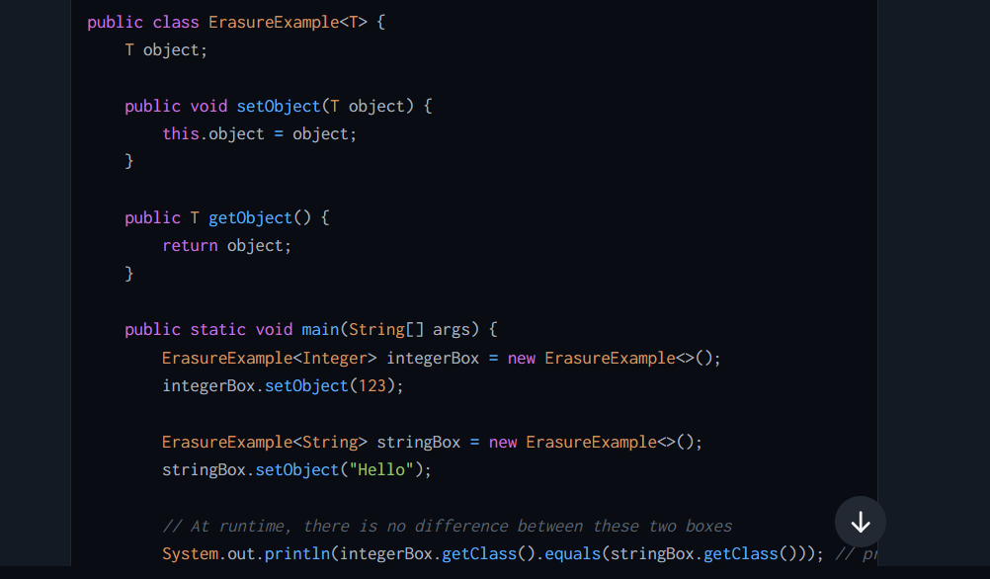

## **What is Wild card in Java Generics?, Explain with an example**

 a wildcard is denoted by the question mark (?) symbol and represents an unknown type. Wildcards are used in generic programming when the type of a parameter is not known or when it is only necessary to specify that the type falls into a certain subset of types. Wildcards help make the code more flexible by allowing various actual types to be used interchangeably.

There are three primary types of wildcards in Java:

1. **Unbounded Wildcards (?)**:
   * An unbounded wildcard represents any type. It is used when the code being written is completely generic and can handle any Java **Object**.

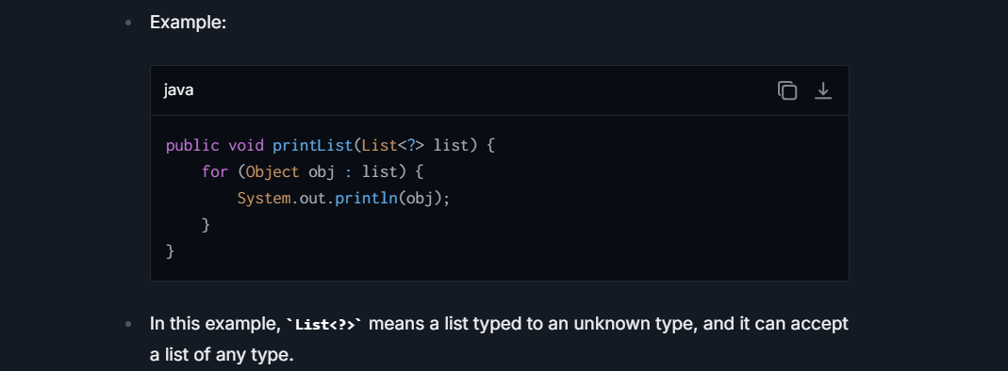

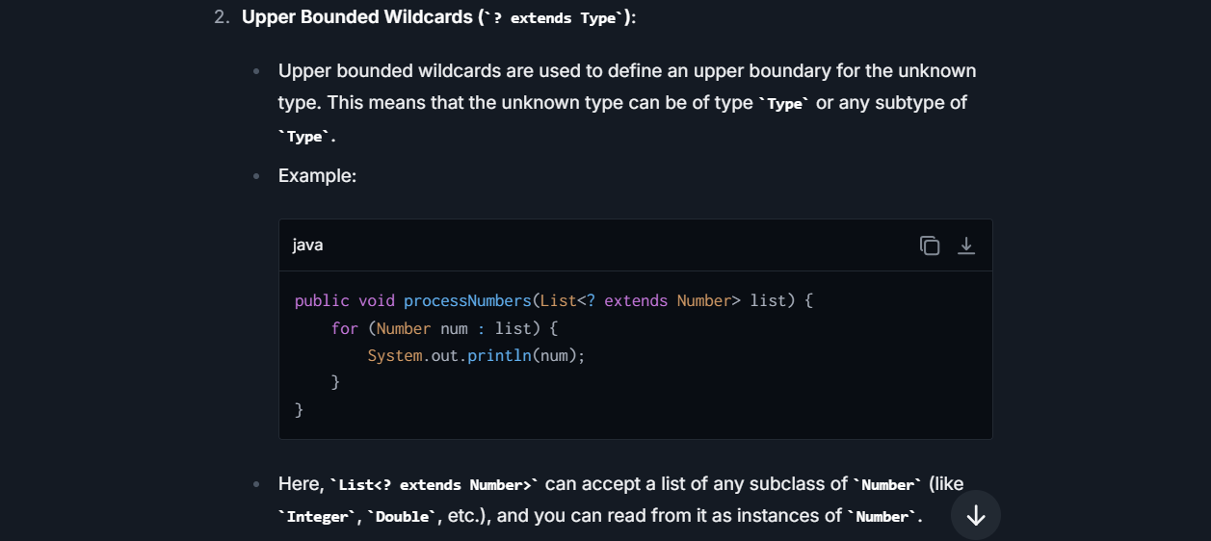

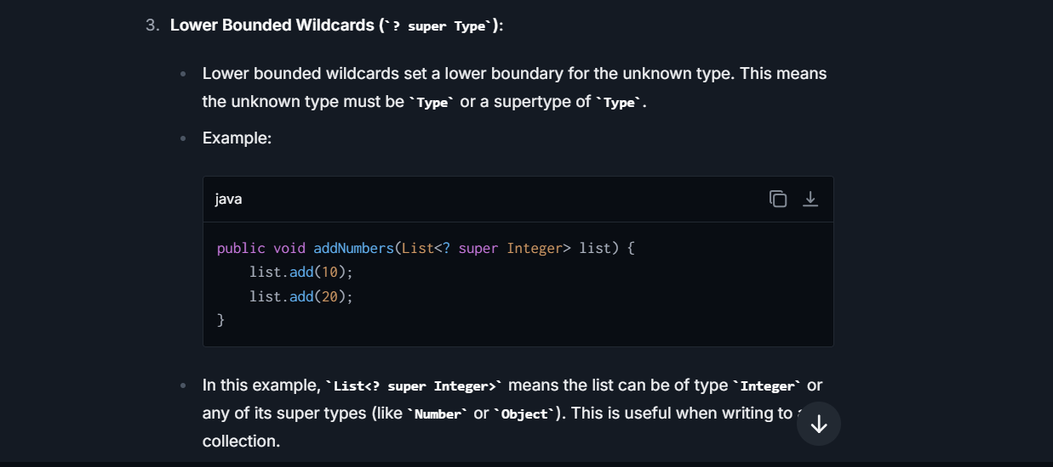

## Difference between Upper Bound and Lower Bound ?



# **Stream Question**

## **Remove duplicates from string and return in same order?**

**Ans-1 s.chars().distinct().mapToObj( c-> (char) c ).forEach(System.out::println);**

**Ans-2 Arrays.stream(s.split("")).distinct().forEach(System.out::print);**

## **Find the length of the longest word ?**

Arrays.stream(s.split(" ")).mapToInt(l -> l.length()).max().getAsInt();

## **Find the length of the 2nd highest word ?**

**Ans-1)** Arrays.stream(s.split(" ")).map(l -> l.length()).sorted(Comparator.reverseOrder()).skip(1).findFirst().get();

**Ans-2**) Arrays.stream(sentence.split("\\s+")).map(String::length).distinct().sorted(Comparator.reverseOrder())

.skip(1)..findFirst().orElse(0);

## **Find the word that has the highest length.**

String s = "I am interested123455 to grow in my organization";

Ans:- String maxString = Arrays.stream(words.split(" ")).max(Comparator.comparing(String::length)).get();

System.out.println("The maxString is: " + maxString);

## **Find the word that has the 2nd (Nth) highest length.**

Stringa=Arrays.stream(s.split("\\s+")).sorted(Comparator.comparing(String::length).reversed()).skip(1).findFirst().get(); System.out.println(a);

## **Find the number of occurrence of each word.**

String input = "the quick brown fox jumps right over the little lazy dog little";

Map<String, Long> collect = Arrays.stream(input.split(" ").collect(Collectors.groupingBy(Function.identity(), Collectors.counting()));

System.out.println(collect);

## **Find Frequency of each character in a string?**

String inputString = "Java Concept Of The Day";

Ans - Map<Character, Long> charCountMap = inputString.chars().mapToObj(c -> (char)c).collect(Collectors.groupingBy(Function.identity(), Collectors.counting()));

## **Find Frequency of each Words in a string?**

 List<String> stationeryList = Arrays.asList("Pen", "Eraser", "Note Book", "Pen", "Pencil", "Stapler", "Note Book", "Pencil");

   Ans-      Map<String, Long> stationeryCountMap = stationeryList.stream().collect(Collectors.groupingBy(Function.identity(), Collectors.counting()));

## **List of integers, Separate Even and Odd No**

**// 1st Solution** List<Integer> list = Arrays.*asList*(1,2,3,45,6,7,89,34);  
 Map<Boolean,List<Integer>> collect1 = list.stream().collect(Collectors.*groupingBy*(n -> n%2==0));  
// System.out.println(collect1);  
  
 **// 2nd Solution** List<Integer> list1 = Arrays.*asList*(1,2,3,45,6,7,89,34);  
 Map<Boolean, List<Integer>> collect2 = list1.stream().collect(Collectors.*partitioningBy*(n -> n % 2 == 0));  
 //System.out.println(collect2);

**//3rd Solution**

List<Integer> numbers = Arrays.asList(1, 2, 3, 4, 5, 6, 7, 8, 9, 10);

List<Integer> evens = numbers.stream().filter(num -> num % 2 == 0).collect(Collectors.toList());

List<Integer> odds = numbers.stream() .filter(num -> num % 2 != 0).collect(Collectors.toList());

System.out.println("Even numbers: " + evens);

System.out.println("Odd numbers: " + odds);

## **Find maximum and minimum From numbers ?**

List<Integer> listOfIntegers = Arrays.asList(45, 12, 56, 15, 24, 75, 31, 89);

**Ans**-     **int** max = listOfIntegers.stream().max(Comparator.naturalOrder()).get();

**Ans - int** min = listOfIntegers.stream().min(Comparator.naturalOrder()).get();

## **How you merge two unsorted arrays into single sorted array ?**

**int**[] a = **new** **int**[] {4, 2, 7, 1};  **int**[] b = **new** **int**[] {8, 3, 9, 5};

**int**[] c = IntStream.concat(Arrays.stream(a), Arrays.stream(b)).sorted().toArray();

 System.out.println(Arrays.toString(c));

🡨------ **without duplicates?** **int**[] c = IntStream.concat(Arrays.stream(a), Arrays.stream(b)).sorted().distinct();

 System.out.println(Arrays.toString(c));

## **Find the words with the maximum number of vowels?**

Arrays.*stream*(s.split(" ")).filter(e -> e.replaceAll("[^aeiouAEIOU]", "").length() == 2)  
 .forEach(System.*out*::println);

## **Rearrange the elements to form a smallest possible value?**

Arrays.stream(arr).mapToObj(i-> i+"").sorted().forEach(System.out:: print);

## **Rearrange the elements to form a Highest possible value?**

Arrays.stream(arr).mapToObj(i-> i+"").sorted((o1,o2) -> (o2+o1).compareTo(o1+o2)).forEach(System.out::print);

## **Find first repeated character in a string?**

String inputString = "Java Concept Of The Day".replaceAll("\\s+", "").toLowerCase();

        Map<String, Long> charCountMap = Arrays.stream(inputString.split("")).collect(Collectors.groupingBy(Function.identity(), LinkedHashMap::**new**, Collectors.counting()));

     String firstRepeatedChar = charCountMap.entrySet().stream() .filter(entry -> entry.getValue() > 1).map(entry -> entry.getKey()) .findFirst().get();

        System.out.println(firstRepeatedChar);

## **Find the first non-repeated character?**

String input = "thequickbrownfoxjumpsoverthelazydog";

**Ans-** Character result = input.chars() ***// Convert the input string into an IntStream***

.mapToObj(c -> (char) c) ***// Convert each int in the stream back to char***

.collect(Collectors.groupingBy(Function.identity(), LinkedHashMap::new, Collectors.counting())) **// Collect characters as keys and their counts as values**

.entrySet()

.stream() **// Stream the entrySet of the map**

.filter(entry -> entry.getValue() == 1) ***// Keep only those entries with a count of 1*** *(non-repeated)*

.map(Map.Entry::getKey) ***// Extract the keys, which are the characters***

.findFirst() ***// Find the first character that meets the criteria***

.orElse(null); ***// Return null if no character found***

System.out.println("The first non-repeated character is: " + result);

}

## **Find the sum of the unique elements?**

integers arr = {5,6,7,8,5,5,8,8,7);

Arrays.stream(arr).distinct().sum();

## **Find Sort the list in reverse order ?**

List<Double> decimalList = Arrays.asList(12.45, 23.58, 17.13, 42.89, 33.78, 71.85, 56.98, 21.12)

Ans - decimalList.stream().sorted(Comparator.reverseOrder()).forEach(System.out::println);

# Azure

## **Important Azure Question**

### **What is a Pipeline in Azure Data Factory?**

A **Pipeline** in **Azure Data Factory (ADF) or Azure Synapse** is a **workflow** that orchestrates and automates data movement and transformation across different services. It consists of **multiple activities** that work together to ingest, process, and store data.

**Key Features of Pipelines**

✔ **Orchestration** → Automates data workflows.  
✔ **Scalability** → Can handle large-scale data processing.  
✔ **Reusability** → Can be triggered multiple times with different parameters.  
✔ **Monitoring** → Supports logs and alerts for pipeline execution tracking.

✅ **Example:** A pipeline can extract data from an **on-premises SQL Server**, transform it using **Databricks**, and load it into **Azure Synapse Analytics**.

**When to Use Pipelines vs. Copy Activity?**

* ✅ **Use Pipelines** → When you need to orchestrate **multiple steps**, including **data movement, transformations, and logic-based decisions**.
* ✅ **Use Copy Activity** → When you **only need to move data** from **one location to another** without additional transformations.

### **What is Copy Activity in Azure Data Factory?**

It is used to **move data from a source to a destination (sink)**. It is one of the most commonly used activities in **Azure Data Factory (ADF) and Azure Synapse** for **ETL (Extract, Transform, Load) processes**.

**How Copy Activity Works?**

1️ **Source:** The location where data is extracted from (e.g., **Azure SQL Database, Blob Storage, On-Premises DB**).  
2️ **Transformation (Optional):** Data can be mapped, filtered, or converted.  
3️ **Sink (Destination):** The target where the data is stored (e.g., **Azure Data Lake, Cosmos DB, Synapse Analytics**).

**When to Use Pipelines vs. Copy Activity?**

* ✅ **Use Pipelines** → When you need to orchestrate **multiple steps**, including **data movement, transformations, and logic-based decisions**.
* ✅ **Use Copy Activity** → When you **only need to move data** from **one location to another** without additional transformations.

### **What is Blob storage and ADLS, Beneficial,UseCases?**

Azure **Blob Storage** and **Azure Data Lake Storage (ADLS)** are **cloud-based storage solutions** designed to handle **unstructured** and **structured** data. While both are built on **Azure Storage**, they serve different purposes.

* **Azure Blob Storage** is a general-purpose **object storage** service for storing large amounts of unstructured data (e.g., images, videos, logs).
* **Azure Data Lake Storage (ADLS)** is optimized for **big data analytics**, offering hierarchical namespaces and better security features.

**Which One is More Beneficial?**

It **depends on the use case**:

* **Use Azure Blob Storage** when you need a **cost-effective, scalable storage** solution for unstructured data (e.g., images, backups, logs).
* **Use ADLS** if you require **big data processing, analytics, and fine-grained access control**.

**When to use Azure Blob Storage?**

**Scenario:** A company needs to store images, videos, and documents for a web application.  
✔ Blob Storage allows direct access via **URLs**, making it ideal for storing web content.  
✔ Example: Hosting images for an **e-commerce website**.

**When to Use Azure Data Lake Storage (ADLS)?**

**Scenario:** A data analytics team needs to process **petabytes of structured log data** for machine learning.  
✔ ADLS supports **big data workloads** with tools like **Azure Synapse, Databricks, and HDInsight**.  
✔ Example: Running ETL (Extract, Transform, Load) pipelines for **financial transaction analysis**.

• **Blob Storage** → Best for **general-purpose storage** (cheaper, scalable).

• **ADLS** → Best for **big data analytics and machine learning** (hierarchical, fine-grained control).

• **Choose ADLS** if your use case involves **big data processing**, otherwise **Blob Storage** is more cost-effective.

### **What are Triggers and IR in Azure ?**

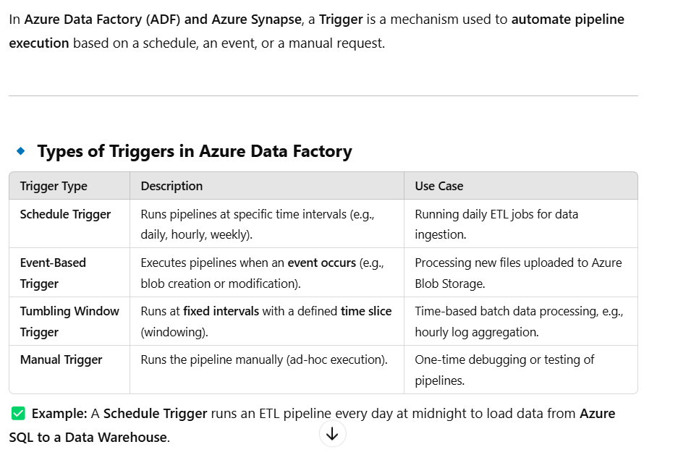

**Integration Runtime :-**

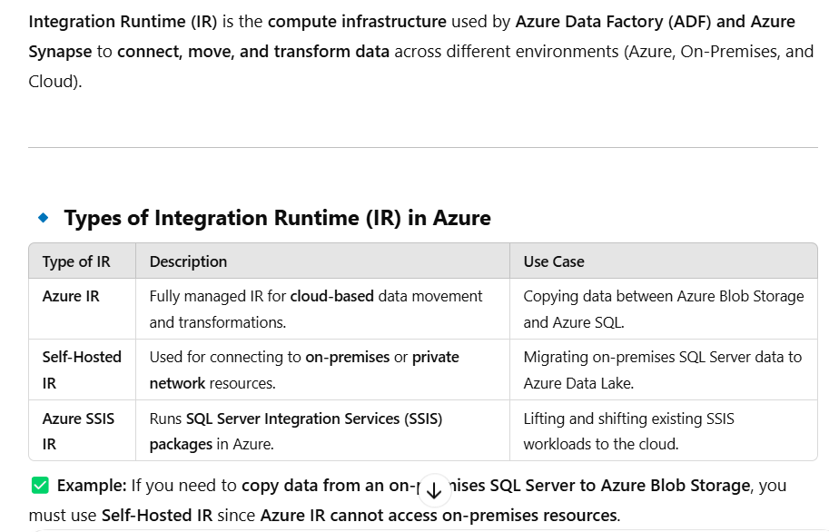

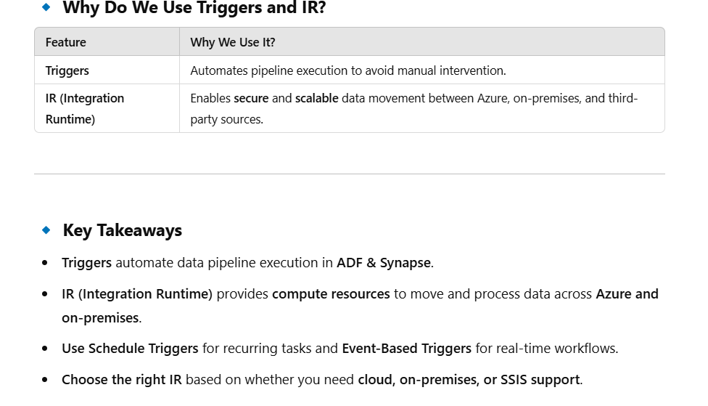

### **Difference Between Blob Storage and ADLS?**

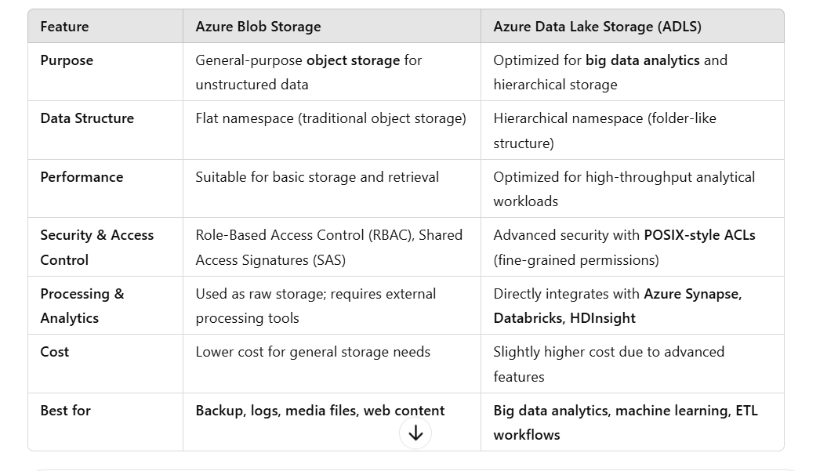

### **Azure Function:-**

#### **How does binding work in Azure Functions?**

In **Azure Functions**, bindings provide a way to easily connect functions to external services **without writing boilerplate code** for integration. Bindings define how data **flows into (input bindings)** and **flows out of (output bindings)** a function.

**How Binding Works?**

1. **Input Binding**: Automatically fetches data from an external source (e.g., Blob Storage, Cosmos DB, Queue Storage) and passes it to the function as a parameter.
2. **Output Binding**: Automatically sends processed data from the function to an external service (e.g., saving data to Blob Storage, sending messages to a queue).
3. **Trigger (Special Input Binding)**: A trigger is a special binding that starts the function execution when an event occurs (e.g., HTTP request, Queue message, Timer event).

Summary :-

**1. Bindings define how data moves in and out of a function.**  
2️. **There are three types of bindings: Triggers, Input, and Output.**  
3️. Azure **automatically manages the connections, reducing complexity.**  
4️. Multiple **bindings (input/output) can be used, but only one trigger per function.**

#### **Benefits of Bindings**

✔ **Simplifies Integration**: No need to manually write connection logic.  
✔ **Reduces Boilerplate Code**: No explicit SDK calls for services.  
✔ **Supports Multiple Services**: Works with **Blob Storage, Cosmos DB, SQL, Event Grid, Service Bus, etc.**  
✔ **Auto-Managed by Azure**: Azure manages the binding lifecycle, reducing manual configuration.

#### **How many triggers can be used in Azure Functions?**

In **Azure Functions**, a function **can have only one trigger**, but there are **multiple types of triggers** available. The trigger determines **when and how** a function executes.

• **Only one trigger** per Azure Function.

• **Multiple bindings** (input/output) can be used alongside a trigger.

• Triggers are **event-driven** and automatically execute based on service interactions.

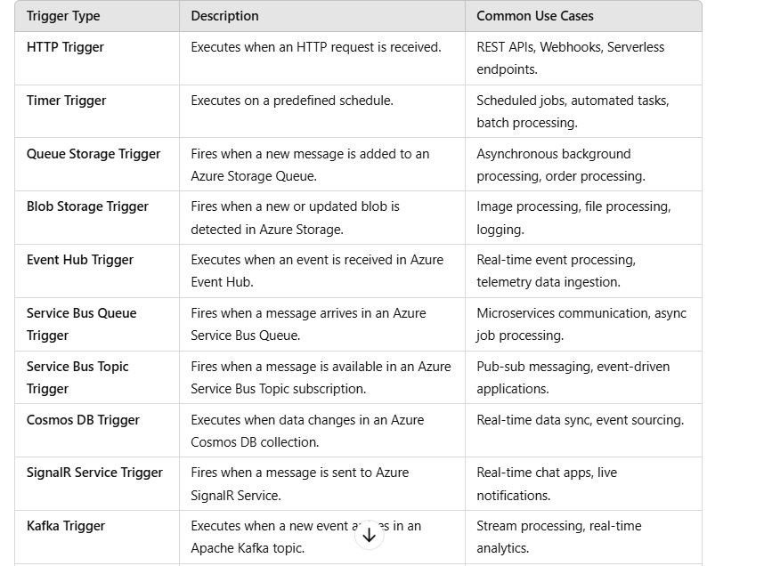

#### **What is the purpose of a storage queue trigger in Azure Functions?**

The purpose of a storage queue trigger in Azure Functions is to trigger an Azure Function execution when a new queue message is created in an Azure Storage Queue. A storage queue trigger allows you to perform custom functions or operations on newly added messages, such as processing data, creating new records or sending out notifications when a new message is received.

#### **How can we monitor function apps in Azure Functions,?**

Monitoring Azure Function Apps is crucial for tracking performance, diagnosing issues, and ensuring reliability. Azure provides **multiple ways to monitor Function Apps**, including **Azure Monitor, Application Insights, Log Streaming, and Metrics**.

**Key Methods to Monitor Azure Functions**

**Application Insights (Recommended)**

* **What It Does?** Provides **real-time telemetry, request logs, dependencies, and error tracking** for Function Apps.
* **How to Enable?**
  + In **Azure Portal**, go to your Function App.
  + Navigate to **Monitoring > Application Insights** and enable it.
  + Use **Kusto Query Language (KQL)** to query logs.

💡 **Example KQL Query** (Check function execution logs):

✅ **Best for:** **End-to-end tracing, error debugging, and performance monitoring.**

**Azure Monitor**

* **What It Does?** Collects **logs, metrics, alerts, and diagnostics** for Function Apps.
* **Key Features:**
  + **Log Analytics**: Aggregates logs for deep analysis.
  + **Metrics**: Monitors CPU, memory, and execution times.
  + **Alerts**: Notifies when function errors occur.

💡 **Example Use Case:**  
✅ **Set up an alert when function execution time exceeds a threshold.**

**Log Streaming**

* **What It Does?** Provides **real-time logs** of function execution.
* **How to Use?**
  + In Azure Portal, go to **Function App > Log Streaming**.
  + Alternatively, use **Azure CLI**:

✅ **Best for:** **Live debugging of function execution.**

**Application Insights** → Best for **detailed logs, telemetry, and tracing.**  
2️⃣ **Azure Monitor** → Best for **alerts, metrics, and deep log analysis.**  
3️⃣ **Log Streaming** → Best for **real-time debugging.**  
4️⃣ **Metrics** → Best for **performance tracking (execution count, failures, CPU/memory usage).**  
5️⃣ **Diagnostic Logs** → Best for **capturing detailed system logs.**

#### **How Do You Set Up Routing in Azure Functions?**

There are **two main ways** to configure routing in Azure Functions:

1.Define Route in Function Attribute (C# Example)

2️. Configure Routing in host. Json (Global Level)

#### **How Do You Adjust Log Levels for Azure Functions?**

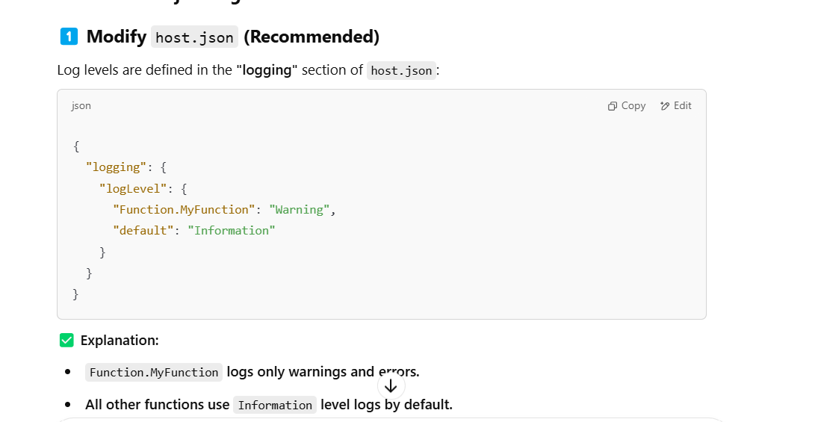

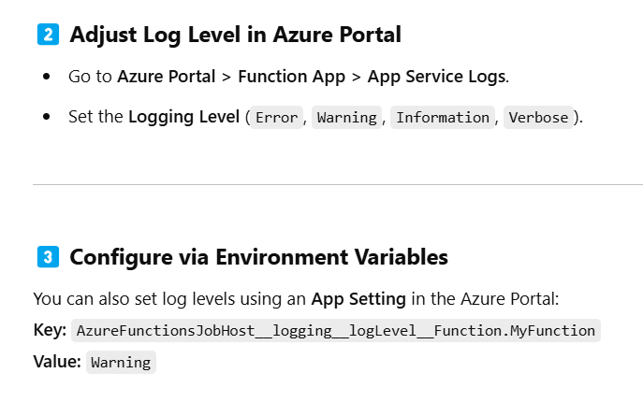

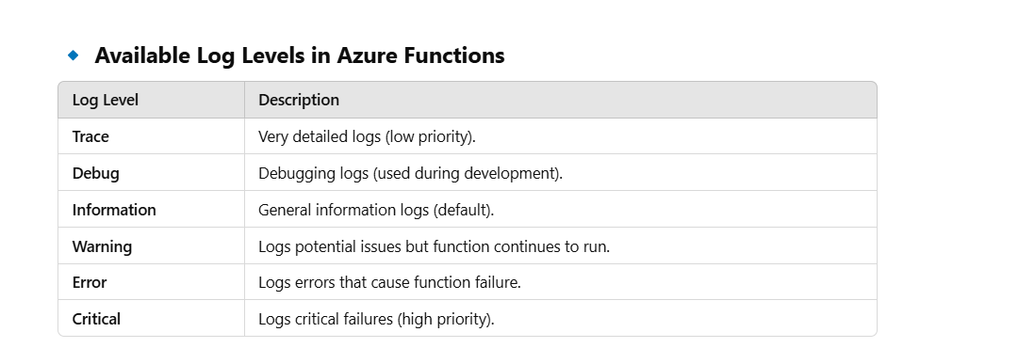

## **What is Azure functions service, Explain?**

Azure Functions is a serverless computing service hosted on the Microsoft Azure public cloud, designed to accelerate and simplify application development. The term "serverless" doesn't imply there are no servers involved, rather, it means that developers can build applications without having to manage infrastructure. The server management and capacity planning are handled by Azure, allowing developers to focus solely on code.

**Real-Life Example Using Spring Boot Application:**

Suppose you have a Spring Boot application designed to process data from IoT devices. The data processing can be offloaded to an Azure Function, which triggers every time new data is received. This way, the data processing logic is separate from your main application, making the system more modular, scalable, and cost-effective.

**Steps to Implement Azure Function with a Spring Boot Application:**

1. **Create an Azure Function App:**
   * Log in to Azure Portal.
   * Create a new Function App, specifying details such as the execution environment (.NET, Java, Node.js, etc.), location, and hosting plan.
2. **Develop the Function:**
   * Choose a trigger for the function, such as an HTTP trigger if you want the function to respond to HTTP requests.
   * Using an IDE like VS Code with Azure Functions extension or IntelliJ, write your function code. For Java-based applications, you can use the Azure Functions Maven plugin to aid in development.
   * Ensure the function can interact with your Spring Boot application. For instance, the function might process data and store the results in a database accessed by your Spring Boot application.
3. **Deploy the Function:**
   * Deploy your function code to the Azure Function App from your IDE or using Azure CLI.
   * Configure application settings and connection strings as environment variables in the Function App settings.
4. **Integrate with Spring Boot Application:**
   * Modify your Spring Boot application to send data to or trigger the Azure Function as necessary.
   * Use REST template, WebClient, or similar web client tools in Spring Boot to make HTTP calls to the Azure Function.

**Advantages of Azure Functions:**

1. **Cost Efficiency:** You pay only for the compute time you consume, reducing the cost of maintaining idle servers.
2. **Scalability:** Azure handles scaling automatically, making it easier to handle peaks in demand without manual intervention.
3. **Focus on Code:** Developers can focus more on writing business logic rather than managing servers and infrastructure.
4. **Integration:** Easily integrates with other Azure services for logging, data storage, and security.

**Disadvantages of Azure Functions:**

1. **Cold Start:** There can be a delay when the function is invoked after being inactive, known as the cold start problem.
2. **Complexity in Testing:** Testing serverless applications can be more complex due to the distributed nature and reliance on external triggers.
3. **Limitations:** There are runtime and execution timeouts that might not suit long-running jobs.
4. **Vendor Lock-in:** Being heavily integrated into the Azure ecosystem might make it difficult to migrate to another platform without significant changes.

## **What are IaaS, PaaS, and SaaS?**

**1. Software as a Service (SaaS):**

* **Definition**: SaaS provides fully managed applications to users over the internet. Users can access and use the software without worrying about underlying infrastructure, middleware, or app development.
* **Real-Life Scenario**: Consider tools like Google Workspace (formerly G Suite) or Microsoft Office 365. These provide applications like email, word processing, and spreadsheets without the hassle of installation, updates, or maintenance on user computers. Users simply log in through their web browser and access the latest version of the application.

**2. Platform as a Service (PaaS):**

* **Definition**: PaaS provides a cloud platform and environment to allow developers to build applications and services. This service includes infrastructure—servers, storage, and networking—but also middleware, development tools, business intelligence (BI) services, database management systems, and more.
* **Real-Life Scenario**: Imagine a developer building a custom web application. Instead of setting up servers, installing software, and configuring databases, the developer uses a PaaS like Azure App Service or Google App Engine. The platform handles all the underlying infrastructure, allowing the developer to focus solely on writing and deploying code.

**3. Infrastructure as a Service (IaaS):**

* **Definition**: IaaS provides fundamental compute, network, and storage capabilities to consumers on-demand, over the internet, and on a pay-as-you-go basis. This is the most flexible cloud computing model and allows for automated deployment of servers, processing power, storage, and networking.
* **Real-Life Scenario**: Consider a company needing to run several powerful applications that require custom configurations. Using an IaaS provider like Amazon Web Services (AWS), Azure, or Google Cloud Platform (GCP), the company can rent the virtual hardware and configure its virtual machines exactly as needed, with the exact desired operating system, applications, and network configurations. They manage the software, middleware, and OS, while the cloud provider manages the physical infrastructure.

These models offer various levels of customization and management, making them suitable for different kinds of services and business models. In essence:

* **SaaS** removes the need for organizations to handle the applications or the infrastructure.
* **PaaS** allows organizations to focus more on their application development and less on managing hardware or operating systems.
* **IaaS** provides the raw building blocks for cloud IT, giving more control over operating environments but requires users to manage those environments more actively.

## **What are the various type of Cloud models ?**

Cloud deployment models define where your data is stored, how your services are managed, who manages them, and how your applications are deployed in the cloud. Choosing the right deployment model is crucial for optimizing resource usage, managing costs, and ensuring security and compliance according to your requirements. The primary cloud deployment models are:

1. **Public Cloud**:
   * In a public cloud model, cloud services are delivered over the internet and shared across multiple organizations. The cloud resources (servers, storage, etc.) are owned and managed by a third-party cloud service provider (like Microsoft Azure, Amazon AWS, or Google Cloud Platform).
   * **Advantages**: High scalability, no maintenance of hardware, lower cost of entry as you pay only for what you use, and reliability.
   * **Disadvantages**: Less control over data security and network performance, potential for data access and governance concerns.
   * **Use Cases**: Ideal for small to medium-sized companies or startups that need high scalability without significant capital expenditure. Also, for applications that demand robust computational resources intermittently.
2. **Private Cloud**:
   * Private cloud involves cloud infrastructure dedicated solely to one organization. It can be physically located at the company’s on-site data center, or hosted by a third-party service provider but remains exclusively used by one client.
   * **Advantages**: Enhanced control and customization of the computing environment, increased security because resources are not shared, compliance with regulatory standards.
   * **Disadvantages**: Higher cost due to dedicated hardware, operational costs, and management. Requires investment in hardware and expertise in cloud infrastructure.
   * **Use Cases**: Suitable for large enterprises and organizations with high requirements for security, privacy, and control. Often used by government agencies, financial institutions, and healthcare organizations.
3. **Hybrid Cloud**:
   * Hybrid clouds combine public and private clouds, bound together by technology that allows data and applications to be shared between them. This allows data and applications to move between private and public clouds for greater flexibility and deployment options.
   * **Advantages**: Flexibility and scalability, cost-effectiveness by mixing on-premises infrastructure with public cloud, improved compliance and security protocols by keeping sensitive data in the private cloud.
   * **Disadvantages**: Can be complex to set up and manage, integration and networking can be a challenge.
   * **Use Cases**: Ideal for businesses that want to maintain control over sensitive data but want to leverage cloud resources for non-critical operations. It’s also used for business continuity and disaster recovery solutions.
4. **Community Cloud**:
   * A community cloud model is shared among several organizations from a specific community with common concerns (security, compliance, jurisdiction, etc.), whether managed internally or by a third-party, and hosted internally or externally.
   * **Advantages**: Cost-effective cloud solution for multiple organizations with similar needs, shared policies, and compliance considerations.
   * **Disadvantages**: Less flexibility than a private cloud, potentially more cost than a public cloud depending on scale, shared infrastructure can lead to possible service delays.
   * **Use Cases**: Suitable for government organizations, research organizations, or companies working on joint projects or applications that require a centralized cloud computing facility.

## **What is Resource group?**

In Azure, a **Resource Group** is a block that holds related resources for an Azure solution. A resource group is essentially a container that groups related resources for an Azure application or project. This grouping simplifies the management, deployment, and monitoring of resources. **Real-Life Example:** Imagine you are managing an e-commerce platform, which includes various components such as a web app, a database, and storage accounts. To organize these, you could use a Resource Group.

**Key Characteristics:**

* **Lifecycle:** All resources in a resource group can share the same lifecycle. You deploy, update, and delete them together. If a resource, such as a virtual machine needs to exist on a different deployment cycle, it should be in another resource group.
* **Location:** Resource groups are also defined by a geographic location where their metadata is stored. This defines where that metadata is available and complies with data residency regulations. However, the resources contained in a resource group can span multiple regions.

**Steps:**

1. **Create a Resource Group**: You start by creating a Resource Group named **ECommercePlatform**.
2. **Add Resources**:
   * **Web App**: Host your website.
   * **SQL Database**: Manage product catalog and user data.
   * **Storage Account**: Store product images and logs.
   * **Virtual Network**: Secure communication between your resources.
3. **Manage the Resources**: All these resources can be managed, deployed, and monitored together. Updates or changes to the network settings can be made once and affect all resources within the group.

**Purpose of Resource Groups:**

1. **Management Simplicity:** Resource groups enable you to manage and monitor resources collectively. You can deploy, update, or delete all the resources for a specific solution in a single, coordinated operation. They make it easier to manage and visualize the assets for a particular application or project together, rather than dealing with them individually.
2. **Granular Access Control:** You can apply access control policies to the entire group, which simplifies the administration of permissions. This allows you to control who has access to these resources, and what actions they can perform on them, fostering security and compliance.
3. **Cost Management and Billing:** Resource groups help in organizing resources that share the same life-cycle, thereby simplifying billing and subscription management. You can track and manage costs collectively, set up budgets, and view aggregated metrics.
4. **Scope for Policies and Compliance:** They provide a scope for applying and enforcing policies, compliance checks, and tagging which are crucial for governance and regulations.

**Benefits of Using a Resource Group:**

* **Management**: Easier to manage resources as a group. For instance, you can deploy, update, or delete all resources in one operation.
* **Billing**: You can view collective billing for the group, making it straightforward to understand the costs associated with the solution and keep a budget.
* **Access Control**: Manage access settings for all resources within the resource group. This makes it easier to control who has access to what, improving security.

## **What is Virtual Machine?**

It is a software-based emulation of a physical computer. It runs an operating system and applications just like a physical computer, but it's created and managed purely in a software environment. VMs operate based on the concept of virtualization, where a physical server is divided into multiple isolated environments, each functioning as a standalone system.

**Real-Life Example:**

Suppose you own a small business and need to run multiple applications, each requiring different operating systems. Instead of purchasing separate physical servers for each application, you can use virtual machines.

**Steps:**

1. **Choose a Host Machine**: You select a powerful physical server that will host the virtual machines. This server is known as the host machine.
2. **Install Hypervisor**: You install virtualization software (known as a hypervisor) on the host machine, such as VMware ESXi, Microsoft Hyper-V, or Oracle VirtualBox.
3. **Create Virtual Machines**:
   * **VM1**: Runs Windows 10, used for accounting software.
   * **VM2**: Runs Ubuntu Linux, used for your website's backend.
   * **VM3**: Runs another instance of Windows or Linux for email services.
4. **Allocate Resources**: Each VM is allocated a portion of the host's CPU power, RAM, and storage, depending on the needs of the application it runs.

**Benefits of Using Virtual Machines:**

* **Cost Efficiency**: Reduces the need for physical hardware, as multiple VMs can run on a single physical server.
* **Isolation**: Each VM operates independently. If one VM crashes, it doesn’t affect the others.
* **Flexibility**: You can run different operating systems and applications on the same physical hardware.
* **Scalability**: You can create new VMs as needed without the need to invest in new physical hardware.
* **Snapshot and Backup**: It is easier to create a snapshot (a saved state) of a VM, which can be reverted to at any time. This is beneficial for recovery during failures.

**Disadvantages of Virtual Machines:**

* **Resource Overhead**: Running multiple VMs on a single server can lead to performance degradation if not managed properly because each VM needs a portion of the physical resources.
* **Maintenance**: Requires regular maintenance and updates for each OS and application running on the VMs.
* **Complex Configuration**: Sometimes setting up and managing VMs and their interconnectivities can be complex.

## **What are the Azure - Architectural Components like Region's & Region's Pairs, Availability zone, Azure Resources, Resource Group, Azure Resource manager's, subscriptions and Azure Management group's. ?**

Understanding Azure's architectural components is crucial when architecting, deploying, and managing applications on the Azure platform. Let’s break down these components, providing examples for better clarity.

**1. Regions & Region Pairs**

**"Azure Regions"** refer to the geographic locations around the world where Microsoft hosts its data centers. When you deploy a service, VM, or database in Azure, you choose a region where that resource will live.

**For example**, you might choose the "East US" region to serve your users better on the east coast of the United States.

**"Region Pairs"** are designed for redundancy and failure isolation. Each Azure region is paired with another region within the same geography, at least 300 miles away.

**Example** is the "East US" region paired with the "West US" region. These pairs are crucial for strategies such as disaster recovery; if one region were to experience a disaster, the paired region would still be operational.

**2. Availability Zones**.

They are physically separate zones within an Azure region. Each zone is made up of one or more data centers equipped with independent power, cooling, and networking. Each Zone are interconnected via fiber-optics networks

**Example :-** If you deploy a Virtual Machine in "East US 2" region, you can specify it to be placed in Availability Zone 1. This way, you can ensure that even if one zone goes down, parts of your service in other zones will still be functional, thereby increasing the resilience of your application.

**3. Azure Resources**

An **"Azure Resource"** is a manageable item that is available through Azure. It could be a virtual machine, storage account, web app, database, or more.

**For example,** a single Azure Storage Account or an Azure SQL Database are considered individual resources. These resources are maintained and managed individually but can be interconnected to build an entire service or application.

**4. Resource Group**

A **"Resource Group"** is a container that holds related resources for an Azure solution. **For instance,** if you're deploying a web application, you might create a resource group that includes your web app's Azure Web App, related databases, and storage accounts. Everything needed for the web application can be grouped together for simpler management and deployment**. Resource can exist in only one resource group and Every resource have a location**.

**5. Azure Resource Manager**

**"Azure Resource Manager"** (ARM) is the service used to provision resources in your Azure account. It acts as the management layer that allows you to create, update, and delete resources within your Azure subscription using a declarative template in JSON format. **Imagine** you need to deploy several VMs with the same configurations; ARM makes it straightforward through ARM templates, ensuring all VMs are uniformly set up.

**6. Subscriptions**

An **"Azure Subscription"(Billing +Access Control Boundaries)** is a logical container into which all your Azure resources are grouped and billed. **For instance**, you might have a subscription for your production environments and another for development and testing. This organization helps manage costs and access control in a large organization. Each subscription can support the deployment of various resources and is used to manage billing, resource usage, and service administration.  
**Billing Boundary** It generates separate billing reports and invoice for each subscription and control resources.

**7. Azure Management Groups**

**"Azure Management Groups"** are containers that help manage governance and Azure policies across multiple Azure subscriptions. Suppose a large organization has multiple subscriptions for different departments or regions. Management groups can be used to apply policies at a broad level. **For example**, you could enforce a policy within a management group that all virtual machines should have antivirus software installed, and this policy would automatically apply to all subscriptions in that group.

## **What is Azure Resource Manager (ARM)?**

ARM is a JSON Document(overview>input>output>Templates)

**"Azure Resource Manager"** (ARM) is the service used to provision resources in your Azure account. It acts as the management layer that allows you to create, update, and delete resources within your Azure subscription using a declarative template in JSON format. **Imagine** you need to deploy several VMs with the same configurations; ARM makes it straightforward through ARM templates, ensuring all VMs are uniformly set up.

## **What is Azure functions service, Explain?**

Azure Functions is a serverless computing service hosted on the Microsoft Azure public cloud, designed to accelerate and simplify application development. The term "serverless" doesn't imply there are no servers involved, rather, it means that developers can build applications without having to manage infrastructure. The server management and capacity planning are handled by Azure, allowing developers to focus solely on code.

**Real-Life Example Using Spring Boot Application:**

Suppose you have a Spring Boot application designed to process data from IoT devices. The data processing can be offloaded to an Azure Function, which triggers every time new data is received. This way, the data processing logic is separate from your main application, making the system more modular, scalable, and cost-effective.

**Steps to Implement Azure Function with a Spring Boot Application:**

1. **Create an Azure Function App:**
   * Log in to Azure Portal.
   * Create a new Function App, specifying details such as the execution environment (.NET, Java, Node.js, etc.), location, and hosting plan.
2. **Develop the Function:**
   * Choose a trigger for the function, such as an HTTP trigger if you want the function to respond to HTTP requests.
   * Using an IDE like VS Code with Azure Functions extension or IntelliJ, write your function code. For Java-based applications, you can use the Azure Functions Maven plugin to aid in development.
   * Ensure the function can interact with your Spring Boot application. For instance, the function might process data and store the results in a database accessed by your Spring Boot application.
3. **Deploy the Function:**
   * Deploy your function code to the Azure Function App from your IDE or using Azure CLI.
   * Configure application settings and connection strings as environment variables in the Function App settings.
4. **Integrate with Spring Boot Application:**
   * Modify your Spring Boot application to send data to or trigger the Azure Function as necessary.
   * Use REST template, WebClient, or similar web client tools in Spring Boot to make HTTP calls to the Azure Function.

**Advantages of Azure Functions:**

1. **Cost Efficiency:** You pay only for the compute time you consume, reducing the cost of maintaining idle servers.
2. **Scalability:** Azure handles scaling automatically, making it easier to handle peaks in demand without manual intervention.
3. **Focus on Code:** Developers can focus more on writing business logic rather than managing servers and infrastructure.
4. **Integration:** Easily integrates with other Azure services for logging, data storage, and security.

**Disadvantages of Azure Functions:**

1. **Cold Start:** There can be a delay when the function is invoked after being inactive, known as the cold start problem.
2. **Complexity in Testing:** Testing serverless applications can be more complex due to the distributed nature and reliance on external triggers.
3. **Limitations:** There are runtime and execution timeouts that might not suit long-running jobs.
4. **Vendor Lock-in:** Being heavily integrated into the Azure ecosystem might make it difficult to migrate to another platform without significant changes.

## **What is Azure Blob storage, Explain?**

**Azure Blob Storage** is a service from Microsoft Azure that provides scalable, cost-efficient cloud storage for unstructured data. This data, which primarily includes text or binary data, is stored as objects called "blobs." Azure Blob storage is highly suited for scenarios including serving images or documents directly to a browser, storing files for distributed access, streaming video and audio, and storing data for backup, disaster recovery, and archiving.

**Key Features:**

1. **Scalability and Flexibility:** Blob storage is designed to store massive amounts of unstructured data. The storage service can scale as needed, making it a convenient choice for applications requiring extensive storage capacity.
2. **Durability and High Availability:** Data is replicated across Microsoft managed data centers to ensure high availability and durability. You can choose from various replication strategies depending on your need for redundancy.
3. **Security:** Supports advanced security features including role-based access control (RBAC), encryption at rest, and advanced threat protection.
4. **Access Tiers:** Offers access tiers that allow you to store blob data in the most cost-effective manner depending on how frequently the data is accessed.

**Use Cases:**

* **Data Lakes for Analytics:** Store large amounts of data for big data analytics.
* **Content Delivery:** Websites can store content like images and videos in Blob Storage, which can then be directly served to end-users.
* **Backup and Restore:** Blob storage provides robust and secure storage options suitable for backing up and restoring important data.

## **What are Azure Container Instances (ACI)?**

It is a solution for running containers on Azure without having to manage underlying virtual machines or additional services. It provides a straightforward and scalable way to run containers in the cloud, making it ideal for simple applications, task automation, and rapid deployment scenarios.

**Key Features of ACI:**

1. **Serverless Containers:** ACI is often considered a serverless offering because it abstracts all the underlying hardware and infrastructure, allowing you to focus solely on the containers.
2. **Fast Startup Times:** Containers in ACI start in seconds, which is significantly faster compared to more traditional methods involving VMs.
3. **Per-second Billing:** You are billed only for the seconds your container runs, combined with the resources it consumes.
4. **Group Deployment:** Ability to deploy multiple containers as a group, which share the same lifecycle, networking, and storage context.

**Use Cases for ACI:**

* Running short-lived containers.
* Situations where rapid deployment and undemanding, autonomous management are required.
* Batch jobs and workload automation.
* Situations not requiring large-scale orchestration.

## **What is Azure SQL service, Explain?**

Azure SQL is a family of fully managed relational database services provided by Microsoft Azure. It is built on SQL Server technology and offers a range of services that allow businesses to run relational databases on the cloud without worrying about managing the underlying hardware and infrastructure. Azure SQL is a part of Azure's Platform-as-a-Service (PaaS) offerings, enabling developers to focus on building applications while Azure handles the database management.

**Key Components of Azure SQL**

1. **Azure SQL Database**:
   * **Azure SQL Database** is a fully managed relational database-as-a-service (DBaaS). It is designed for single databases or multiple databases that share a common architecture. It’s ideal for cloud applications where you need high availability, scalability, and security.
   * It provides automatic patching, backups, monitoring, and scaling, and allows you to focus on your application without worrying about database management.
2. **Azure SQL Managed Instance**:
   * **Azure SQL Managed Instance** is a fully managed instance of SQL Server that allows you to migrate on-premises SQL Server databases to Azure with minimal changes.
   * It is designed to provide **near 100% compatibility** with on-premises SQL Server and is suitable for applications that require more control over database settings and configurations, but still want the advantages of a managed service.
   * It offers features like **automatic backups**, **auto-scaling**, and **advanced security**, while also supporting a wide range of SQL Server features that may not be available in Azure SQL Database.
3. **SQL Server on Azure Virtual Machines (VM)**:
   * **SQL Server on Azure VMs** provides the most control and flexibility by running SQL Server inside a virtual machine on Azure. It is not a fully managed service like SQL Database or Managed Instance, but it provides full administrative access to the SQL Server instance, operating system, and storage.
   * This option is best suited for applications that need custom configurations, and it is ideal for lift-and-shift migrations from on-premises environments.

**Key Features of Azure SQL**

1. **Scalability**:
   * **Elastic Pools**: With Azure SQL Database, you can scale your resources up or down based on your app’s needs. Elastic pools allow multiple databases to share resources (CPU, memory, I/O) and scale together as demand fluctuates.
   * **Automatic Scaling**: Azure SQL can automatically scale depending on the performance and usage demands. You can configure your database to automatically adjust resources (compute and storage) based on actual traffic patterns.
2. **High Availability**:
   * **Built-in Availability**: Azure SQL comes with built-in high availability with **automatic failover** across multiple replicas in different regions.
   * **Geo-replication**: You can replicate your database across multiple regions worldwide, ensuring that your data remains available even during regional outages.
   * **Automated Backups**: Azure SQL provides **automatic backups** that are stored for up to 35 days (in Azure SQL Database) and can be restored to any point in time within that window.
3. **Security**:
   * **Data Encryption**: All data stored in Azure SQL is encrypted by default using **Transparent Data Encryption (TDE)**. In addition, data in transit is encrypted using **SSL/TLS**.
   * **Advanced Threat Protection**: Azure SQL provides security features like **advanced threat protection**, which includes features such as **SQL injection protection**, **vulnerability assessments**, and **firewall rules**.
   * **Azure Active Directory (AAD) Authentication**: You can integrate Azure SQL with Azure Active Directory for secure authentication and centralized identity management.
   * **Always Encrypted**: Azure SQL supports **Always Encrypted**, which ensures that sensitive data (such as credit card numbers) is encrypted both at rest and in transit.
4. **Performance Optimization**:
   * **Automated Tuning**: Azure SQL continuously monitors and tunes the database to optimize performance. It uses features like **automatic indexing** and **query performance insights** to improve query execution times and resource usage.
   * **Query Store**: This feature stores historical performance data, allowing you to analyze and troubleshoot query performance issues.
   * **In-Memory OLTP**: Azure SQL supports **in-memory technologies** for faster transaction processing and performance optimization.
5. **Advanced Analytics**:
   * Azure SQL allows you to perform **advanced analytics** directly in the database. You can run **R** and **Python** scripts in the database using **SQL Server Machine Learning Services** (formerly SQL Server R Services) to perform predictive analytics and data processing without needing to move the data.
   * Integration with **Azure Synapse Analytics** and **Power BI** provides enhanced analytics and reporting capabilities.
6. **Built-in Monitoring and Diagnostics**:
   * Azure SQL provides robust monitoring tools, such as **Azure Monitor**, **SQL Analytics**, and **Application Insights**, which allow you to monitor database performance, detect anomalies, and track performance metrics.
   * **Query Performance Insights** and **Automatic Tuning** help you identify bottlenecks and optimize database queries and performance.

**How Azure SQL is Used in Real-Life Scenarios**

1. **Web and Mobile Applications**:
   * Azure SQL is used for hosting the back-end relational database for web and mobile applications, providing fast and reliable access to data with minimal latency.
   * Examples: E-commerce websites, social media platforms, content management systems (CMS), and customer relationship management (CRM) systems.
2. **Business Intelligence and Data Warehousing**:
   * Azure SQL integrates with other Azure services, such as **Azure Synapse Analytics**, **Power BI**, and **Azure Data Factory**, making it ideal for data warehousing, business intelligence, and reporting.
   * Organizations can use Azure SQL to store structured data and run complex analytical queries to gain insights into their business operations.
3. **Cloud Migrations**:
   * Many organizations are moving their on-premises SQL Server databases to Azure SQL to benefit from **scalability**, **high availability**, and **security**.
   * **Lift-and-shift migrations** from on-premises environments to Azure SQL Database or Azure SQL Managed Instance help reduce the complexity of database management.
4. **SaaS Applications**:
   * Software-as-a-Service (SaaS) platforms often use Azure SQL to manage multi-tenant databases, providing scalability and high availability while isolating customer data.
   * Example: A customer support SaaS application might use Azure SQL to store customer tickets, feedback, and data across many customers, while ensuring security and compliance.

**Azure SQL Pricing**

Azure SQL offers different pricing models based on your needs, including:

1. **DTU-Based Model** (Database Transaction Unit):
   * A pricing model where you pay for a bundle of compute, storage, and I/O resources.
2. **vCore-Based Model**:
   * A more flexible and modern pricing model where you pay based on virtual cores (vCores), storage, and backup requirements. You can choose from different tiers such as **General Purpose**, **Business Critical**, and **Hyperscale**.
3. **Azure SQL Managed Instance** also has a similar pricing model, but it's often priced higher due to its full compatibility with on-premises SQL Server.
4. **Pay-as-you-go**: Pricing is based on the consumption of resources such as storage, compute power, and I/O requests.

## **What is Azure Kubernetes Service?**

Azure Kubernetes Service (AKS) is a managed Kubernetes service offered by Microsoft as part of the Azure cloud platform. It provides a way for organizations to deploy and manage their containerized applications at scale, leveraging the powerful features of Kubernetes. By providing a fully managed service that handles many of the underlying infrastructure and management chores, AKS makes it easier to build and operate Kubernetes clusters. Because of this, businesses can concentrate on their apps and services rather than worrying about the infrastructure as a whole.

**Key Features of AKS :-**

1. **Managed Kubernetes**: AKS manages your hosted Kubernetes environment, making it easier to deploy and manage containerized applications without container orchestration expertise. It automates tasks such as upgrades, patching, and scaling.
2. **Integrated Developer Tools**: AKS integrates with Azure DevOps, Visual Studio Code, and other Git repositories for development, testing, and deployments, facilitating continuous integration and continuous delivery (CI/CD).
3. **Scaling**: AKS supports both manual and automatic scaling. You can scale your applications automatically based on resource utilization like CPU and memory, or on custom metrics.
4. **Multi-Node Pools**: Support for multiple node pools allows you to run different types of workloads on different types of VMs within the same AKS cluster, which can be optimized per workload requirements such as CPU or memory-intensive applications.
5. **Security and Compliance:** Built-in security features include Azure Active Directory integration, role-based access control (RBAC), network policies, and encryption at rest. Azure Policy and Azure Security Center provide deep Kubernetes security and configuration analysis.
6. **Networking Features:** AKS provides advanced networking features, allowing the establishment of private clusters with restricted access using Azure Private Link. Integration with Azure Network Policy and Application Gateway aids in enhancing network security and functionality.

**How AKS Works :-**

* **Clusters and Nodes:**An AKS cluster consists of a control plane (managed by Azure) and nodes or node pools. The nodes are standard Azure VMs that you can configure, and they run the containers.
* **Control Plane:**AKS abstracts and manages the control plane for free. The control plane consists of components that make global decisions about the cluster, as well as detecting and responding to cluster events.
* **Node Pools:**Node pools in AKS allow you to run different types of workloads on different VM sizes or to use different VM images customized to your requirements.

**How to Create AKS Cluster :-**

🡪 In the Azure Portal, search for "Kubernetes services" in the search bar and select it.

* In the Kubernetes services page, click on "+ Create" and then select "+ Create Kubernetes cluster".
* Fill in the required fields:

🡪 Subscription: Select your Azure subscription.

🡪Resource Group: Select the resource group you created or an existing one.

🡪Kubernetes Cluster Name: Enter a unique name for your AKS cluster.

🡪Region: Choose the Azure region in which to deploy your cluster. This should be closest to your users to reduce latency.

* Under "Node size", you can select the size of the VMs that will be used for the nodes. Choose a VM size that suits your budget and expected workload.
* Specify the "Node count", which is the number of nodes you want in your cluster.

🡪Authentication:

If not using an existing service principal or system-assigned managed identity, AKS will create these for you during the cluster creation process.

* Networking:

Configure the networking model, either basic or advanced (CNI). The Azure CNI is often recommended for production environments because it offers greater flexibility and integration with Azure virtual networks.

Monitoring:

Enable monitoring to collect health and performance metrics. You will be prompted to either create a new Log Analytics workspace or select an existing one.

Click "Review + Create" once you’ve configured all options, and then "Create" to provision the AKS cluster. This process can take a few minutes.Use Cases

* **Microservices:**AKS is ideal for microservices architecture because it supports complex applications and services that consist of multiple interdependent components and services**.**
* **Batch Processing:**Automatic scaling in AKS allows for efficient handling of batch processing jobs during fluctuations in demand**.**

## **What is Azure App Service, Explain ?**

**Azure App Service** is a fully managed platform-as-a-service (PaaS) offering from Microsoft Azure that allows you to build, host, and scale web applications, APIs, and mobile backends. It provides a rich set of features to facilitate the development and deployment of applications, including integration with other Azure services, automatic scaling, high availability, and more.

In simpler terms, **Azure App Service** enables developers to focus on writing code without having to worry about infrastructure management. Azure handles the infrastructure for you, such as the servers, storage, load balancing, security patches, and updates, allowing you to deploy and scale applications seamlessly.

**Key Features of Azure App Service :-**

1. **Fully Managed Platform (PaaS)**:
   * **Azure App Service** is a Platform-as-a-Service (PaaS) offering, meaning you don't need to manage the underlying infrastructure (servers, storage, or networking). Azure handles all the maintenance tasks such as patching, updates, and scaling.
   * You simply focus on deploying your code, and Azure handles everything else automatically.
2. **Supports Multiple Programming Languages**:
   * You can develop applications using a wide range of programming languages, including:
     + **.NET**
     + **Java Python**
3. **Automatic Scaling**:
   * Azure App Service offers both **vertical** (increasing the resources of your instance) and **horizontal** (scaling out by adding more instances) scaling.
   * It can scale automatically based on demand, ensuring that your application remains available during high traffic periods.
4. **Integrated Developer Tools**:
   * You can deploy your applications to Azure App Service using popular **CI/CD (Continuous Integration and Continuous Deployment)** tools such as:
     + **GitHub Actions**
     + **Azure DevOps**
     + **Bitbucket**
     + **Local Git repository**
   * You can also use **FTP** and **Azure CLI** for deployments.
5. **High Availability and Reliability**:
   * **App Service** offers **99.95% uptime** SLA for production workloads. Azure provides high availability through multiple **data centers** and **regions** to ensure that your application is resilient to failures.
   * You can configure **Availability Zones** and deploy your application across multiple data centers to ensure business continuity.
6. **Integrated Security Features**:
   * Azure App Service includes robust security features, such as:
     + **SSL/TLS encryption** for securing data in transit.
     + **Azure Active Directory (AAD) integration** for authentication and access control.
     + **Built-in DDoS protection** and **firewall rules** to protect your app from malicious traffic.
     + **App Service Environment (ASE)** for running apps in a fully isolated, highly secure environment.
7. **Global Reach**:
   * Azure App Service is available in **multiple Azure regions** worldwide, ensuring that you can deploy your application close to your users, which helps improve performance and reduce latency.
   * You can easily deploy applications across multiple regions for **global availability** and **geo-replication**.
8. **Custom Domains & SSL**:
   * Azure allows you to map custom domains to your App Service and configure **SSL** certificates for secure connections.
   * You can use **Azure-managed SSL certificates** or upload your own custom SSL certificates for encrypted communication.
9. **Easy Integration with Other Azure Services**:
   * Azure App Service integrates well with other Azure services, such as:

**Azure SQL Database**, **Azure Cosmos DB**, **Azure Redis Cache**, **Azure Storage**, **Azure Active Directory**, **Azure Logic Apps, Functions, and Event Grid.**

**Types of Azure App Service**

Azure App Service has several offerings based on your needs:

1. **Web Apps**:
   * Primarily designed to host web applications written in **any programming language** (like .NET, Java, Node.js, Python).
2. **API Apps**:
   * This service is specifically for hosting and exposing **RESTful APIs**. You can host APIs written in any of the supported languages (Java, .NET, Node.js, Python).
3. **Mobile Apps**:
   * Azure App Service also includes **Mobile App Services**, designed for building backends for **mobile applications**.
4. **Function Apps**:
   * **Azure Functions** allow you to run event-driven, serverless functions in the cloud. This is ideal for running lightweight, single-purpose code triggered by various events like HTTP requests, queue messages, or timer-based actions.

**How to Use Azure App Service**

1. **Create an App Service**:
   * You can create a new App Service via the **Azure Portal**, Azure CLI, or **ARM Templates**.
   * In the portal, choose **Create a resource** > **App Service** and configure the basic settings like subscription, resource group, name, and region.
2. **Deploying an Application**:
   * After setting up the App Service, you can deploy your application via several methods:
     + **Git** (GitHub, Bitbucket, Azure Repos)
     + **FTP**
3. **Scaling the Application**:
   * Once the app is deployed, you can scale it by adjusting the number of instances or upgrading the pricing tier (e.g., **Basic, Standard, Premium**) to get more features such as autoscaling and more storage.
4. **Monitoring and Logging**:
   * After deployment, use **Azure Monitor** and **Application Insights** to track the performance and errors of your application.
   * You can set up custom alerts to be notified of issues such as high CPU usage or failed requests.
5. **Configuring Custom Domains**:
   * You can easily add **custom domains** to your App Service and secure it with SSL certificates.

**Pricing Tiers for Azure App Service**

Azure App Service has different pricing tiers that you can choose from based on your requirements:

* **Free**: A basic tier for testing and development, with limited features (up to 1GB of storage, no custom domains, etc.).
* **Shared**: A basic plan where the app runs on shared infrastructure, with features like custom domains and SSL.
* **Basic**: Suitable for small production workloads, with scaling options and more resources than the shared plan.
* **Standard**: Includes autoscaling, more storage, and enhanced features like custom domains and SSL.
* **Premium**: Best suited for high-performance applications, with advanced scaling options and higher resource availability.
* **Isolated (App Service Environment)**: Runs in a customer's own virtual network with high isolation, used for critical applications that need more control over networking.

**Benefits of Azure App Service**

1. **Ease of Use**: You can quickly deploy and manage applications with minimal effort.
2. **Scalability**: Automatically scale up or out depending on the load.
3. **Security**: Built-in security features, including authentication, SSL, and DDoS protection.
4. **Integration**: Seamless integration with other Azure services like databases, networking, and monitoring tools.
5. **Cost-Efficiency**: Pay only for what you use and scale as needed, offering cost savings over traditional infrastructure management.

## **What is Azure Scheduler in Azure?**

It is a cloud-based service that enables you to create jobs—defined actions such as calling HTTP/S endpoints or posting messages to Azure Storage queues—that run on simple or complex recurring schedules, has been retired. It has been replaced by Azure Logic Apps, which includes all functionality provided by Azure Scheduler and much more.

**Overview of Azure Scheduler:**

Azure Scheduler was designed to allow users to create jobs that called services inside and outside of Azure at specific times. Scheduler supported the following capabilities:

1. **Flexible Scheduling**:
   * Scheduler allowed tasks to be run in simple or complex recurring patterns across minutes, days, weeks, and months.
2. **Action Types**:
   * The service supported executing HTTP/S requests or posting message actions to Azure Storage queues.
3. **Fault Tolerance**:
   * Jobs were executed in multiple datacenters to ensure high availability and resilience to failures.

Although Azure Scheduler has been retired, its primary functions for timing and operations are now part of Azure Logic Apps.

**Transition to Azure Logic Apps:**

Azure Logic Apps expands upon Scheduler's capabilities, providing a more comprehensive solution for integrating apps, data, systems, and services across enterprises or organizations. Some additional features include:

1. **Extensive Connectivity**:
   * Logic Apps provides connectors to more than 200 different services, including both Microsoft services such as Office 365 and SQL Server, and other services like Salesforce, Dropbox, and social media platforms.
2. **Comprehensive Workflow Execution**:
   * Unlike Scheduler, Logic Apps supports building complex workflows involving condition checking, looping, branching, and more.
3. **Visual Designer**:
   * Logic Apps comes with an intuitive visual designer that helps in designing workflows by simply clicking through options, dramatically decreasing the complexity and the time involved in creating and managing automation tasks.
4. **Integrated Monitoring and Management**:
   * Integration with Azure Monitor and Log Analytics provides users the capability to monitor their logic apps and receive alerts on execution and potential issues.

**Migration from Azure Scheduler to Logic Apps:**

Users of Azure Scheduler were required to migrate their scheduled jobs to Logic Apps as Scheduler has been decommissioned. Azure provided guides and tools to assist in this migration process, making it straightforward for users to transition without loss of functionality. This transition not only meant a replacement of capabilities but also offered enhanced functionalities, paving the way for more complex and integrated automation strategies.

## **What is Azure Active Directory AAD? Features, Uses ?**

It is Microsoft’s cloud-based identity and access management service, which helps your employees sign in and access resources in:

* **External resources**, like Microsoft Office 365, the Azure portal, and thousands of other SaaS applications.
* **Internal resources**, such as apps on your corporate network and intranet, along with any cloud apps developed by your own organization.

**Core Features of Azure Active Directory :-**

1. **Single Sign-On (SSO):**
   * AAD enables Single Sign-On (SSO) to simplify how users access and use applications on premises and in the cloud. Once logged in, users can access multiple resources without needing to authenticate separately for each service.
2. **Multi-Factor Authentication (MFA):**
   * Azure AD supports Multi-Factor Authentication (MFA), strengthening security by requiring two or more verification methods to confirm a user’s identity. This could be a password, a phone call, a text message, or app notifications.
3. **Device Management:**
   * Integrates closely with services like Microsoft Intune to provide device management capabilities, ensuring that only registered and compliant devices can access secured resources.
4. **Application Management:**
   * Azure AD provides a comprehensive platform for managing cloud and on-premise applications. It integrates smoothly with major SaaS applications, providing identity services used for user authentication and authorization.
5. **Conditional Access:**
   * Conditional Access policies in Azure AD help protect your organization’s data based on user context, including user identity, location, device health, service, or workload authentication, and data sensitivity.

**How Azure Active Directory Works :-**

Azure AD stores information about users (such as passwords, profile data, permissions), and provides authentication and authorization services to your applications. When a user tries to access a resource, Azure AD handles the verification of the user's identity and checks whether the user has permission to access the resources.

The service integrates with your on-premises Active Directory and other directories, providing a hybrid identity solution that can protect and govern access regardless of where the user is located or what device they are using.

**Uses of Azure Active Directory :-**

1. **Office 365 and Microsoft Services:** Azure AD is the backbone for authentication in Microsoft 365 services including Office 365, Dynamics 365, and others.
2. **Third-Party SaaS Applications:** You can configure single sign-on into thousands of SaaS applications including Google Apps, Salesforce, Dropbox, and more.
3. **Application Modernization:** Developing new applications in the cloud with Azure AD allows you to utilize modern authentication protocols like OpenID Connect and OAuth 2.0.

## **What is Azure Virtual Machine,How to create VM in azure portal ?**

An **Azure Virtual Machine (VM)** is an on-demand, scalable computing resource provided by Microsoft Azure as part of its Infrastructure as a Service (IaaS) offering. Essentially, it's an emulation of a computer (like your desktop or server) based on computer architectures, providing the functionality of a physical computer. It allows users to run applications and store data on virtual hardware, which is designed to run just like a standalone computer.

Azure VMs offer:

* **Flexibility:** Ability to choose from various operating systems such as Windows Server, Linux, and others.
* **Scalability:** Capability to scale up or down resources (e.g., CPU, RAM) based on demand.
* **Control:** You maintain full control of the VM to configure, administer, and manage the operating system and the software stack.
* **Cost-efficiency:** Pay-as-you-go pricing model, which means you pay only for what you use, and the ability to stop the VM when it’s not in use to save costs.

**How to Create a VM in Azure Portal**

Creating a VM in the Azure portal is a straightforward process. Below are the steps to get you started:

**Step 1: Log In to Azure Portal**

First, you need to log in to the Azure Portal at [https://portal.azure.com](https://portal.azure.com/).

**Step 2: Create a New Virtual Machine**

1. **Navigate to Virtual Machines:**
   * From the Azure home page, click on "Create a resource" or navigate to the "Virtual Machines" page from the side menu and click on “+ Create”.
2. **Basics Tab:**
   * **Subscription:** Select an active subscription under which you want to deploy the VM.
   * **Resource Group:** Select an existing resource group or create a new one.
   * **Virtual Machine Name:** Enter a name for your VM.
   * **Region:** Choose the Azure region where you want your VM to be located.
   * **Availability Options:** Choose whether it needs to be part of an availability set, availability zone, etc.
   * **Image:** Select the OS image (e.g., Ubuntu, Windows Server) that you want to install.
   * **Size:** Choose the VM size that matches your performance and cost requirements.
   * **Authentication Type:** Choose SSH public key or password for Linux VMs or a username and password for Windows VMs.
   * **Username and Password/SSH Key:** Provide either a secure password or an SSH public key.
3. **Disk Tab:**
   * Choose the type of disk (HDD or SSD) and configure additional disk options as required.
4. **Networking Tab:**
   * Configure virtual network, subnet, public IP, and other networking settings. It generally auto-populates with default settings which you can modify according to your needs.
5. **Management Tab:**
   * Configure monitoring tools, identity, and auto-shutdown settings according to your requirements.
6. **Advanced and Tags Tab:**
   * Configure any advanced settings (not typically necessary for basic setups).
   * Add tags as necessary to categorize and organize Azure resources.
7. **Review + Create:**
   * Azure will validate your configuration. Once validation passes, you can review your settings.
   * Click on “Create” to deploy the VM.

**Step 3: VM Deployment**

Once you click "Create", Azure will start deploying the VM. It usually takes a few minutes. You can track the deployment status in the notifications area.

**Step 4: Connect to Your VM**

After the VM is deployed, you can:

* **Connect to a Windows VM** using Remote Desktop Protocol (RDP).
* **Connect to a Linux VM** using SSH.

Both options are available in the VM's "Overview" page in the Azure Portal where you’ll find the options to "Connect" using RDP or SSH instructions.

## **How does Azure Active Directory (AAD) integrate with on-premise Active Directory?**

The following are some of those methods:

1. **Azure AD Connect:** In this method, Azure AD Connect will synchronize the on-premise AD with the Azure Active Directory. It allows users, groups and their attributes to be replicated over cloud facilitating consistency across the environments.
2. **Credential Consistency:** In this hashes of on-premise Active Directory passwords are synchronized with Azure Active Directory. It facilitates the users to sign in with the same credentials for both on-premise and cloud services.
3. **Pass-through Authentication (PTA):** In this, It authenticates the users against on-premise AD without storing the passwords in the cloud. When a user trying to attempt for sign in, the authentication request is passed through to the on-premise AD

## **What do you understand by "Availability Set"? Explain?**

An Availability Set is a service offered by Azure to ensure the high availability of applications by distributing VM instances across multiple fault domains and update domains within a data centre. This approach helps to protect your application from failure of a single physical hardware or from undergoing downtime during routine maintenance.

**Key Concepts:**

1. **Fault Domains (FDs)**:
   * Fault domains are essentially physical separations within an Azure data center. Each fault domain represents a unit that shares a common power source and network switch. By distributing VMs across multiple fault domains, you reduce the chance that a hardware failure within one fault domain will affect all instances of your application. Typically, Azure allows you to have up to 3 fault domains depending on the region and other factors.
2. **Update Domains (UDs)**:
   * Update domains represent logical groups into which virtual machines are deployed and managed by Azure. These are used during planned maintenance events by Azure, ensuring that only VMs within one update domain are rebooted at a time. This arrangement helps in keeping parts of your application running while others are being updated or maintained. Azure supports up to 20 update domains in an availability set.

**How It Works:**

When you place two or more VMs inside an Availability Set, Azure ensures that those VMs are distributed across the fault and update domains. This means that if there's a hardware issue (like a disk failure, power outage, or network interruption), only a subset of your VMs will likely be affected, ensuring that at least one instance of your application remains unaffected and available. Similarly, during planned maintenance windows, only one update domain is rebooted at a time, minimizing the impact on your overall application availability.

**Benefits of Using Availability Sets:**

* **Increased Availability**: They are crucial for running mission-critical applications that require high availability. Azure guarantees a higher Compute SLA (Service Level Agreement) when two or more VMs are placed in an availability set.
* **Fault Tolerance**: By spreading VMs across multiple physical and logical segments, your application can withstand partial data center failures or maintenance events without significant downtime.
* **Easy Configuration**: Setting up Availability Sets is straightforward in Azure and doesn't require changes to VMs or applications. The complexity of how resources are distributed across fault and update domains is managed by Azure.

**Best Practices:**

* **Combine with Other Services**: For maximum resilience, combine Availability Sets with Azure Load Balancers and Application Gateways to distribute incoming user traffic across available VM instances.
* **Design Considerations**: Plan and configure the architecture of your deployment to make effective use of the fault and update domains. Try to balance the load evenly across domains.
* **Scalability**: Ensure that your application design supports dynamic scaling within the constraints of the availability set.

**Use Cases:**

* **Enterprise Applications**: Any enterprise-grade application, like ERP systems or large-scale databases, needing high uptime.
* **Gaming and Media Servers**: Services where downtime directly affects user engagement and revenue.
* **Healthcare and Financial Services**: Systems where data availability and application reliability are crucial due to regulatory and user trust implications.

## **What are Options for deployment environments provided by Azure?**

Azure offers several deployment environments: **Azure App Service** for web apps, [**Azure Kubernetes Service**](https://www.geeksforgeeks.org/what-is-azure-kubernetes-service)**(AKS)** for containerized applications, **Azure Virtual Machines** for custom environments, and **Azure Functions** for serverless computing.

## **Define Azure Service Level Agreements (SLA)?**

It defines the performance standard that Microsoft commits to maintaining while delivering its Azure services. SLAs are crucial for customers to understand the reliability and availability they can expect from Azure, setting expectations for service quality and uptime.

**Key Components of Azure SLAs:**

1. **Performance Targets**:
   * Each Azure service has defined performance metrics, often quantified as uptime and connectivity percentages. For example, an SLA might guarantee that a specific service will be available 99.9% of the time in a given billing cycle.
2. **Guarantees and Penalties**:
   * SLAs specify the actions or remunerations (such as service credits) that Microsoft will provide if the service levels are not achieved. Service credits are typically the primary form of compensation for not meeting an SLA.
3. **Exclusions**:
   * This section details scenarios where the SLA guarantees do not apply. These can include factors like planned downtime for maintenance, problems caused by third-party services or software, or customer's configuration issues.

**Types of SLAs:**

1. **Composite SLAs**:
   * When using multiple Azure services together, the overall availability can be impacted by the combination of SLAs for each used service. Composite SLAs need careful consideration, especially in complex architectures involving numerous components.
2. **Application SLAs**:
   * Beyond individual services, Microsoft also provides guidelines on how to architect solutions to achieve desired application-level SLAs. This usually involves combining services, redundancy strategies, and best practices.

**Importance of Azure SLAs:**

* **Reliability Assurance**: Provides a quantifiable assurance of service reliability which enterprises can depend upon for mission-critical applications.
* **Risk Management**: Helps in risk assessment and mitigation planning by defining the precise levels of service expected.
* **Decision Making**: Enables customers to make informed decisions about which cloud services to choose based on their specific requirements for availability, performance, and response times.

**Examples of Azure SLA Specifications:**

* **Compute SLAs**: Virtual Machines are covered by an SLA of 99.9% when deployed within a single instance and 99.95% when deployed across multiple availability zones in the same region.
* **Database SLAs**: Azure SQL Database, for instance, guarantees 99.99% availability.
* **Storage SLAs**: Azure Blob Storage promises an SLA of 99.9% availability.

**Monitoring and Managing SLAs:**

* **Monitoring Tools**: Azure Monitor and Azure Service Health can be leveraged to track service performances and health, helping to ensure that SLAs are being met.
* **Performance Metrics**: Customers should monitor metrics covered by the SLA to manage them proactively and submit claims if an SLA is breached.
* **Claims Process**: Microsoft typically requires customers to file a claim with supporting logs if an SLA breach is suspected. Upon validation, credits or other forms of compensation are provided.

## **What are the advantages of Scaling In Azure?**

The following are the advantages of Scaling in Azure Cloud Platform:

* Improved application performance and availability.
* Cost efficiency by paying only for what you use.
* Automatic adjustment to changing workloads.
* Enhanced fault tolerance and redundancy

## **What are causes of client application to be disconnected from the cache?**

The following are the some of the possible causes of the Client application to be disconnected from the cache:

* **Network Issues:** They is a chance of connection failure between the client and server cache can be one of the reason for network disconnection.
* **Cache Server Failure:** If the cache server experiencing any failure of unreachability because of its hardware issues or software bugs may leads in loosing the connectivity to the cache.
* **Resource Exhaustion:** On exhaustion of underlying infrastructure resource utilization such as CPU, memory or storage may results in unresponsiveness because of high loads or unexpected traffic spikes.

## **How to deploy Spring boot application based on monolithic architecture?**

Deploying a monolithic Spring Boot application on Azure can be straightforward and efficient, particularly when choosing a Platform as a Service (PaaS) that reduces the need to manage underlying infrastructure. For a monolithic application where all components are tightly integrated and deployed as a single executable unit, Azure offers several options, but the most suited ones are Azure App Service and Azure Spring Cloud.

**1. Azure App Service**

**Best Suited For:** Spring Boot applications that require a straightforward, managed hosting environment with support for automatic scaling, patching, and DevOps integrations.

**Features:**

* **Simplified Management:** Azure App Service manages the underlying infrastructure, allowing you to focus on application development without worrying about the operating system, server provisioning, or scaling.
* **Built-in CI/CD Integrations:** It integrates easily with Azure DevOps, GitHub, Bitbucket, or any Git repo for continuous integration and deployment.
* **Auto-Scaling:** Automatically scales your application based on demand. Scale out manually or automatically.
* **Runtime Patching and Maintenance:** Ensures that the underlying web server and operating system are patched and maintained by Microsoft.
* **Multiple Deployment Environments:** Supports staging environments and production environments, enabling blue-green deployments.

**Steps to Deploy on Azure App Service:**

1. **Create an App Service Plan:** Decide the scale of compute resources.
2. **Build your Spring Boot application into a JAR file.**
3. **Create a Web App within Azure Portal and configure application settings like JVM options.**
4. **Deploy your JAR file using FTP, local Git, GitHub Actions, Azure DevOps or from your local machine through Azure CLI or Azure PowerShell.**
5. **Set up continuous deployment if needed.**
6. **Monitor and manage your app directly from Azure Portal.**

**2. Azure Spring Cloud**

**Best Suited For:** Developers who specifically focus on running Spring Boot applications at scale with integrated components for microservices scalability.

**Features:**

* **Fully Managed Service:** Azure Spring Cloud is built and operated with VMware, providing a fully managed infrastructure for Spring Boot apps.
* **Service Discovery and Configuration Management:** Built-in features such as Eureka, Config Server, and distributed tracing.
* **Performance Monitoring:** Integration with Azure Monitor and Application Insights for in-depth performance analysis and monitoring.
* **Easy Scaling:** Provision additional resources to handle increased load seamlessly.

**Steps to Deploy on Azure Spring Cloud:**

1. **Set up an Azure Spring Cloud instance in the Azure Portal.**
2. **Configure your application properties and any specific microservices settings in Azure Spring Cloud.**
3. **Build your Spring Boot application into a JAR.**
4. **Deploy using Azure CLI or through the Azure portal by connecting to source control like GitHub.**
5. **Monitor and manage your applications using Azure Portal encompassing metrics, logs, and service health.**

**Conclusion:**

**Azure App Service** is generally more suitable for straightforward monolithic applications that don't require the advanced features tailored for Spring applications. It's easy to use, supports direct deployments, and offers robust scaling and management features.

**Azure Spring Cloud** offers more specialized features for Spring Boot applications, providing native support for Spring tools and enabling you to focus on coding. It makes handling large-scale Spring applications simpler, especially if you anticipate evolving towards a microservices architecture in the future.

## **Difference b/w Azure Storage Queue and Azure Service Bus Queue ?**

| **Feature/Aspect** | **Azure Storage Queue** | **Azure Service Bus Queue** |
| --- | --- | --- |
| **Service Type** | A part of Azure Storage services. | A standalone messaging service for more complex messaging scenarios. |
| **Use Case** | Suitable for simple messaging needs. | Designed for high-volume, enterprise-level messaging across applications. |
| **Message Size Limit** | Maximum of 64 KB per message. | Can handle messages up to 256 KB in Standard Tier, and up to 1 MB in Premium Tier. |
| **Message Retention** | Messages can be retained for up to 7 days. | Messages can be retained for an unlimited period, provided they don’t exceed the queue size limit. |
| **Protocol Support** | Supports HTTP/HTTPS. | Supports AMQP, HTTP/HTTPS, and more, providing broader integration with different systems. |
| **Transactional Support** | Does not support transactions. | Supports transactions, allowing batch processing of messages. |
| **Duplicate Detection** | Does not have native duplicate detection. | Supports duplicate detection which prevents processing messages more than once. |
| **Dead-letter Handling** | Lacks automatic dead-letter handling. | Provides automatic dead-lettering capabilities, moving messages to a dead-letter queue if processing fails repeatedly. |
| **Order Guarantee** | No strict order guarantee. First in, first out (FIFO) is aimed but not guaranteed. | Provides strict FIFO delivery guarantee. |
| **Scalability and Performance** | Scales with the storage account but may have limitations in high-throughput scenarios. | Designed to handle higher loads and complex operations more efficiently. |
| **Session Support** | No support for sessions. | Supports sessionful messaging, useful for handling messages in a specific order related to business processes. |
| **Pricing** | Typically cheaper than Service Bus, pay per transactions. | More expensive, pay per operations plus additional features like transactions, sessions, etc. |
| **Security Features** | Uses shared key or SAS tokens for authentication. | Supports Azure AD integration and Shared Access Signature (SAS) authentication, offering greater security flexibility. |
| **Management Overhead** | Minimal management required. | Higher management due to more advanced features. |
| **Integration** | Basic integration suitable for simple workflows. | More extensive integration capabilities with other Azure services. |

## **Difference b/w Azure Table Storage and Azure SQL service ?**

| **Feature** | **Azure Table Storage** | **Azure SQL Database** |
| --- | --- | --- |
| **Type** | NoSQL data store (Key-attribute store, part of Azure Storage) | Relational Database Management System (RDBMS) |
| **Data Model** | Non-relational, schema-less. Stores data in tables with a pair of partitions and row key which serve as the primary key. | Relational, schema-based. Uses structured query language (SQL) to manage data and relationships. |
| **Use Cases** | Suitable for applications that require a fast and flexible NoSQL database with a schema-free design. Ideal for storing large volumes of non-relational data. | Best for applications that require complex queries, transaction support, and relational data modeling. Ideal for web, mobile apps, or any solutions that require multi-user capabilities. |
| **Pricing** | Pay-as-you-go based on storage used and operations performed. Generally more cost-effective for large amounts of data that don't require complex querying. | Based on the size of the database, the compute capacity, and backup retention period. Can become expensive with high compute, high I/O operations, and high transaction rates. |
| **Performance** | Optimized for fast access to large volumes of data, with potential performance bottlenecks with complex queries because it lacks secondary indexes. | High-performance offering for complex queries, with support for indexing, which can handle relations and transactions effectively. |
| **Scalability** | Highly scalable in terms of storage and throughput. Horizontal scaling is managed automatically by the system. | Scalable in terms of compute and data size, with automatic scaling options available in premium tiers. Requires management of indexes and partitions for optimal performance. |
| **Management** | Low management overhead because of its simplicity in design. No need to manage schema or database size. | Higher management overhead due to backups, tuning indexes, and query performance optimization. |
| **Transaction Support** | Limited to batch transactions in a single partition. | Full transactional support with ACID properties. Supports transactions across multiple rows and tables. |
| **Security** | Supports access control at the account level using shared key authentication or SAS tokens. | Provides robust security features like Azure Active Directory integration, data encryption at rest and in transit, and advanced threat protection. |
| **Backup and Recovery** | Not explicitly provided; needs to be manually managed or handled via snapshot and replication strategies. | Automated backups and point-in-time restore capabilities. Easily recoverable to any point in time within the retention period. |
| **Integration** | Integrates well with other Azure services, especially those designed for big data and analytics. | Extensive integration capabilities with other Azure services and external systems using various connectors and APIs. |

## **Difference b/w Repetitive and Minimal monitoring?**

| **Aspect** | **Repetitive Monitoring** | **Minimal Monitoring** |
| --- | --- | --- |
| **Purpose** | To continuously monitor and assess conditions at regular and frequent intervals. | To monitor conditions sporadically or only when necessary based on specific criteria or triggers. |
| **Frequency** | High frequency — often involves automated systems that monitor conditions constantly or at short regular intervals. | Low frequency — monitoring occurs less frequently, sometimes only as a one-time check or at long intervals. |
| **Scope** | Broad and comprehensive; aims to capture all relevant data points to provide a thorough understanding of the situation. | Narrow and targeted; focuses on specific aspects or metrics that are critical, avoiding unnecessary data collection. |
| **Resource Intensity** | High — requires more resources in terms of time, personnel, and technology due to the continuous nature of the monitoring. | Low — uses fewer resources as monitoring is less frequent or conducted only when certain conditions are met. |
| **Data Volume** | Generates a large volume of data which requires substantial storage and analysis capacity. | Produces minimal data that is easier to store and analyze. |
| **Reactivity** | Highly reactive; can quickly respond to changes due to the regular assessment of conditions. | Less reactive; response times might be slower unless specifically designed to react to certain triggers. |
| **Examples** | - Environmental monitoring in sensitive ecosystems. <br> - Continuous patient monitoring in intensive care units. <br> - Network performance monitoring in data centers. | - Checking compliance through audits at scheduled times. <br> - Periodic maintenance checks on equipment. <br> - Monitoring of low-risk processes in stable environments. |

# **Scenario Azure :-**

## **Azure SQL Database :**

### **Azure SQL Geo-Replication is lagging behind the primary database. What actions will you take?**

1. **Check Replication Lag:** Run sys.dm_geo_replication_link_status to see the lag time.
2. **Monitor Write Load:** High write operations can slow replication. Optimize heavy transactions.
3. **Check Network Latency:** If using cross-region replication, check for network latency issues.
4. **Resynchronize Replicas:** If lag is too high, consider failing over and re-establishing replication.
5. **Scale Up the Secondary DB:** If the secondary database is under-provisioned, scale up its performance tier.

### **Your Azure SQL Database is experiencing slow queries. How do you diagnose and fix this?**

• **Check DTU or vCore Usage:** Go to the Azure portal → SQL Database → Performance Overview. If CPU/memory is high, consider scaling up.

• **Enable Query Performance Insights:** Identify slow queries and missing indexes.

• **Use Azure SQL Index Advisor:** Implement suggested indexes and review execution plans.

• **Check Geo-Replication Lag:** If using geo-replication, check if replication lag is causing stale reads.

• **Optimize Queries:** Use indexing, avoid SELECT *, and batch database operations.

### **Your SQL automated backup restore operation is failing. How will you resolve it?**

• **Check Backup Retention Policy:** Ensure the database has point-in-time restore enabled.

• **Use Azure CLI/PowerShell:** Run az sql db restore to manually trigger a restore.

• **Check Storage Account:** Ensure the backup storage account has enough space and is accessible.

• **Check Logs for Errors:** Look for error messages in sys.dm_operation_status.

• **Try an Alternative Restore:** If point-in-time restore fails, use a long-term backup (LRS/GRS) restore option.

### **Your app is getting frequent database connection timeouts. How do you fix this?**

• **Check Max Connections:** Verify if the connection limit is being exceeded (sys.dm_exec_sessions).

• **Use Connection Pooling:** Ensure the application is reusing database connections efficiently.

• **Check Firewall Rules:** Ensure the client app’s IP is allowed in SQL Server firewall settings.

• **Check Query Locks & Deadlocks:** Use sys.dm_tran_locks to check for excessive locking.

• **Enable Retry Logic:** Implement exponential backoff in case of transient failures.

## **AKS (Azure Kubernetes Service) :**

### **One of your AKS pods is stuck in CrashLoopBackOff. How do you troubleshoot?**

• **Check Logs:** Run kubectl logs <pod-name> to check for errors.

• **Describe Pod:** Use kubectl describe pod <pod-name> to see events and failure reasons.

• **Check Resource Limits:** If the container is running out of memory/CPU, increase requests and limits in the deployment YAML.

• **Verify ConfigMap/Secrets:** Ensure all required secrets and config maps are correctly mounted.

• **Check Readiness & Liveness Probes:** If probes are incorrectly configured, the pod may keep restarting.

### **Your AKS node has gone down. What are your steps to recover?**

• **Check Node Status:** Run kubectl get nodes to see if the node is NotReady.

• **Check Logs & Events:** Use kubectl describe node <node-name> to check failure reasons.

• **Restart Node:** If using VM Scale Sets, restart the affected VM from the Azure portal.

• **Drain & Replace Node:** Run kubectl drain <node-name> --ignore-daemonsets to safely evict pods and replace the node.

• **Auto-Scaling:** If enabled, AKS should automatically replace unhealthy nodes.

### **Your AKS Ingress Controller is not routing traffic correctly. How will you fix it?**

• **Check Ingress Status:** Run kubectl get ingress to see if the ingress resource is created correctly.

• **Verify Service Endpoint:** Ensure the ingress is pointing to the correct service (kubectl get svc).

• **Check NGINX Logs:** If using NGINX Ingress, check logs using kubectl logs -n ingress-nginx <pod-name>.

• **Check DNS Configuration:** Ensure the domain is correctly pointing to the AKS load balancer IP.

• **Check TLS/Certificate Issues:** If using HTTPS, verify the SSL certificate is valid and correctly installed.

## **Deploying a Spring Boot application on Azure. How would you deploy it, and Azure app services is using?**

Deploying a Spring Boot application on Microsoft Azure using Azure App Service is a popular method that simplifies hosting and managing applications without worrying about the underlying infrastructure. Here's a step-by-step guide on how to deploy a Spring Boot application using Azure App Service:

**Step 1: Prepare Your Spring Boot Application**

1. **Ensure Your Application is Production-Ready**: Make sure your Spring Boot application is complete and functioning as expected locally.
2. **Add the Azure Web App Maven Plugin**: This plugin simplifies the process of deploying your Java applications to Azure App Service. Add it to your **pom.xml**:

**Step 2: Create an Azure Web App**

1. **Log in to Azure Portal**: Go to the [Azure Portal](https://portal.azure.com/).
2. **Create a New Web App**:
   * Navigate to "App Services" and click "Add".
   * Fill in details such as name, subscription, resource group (create new or use existing), runtime stack (select Java and the version you use), region, and appropriate Windows or Linux OS.
   * Select an appropriate service plan for scaling requirements and costs.

**Step 3: Configure Database (if applicable)**

If your application needs a database, configure it:

1. **Create a database in Azure**: Options include Azure SQL Database, Cosmos DB, MySQL, PostgreSQL, etc.
2. **Add Database Configuration** to your application properties or through environment variables.
3. **Update Connection Strings** in your application to point to the Azure-hosted database.

**Step 4: Deploy Your Application**

1. **Using Azure CLI**:
   * Make sure you had the Azure CLI installed.
   * Login using **az login**.
   * Deploy using a command like:

**Using Maven Plugin**:

* Ensure everything is committed, and your working directory is clean.
* Deploy directly from your IDE or use the command line:

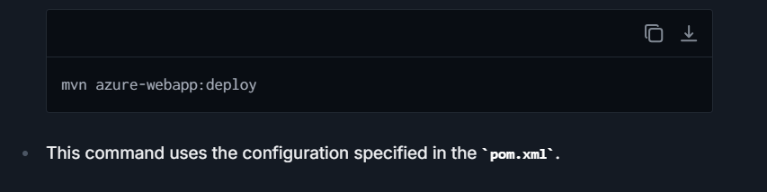

* + This command uses the configuration specified in the **pom.xml**.

**Step 5: Configure Application Settings**

1. **Environment Variables**: Set in the Configuration section of the App Service on the Azure Portal.
2. **Logging and Diagnostics Settings**: Configure them according to your needs for better monitoring and troubleshooting.

**Step 6: Enable Continuous Deployment (Optional)**

1. **CI/CD Integration**: Connect your Azure App Service to Azure DevOps, GitHub Actions, or other CI/CD tools for continuous deployment.
2. **Setting up Deployment Center**: Use the Deployment Center option in App Service for configuration.

**Step 7: Monitoring and Maintenance**

1. **Monitor Your Application**: Utilize Azure Monitor and Application Insights to keep tabs on your application's performance and health.
2. **Scale App Service**: Based on the demand, you can scale up (increase the capabilities of your plan) or scale out (increase the number of VM instances).

## **How you scale a Spring Boot application running in Azure App Service or Azure Kubernetes Service (AKS) to handle increased traffic?**

**Scaling in Azure App Service:-**

Azure App Service enables both vertical scaling (scale up) and horizontal scaling (scale out):

1. **Vertical Scaling (Scale Up):**
   * This involves upgrading to a higher pricing tier with more CPU, RAM, and additional capabilities like auto-scaling, daily backups, and traffic manager integration.

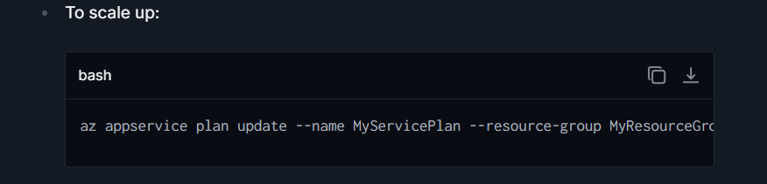

* + Choose a pricing tier that matches your need for more powerful compute resources.

1. **Horizontal Scaling (Scale Out):**
   * This involves increasing the number of VM instances that run your application, distributing the load and increasing availability.
   * Azure App Service offers manual scale-out options, as well as autoscale settings where you define rules based on metrics such as CPU usage, memory, or request queue length.
   * To configure autoscale:
     1. Navigate to your App Service in the Azure Portal.
     2. Go to the "Scale out (App Service plan)" section.
     3. Enable autoscale and add scaling rules based on metrics that reflect the traffic and load patterns your application experiences.
2. **Implementation of Best Practices:**
   * Optimize your application's startup times and resource usage to enhance overall performance during scaling operations.
   * Use Azure's deployment slots for staging new versions of your application to ensure smooth transitions and minimal downtime.

**Scaling in Azure Kubernetes Service (AKS) :-**

AKS provides robust mechanisms for orchestrating containerized applications with Kubernetes, allowing complex scaling strategies including horizontal pod autoscaling, cluster autoscaling, and more.

1. **Horizontal Pod Autoscaling:**
   * Automatically adjusts the number of pods in a deployment based on observed CPU utilization or other select metrics.
   * Requires metrics-server in your AKS cluster to retrieve metrics like CPU and memory usage.
   * Example: To autoscale based on CPU utilization for a Spring Boot application deployment:

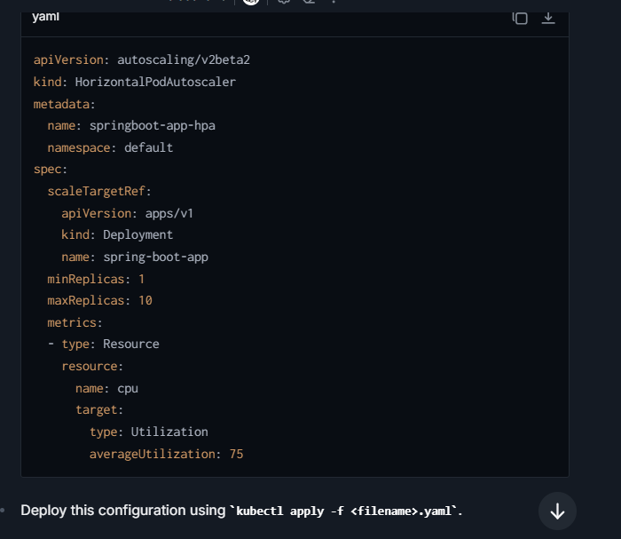

1. **Cluster Autoscaler:**
   * Automatically adjusts the number of nodes in your AKS cluster.
   * It increases the nodes when there isn't enough capacity in existing nodes to accommodate all pods, and decreases when many nodes are under-utilized.
   * To enable and manage Cluster Autoscaler:
     1. Ensure your AKS cluster is created with VMSS (Virtual Machine Scale Sets).
     2. Use the Azure CLI or Azure portal to configure the cluster autoscaler settings by specifying the minimum and maximum number of nodes.
2. **Best Practices and Monitoring:**
   * Implement resource requests and limits in pod specifications to optimize resource use efficiently and prevent one pod/service from consuming all available resources.
   * Utilize AKS monitoring with Azure Monitor to gain insights and actionable performance metrics, helping inform scaling decisions.

# **KAFKA**

* What is kafka and when should it be used?
* How can we implement producer and consumer for kafka?
* Explain the internal architecture of kafka?
* How are kafka topics created?
* How does kafka handles SPOF ?
* How does kafka handles failure?
* What is zookeeper?
* How will I use kafka sequentially to complete a certain set of jobs?
* How does a consumer work in kafka?
* What type of connection is established between a service and kafka?
* What is consumer-rebalancing?
* How can we make multiple instances of same consumer?
* Write the code/configuration for consuming events from a topic?

# **System Design**

Design a URL Shortener (Easy)

Design an Online Book Reader System (Easy)

Design a Parking Lot (Easy)

Design a Library Management System (Medium)

Design a Social Media Feed (Medium)

Design an E-commerce Website (Medium)

Design a Messaging Queue (Medium)

Design a Cache System (Medium)

Design a Rate Limiter (Medium)

Design a Search Autocomplete System (Medium)

Design YouTube (Medium)

Design a Web Crawler (Medium)

Design Twitter (Medium)

Design a Distributed File Storage System (Medium)

Design a Hotel Management System (Medium)

# **Coding Question**

## **Coding Easy**

1. Reverse a String   
2. Check if a String is a Palindrome   
3. Remove Duplicates from a String   
4. Find the First Non-Repeating Character   
5. Count the Occurrences of Each Character   
6. Reverse Words in a Sentence   
7. Check if Two Strings are Anagrams   
8. Find the Longest Substring Without Repeating Characters   
9. Convert a String to an Integer (atoi Implementation)   
10. Compress a String (Run-Length Encoding)   
11. Find the Most Frequent Character   
12. Find All Substrings of a Given String   
13. Check if a String is a Rotation of Another String   
14. Remove All White Spaces from a String   
15. Check if a String is a Valid Shuffle of Two Strings   
16. Convert a String to Title Case   
17. Find the Longest Common Prefix   
18. Convert a String to a Character Array   
19. Replace Spaces with %20 (URL Encoding)   
20. Convert a Sentence into an Acronym   
21. Check if a String Contains Only Digits   
22. Find the Number of Words in a String   
23. Remove a Given Character from a String   
24. Find the Shortest Word in a String   
25. Find the Longest Palindromic Substring

## **Leet Code**

**Array**

1. [Two Sum (Easy)](<https://leetcode.com/problems/two-sum/>)
2. [Best Time to Buy and Sell Stock (Easy)](<https://leetcode.com/problems/best-time-to-buy-and-sell-stock/>)
3. [Maximum Subarray (Easy)](<https://leetcode.com/problems/maximum-subarray/>)
4. [Contains Duplicate (Easy)](<https://leetcode.com/problems/contains-duplicate/>)
5. [Product of Array Except Self (Medium)](<https://leetcode.com/problems/product-of-array-except-self/>)
6. [Find the Duplicate Number (Medium)](<https://leetcode.com/problems/find-the-duplicate-number/>)
7. [Merge Intervals (Medium)](<https://leetcode.com/problems/merge-intervals/>)
8. [Insert Interval (Medium)](<https://leetcode.com/problems/insert-interval/>)
9. [Set Matrix Zeroes (Medium)](<https://leetcode.com/problems/set-matrix-zeroes/>)
10. [Rotate Image (Medium)](<https://leetcode.com/problems/rotate-image/>)
11. [Spiral Matrix (Medium)](<https://leetcode.com/problems/spiral-matrix/>)
12. [Kth Largest Element in an Array (Medium)](<https://leetcode.com/problems/kth-largest-element-in-an-array/>)

**Linked List**

1. [Reverse Linked List (Easy)](<https://leetcode.com/problems/reverse-linked-list/>)
2. [Merge Two Sorted Lists (Easy)](<https://leetcode.com/problems/merge-two-sorted-lists/>)
3. [Linked List Cycle (Easy)](<https://leetcode.com/problems/linked-list-cycle/>)
4. [Remove Nth Node From End of List (Medium)](<https://leetcode.com/problems/remove-nth-node-from-end-of-list/>)
5. [Reorder List (Medium)](<https://leetcode.com/problems/reorder-list/>)
6. [Intersection of Two Linked Lists (Easy)](<https://leetcode.com/problems/intersection-of-two-linked-lists/>)
7. [Add Two Numbers (Medium)](<https://leetcode.com/problems/add-two-numbers/>)
8. [Flatten a Multilevel Doubly Linked List (Medium)](<https://leetcode.com/problems/flatten-a-multilevel-doubly-linked-list/>)
9. [Copy List with Random Pointer (Medium)](<https://leetcode.com/problems/copy-list-with-random-pointer/>)
10. [LRU Cache (Medium)](<https://leetcode.com/problems/lru-cache/>)

**Stack**

1. [Valid Parentheses (Easy)](<https://leetcode.com/problems/valid-parentheses/>)
2. [Min Stack (Easy)](<https://leetcode.com/problems/min-stack/>)
3. [Evaluate Reverse Polish Notation (Medium)](<https://leetcode.com/problems/evaluate-reverse-polish-notation/>)
4. [Generate Parentheses (Medium)](<https://leetcode.com/problems/generate-parentheses/>)
5. [Daily Temperatures (Medium)](<https://leetcode.com/problems/daily-temperatures/>)
6. [Trapping Rain Water (Hard)](<https://leetcode.com/problems/trapping-rain-water/>)

**Queue**

1. [Implement Queue using Stacks (Easy)](<https://leetcode.com/problems/implement-queue-using-stacks/>)
2. [Perfect Squares (Medium)](<https://leetcode.com/problems/perfect-squares/>)
3. [Sliding Window Maximum (Hard)](<https://leetcode.com/problems/sliding-window-maximum/>)

**Tree**

1. [Maximum Depth of Binary Tree (Easy)](<https://leetcode.com/problems/maximum-depth-of-binary-tree/>)
2. [Symmetric Tree (Easy)](<https://leetcode.com/problems/symmetric-tree/>)
3. [Binary Tree Level Order Traversal (Medium)](<https://leetcode.com/problems/binary-tree-level-order-traversal/>)
4. [Convert Sorted Array to Binary Search Tree (Easy)](<https://leetcode.com/problems/convert-sorted-array-to-binary-search-tree/>)
5. [Binary Tree Inorder Traversal (Easy)](<https://leetcode.com/problems/binary-tree-inorder-traversal/>)
6. [Balanced Binary Tree (Easy)](<https://leetcode.com/problems/balanced-binary-tree/>)
7. [Same Tree (Easy)](<https://leetcode.com/problems/same-tree/>)
8. [Path Sum (Easy)](<https://leetcode.com/problems/path-sum/>)
9. [Construct Binary Tree from Preorder and Inorder Traversal (Medium)](<https://leetcode.com/problems/construct-binary-tree-from-preorder-and-inorder-traversal/>)
10. [Populating Next Right Pointers in Each Node (Medium)](<https://leetcode.com/problems/populating-next-right-pointers-in-each-node/>)
11. [Validate Binary Search Tree (Medium)](<https://leetcode.com/problems/validate-binary-search-tree/>)
12. [Kth Smallest Element in a BST (Medium)](<https://leetcode.com/problems/kth-smallest-element-in-a-bst/>)

**Graph**

1. [Clone Graph (Medium)](<https://leetcode.com/problems/clone-graph/>)
2. [Course Schedule (Medium)](<https://leetcode.com/problems/course-schedule/>)
3. [Number of Islands (Medium)](<https://leetcode.com/problems/number-of-islands/>)
4. [Graph Valid Tree (Medium)](<https://leetcode.com/problems/graph-valid-tree/>)
5. [Word Ladder (Hard)](<https://leetcode.com/problems/word-ladder/>)
6. [Alien Dictionary (Hard)](<https://leetcode.com/problems/alien-dictionary/>)

**Dynamic Programming**

1. [Climbing Stairs (Easy)](<https://leetcode.com/problems/climbing-stairs/>)
2. [House Robber (Easy)](<https://leetcode.com/problems/house-robber/>)
3. [Coin Change (Medium)](<https://leetcode.com/problems/coin-change/>)
4. [Longest Increasing Subsequence (Medium)](<https://leetcode.com/problems/longest-increasing-subsequence/>)
5. [Maximum Subarray (Easy)](<https://leetcode.com/problems/maximum-subarray/>)
6. [Edit Distance (Hard)](<https://leetcode.com/problems/edit-distance/>)
7. [Word Break (Medium)](<https://leetcode.com/problems/word-break/>)
8. [Decode Ways (Medium)](<https://leetcode.com/problems/decode-ways/>)
9. [Unique Paths (Medium)](<https://leetcode.com/problems/unique-paths/>)
10. [Longest Common Subsequence (Medium)](<https://leetcode.com/problems/longest-common-subsequence/>)

**String**

1. [Longest Substring Without Repeating Characters (Medium)](<https://leetcode.com/problems/longest-substring-without-repeating-characters/>)
2. [Valid Anagram (Easy)](<https://leetcode.com/problems/valid-anagram/>)
3. [Group Anagrams (Medium)](<https://leetcode.com/problems/group-anagrams/>)
4. [Longest Palindromic Substring (Medium)](<https://leetcode.com/problems/longest-palindromic-substring/>)
5. [Palindromic Substrings (Medium)](<https://leetcode.com/problems/palindromic-substrings/>)
6. [Implement Trie (Prefix Tree) (Medium)](<https://leetcode.com/problems/implement-trie-prefix-tree/>)
7. [Add and Search Word - Data structure design (Medium)](<https://leetcode.com/problems/add-and-search-word-data-structure-design/>)
8. [Word Search (Medium)](<https://leetcode.com/problems/word-search/>)

**Hashing**

1. [Two Sum (Easy)](<https://leetcode.com/problems/two-sum/>)
2. [Contains Duplicate (Easy)](<https://leetcode.com/problems/contains-duplicate/>)
3. [Top K Frequent Elements (Medium)](<https://leetcode.com/problems/top-k-frequent-elements/>)
4. [Valid Sudoku (Medium)](<https://leetcode.com/problems/valid-sudoku/>)
5. [Group Anagrams (Medium)](<https://leetcode.com/problems/group-anagrams/>)
6. [Happy Number (Easy)](<https://leetcode.com/problems/happy-number/>)
7. [Intersection of Two Arrays II (Easy)](<https://leetcode.com/problems/intersection-of-two-arrays-ii/>)
8. [Four Sum II (Medium)](<https://leetcode.com/problems/4sum-ii/>)

**Heap**

1. [Kth Largest Element in a Stream (Easy)](<https://leetcode.com/problems/kth-largest-element-in-a-stream/>)
2. [Last Stone Standing (Medium)](<https://leetcode.com/problems/last-stone-weight/>)
3. [K Closest Points to Origin (Medium)](<https://leetcode.com/problems/k-closest-points-to-origin/>)
4. [Top K Frequent Elements (Medium)](<https://leetcode.com/problems/top-k-frequent-elements/>)
5. [Find Median from Data Stream (Hard)](<https://leetcode.com/problems/find-median-from-data-stream/>)

**Bit Manipulation**

1. [Single Number (Easy)](<https://leetcode.com/problems/single-number/>)
2. [Counting Bits (Easy)](<https://leetcode.com/problems/counting-bits/>)
3. [Number of 1 Bits (Easy)](<https://leetcode.com/problems/number-of-1-bits/>)
4. [Sum of Two Integers (Medium)](<https://leetcode.com/problems/sum-of-two-integers/>)
5. [Reverse Bits (Easy)](<https://leetcode.com/problems/reverse-bits/>)
6. [Missing Number (Easy)](<https://leetcode.com/problems/missing-number/>)

**Math**

1. [Fizz Buzz (Easy)](<https://leetcode.com/problems/fizz-buzz/>)
2. [Power of Three (Easy)](<https://leetcode.com/problems/power-of-three/>)
3. [Roman to Integer (Easy)](<https://leetcode.com/problems/roman-to-integer/>)
4. [Integer to Roman (Medium)](<https://leetcode.com/problems/integer-to-roman/>)
5. [Valid Perfect Square (Easy)](<https://leetcode.com/problems/valid-perfect-square/>)
6. [Sqrt(x) (Easy)](<https://leetcode.com/problems/sqrtx/>)

**Greedy**

1. [Jump Game (Medium)](<https://leetcode.com/problems/jump-game/>)
2. [Jump Game II (Medium)](<https://leetcode.com/problems/jump-game-ii/>)
3. [Candy (Hard)](<https://leetcode.com/problems/candy/>)
4. [Gas Station (Medium)](<https://leetcode.com/problems/gas-station/>)
5. [Queue Reconstruction by Height (Medium)](<https://leetcode.com/problems/queue-reconstruction-by-height/>)
6. [Reorganize String (Medium)](<https://leetcode.com/problems/reorganize-string/>)

**Backtracking**

1. [Subsets (Medium)](<https://leetcode.com/problems/subsets/>)

[Permutations (Medium)](<https://leetcode.com/problems/permutations/>

# Extra Question: -

**Multithreading :-**

Callable, Return types of Callable and how they differ from Runnable.

* CompletableFuture conceptually, but unable to demonstrate usage with examples.
* // What is CountDownLatch and CyclicBarrier and their use cases.
* // Solving Producer-Consumer problems.
* Weak understanding of volatile and Atomic classes for concurrency control.
* Write thread-safe code and lock management.
* Demonstrate thread synchronization (wait/notify).
* demonstrate wait and notify, working code
* demonstrate deadlock, working code
* What is semaphore and Rate Limiter
* CompletableFuture and ForkJoinPool, Why and when it is used
* In multi-threading -> countdownlatch, cyclicbarrier, semaphore. and actual implementations
* Explain - task Queue , thread factory
* Internal working of forkjoin pool
* Work stealing, parallelism
* Understanding of ThreadPoolExecutor, How it works internally.

**Collection :-**  
Internal working of LinkedHashMap, including treeification and untreeification processes.

Concurrent collections (ConcurrentHashMap, CopyOnWriteArrayList).

Internal Working of HashMap, HashSet, ConcurrentHashMap, ArrayList, CopyOnArrayList, get() in hashamp

ConCurrentHashMap v/s SynchronizedHashMap

**Java 8 :-**  
 number of ways we create stream

* ways to use method reference
* Why we have default method
* internal working of parallel streams
* diamond pattern breaking
* options as wrapper, when to use them
* types of functional interface
* **records implicitly extend java.lang.Record**, and Java **does not support multiple inheritance of classes**, so you can't extend another class or record.

**Spring Boot :-**  
1. Spring cyclic Dependency

1. Bean Scopes. Singleton vs prototypes, workarounds on various issues.
2. Auto wiring types, Simulate the exceptions and provide solutions with Qualifier. Purpose of Primary.
3. Spring data jpa related questions.
4. Transaction isolation and propagation levels.
5. How to configure Https.
6. How to implement L2 cache.
7. Base64 encoder what? Why we use it?
8. Encoding vs Encryption vs Hashing
9. Optimistic vs Pessimistic locking
10. Http methods and idempotency
11. How to implement 2 datasource in spring boot app.
12. What is HazzlCast in spring? How its works?
13. ow API gateway help for performance? Suppose user asked one of your service is very slow then how you can monitor and optimize its performance?
14. Explain abount saga pattern? how it works internally?
15. How circuit breaker handle exception and how we exclude exception using configuration in microservices?
16. What is @Transactional? How its works internally?
17. default constructor!  
    Before initialization of bean: jwtTokenProvider  
    this is from init method of postconstruct  
    InitializingBean - afterPropertiesSet called  
    After initialization of bean: jwtTokenProvide
18. **Relational Database:** Use EntityManager for RDBMS to manage entities and persistence.

**NoSQL Database:** Use the respective templates or repositories for NoSQL, e.g., MongoTemplate.

due to this reason we dont have to implement entity manager when one of the dbs is no sql

1. get() and load() methods in

**Spring Security :-**

* Have you worked with authentication protocols like SAML, OAuth, or social login providers in Spring?
* Have you ever used encryption algorithms like RSA or hashing algorithms like SHA in your application?
* spring security? annotations used in spring security?

M**icroServices :-**

1.What all microservice architecture patterns you have used in your project  
2. pros and cons shared library or shared service in microservices  
3. distributed transaction  
4. What is BASE  
5. eventual consistency

6. Can we use multiple Database in a Microservice ?

7. What Configuration we need to do ?

8. Circuit breaker design pattern and how we can implement ?

9. How are Eureka and API Gateway used in a microservices architecture?2  
10. Fundamental concepts and features of Microservices?  
11. Microservice Design Patterns?  
12. 12factor rules?  
13. Explain CAP theorem?  
14. Explain resiliency in microservices?  
15. Explain distributed transactions in microservices?  
16. Explain differences between Monolithic and microservice architecture?  
17. Synchronous and Asynchronous communication

18. How to troubleshoot an exception in microservice architecture?

19. Project high-level design, and how many services are there?

20. Microservices are working fine on QA environment but not on production. How to resolve the issue without logs

21. How will you design microservices and establish proper communication among them. (Explain with design patterns

**SQL:-**

1.-- Write an SQL query to find the customers who have placed orders for multiple different items.  
2. -- Write an SQL query to find the total number of orders placed by each customer.  
3. -- Write an SQL query to find the total amount spent by each customer.  
4. -- Write an SQL query to fetch the customers who haven't placed any orders yet.  
5. -- Write an SQL query to find the average amount spent by customers in each country.  
6. -- Write an SQL query to find the customers who have placed orders for multiple different items.  
7. -- Write an SQL query to find the top 2 customers who have spent the most.

**Client :- MACD**

1.Why String immutable

2.what is @JsonIgnore

3.what is transient keyword

4.Why we need transient if we have @JsonIgnore

5.Write a controller for order service to get data from Product microservice

6.Write Junit for controller and service class

7.Employee class with id,name,dept.Get count of employees in each dept

8.How to implement scheduler in java

9.How to implement Retry pattern

10.How to implement Circuit breaker pattern

11.How to secure rest end points

12.jpa lazy vs eger loading

13.where do we use mapped superclass  in jpa

14.How to do query optimization

15.How to do database table partiotioning

16.Deploment types and which one used in current project

17.Serial_version_id and why we need

18.Annotation for primary key and composite key in entity class

19.How to handle transaction

20.Different transaction propogation types

1. **Introduction to Hibernate**

Hibernate: Java ORM (Object-Relational Mapping) framework to map Java classes to database tables and vice versa.

ORM: Automates the conversion of data between Java objects and relational databases.

Advantages: Reduces boilerplate JDBC code, supports caching, automatic schema updates, HQL, etc.

Architecture: Includes SessionFactory, Session, Transaction, Query, and Configuration.

🧾 2. **Configuration**

hibernate.cfg.xml: Main config file containing DB connection and Hibernate settings.

hibernate.properties: Alternative way to configure Hibernate using key-value pairs.

Programmatic config: Creating SessionFactory directly in code using Configuration.

3. **Core Concepts**

SessionFactory: Heavyweight, immutable factory for sessions. Created once per application.

Session: Represents a single unit of work (one DB interaction). Wraps JDBC connection.

Transaction: Ensures atomicity (commit/rollback) during DB operations.

Query: Used to run HQL/SQL/Criteria-based queries on entities.

Configuration: Class to load and parse configuration files.

4. **Annotations and Mapping**

Basic:

Entity: Marks a class as a Hibernate entity (mapped to a table).

@Table: Maps class to a specific DB table.

@Id: Denotes primary key.

@GeneratedValue: Defines auto-generation strategy for primary keys.

@Column: Maps fields to DB columns.

Relationships:

@OneToOne: One row in table A relates to one row in table B.

@OneToMany: One row relates to many rows in another table.

@ManyToOne: Many rows relate to one row.

@ManyToMany: Many-to-many link using join table.

Advanced:

@Embeddable / @Embedded: Used for composite key/value objects.

@Inheritance: Maps Java inheritance to DB tables using SINGLE_TABLE, JOINED, etc.

💾 5. Hibernate Data Types

Supports primitives, wrappers, Date, BigDecimal, Enum, and more.

Converts Java types into SQL-compatible formats automatically.

🧮 6. **Querying**

HQL (Hibernate Query Language): Object-oriented query language similar to SQL.

Native SQL: Allows raw SQL queries.

Named Queries: Predefined queries using @NamedQuery.

Criteria API: Type-safe, programmatic way to build queries.

🔄 7. **Object States**

Transient: New object, not associated with Hibernate session.

Persistent: Object is saved and tracked by Hibernate.

Detached: Object was persistent but session is closed.

Removed: Object is marked for deletion.

🔁 8. **CRUD Operations**

save(): Saves transient object and returns identifier.

persist(): Makes transient object persistent without returning ID.

update(): Updates detached object.

merge(): Merges detached changes into persistent state.

delete(): Deletes persistent object.

get(): Returns object or null.

load(): Returns proxy; throws exception if not found.

**🛠️ 9. Hibernate Tools**

Hibernate plugins (like in MyEclipse, STS) generate entities from DB.

Enable DB reverse engineering and visual mapping.

**⚙️ 10. Lifecycle**

Defines how objects change states (transient → persistent → detached).

Flush: Synchronizes session state with DB.

Clear: Clears session cache.

Dirty Checking: Detects modified fields and automatically updates DB.

📦 11. **Caching**

First-Level Cache: Per session, enabled by default.

Second-Level Cache: Shared across sessions (EHCache, Infinispan).

Query Cache: Caches result sets.

**🧠 12. Performance Tuning**

Fetch Types:

LAZY: Fetch on demand (default for collections).

EAGER: Fetch immediately.

N+1 Problem: Excessive queries due to EAGER fetching.

Batch Fetching: Fetch multiple records in batches.

Pagination: setFirstResult(), setMaxResults() to limit results.

**📈 13. Hibernate vs JPA**

JPA: Java standard interface for ORM.

Hibernate: One implementation of JPA, also has extra features.

JPA uses EntityManager, while Hibernate uses Session.

**🔒 14. Transactions & Concurrency**

Transaction Management: Ensures ACID operations.

Optimistic Locking: Detects conflicts using versioning (@Version).

Pessimistic Locking: Uses DB locks to prevent concurrent updates.

**🔄 15. Schema Management**

hbm2ddl.auto:

create: Creates schema every time

update: Updates schema

validate: Validates schema

none: Does nothing

Flyway/Liquibase: Used in production for schema versioning.

**🚀 16. Advanced Topics**

Custom UserType: Custom mapping between Java and SQL types.

Interceptors: Custom hooks into lifecycle events.

Event Listeners: Hooks into events like save, update.

Filters: Add dynamic conditions to queries.

Envers: Auditing and versioning for entities.

**🧪 17. Testing**

Use H2 in-memory DB for unit tests.

Use JUnit + Hibernate or Spring Test with embedded DB.

Use TestContainers for integration testing with real DB.

**🧩 18. Real-World Integration**

DAO Layer: Abstracts DB operations.

Spring Boot Integration: Use spring-boot-starter-data-jpa with Hibernate.

REST + Hibernate: Use Hibernate inside service layer of REST APIs.

# **What are the Other frameworks for java Enterprise application**

Java enterprise applications require robust frameworks that can handle complex business logic, database operations, high scalability, and security demands. Here are some popular frameworks that are well-suited for developing Java enterprise applications:

**1. Spring Framework (and Spring Boot)**

Spring remains the most popular framework for developing enterprise applications in the Java ecosystem. It provides comprehensive infrastructure support for developing Java apps, offering features such as Dependency Injection, Aspect-Oriented Programming, transaction management, and more. Spring Boot, a part of the Spring ecosystem, simplifies the creation of stand-alone, production-grade Spring-based applications.

**2. Jakarta EE (formerly Java EE)**

Jakarta EE is the evolution of the old Java EE (Java Platform, Enterprise Edition) and provides APIs for creating scalable, multi-tiered, reliable, and secure network applications. It includes various specifications like JPA (Java Persistence API), JMS (Java Messaging Service), JSF (JavaServer Faces), and EJB (Enterprise JavaBeans).

**3. Quarkus**

Quarkus is a Kubernetes-native Java framework tailored for GraalVM and HotSpot, designed for high-performance and efficiency in cloud environments. It's known as a "Supersonic Subatomic Java" framework, offering first-class support for reactive programming and ensuring that applications use only the resources they need.

**4. Micronaut**

Designed for building modular, easily testable microservice applications, Micronaut is another modern framework optimized for minimal memory footprint and fast startup time. It supports application context and Dependency Injection container, aspect-oriented programming, and management endpoints for health, metrics, and more.

**5. Vert.x**

Eclipse Vert.x is a tool-kit for building reactive applications on the JVM. While not a framework in the traditional sense, it allows building robust, scalable, and concurrent systems typically required by modern enterprise applications. It supports traditional imperative programming as well as reactive, event-driven programming.

**6. Apache Camel**

Apache Camel is an integration framework that empowers you to quickly and easily integrate various systems consuming or producing data. It implements many Enterprise Integration Patterns (EIPs) and connects to a plethora of systems and APIs. Although not a full-stack framework, it's extremely useful for enterprise application integration needs.

# General Interview Question

### **What is GKS ?**

**1. What is Kubernetes?**

Before understanding GKE, it's essential to know **Kubernetes**:

* **Kubernetes** is an open-source container orchestration platform designed to manage containerized workloads and services.
* It automates key tasks, such as **scaling**, **load balancing**, **self-healing**, and **deployment rollouts**.
* It ensures high availability, efficient resource utilization, and portability of containerized apps.

**2. What is GKE?**

**Google Kubernetes Engine (GKE)** is a managed Kubernetes service that lets you run Kubernetes without having to manually set up, maintain, or manage the underlying control plane or worker nodes. It simplifies the complexity of configuring Kubernetes clusters on your own infrastructure.

* GKE is backed by **Google SRE (Site Reliability Engineering)** practices, ensuring reliability and scalability.
* GKE integrates seamlessly with other **GCP services** like Cloud Load Balancer, Cloud Storage, Cloud Monitoring, and Pub/Sub.

**3. Key Features of GKE**

1. **Fully Managed Service**:
   * GKE handles the management of Kubernetes control planes (master nodes) and worker nodes.
   * It manages upgrades, patches, and scaling automatically.
2. **Node Autoscaling**:
   * GKE supports automatic scaling of worker nodes based on workload demand.
   * It also supports **Cluster Autoscaler**, which dynamically adjusts node pools.
3. **Multi-Zonal / Regional Clusters**:
   * GKE supports both **zonal clusters** (for cost-effectiveness) and **regional clusters** (for high availability and disaster recovery).
4. **Load Balancing**:
   * GKE integrates with Google's **Cloud Load Balancer** to distribute traffic across pods running in multiple nodes or zones.
5. **Networking**:
   * It supports **VPC-Native Clusters**, enabling network traffic across multiple clusters to share the same VPC.
   * Allows ingress (external traffic) using **Ingress controllers** and **Internal IP communication** between pods.
6. **Security**:
   * Seamless integration with **IAM** for role-based access control (RBAC).
   * Supports **Workload Identity** for secure identity management of applications.
   * Enables features like **sandboxing** and encryption for secure workloads.

GKE (Google Kubernetes Engine) is a fully-managed, production-ready orchestration service provided by Google Cloud Platform (GCP) that lets you deploy, manage, and scale containerized applications using Kubernetes. You can use GKE to run your applications efficiently, automate deployment processes, and manage workloads with minimal operational overhead.

Let’s break GKE down step by step to better understand it.

1. What is Kubernetes?

Before understanding GKE, it's essential to know Kubernetes:

Kubernetes is an open-source container orchestration platform designed to manage containerized workloads and services.

It automates key tasks, such as scaling, load balancing, self-healing, and deployment rollouts.

It ensures high availability, efficient resource utilization, and portability of containerized apps.

2. What is GKE?

Google Kubernetes Engine (GKE) is a managed Kubernetes service that lets you run Kubernetes without having to manually set up, maintain, or manage the underlying control plane or worker nodes. It simplifies the complexity of configuring Kubernetes clusters on your own infrastructure.

GKE is backed by Google SRE (Site Reliability Engineering) practices, ensuring reliability and scalability.

GKE integrates seamlessly with other GCP services like Cloud Load Balancer, Cloud Storage, Cloud Monitoring, and Pub/Sub.

3. Key Features of GKE

Fully Managed Service:

GKE handles the management of Kubernetes control planes (master nodes) and worker nodes.

It manages upgrades, patches, and scaling automatically.

Node Autoscaling:

GKE supports automatic scaling of worker nodes based on workload demand.

It also supports Cluster Autoscaler, which dynamically adjusts node pools.

Multi-Zonal / Regional Clusters:

GKE supports both zonal clusters (for cost-effectiveness) and regional clusters (for high availability and disaster recovery).

Load Balancing:

GKE integrates with Google's Cloud Load Balancer to distribute traffic across pods running in multiple nodes or zones.

Networking:

It supports VPC-Native Clusters, enabling network traffic across multiple clusters to share the same VPC.

Allows ingress (external traffic) using Ingress controllers and Internal IP communication between pods.

Security:

Seamless integration with IAM for role-based access control (RBAC).

Supports Workload Identity for secure identity management of applications.

Enables features like sandboxing and encryption for secure workloads.

Hybrid and Multi-Cloud Deployments:

GKE supports Anthos, allowing you to extend Kubernetes clusters to hybrid or multi-cloud environments.

Applications running on different cloud providers or on-premises can be managed together.

Automatic Upgrades and Repair:

GKE automatically upgrades nodes and clusters to the latest Kubernetes version.

Self-healing ensures nodes and pods are automatically replaced if they go down.

Monitoring and Logging:

Comes with Cloud Monitoring and Cloud Logging integration to help you monitor cluster health, track issues, and set alerts.

Supports Stateful and Stateless Applications:

Perfect for both types of apps:

Stateless apps like APIs, frontend apps.

Stateful apps like databases using persistent volumes.

4. GKE Architecture

A GKE cluster consists of the following core components:

i) Control Plane (Fully Managed by GKE)

Kubernetes API Server:

Manages communication between the Kubernetes cluster and the application's desired state (like deployments and services).

Scheduler:

Assigns workloads (pods) to available nodes.

Controller Manager:

Ensures resources are reconciled to match the desired state defined in the Kubernetes manifests.

Etcd:

Distributed database to store the cluster’s state.

GKE manages the control plane, ensuring high availability, upgrades, and patching.

ii) Worker Nodes (Managed by You)

These are virtual machines (Compute Engine instances) that run your application pods.

Each node:

Runs a Kubelet, which communicates with the control plane.

Runs Container Runtime (e.g., Docker or containerd) for managing containers.

Manages network proxies (kube-proxy) for service-to-service communication.

Node Pools: Nodes are grouped into pools for management and scaling purposes. You can create multiple node pools with different machine types.

iii) Pods

The smallest deployable unit in Kubernetes, a pod contains one or more containers (e.g., Docker containers).

Pods on GKE run as part of workloads deployed in the cluster.

iv) Services

Services in GKE expose pods to allow communication between them or external traffic to access them.

5. When to Use GKE?

GKE is ideal for the following scenarios:

Containerized Applications:

Use GKE to deploy microservices for apps architected using Docker containers.

Scalable Applications:

Your app experiences variable traffic or needs elastic scaling (e.g., APIs, websites).

Hybrid/Multi-Cloud Strategy:

Managing workloads across on-premises and multiple clouds with Anthos.

High Availability:

Regional clusters allow workloads to be distributed across multiple zones for HA.

Batch Processing:

Run batch workloads and CI/CD pipelines efficiently using Kubernetes CronJobs.

6. How to Deploy Applications on GKE?

Below is a high-level overview of how to deploy an application on GKE.

Step 1: Create a GKE Cluster

Open the GCP Console.

Navigate to Kubernetes Engine → Clusters.

Click Create Cluster:

Specify cluster configuration (zonal/regional, node machine types, autoscaling, etc.).

GKE will provision the Kubernetes control plane and worker nodes automatically.

Use gcloud CLI:

bash

gcloud container clusters create [CLUSTER-NAME] --zone [ZONE]

Step 2: Configure Kubernetes Access

Authenticate your local environment to the cluster:

bash

gcloud container clusters get-credentials [CLUSTER-NAME] --zone [ZONE]

Step 3: Deploy Your Application

Define your app deployment in YAML manifest files (e.g., Deployment, Service). Example deployment.yaml:

yaml

apiVersion: apps/v1

kind: Deployment

metadata:

name: my-app

spec:

replicas: 3

selector:

matchLabels:

app: my-app

template:

metadata:

labels:

app: my-app

spec:

containers:

- name: my-app-container

image: gcr.io/[PROJECT-ID]/my-app-image:latest

ports:

- containerPort: 8080

Deploy the application:

bash

kubectl apply -f deployment.yaml

Step 4: Expose Your Application

Create a service.yaml file to expose your app:

yaml

apiVersion: v1

kind: Service

metadata:

name: my-app-service

spec:

selector:

app: my-app

type: LoadBalancer

ports:

- protocol: TCP

port: 80

targetPort: 8080

Apply the service configuration:

bash

kubectl apply -f service.yaml

Get the external IP of the service using:

bash

kubectl get service my-app-service

### **What both Azure and GCP share many common cloud principles?**

**1. Core Cloud Models and Services**

Both Azure and GCP provide offerings aligned with the major cloud delivery models:

* **IaaS (Infrastructure as a Service):** Supports virtual machines, storage, and networking (e.g., Azure VMs vs. GCP Compute Engine).
* **PaaS (Platform as a Service):** Services for developing, running, and deploying applications without managing infrastructure (e.g., Azure App Service vs. GCP App Engine).
* **SaaS (Software as a Service):** Hosting complete software solutions (e.g., Azure DevOps Services vs. GCP Workspace).

Both platforms also offer capabilities for **serverless computing** (Azure Functions, GCP Cloud Functions) to run code without worrying about the underlying infrastructure.

**2. Virtualization and Scalability**

Both Azure and GCP use virtualization as the backbone of their services:

* They allow the creation and management of virtual machines or containers.
* Both offer **auto-scaling** features for applications and virtual machine instances to meet performance needs dynamically.

For example:

* Azure Autoscale and Azure Kubernetes Service (AKS) = GCP Autoscaler and GKE (Google Kubernetes Engine).

**3. Compute Offerings**

Both platforms offer similar compute services:

* **Google Compute Engine** (GCP) and **Azure Virtual Machines** allow you to create virtual machines (VMs) with similar customization options for operating systems, processor types, memory, and storage.
* Both offer managed **containers** using Kubernetes: **AKS** (Azure Kubernetes Service) vs. **GKE** (Google Kubernetes Engine).

**4. Storage Systems**

Azure and GCP both offer highly durable and scalable storage solutions:

* **Azure Blob Storage = GCP Cloud Storage**: Object-based storage for unstructured data like videos, images, etc.
* **Azure Disk Storage = Persistent Disks on GCP**: Block storage tightly coupled with virtual machines.
* **Azure Data Lake = GCP BigQuery and Data Store**: Data analytics and warehousing solutions for handling big data.

Both platforms ensure data replication, availability, and durability, based on global storage policies.

**5. Networking and Content Delivery**

Both Azure and GCP offer robust networking capabilities:

* **VPC (Virtual Private Cloud):** GCP VPC vs. Azure Virtual Network (VNets) to enable secure communication between resources.
* **Content Delivery Networks (CDNs):** Azure CDN vs. GCP Cloud CDN for speeding up the content delivery to users.
* They also provide **load balancing** services to distribute traffic efficiently across servers.

**6. Containers and Orchestration**

Containers and orchestration are common features:

* Both platforms extensively use **Docker** and **Kubernetes** for managing containers.
* Azure's Kubernetes Service (**AKS**) = Google's Kubernetes Engine (**GKE**).

**7. Identity and Access Management (IAM)**

Both platforms follow strict **identity and access control** principles to secure resources:

* **Azure Active Directory (AD)** = **Google IAM** for role-based access control (RBAC).
* Both offer multifactor authentication (MFA), single sign-on (SSO), and role-based permissions to secure cloud environments.

**8. Databases**

Both Azure and GCP provide robust database systems with support for various workloads:

* **Managed SQL Databases:** Azure SQL Database = Cloud SQL.
* **NoSQL Databases:** Azure Cosmos DB = GCP Firestore or Bigtable.
* **Data Analytics and AI Integration:** Both platforms offer analytics tools, e.g., Azure Synapse vs. GCP BigQuery.

**9. DevOps and CI/CD**

Both Azure and GCP integrate DevOps principles and enable **continuous integration/continuous deployment (CI/CD):**

* **Azure DevOps Pipelines** vs. **GCP Cloud Build** to streamline automated build, test, and deployment processes.
* Both are compatible with GitHub, Bitbucket, and Jenkins.

**10. Security and Compliance**

Both platforms have enterprise-grade security tools:

* Both Azure Security Center and GCP Security Command Center provide threat detection, vulnerability analysis, and recommendations for improving security posture.
* Both offer end-to-end **encryption** (data at rest and in transit) and comply with major standards like **ISO 27001**, **GDPR**, **SOC**, etc.

**11. Monitoring and Logging**

Both platforms offer monitoring and logging tools for debugging and performance analysis:

* **Azure Monitor** integrates with Application Insights.
* **GCP Stackdriver** provides logging and monitoring across services.
* Both help track application performance and ensure uptime.

### **When we prefer azure java function and their advantages? Explain in Detail?**

**When to Prefer Azure Functions with Java:**

1. **Event-Driven Scenarios**:
   * Azure Functions is highly suited for event-driven architectures. You should consider using it when your application components need to react to events, such as changes in data, incoming messages, or custom triggers.
2. **Microservices**:
   * If you're architecting a solution based on microservices, Azure Functions allows you to build lightweight, independent services that scale automatically and are loosely coupled.
3. **Integrating Systems**:
   * When your application needs to connect with different external systems or services, Azure Functions can act as a glue that helps in orchestrating these communications, especially given its extensive range of triggers and bindings.
4. **Processing Data Streams**:
   * For applications that need to process streams of data in real-time, like IoT telemetry or live financial data, Azure Functions can handle this with minimal latency as it scales dynamically based on the incoming data volume.

**Advantages of Azure Functions for Java:**

1. **Serverless Execution**:
   * You don't need to manage any servers or long-running infrastructure, which significantly reduces management overhead and cost. Azure Functions scales automatically and charges only for the compute resources consumed during the function execution.
2. **Built-in Scalability**:
   * Azure Functions handles scaling transparently. As demands increase, whether it's a spike in web requests or a burst of queue messages, the platform automatically allocates more resources to handle the load.
3. **Integrated Security**:
   * Secure your functions using Azure Active Directory, and leverage Azure’s built-in features such as CORS support and OAuth providers. This simplifies building secure applications.
4. **Triggers and Bindings**:
   * Azure Functions offers a wide variety of triggers and bindings that reduce boilerplate code and streamline complex integration tasks. Triggers and bindings support a range of services including queues, tables, blobs, events, and more.
5. **Development Flexibility**:
   * Develop functions directly in the Azure portal, using popular IDEs like Visual Studio and Visual Studio Code, or even build and debug on your local machine. This flexibility accelerates development and testing cycles.
6. **Community and Ecosystem**:
   * Java being one of the popular languages in the enterprise sector, means there's robust community support available, alongside a plethora of libraries and frameworks which can be leveraged in Azure Functions.
7. **Cost-Effective**:
   * Pay only for the compute time you use, with no charge when your function is idle. This can lead to significant cost savings, especially for applications with variable workloads.
8. **Continuous Deployment and Integration**:
   * Azure Functions supports Continuous Integration and Deployment with Azure DevOps, GitHub, and other popular CI/CD tools. This makes it easy to set up a full DevOps pipeline for function deployment and management.

### **When azure function takes more time to start and couldn’t process the binding request?**

When an Azure Function takes more time to start and struggles to process the binding request involves addressing the initialization time and optimizing performance. Below are strategies to mitigate this problem, accompanied by a real-life example.

**Strategies to Optimize Azure Function Start Time**

1. **Pre-Warm the Function:** Azure Functions on a Consumption Plan can suffer from cold starts, where the function takes longer to respond initially. Switching to a Premium Plan or an App Service Plan allows you to use pre-warmed instances to minimize cold starts. Additionally, implementing a timer triggered function that runs at regular intervals can keep the function warm.
2. **Enhance Application Insights:** Employ Azure Application Insights to identify and diagnose performance bottlenecks. It can provide detailed information about the function execution and dependencies, guiding where optimization is necessary.
3. **Optimize Code and Dependencies:** Review and refactor the Azure Function code to make it lean and efficient. Reducing the size of the function by removing unnecessary packages and using asynchronous programming where possible can decrease the load time.

**Real-Life Example:**

***Scenario:*** A company uses an Azure Function to process online orders from their website. The function uses input bindings to get order information from a queue and output bindings to save the processed order details to a database. However, during high sales periods, the function experiences delays in start-up, leading to unprocessed orders piling up in the queue.

***Problem:*** Increased order volume triggers more function starts (Cold starts), and the binding to the database takes longer than expected because it scales out under load, leading to performance bottlenecks.

***Solution Implementation:***

* **Switch Plans:** The company transitioned from a Consumption Plan to a Premium Plan, setting up pre-warmed instances to reduce cold start times.
* **Optimize Code:** They refactored the Azure Function code, removing unnecessary dependencies and ensuring asynchronous operation wherever possible.
* **Infrastructure Scaling:** By implementing Azure Durable Functions, the company managed to spread out the load more efficiently. This not only helped in efficient resource utilization but also in handling internal state much better during peak times.
* **Monitor and Adjust:** Continuous monitoring through Azure Application Insights provided insights into function executions. Based on the data gathered, the company further optimized the timeout settings and resource allocation, tuning the performance finely for expected loads.

Post-Implementation, the company observed a significant reduction in start time delays and an improvement in the overall efficiency of the order processing system. Customer satisfaction grew due to faster order processing, and the system became more reliable even during peak sales periods.

### **When we have minimum duplicate code if we have multiple function with almost same functionality. How to write efficient java azure function ?**

A good approach to writing efficient Java Azure Functions with minimal duplicate code involves using best practices in code organization, design patterns, and leveraging Azure’s capabilities effectively. Here’s how you can achieve it:

1. **Use Shared Libraries**:
   * **Extract Common Logic**: Identify the common functionality across multiple Azure Functions and extract it into separate utility classes or a shared library. This approach ensures that all functions can reuse the same code, which reduces duplication and simplifies maintenance.
   * **Maven/Gradle Modules**: Organize your code into Maven or Gradle modules which can then be included as dependencies in your Azure Functions. This modular approach facilitates code sharing and management.
2. **Implement Design Patterns**:
   * **Strategy Pattern**: Use the strategy design pattern for functions that behave similarly but have different implementations. This allows you to define a family of algorithms, encapsulate each one, and make them interchangeable.
   * **Factory Pattern**: Utilize the factory pattern to create a factory class that returns instances of the classes that implement a common interface. This is particularly useful when you need to instantiate one of several classes based on incoming data.
3. **Azure Durable Functions**:
   * If your functions need to orchestrate a workflow or process events in a certain sequence, consider using Durable Functions. Durable Functions can help centralize and streamline complex logic that would otherwise be duplicated across multiple non-coordinated functions.

**Key Points:**

* **Orchestration Functions**: Define common workflows as orchestration functions. If multiple functions share similar sequences of tasks or dependencies, encapsulating these workflows in an orchestrator can reduce redundancy across your functions.
* **Activity Functions**: These are called by orchestrators to perform specific tasks. By designing fine-grained activity functions that perform generic tasks, you can call the same activity from multiple orchestrators, significantly reducing duplicate code.
* **Reusability and Maintainability**: Durable Functions promote reusability and maintainability by logically separating the control and work, allowing multiple flows to reuse the same work functions with different data, thus minimizing duplication and simplifying updates.

1. **Dependency Injection**:
   * Leverage the built-in support for dependency injection in Azure Functions (starting from Azure Functions v2). This allows you to share common services and configurations across your functions easily. Dependency injection not only reduces code duplication but also enhances the testability of your functions.

**Key Points:**

* **Centralized Business Logic**: By injecting shared services or providers into your functions, you can centralize common business logic and database access logic into single responsibility service classes, which can then be reused across all functions.
* **Configurations and Settings**: Instead of repeating configuration code in every function, use DI to inject configuration settings, making it easy to manage and update configurations in a centralized manner.
* **Testing and Mocking**: Dependency Injection greatly simplifies unit testing of your functions by allowing you to pass mock implementations of dependencies, making your tests more predictable and reliable.

**Practical Application**

Imagine an eCommerce platform that processes orders, sends notifications, and updates inventory. Without Durable Functions, handling these tasks would involve individual Azure functions with overlapping functionalities. By using a Durable Function, you could create an orchestrator function that manages the workflow of handling an order, calling activity functions for each step (process order, send notification, update inventory), each of which could be reused in different workflows (e.g., returns, special orders).

Additionally, using Dependency Injection, you can inject services such as email services, payment gateways, or inventory management systems into the functions. This means you set them up once and reuse them wherever needed, without duplicating setup and configuration code.

In summary, combining Azure Durable Functions with Dependency Injection creates a robust framework for developing Azure Functions applications with minimal duplicate code, improved maintainability, and enhanced testability.

### **How to Consume Data from Azure Service Bus (ASB) ?**

To consume data from Azure Service Bus, you typically use either a Queue or a Topic (which offers publish-subscribe capabilities with filters). The simplest way to consume messages is by using Azure Functions with a Service Bus Trigger or hosted services in ASP.NET Core

### **What to Do When We Couldn't Process a Message?**

When a message can't be processed successfully—perhaps due to temporary issues like a downstream service being unavailable—it's crucial to handle this gracefully:

* **Retry Mechanisms**: Implement logic to retry the message a specific number of times. Azure Functions can be configured to handle this automatically using **maxDeliveryCount** to specify how many times a message should be delivered before being considered dead.
* **Dead-lettering**: If after several retries the message still cannot be processed, it should be moved to a dead-letter queue (DLQ). This prevents a problematic message from blocking other messages in the queue.

### **What is the Usage of Dead Letter Queue?**

The Dead Letter Queue (DLQ) serves as a secondary queue where messages that could not be processed are stored. Reasons messages are sent to the DLQ include:

* **Exceeding maximum delivery attempts**: The message has been delivered to the application more than the specified number of times but was not processed successfully.
* **Expiration**: The message has expired and has not been consumed.
* **Specific rejection by application**: The application could programmatically send messages to DLQ if certain conditions are not met, signaling specific business or validation errors.
* **Error Segregation**: DLQ acts as a separate storage for messages that cannot be processed due to various reasons (e.g., format errors, system exceptions). This segregation helps in isolating problem messages from the flow of regular messages.
* **Troubleshooting and Diagnostics**: Administrators and developers can examine the messages in the DLQ to understand what went wrong. Each dead-lettered message retains additional system properties (such as the exception details and the count of delivery attempts), which are useful for diagnostics.
* **Reprocessing**: Once issues are resolved (e.g., after code fixes or system adjustments), messages can be reviewed and reprocessed either automatically or manually, depending on the system's design

**Example Usage of DLQ:** Imagine a scenario in an e-commerce platform where payment processing messages are intermittently failing due to an external API downtime. When a payment message cannot be processed after several attempts (let’s say 5 retries), it's sensible to move it to a dead-letter queue. From there, an admin or a scheduled job can review and manually trigger the processing of these messages when the issue is resolved, ensuring that no order is lost due to temporary API failures.

### **How deploy the spring boot application LOCALLY?**

There are several ways to deploy a Java application locally :-

**Steps to Deploy a Spring Boot Application on Kubernetes:**

1. **Containerize the Application:**
   * Write a **Dockerfile** that specifies the base image (e.g., OpenJDK), builds your application (e.g., using Maven or Gradle), and sets the command to run your application.
   * Build the Docker image and push it to a Docker registry (e.g., Docker Hub, Azure Container Registry).
2. **Create Kubernetes Manifests:**
   * **Deployment.yaml:** This file defines a Kubernetes Deployment that manages the lifecycle of your application pods. It specifies the Docker image to use, the number of replicas, resource limits, and more.
   * **Service.yaml:** This file defines a Kubernetes Service that provides a stable IP address and DNS name for internal load balancing and service discovery.
3. **Deploy to Kubernetes:**
   * Apply the Kubernetes manifests using **kubectl apply -f <filename>**.
   * Monitor the deployment process using **kubectl get pods**, **kubectl describe pod <pod_name>**, and other **kubectl** commands.
4. **Maintain and Update:**
   * Implement logging and monitoring using tools like Prometheus and Grafana, or integrate with cloud-provider tools (if available).
   * Update the application by modifying the Docker image and updating the Deployment to point to the new image version.

### **How deploy and challenges spring boot application locally using kubernets ?**

Deploying a Spring Boot application on Kubernetes involves packaging your application in a Docker container and then configuring Kubernetes resources to manage and orchestrate the container.

**Steps to Deploy a Spring Boot Application on Kubernetes:**

1. **Containerize the Application:**
   * Write a **Dockerfile** that specifies the base image (e.g., OpenJDK), builds your application (e.g., using Maven or Gradle), and sets the command to run your application.
   * Build the Docker image and push it to a Docker registry (e.g., Docker Hub, Azure Container Registry).
2. **Create Kubernetes Manifests:**
   * **Deployment.yaml:** This file defines a Kubernetes Deployment that manages the lifecycle of your application pods. It specifies the Docker image to use, the number of replicas, resource limits, and more.
   * **Service.yaml:** This file defines a Kubernetes Service that provides a stable IP address and DNS name for internal load balancing and service discovery.
   * **Ingress.yaml** (Optional): If you need external access, define an Ingress to manage access to the service via an external URL.
3. **Deploy to Kubernetes:**
   * Apply the Kubernetes manifests using **kubectl apply -f <filename>**.
   * Monitor the deployment process using **kubectl get pods**, **kubectl describe pod <pod_name>**, and other **kubectl** commands.
4. **Maintain and Update:**
   * Implement logging and monitoring using tools like Prometheus and Grafana, or integrate with cloud-provider tools (if available).
   * Update the application by modifying the Docker image and updating the Deployment to point to the new image version.

**Challenges in Deploying on Kubernetes and Solutions:**

1. **Complex Configuration:**
   * **Challenge:** Kubernetes manifest files can become complex and hard to manage, especially with larger applications.
   * **Solution:** Use Helm charts to define, install, and upgrade Kubernetes applications. Helm simplifies the management of Kubernetes manifests and variables.
2. **Networking and Service Discovery:**
   * **Challenge:** Configuring networking, load balancing, and service discovery can be complex.
   * **Solution:** Utilize Kubernetes Services, Ingress, and DNS for service discovery and network configuration. Use annotations and labels effectively to manage connections between services.
3. **Security and Compliance:**
   * **Challenge:** Ensuring that the application and its data are secure in a distributed environment.
   * **Solution:** Use Kubernetes secrets for sensitive information. Implement network policies and security contexts. Regularly update the images and Kubernetes to patch vulnerabilities.
4. **Resource Management:**
   * **Challenge:** Balancing and optimizing resource allocation can be difficult, leading to either inefficient resource use or insufficient resources for the application.
   * **Solution:** Define resources requests and limits in your deployment configurations. Use Horizontal Pod Autoscalers to automatically adjust the number of pods based on CPU usage or other metrics.
5. **State Management:**
   * **Challenge:** Managing stateful data (e.g., databases) can be tricky in Kubernetes, a platform designed primarily for stateless applications.
   * **Solution:** Use StatefulSets for stateful applications, which provide stable, unique network identifiers, stable persistent storage, and ordered deployment and scaling.
6. **Logging and Monitoring:**
   * **Challenge:** Aggregating logs and monitoring metrics across many pods and nodes can be daunting.
   * **Solution:** Implement centralized logging and monitoring using the EFK stack (Elasticsearch, Fluentd, Kibana) or integrated cloud solutions. Integrate Prometheus for monitoring and Grafana for visualizing metrics.
7. **Continuous Deployment:**
   * **Challenge:** Setting up continuous deployment pipelines that work with Kubernetes can be complex.
   * **Solution:** Use CI/CD tools like Jenkins, GitLab CI/CD, or GitHub Actions to automate the build, test, and deployment processes. Integrate these tools with Kubernetes for smoother deployments.

### **How deploy this app on cloud (Azure) ?**

**Deployment on Azure**

**1. Azure Kubernetes Service (AKS):**

* **Set up AKS**: This service allows you to deploy, manage, and scale containerized applications using Kubernetes.

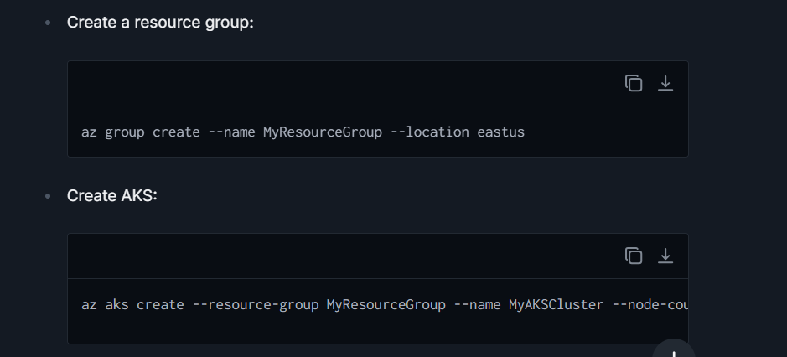

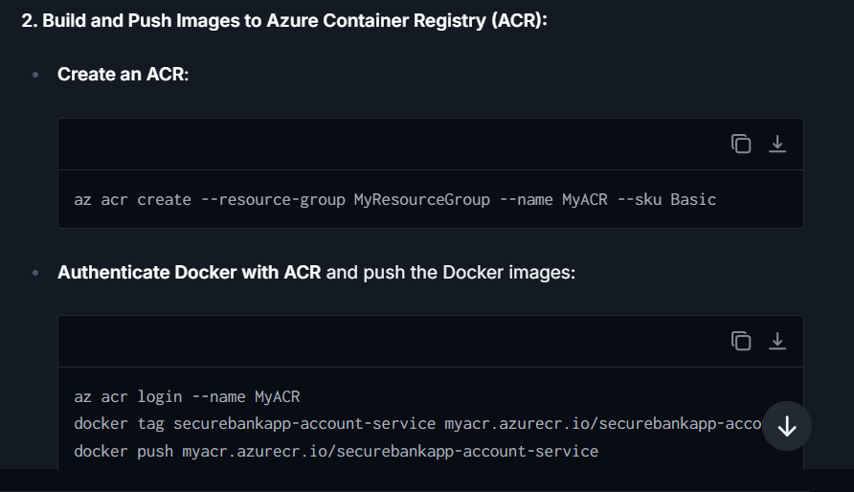

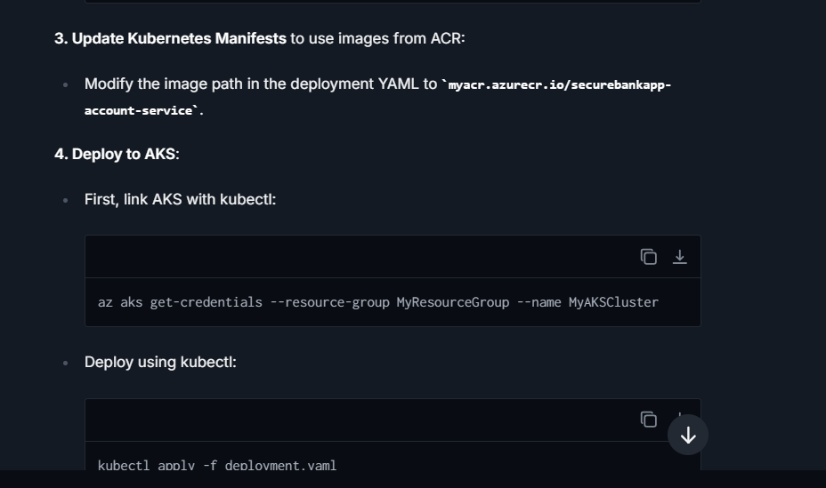

### **What challenges and Solution deploying application on azure cloud ?**

Deploying a microservices-based application like "SecureBankApp" on Azure Cloud can come with a set of challenges. These can stem from various factors including configuration complexities, network issues, security concerns, and service integration. Here's a breakdown of common challenges and considerations:

**1. Complex Configuration**

* **Service Dependencies:** Microservices often have dependencies on other services or databases, and ensuring these are properly configured in Azure can be challenging.
* **Environment Consistency:** Achieving parity between different deployment environments (development, staging, production) can be difficult. Discrepancies in environment configurations can lead to unexpected behavior.

**2. Networking and Connectivity**

* **Service Discovery:** In a microservices architecture, services need to communicate with each other. Setting up and maintaining service discovery in Azure Kubernetes Service (AKS) requires careful configuration of DNS or a service mesh like Istio.
* **Ingress and Egress Rules:** Properly configuring network inbound and outbound rules in AKS for secure and functional connectivity can be complex and needs thorough understanding.

**3. Data Management**

* **Persistent Storage:** Microservices may need to maintain state or handle user data. Configuring persistent storage that is reliable and consistent with Azure storage solutions (like Azure Disk, Azure File Storage) can be challenging.
* **Data Consistency:** Ensuring data consistency across distributed databases or when using caching mechanisms in a distributed environment requires implementing strategies such as Saga, Event Sourcing, or CQRS, which adds to the complexity.

**4. Security Concerns**

* **Data Security:** Protecting sensitive data in transit and at rest, implementing proper encryption, and managing keys securely using Azure Key Vault.
* **Identity and Access Management:** Configuring Azure Active Directory for handling service-to-service and user-to-service authentications. Implementing Role-Based Access Control (RBAC) in AKS can be challenging.

**5. Resource Management and Scaling**

* **Resource Allocation:** Properly sizing and allocating resources (CPU, memory) to different services can be challenging. Over or under-provisioning can lead to cost inefficiencies or performance issues.
* **Autoscaling:** Implementing autoscaling (Horizontal Pod Autoscaler in AKS) that reacts properly to demand spikes involves careful tuning and understanding of the metrics that drive scaling decisions.

**6. Monitoring and Logging**

* **Centralized Monitoring and Logging:** Setting up robust monitoring and logging with Azure Monitor and integrating it with other tools like Prometheus and Grafana. Ensuring that logs from all services are aggregated in a coherent manner for troubleshooting.

**7. Deployment and Versioning**

* **Rolling Updates and Rollbacks:** Managing CI/CD pipelines using Azure DevOps for microservices, handling rolling updates, and rollbacks without downtime.
* **Blue/Green or Canary Deployments:** Implementing advanced deployment strategies to minimize risks during updates.

**8. Compliance and Regulations**

* Ensuring that the application meets regulatory requirements such as GDPR, HIPAA, or others, which might involve data residence considerations or compliance checks within Azure settings.

**Solutions or Approaches:**

1. **Utilize Azure Configuration Management Tools**
   * Use Azure App Configuration and Azure Key Vault to centralize and secure application settings and secrets. Implement automated scripts using Azure CLI or PowerShell to manage configurations across environments consistently.
2. **Leverage Azure Networking Services**
   * Set up Azure Load Balancer and Azure Application Gateway to manage traffic effectively. Utilize Azure Virtual Network and Network Security Groups to secure network traffic. Service Mesh like Istio or Linkerd can be used for easier service-to-service communication within AKS.
3. **Implement Robust Data Solutions**
   * Use Azure SQL Database or Azure Cosmos DB for managed database services with built-in high availability. Employ strategies like sharding, CQRS, or event sourcing to maintain data consistency and integrity.
4. **Enhance Security Measures**
   * Implement Azure Active Directory for identity management and integrate it with Azure RBAC for fine-grained access control. Ensure all data is encrypted in transit and at rest using Azure’s built-in capabilities. Regularly audit and align with Azure’s compliance offerings.
5. **Optimize Resource and Scalability Management**
   * Use Azure Kubernetes Service (AKS) with auto-scaling enabled to manage load effectively. Monitor resource usage with Azure Monitor and optimize with Azure Advisor to keep costs under control.

### **What are the Command that we use for deploying kubernets ?**

When deploying a Spring Boot application in Kubernetes, you'll primarily interact with Kubernetes using the **kubectl** command-line tool. Here are some essential **kubectl** commands you'll commonly use, explained in the context of managing a Spring Boot application:

1. **kubectl apply -f <file or directory>:**
   * This command is used to apply a configuration to a resource from a file or set of files. For deploying a new Spring Boot application or updating an existing one, you would use this command with your deployment manifest files, which typically include your Deployment, Service, and possibly Ingress objects.
   * Example: **kubectl apply -f deployment.yaml**
2. **kubectl get <resource>:**
   * This command retrieves information about one or more resources. It's frequently used to list resources like pods, services, deployments, etc. This can help check the status of your Spring Boot application components.
   * Examples:
     + **kubectl get pods** - Lists all pods in the current namespace.
     + **kubectl get deployments** - Lists all deployments in the current namespace.
3. **kubectl describe <resource> <resource_name>:**
   * Provides detailed information about a specific resource, such as a pod or deployment. This is useful for getting more context on the state of a component, such as looking into events or specific configuration details of a Spring Boot application pod.
   * Example: **kubectl describe pod my-spring-boot-pod**
4. **kubectl logs <pod_name>:**
   * Retrieves the logs from a container in a pod. If your pod only has one container, you can just specify the pod name. This command is crucial for debugging your Spring Boot application if it's not behaving as expected.
   * Example: **kubectl logs my-spring-boot-pod**
5. **kubectl exec -it <pod_name> -- <command>:**
   * Executes a specific command inside a running container within a pod. This is useful for interactive troubleshooting and ad-hoc operational tasks within the container running your Spring Boot application.
   * Example: **kubectl exec -it my-spring-boot-pod -- bash**
6. **kubectl set image <deployment_name> <container_name>=<new_image>:**
   * Updates the image of a container running in a deployment. This is commonly used for rolling updates of a Spring Boot application to a new version.
   * Example: **kubectl set image deployment/my-spring-boot-deployment my-spring-boot-container=my-spring-boot-image:v2**
7. **kubectl rollout status <deployment_name>:**
   * Shows the rollout status of a deployment. This command helps you track the progress of a deployment update, such as after updating the image of your Spring Boot application.
   * Example: **kubectl rollout status deployment/my-spring-boot-deployment**
8. **kubectl rollout undo <deployment_name>:**
   * Reverts a deployment to its previous state, essentially rolling back the last set of changes applied. This may be necessary if the new version of your Spring Boot application has issues.
   * Example: **kubectl rollout undo deployment/my-spring-boot-deployment**
9. **kubectl delete <resource> <resource_name>:**
   * Deletes a specific resource. Use this with caution, because it's used to remove entities from your cluster, such as pods, deployments, services, etc.
   * Examples:
     + **kubectl delete pod my-spring-boot-pod**
     + **kubectl delete deployment my-spring-boot-deployment**
10. **kubectl scale deployment <deployment_name> --replicas=<num_replicas>:**
    * Manually scales a deployment to a specified number of replicas. Useful for managing the load on your Spring Boot application by increasing or decreasing the number of running instances.
    * Example: **kubectl scale deployment my-spring-boot-deployment --replicas=4**

### **How did you check memory consumption in java application ?**

Monitoring memory consumption in a Java application is critical to ensuring its performance, scalability, and reliability. There are several tools and methods available that can help you effectively monitor and analyze memory usage in Java applications:

1. **JConsole:** JConsole is a graphical monitoring tool included in the JDK that can connect to a running Java process. It provides information about the memory consumption, CPU usage, class loading, and runtime statistics. To use JConsole, start your Java application with JMX enabled:

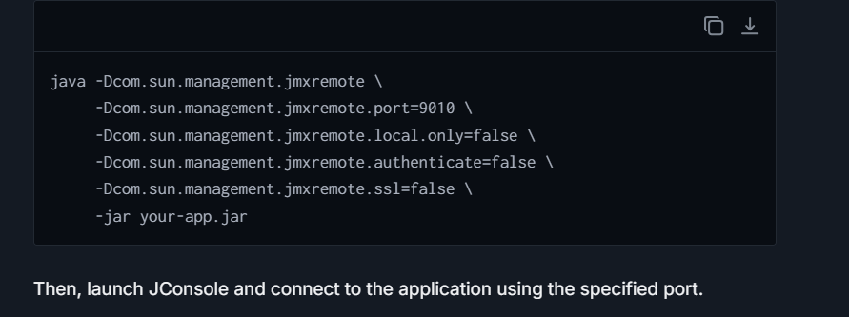

1. **VisualVM:** VisualVM is another powerful tool that comes with the Oracle JDK and can be used for monitoring memory usage among other metrics. It provides a more detailed graphical interface and can help you analyze heap, monitor garbage collection, and review thread activity. VisualVM can also take snapshots and analyze heap dumps.
2. **Java Mission Control and Flight Recorder:** Java Mission Control together with Flight Recorder is a more advanced tool that allows deep dive diagnostics with minimal performance overhead. It is particularly useful for monitoring Java applications running in production. Memory consumption, as well as detailed information about the garbage collection, latency, and other JVM internals, can be analyzed.

### **What challenges developing "SecureWebApp” and How you resolve it ?**

**Bottlenecks & Issues:**

1. **Service Interdependencies and Communication Delays** Microservices need to communicate efficiently, and network latency or misconfigurations can lead to delays and downtime.
2. **Database Performance and Management** High transaction volumes typical of banking applications can strain conventional databases, leading to performance bottlenecks.
3. **Security Vulnerabilities** Maintaining security in a distributed system, especially one handling sensitive financial data, is challenging. Vulnerabilities can arise from various sources, including external attacks and internal misconfigurations.
4. **Debugging and Logging Challenges** In a microservices architecture, correlating logs and debugging issues across services can be daunting due to the distributed nature of the system.

**Resolutions**

1. **Optimizing Service Communication**
   * **Service Mesh**: Implementing a service mesh like Istio or Linkerd to manage service communications efficiently. These tools help in load balancing, service discovery, failure recovery, and making the communication secure.
   * **API Gateway**: Using Azure API Management as a central point to manage APIs reduces the complexity of direct service-to-service communications and centralizes authentication.
2. **Enhancing Database Performance**
   * **Scaling**: Implement database sharding or partitioning to distribute the workload more evenly across servers.
   * **Caching**: Introduce caching mechanisms using Azure Redis Cache to reduce database load and improve response times for frequently accessed data.
   * **Database as a Service (DBaaS)**: Use Azure SQL Database or Cosmos DB which offers built-in scalability and performance maintenance features.

### **How we can optimize the code and improve the performance ?**

The strategies encompass clean coding practices, efficient resource management, leveraging the right tools and technologies, and continuously monitoring and tuning performance :-

**1. Code Optimization**

* **Refactor and Clean Up Code**: Periodically review and refactor the code to remove redundancies, improve readability, and enhance maintainability. Use principles like DRY (Don't Repeat Yourself) and KISS (Keep It Simple, Stupid) to keep the codebase efficient and straightforward.
* **Effective Use of Algorithms and Data Structures**: Analyze and optimize your choice of algorithms and data structures for efficiency. Choosing the right data structure can significantly speed up application response times, especially for operations like search, insert, and delete.
* **Concurrency and Multithreading**: Utilize Java’s Concurrency utilities to handle multiple tasks simultaneously, effectively reducing the response time, especially in I/O-bound or computational-heavy operations.

**2. Database Optimization**

* **Indexing**: Implement indexes on columns that are frequently used in WHERE clauses or as joins in SQL queries to speed up data retrieval.
* **Query Optimization**: Write efficient queries to minimize the data fetched from the database. Avoid SELECT * queries; instead, fetch only specific fields necessary for the operation.
* **Connection Pooling**: Use connection pooling to reduce the overhead of creating and closing connections for every database interaction. Frameworks like HikariCP (which is the default in Spring Boot when using Spring Data) provide a high-performance JDBC connection pool.

**3. Application-Level Optimization**

* **Asynchronous Processing**: Implement asynchronous methods in services where applicable to prevent bottlenecks, using Spring’s **@Async** annotation.
* **Caching**: Leverage caching to store and reuse frequently accessed data, reducing the number of database hits and speeding up response times. Spring provides integrated support for caching abstractions such as EhCache or Caffeine.
* **Stateless Design**: In a microservices architecture, design stateless applications where possible. This makes the application easy to scale and improves performance as there is less overhead in syncing state across multiple instances.

### **How do you Communicate to the customer if a team member misses a deadline?**

I gather all the facts to understand the reason for the delay and assess the new timeline. Once I have all pertinent information, I would contact the customer as soon as possible.

1. **Acknowledge the Missed Deadline**: I begin by openly acknowledging that we have missed the deadline and express our commitment to the project and respect for their time. This sets a honest tone for the conversation.
2. **Explain Without Excusing**: I provide a clear explanation for the delay without making excuses. This might include unforeseen issues or challenges that impacted the timeline and provide a brief explanation of why the deadline was missed, focusing on facts rather than excuses.
3. **Present a Revised Plan**: Most importantly, I immediately present a revised plan with a new deadline. I ensure this new timeline is realistic, includes buffer time if possible, and reflects any adjustments in project management to address the cause of the delay.
4. **Seek Feedback**: I engage the customer by asking for their input or any concerns they might have about the new timeline, ensuring they feel heard and involved in the process moving forward.
5. **Apologize and Reassure**: Finally, I apologize for any inconvenience caused and reassure them of our commitment to the quality and timely delivery of the project.

### **What Steps do you take to manage the customer’s expectations when timelines are delayed?**

Managing expectations is crucial not only after a delay has occurred but throughout the project lifecycle. Here’s how I handle it:

1. **Proactive Communication**: I believe in maintaining regular updates with the client. This involves not only sharing progress but also potential challenges that might impact the timeline. Being proactive allows us to manage expectations early and gives the client room to plan their schedules accordingly.
2. **Adjust Scope or Resources if Needed**: If frequent delays occur, I review the project scope and resources. Sometimes, bringing additional resources or adjusting project scope helps in adhering to timelines without compromising on quality.
3. **Set Clear, Realistic Deadlines**: From the onset, I focus on setting realistic deadlines, taking into account all possible variables. Clear deadlines and a well-thought-out project timeline help in managing customer expectations effectively from the start.
4. **Include the Customer in Planning Stages**: Including the customer in the planning and decision-making stages for key milestones or deliverables ensures they have a realistic understanding of what to expect and when to expect it.
5. **Offer Compensation or Value-Adds**: If the delay significantly impacts the customer, offering some form of compensation or additional value can help in maintaining goodwill. This could be in the form of a discount on the current project or added services at no additional charge.